**A**

**PROJECT WORK**

**ON**

**(SQL)**



**Work Carried Out At “Celebal Technologies”**

Submitted To: Submitted by:

---------------------- --------------------------

Celebal Technologies SQL-1 Vivek Chhangani

Sharve Parihar

Sailesh Verma

CSE III Year, JIET

**TASK 1**

**1.1.** You are given a table, Projects, containing three columns: Task_ID, Start_Date and End_Date. It is guaranteed that the difference between the End_Date and the Start_Date is equal to 1 day for each row in the table.

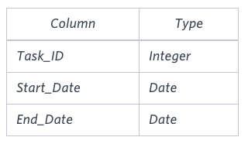

If the End_Date of the tasks are consecutive, then they are part of the same project. Samantha is interested in finding the total number of different projects completed. Write a query to output the start and end dates of projects listed by the number of days it took to complete the project in ascending order. If there is more than one project that have the same number of completion days, then order by the start date of the project

**SOLUTION:**

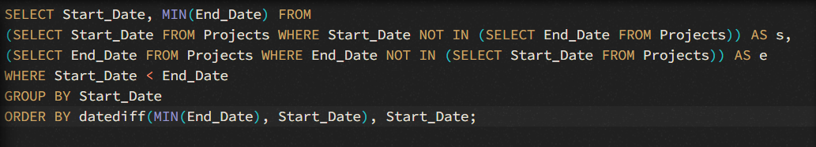

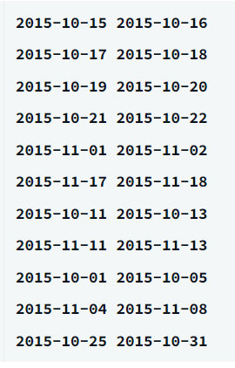

**1.2.** You are given three tables: Students, Friends and Packages. Students contains two columns: ID and Name. Friends contains two columns: ID and Friend_ID (ID of the ONLY best friend). Packages contains two columns: ID and Salary (offered salary in $ thousands per month)

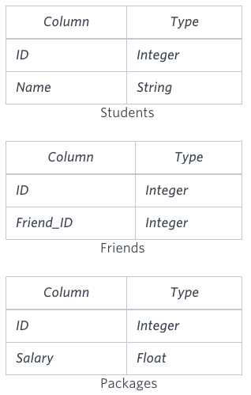

Write a query to output the names of those students whose best friends got offered a higher salary than them. Names must be ordered by the salary amount offered to the best friends. It is guaranteed that no two students got same salary offer.

**SOLUTION:**

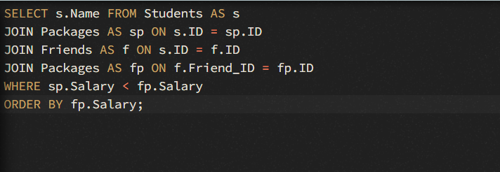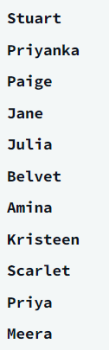

**1.3.**You are given a table, Functions, containing two columns: X and Y.

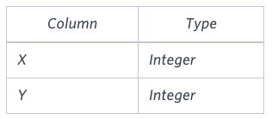

Two pairs (X1, Y1) and (X2, Y2) are said to be symmetric pairs if X1 = Y2 and X2 = Y1.Write a query to output all such symmetric pairs in ascending order by the value of X

**SOLUTION:**

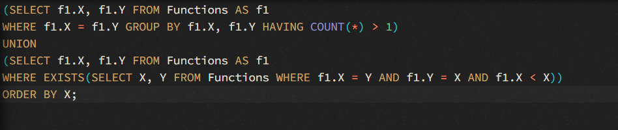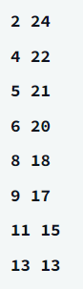

**1.4.** Samantha interviews many candidates from different colleges using coding challenges and contests. Write a query to print the contest_id, hacker_id, name, and the sums of total_submissions, total_accepted_submissions, total_views, and total_unique_views for each contest sorted by contest_id. Exclude the contest from the result if all four sums are 0.

Note: A specific contest can be used to screen candidates at more than one college, but each college only holds screening contest.

Input Format

The following tables hold interview data:

Contests: The contest_id is the id of the contest, hacker_id is the id of the hacker who created the contest, and name is the name of the hacker.

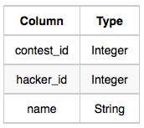

Colleges: The college_id is the id of the college, and contest_id is the id of the contest that Samantha used to screen the candidates.

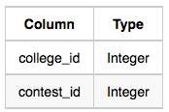

Challenges: The challenge_id is the id of the challenge that belongs to one of the contests whose contest_id Samantha forgot, and college_id is the id of the college where the challenge was given to candidates.

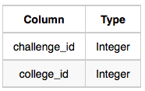

View_Stats: The challenge_id is the id of the challenge, total_views is the number of times the challenge was viewed by candidates, and total_unique_views is the number of

times the challenge was viewed by unique candidates.

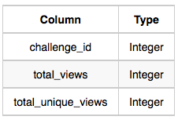

Submission_Stats: The challenge_id is the id of the challenge, total_submissions is the number of submissions for the challenge, and total_accepted_submission is the number of submissions that achieved full scores.

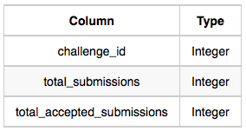

**SOLUTION:**

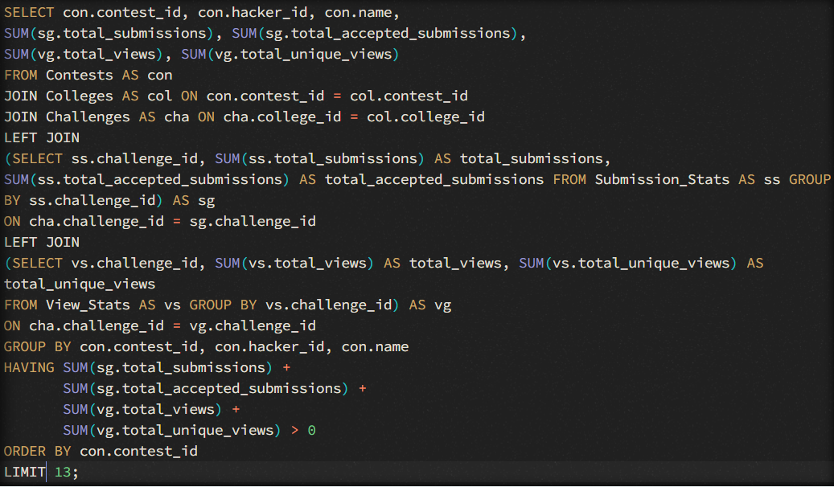

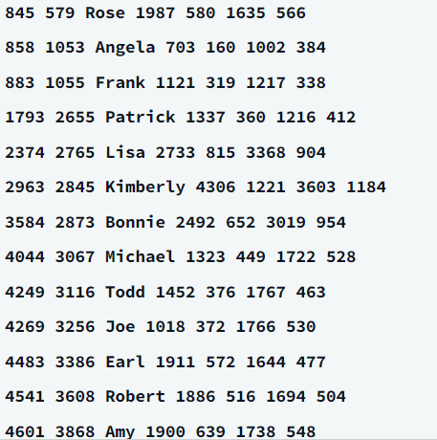

**TASK 2**

**2.1**.Julia conducted a days of learning SQL contest. The start date of the contest was March 01, 2016 and the end date was March 15, 2016.

Write a query to print total number of unique hackers who made at least submission each day (starting on the first day of the contest), and find the hacker_id and name of the hacker who made maximum number of submissions each day. If more than one such hacker has a maximum number of submissions, print the lowest hacker_id. The query should print this information for each day of the contest, sorted by the date.

Input Format

The following tables hold contest data:

* Hackers: The hacker_id is the id of the hacker, and name is the name of the hacker.

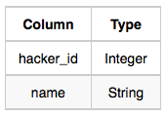

* Submissions: The submission_date is the date of the submission, submission_id is the id of the submission, hacker_id is the id of the hacker who made the submission, and score is the score of the submission. 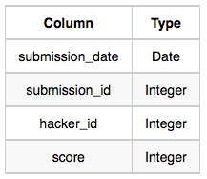

**SOLUTION:**

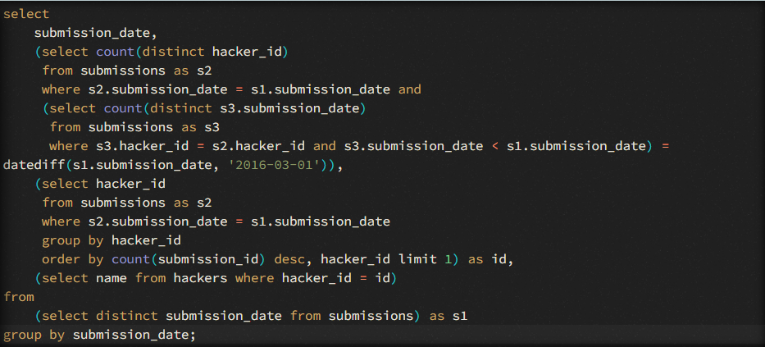

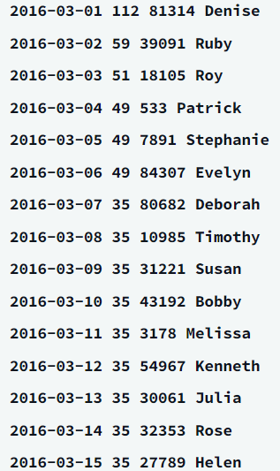

**2.2.**Consider P1(a,b) and P2(c,d) to be two points on a 2D plane.

* happens to equal the minimum value in Northern Latitude (LAT_N in STATION).
* happens to equal the minimum value in Western Longitude (LONG_W in STATION).
* happens to equal the maximum value in Northern Latitude (LAT_N in STATION).
* happens to equal the maximum value in Western Longitude (LONG_W in STATION).

Query the [Manhattan Distance](https://xlinux.nist.gov/dads/HTML/manhattanDistance.html) between points P1 and P2 and round it to a scale of 4 decimal places.

Input Format

The STATION table is described as follows:

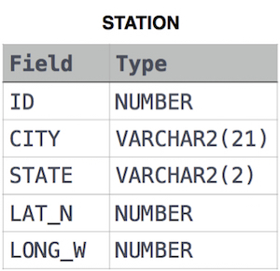

where LAT_N is the northern latitude and LONG_W is the western longitude.

**SOLUTION:**





**2.3**.Pivot the Occupation column in OCCUPATIONS so that each Name is sorted alphabetically and displayed underneath its corresponding Occupation. The output column headers should be Doctor, Professor, Singer, and Actor, respectively.

Note: Print NULL when there are no more names corresponding to an occupation.

Input Format

The OCCUPATIONS table is described as follows:

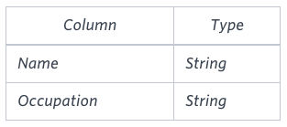

Occupation will only contain one of the following values: Doctor, Professor, Singer or Actor.

**SOLUTION:**

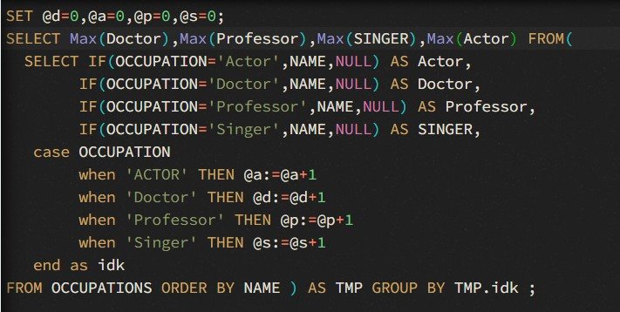

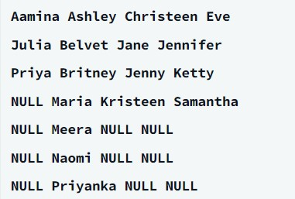

**2.4**.Amber's conglomerate corporation just acquired some new companies. Each of the companies follows this hierarchy:

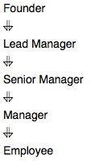

Given the table schemas below, write a query to print the company_code, founder name, total number of lead managers, total number of senior managers, total number of managers, and total number of employees. Order your output by ascending company_code.

Note:

* The tables may contain duplicate records.
* The company_code is string, so the sorting should not be numeric. For example, if the company_codes are C_1, C_2, and C_10, then the ascending company_codes will be C_1, C_10, and C_2.

Input Format

The following tables contain company data:

* Company: The company_code is the code of the company and founder is the founder of the company.

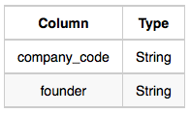

* Lead_Manager: The lead_manager_code is the code of the lead manager, and the company_code is the code of the working company.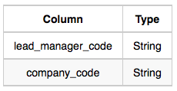
* Senior_Manager: The senior_manager_code is the code of the senior manager, the lead_manager_code is the code of its lead manager, and the company_code is the code of the working company

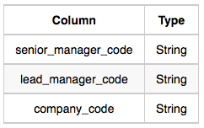

* Manager: The manager_code is the code of the manager, the senior_manager_code is the code of its senior manager, the lead_manager_code is the code of its lead manager, and the company_code is the code of the working company.

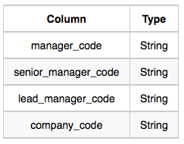

* Employee: The employee_code is the code of the employee, the manager_code is the code of its manager, the senior_manager_code is the code of its senior manager, the lead_manager_code is the code of its lead manager, and the company_code is the code of the working company.

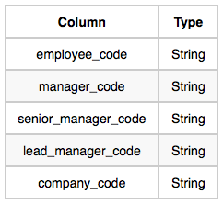

**SOLUTION:**

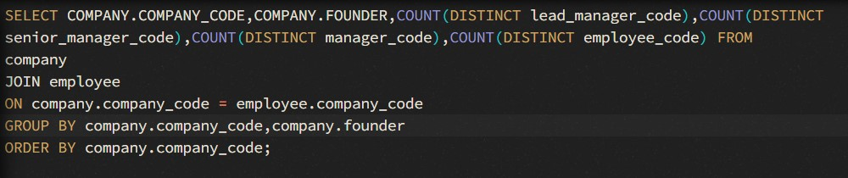

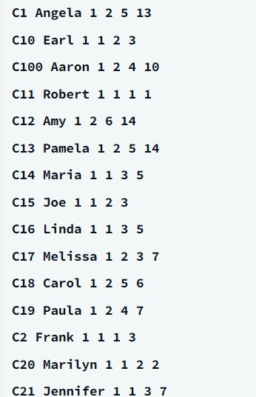

**2.5**.You are given a table, BST, containing two columns: N and P, where N represents the value of a node in Binary Tree, and P is the parent of N.

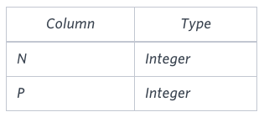

Write a query to find the node type of Binary Tree ordered by the value of the node. Output one of the following for each node:

* Root: If node is root node.
* Leaf: If node is leaf node.
* Inner: If node is neither root nor leaf node.

**SOLUTION:**

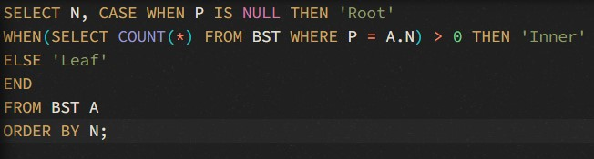

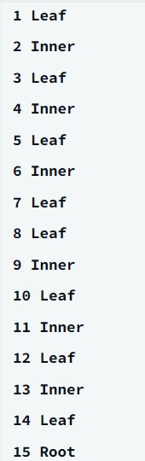

**References**

* <https://www.w3schools.com/sql/sql_syntax.asp>
* <https://www.w3schools.com/sql/sql_ref_union.asp>
* <https://www.w3schools.com/sql/sql_join.asp>
* <https://www.geeksforgeeks.org/pivot-and-unpivot-in-sql>.
* <https://stackoverflow.com/questions/4095000/how-to-calculate-the-manhattan-distance-with-sql-function-procedure>
* Hackerrank IDE