Program1:my first program

class myfirstprogram

{

public static void main(String arg[]){

System.out.println("welcome");

}

}

Output:

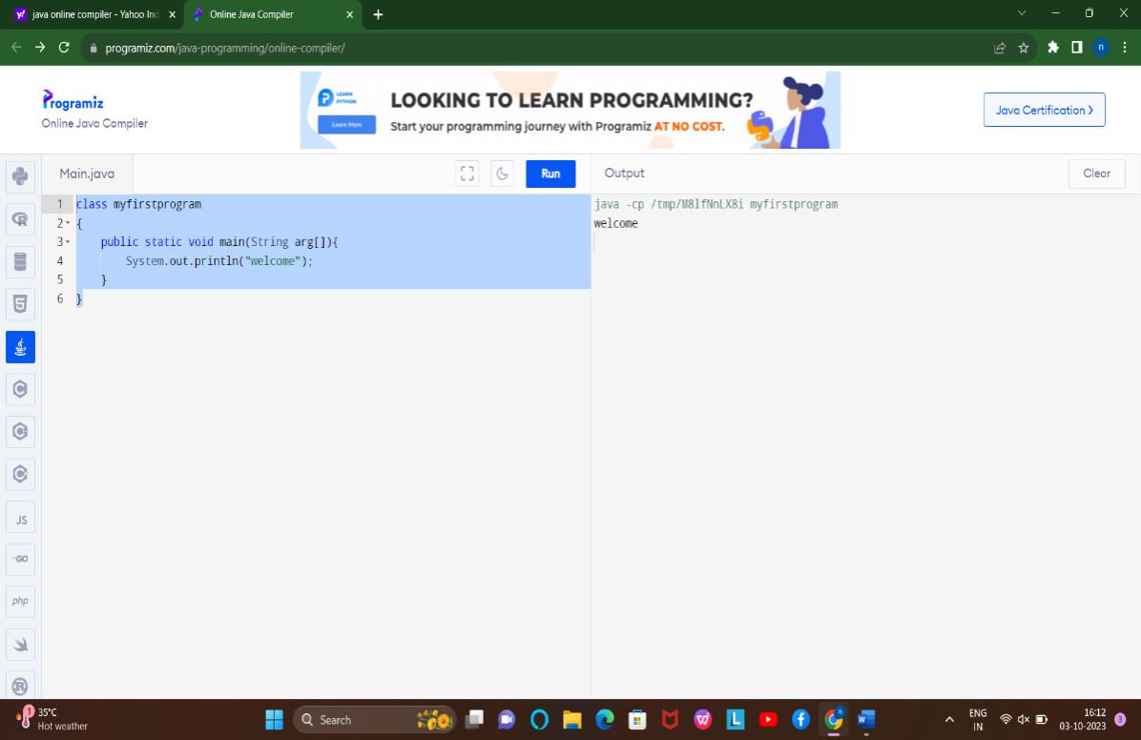

Program2:Addition

class additon

{

public static void main(String arg[]){

int a=10,b=20,c;

c=a+b;

System.out.println("output ="+c);

}

}

Output:

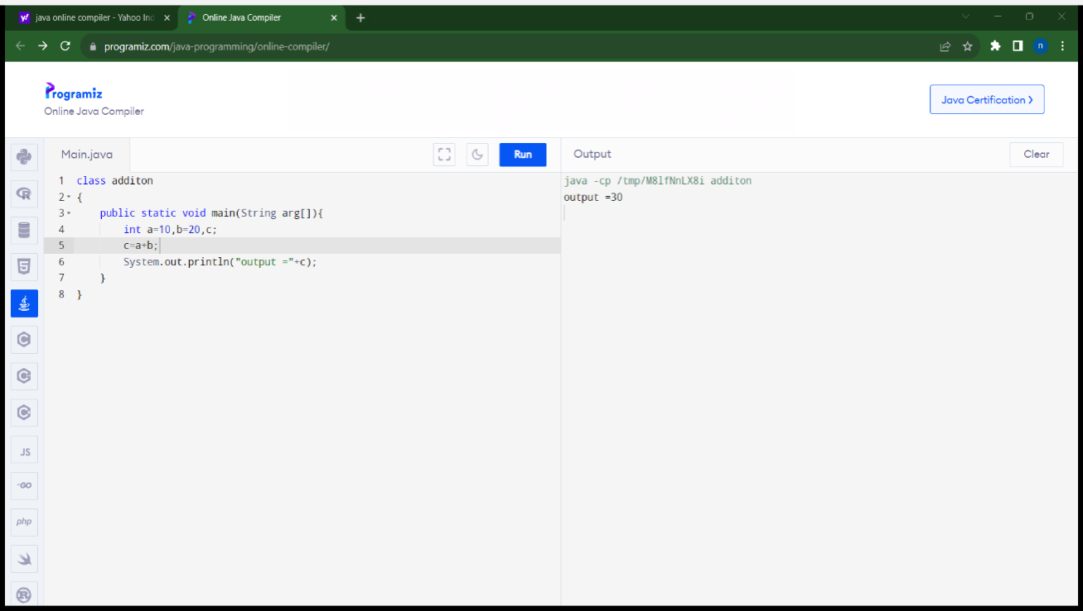

Program3:Simple intrest

class simpleinterst

{

public static void main(String arg[]){

float p,r,t,si;

p=130000;

r=2;

t=2;

si=(p*t*r)/100;

System.out.println("simple intrest ="+si)}}

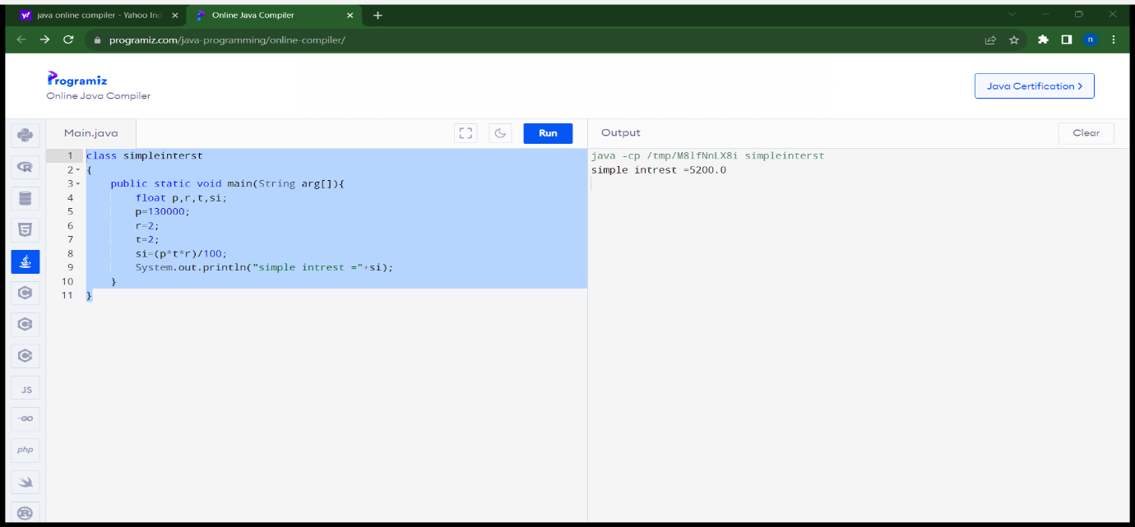

Program 4:Addtion

import java.util.*;

class addition{

public static void main(String args[]){

Scanner S=new Scanner(System.in);

int a,b,c;

a=S.nextInt();

b=S.nextInt();

c=a+b;

System.out.println("additon:"+c);

}

}

Output:

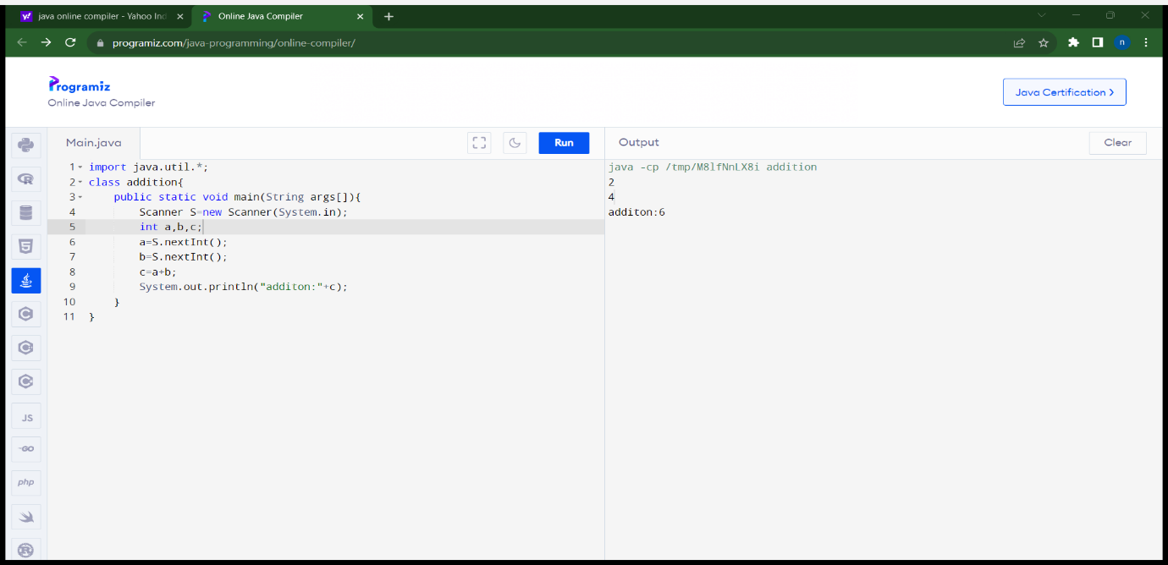

Program5:Convert Celsius to farhrenheit

import java.util.*;

class temperature{

public static void main(String args[]){

Scanner S=new Scanner(System.in);

float celsius,farhrenheit;

celsius=S.nextFloat();

farhrenheit=((celsius*9)/5)+32;

System.out.println("farhrenheit"+farhrenheit);

}

}

Output:

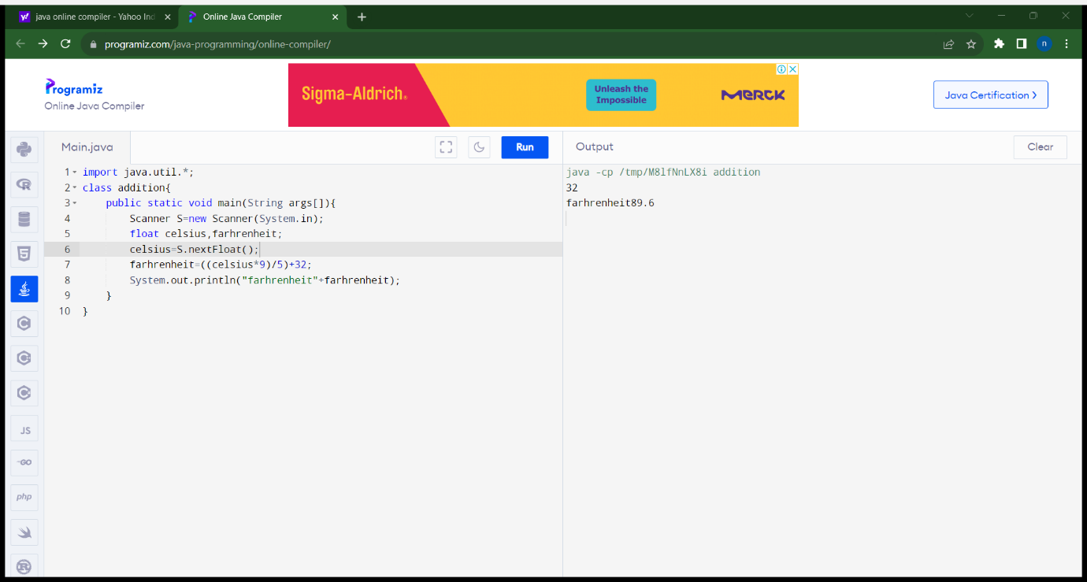

Program6:odd or even

import java.util.*;

class oddeven{

public static void main(String args[]){

Scanner S=new Scanner(System.in);

int num;

num=S.nextInt();

if(num%2==0)

System.out.println("even number");

else

System.out.println("odd number");

}

}

Output:

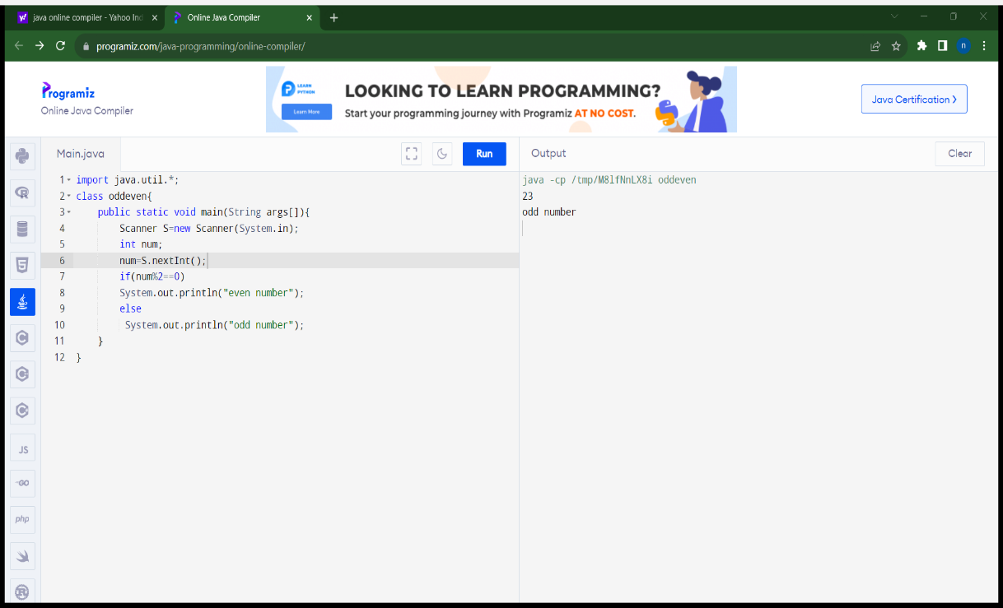

Program7:leap year or not

import java.util.*;

class leapyear{

public static void main(String args[]){

Scanner S=new Scanner(System.in);

int year;

System.out.println("enter a year");

year=S.nextInt();

if(((year%4==0)&&(year%100!=0))||(year%400==0))

System.out.println("leap year");

else

System.out.println("not leap year");

}

}

Output:

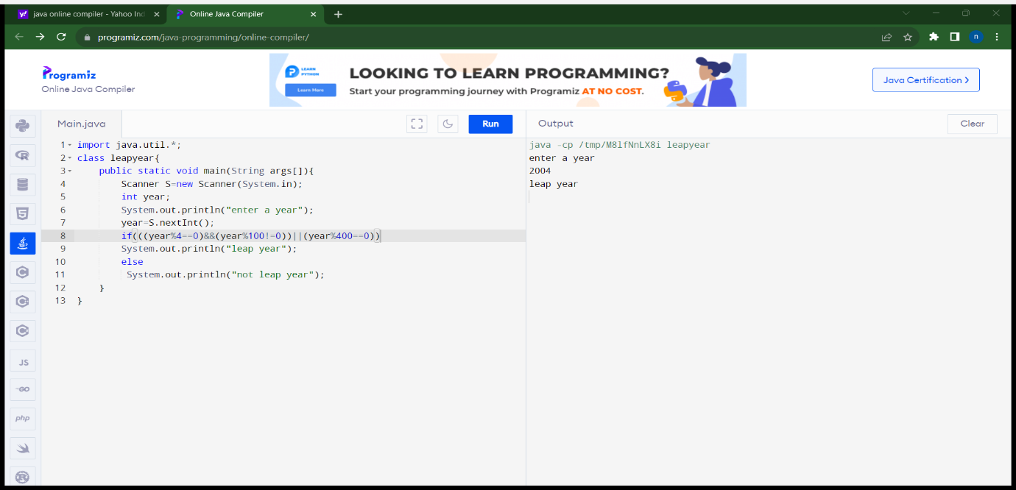

Program8:voting

import java.util.*;

class voting{

public static void main(String args[]){

Scanner S=new Scanner(System.in);

int age;

System.out.println("enter a age");

age=S.nextInt();

if(age>=18)

System.out.println("eligible for voting");

else

System.out.println("not eligible for voting");

}

Output:

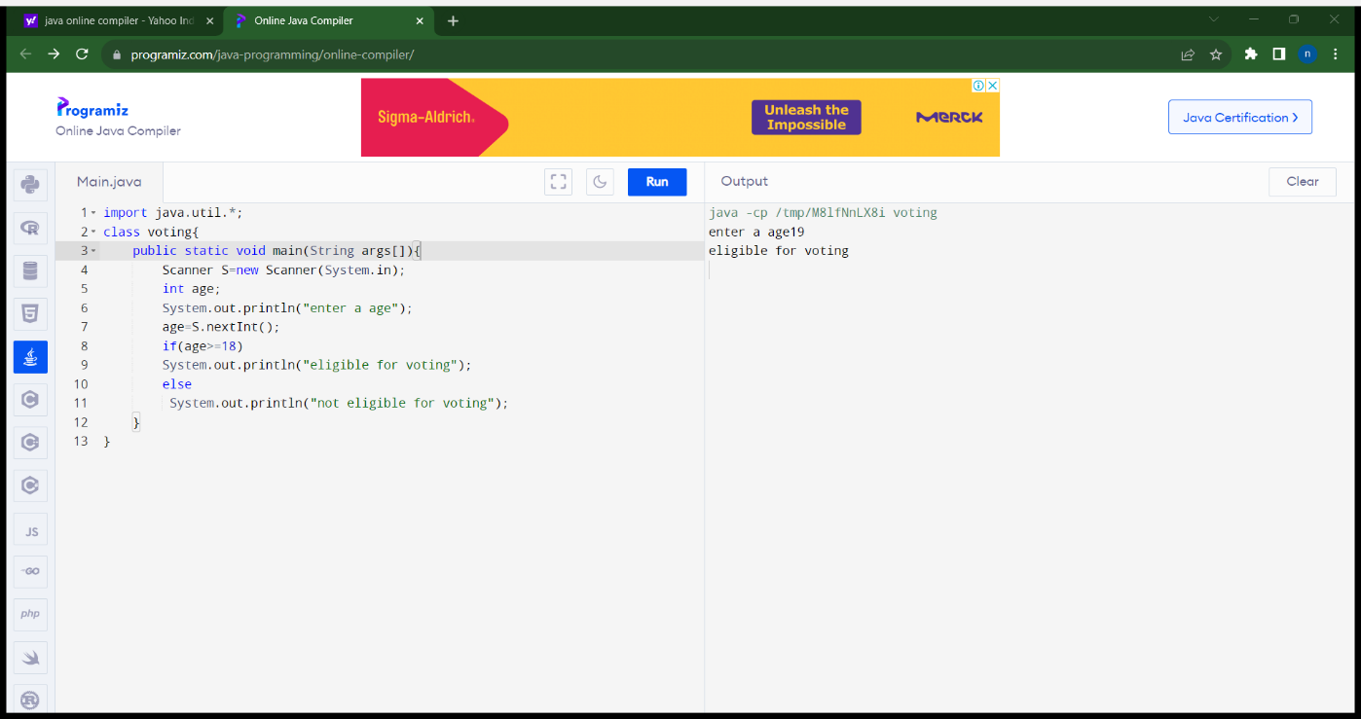

Program9:Positive or negative

import java.util.*;

class positiveornegative{

public static void main(String args[]){

Scanner S=new Scanner(System.in);

int num;

System.out.println("enter a number");

num=S.nextInt();

if(num>0)

System.out.println("positive number");

else if(num==0)

System.out.println("zero number");

else

System.out.println("negative number");

}

}

Output:

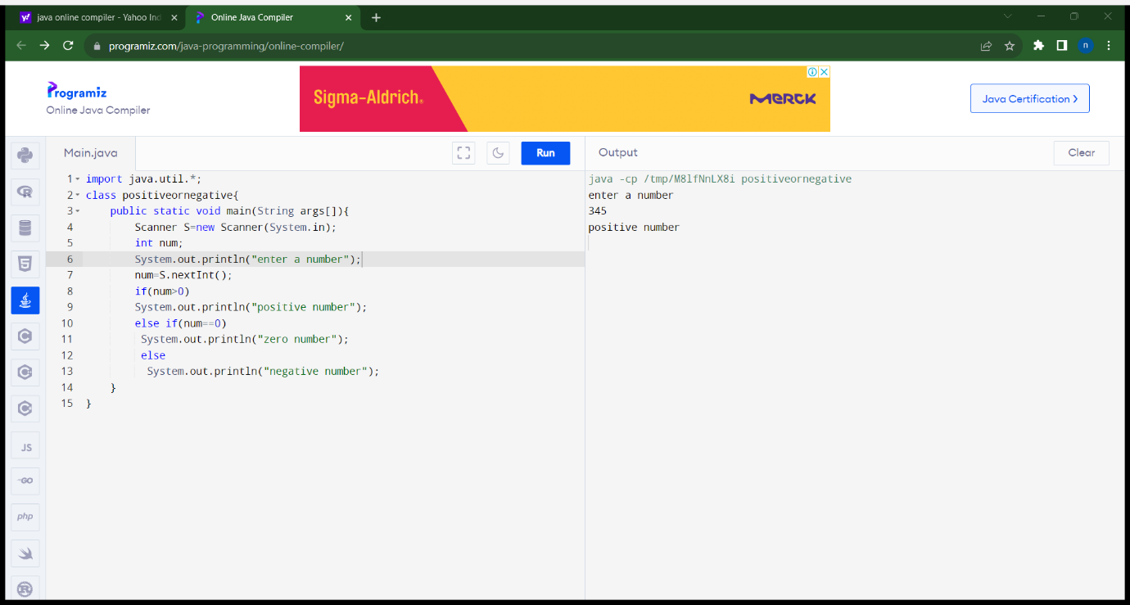

Program10:Sum of series

import java.util.*;

class sum of series{

public static void main(String args[]){

Scanner S=new Scanner(System.in);

int num,i,sum=0;

System.out.println("enter a number");

num=S.nextInt();

for(i=0;i<num;i++)

sum=sum+i;

System.out.println("sum of series "+sum);

}

}

Output:

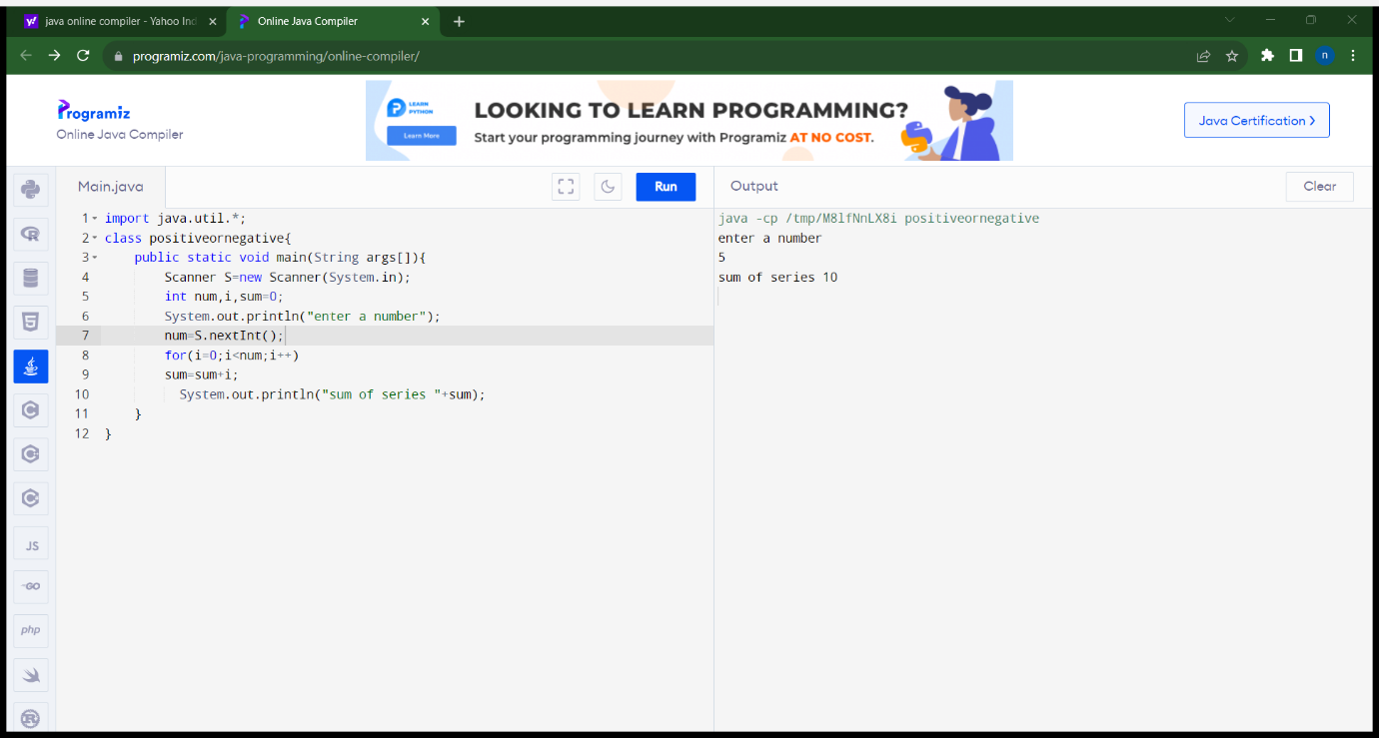

Program11:Factorial of a number

import java.util.*;

class factorial{

public static void main(String args[]){

Scanner S=new Scanner(System.in);

int num,i,fact=1;

System.out.println("enter a number");

num=S.nextInt();

for(i=1;i<=num;i++)

fact=fact*i;

System.out.println("factorial of number "+fact);

}

}

Output:

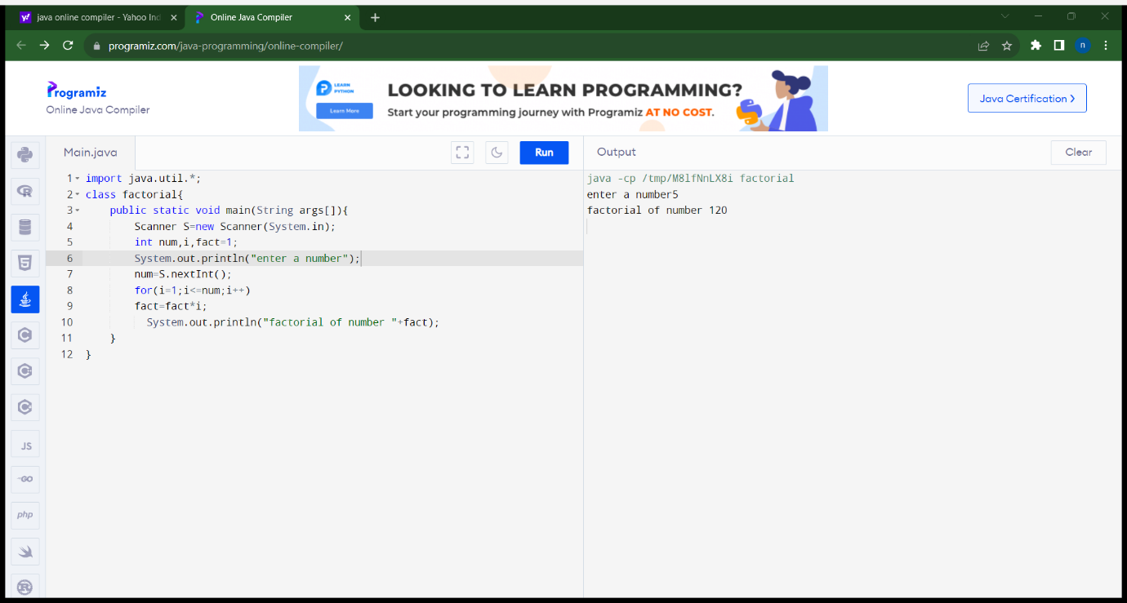

Program12:prime or not

import java.util.*;

class prime{

public static void main(String args[]){

Scanner S=new Scanner(System.in);

int num,i,count=0;

System.out.println("enter a number");7

num=S.nextInt();

for(i=1;i<=num;i++)

if(num%i==0)

count++;

if(count==2)

System.out.println("prime number");

else

System.out.println("not prime number");

}

}

Output:

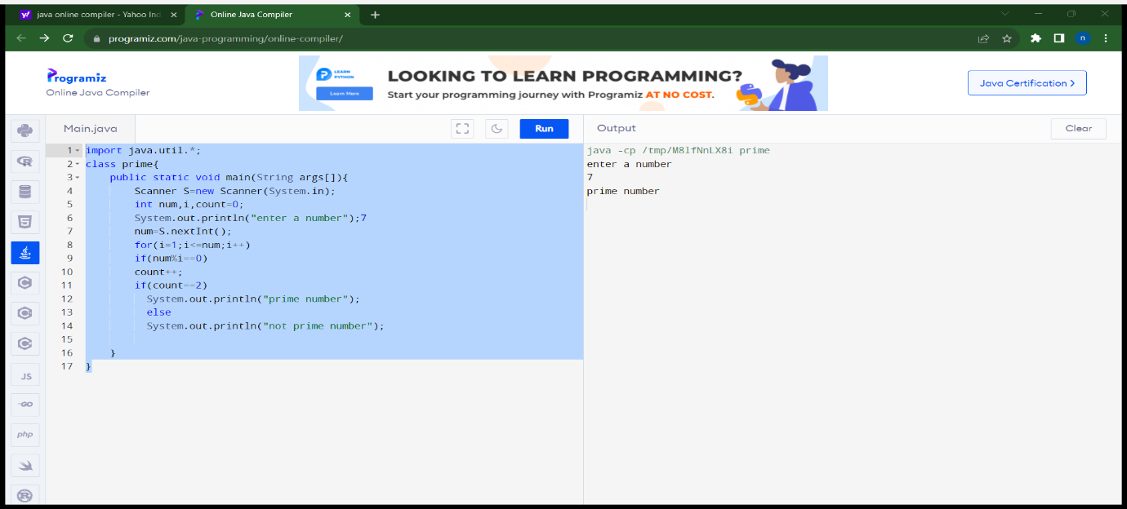

Program13:clg name and dept name

import java.util.*;

class clgname{

public static void main(String args[]){

Scanner S=new Scanner(System.in);

String clgname,deptname;

System.out.println("enter clg name");

clgname=S.next();

System.out.println("enter dept name");

deptname=S.next();

System.out.println(clgname + deptname);

}

}

Output

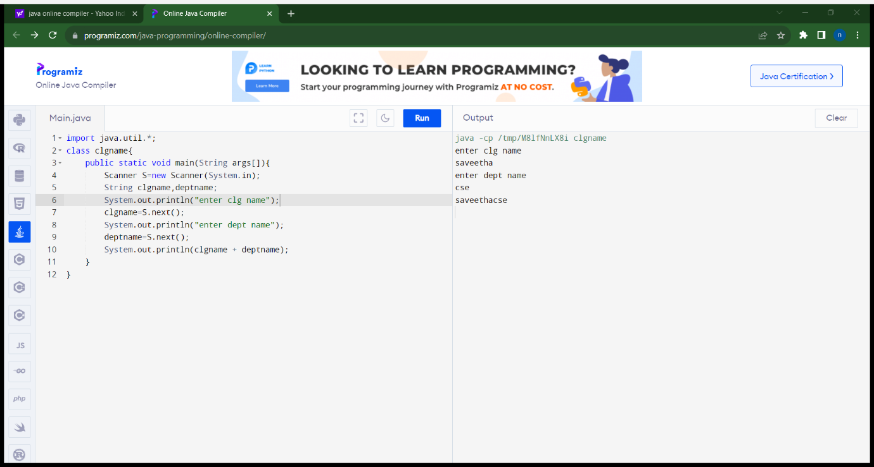

Program14:Reverse a number

import java.util.*;

class reverse{

public static void main(String args[]){

Scanner S=new Scanner(System.in);

int num,rev=0,rem;

System.out.println("enter a number");

num=S.nextInt();

while(num!=0)

{

rem=num%10;

rev=rev*10+rem;

num=num/10;

}

System.out.println("reverse "+rev);

}

Output:

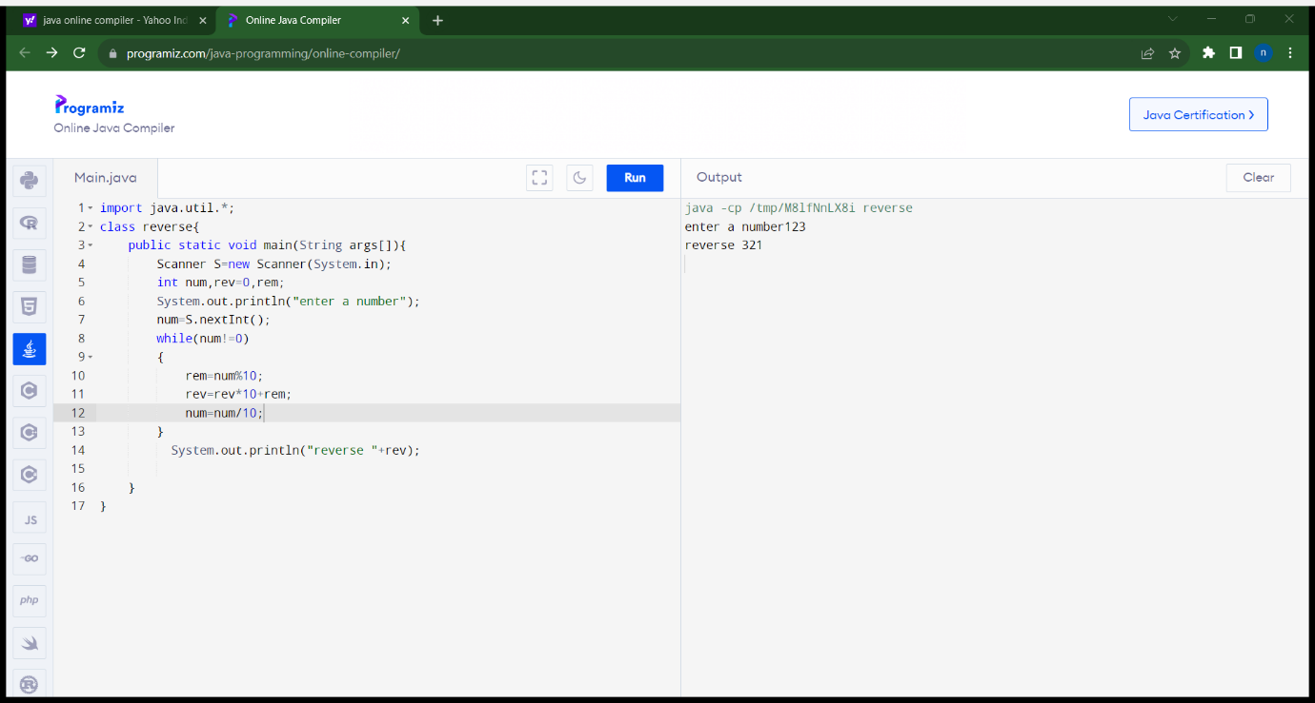

Program15:palindrome or not

import java.util.*;

class plaindrome{

public static void main(String args[]){

Scanner S=new Scanner(System.in);

int num,rev=0,rem;

System.out.println("enter a number");

num=S.nextInt();

while(num!=0)

{

rem=num%10;

rev=rev*10+rem;

num=num/10;

}

if(rev==num)

System.out.println("plaindrome");

else

System.out.println(" not plaindrome");

}

}

Output:

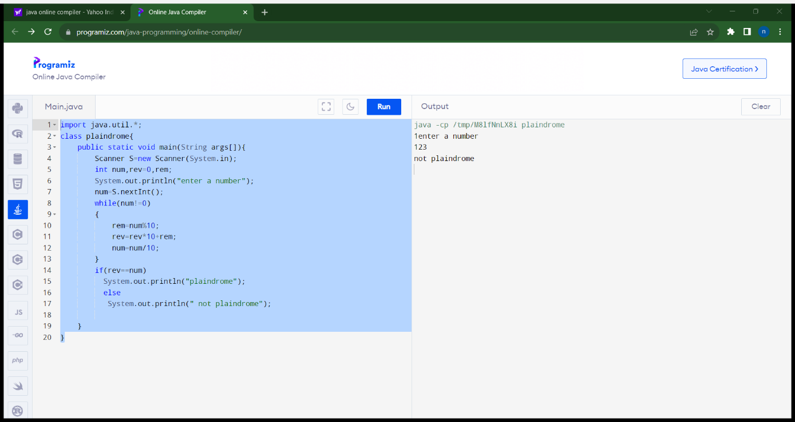

import java.util.Scanner;

public class Year_Week_Day

{

public static void main(String args[])

{

int m, year, week, day;

Scanner s = new Scanner(System.in);

System.out.print("Enter the number of days:");

m = s.nextInt();

year = m / 365;

m = m % 365;

System.out.println("No. of years:"+year);

week = m / 7;

m = m % 7;

System.out.println("No. of weeks:"+week);

day = m;

System.out.println("No. of days:"+day);

    }

}