**2nd years:**

Ques 1:

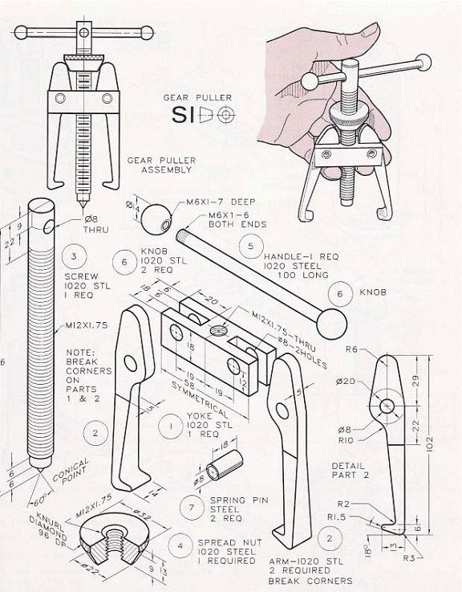

Design and assemble the above given mechanism with proper dimensions and mates with the help of 3D designing softwares(preferably Solidworks)

(*Note: all the screw thread can be excluded)

Ques 2:

You have been given a manipulator(3dof) to lift a load weighing 2.5kg having two links(80mm) and an end-effector weighing 0.75kg. and three motors M1, M2 and M3.

M1- Base motor

M2- motor for first link

M3- motor for second link

Calculate the **torque** provided by the motors to the links and the end-effector if the weight of links is 0.65kg and weight of each motor is 0.8kg.

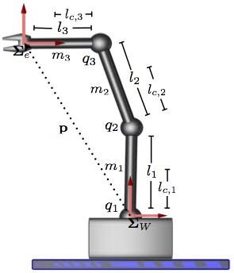

**1st years:**

Ques 1:

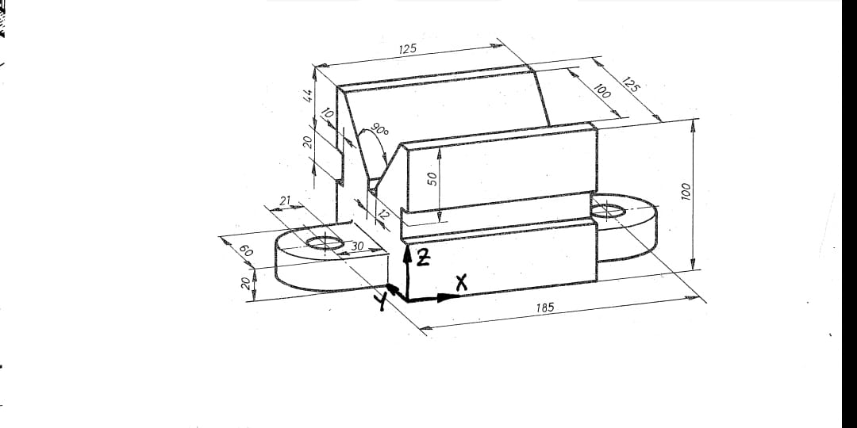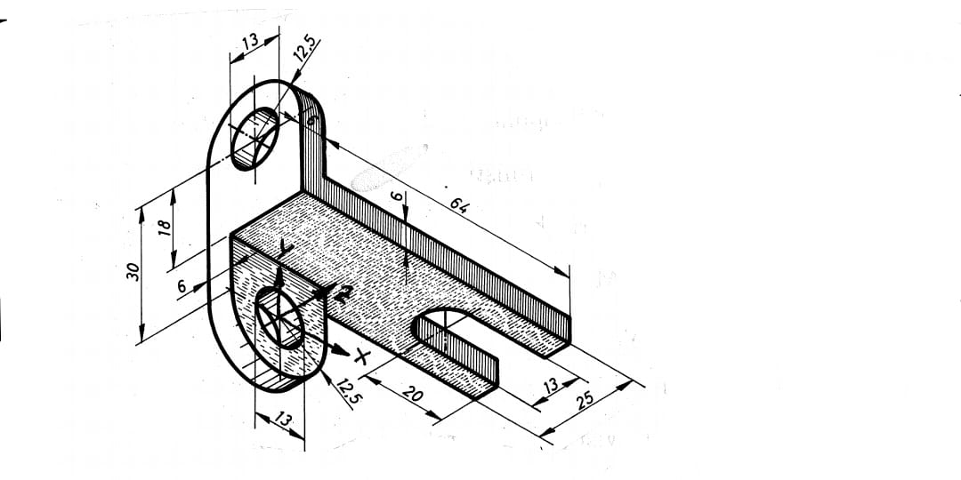

Design the above given figures using a 3D designing software(preferably Solidworks) with proper dimensions.

Ques 2:

In the diagram OA = 2a, OB=3a-2b, and OC=51-6b. Express in terms of b, as simple as possible and convert into matrix form :

a. AB

B.BC

