**ULTRON – 2K18**

**A National Level Technical Symposium on**

**Recent Innovations in Engineering & Technology**

**22nd & 23rd Feb, 2018**

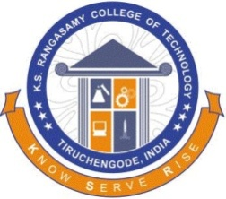 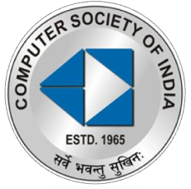

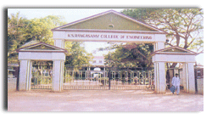

**Organized by**

**Computer Society of India**

**K.S.Rangasamy College of Technology**

*(Autonomous)*

**Tiruchengode – 637215**

**Mailing Address**

The Co-ordinator

ULTRON – 2K18

Department of Information Technology

K.S.Rangasamy College of Technology

Tiruchengode - 637215

**ABOUT THE SYMPOSIUM**

The aim of the National level Technical symposium **ULTRON’18** is to bring the Research Professionals, Academicians and Student community together to share their Innovative Ideas on the Advancements of Engineering and Technology.

ULTRON’18 covers various aspects of Engineering and Technology like (But not restricted to)

* Wireless Communication
* Signal and Image Processing
* Ad-hoc Networks
* Cloud Computing
* Neural Networks
* Mobile Computing
* Medical Image and Biometrics
* Image, Web and Data Mining
* Bio-Polymers
* Green Buildings
* Automation
* SCADA
* Power Drives
* Control Systems

|  |  |
| --- | --- |
| **IMPORTANT DATES** | |
| Paper Submission Date | **10.02.2018** |
| Acceptance Notification | **23.02.2018** |
| Symposium Date | **22nd Feb, 2018** |

**ULTRON’18 EVENTS**

1. ***PAPER PRESENTIA’18***

**Abstract :** 300 Words, 2 Authors per paper

**Full paper :** IEEE Format, Limited to 8 pages

Soft copies (.doc, .docx, .pdf) of the paper are to be sent to **csiksrct@gmail.com**

1. **IOT-PRESENTATION**

Get your ideas intact with internet.

1. **DEBUGGING**

Unleash your programming skills to kill the bugs and execute a given task easily.

1. **RAPID CODE**

Code it out and explore your programming skill.

1. **BE A SPIDER**

Worth your design.

**CONTACT**

**Faculty Coordinator :** Mr. S. Balu

9843477791

**Student Coordinator :** P. Pradeep

9976322613

**Email :** csiksrct@gmail.com