**Content Management System**

**VISION**

**-14BCE059**

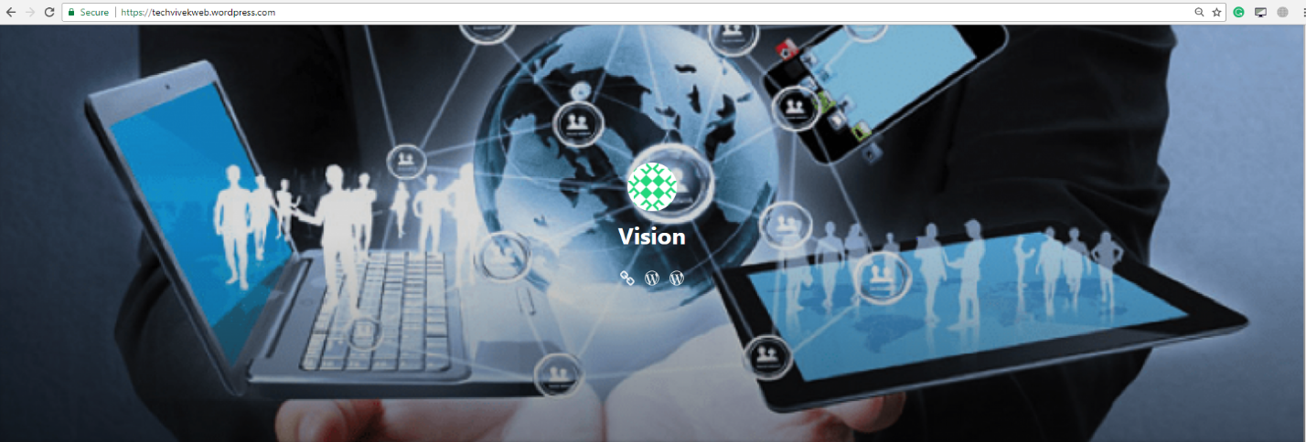

**Abstract:**

WordPress is a multi-user and multi-blogging platform. My blog focuses on the new technologies that every technical person should be aware about. I have explained the basics of most recent and new ones that I have a hands on experience with.

**Introduction:**

I have described briefly about the five important and new technologies. Starting with **Aspect-Oriented technique** which will be adopted by almost all of the future technical projects. It cross cuts the overlapping functionalities in an efficient way. Next is Task Scheduling in **Cloud Computing,** which deals with the storage of data that is over flooding these days. Now we cannot store everything with the original size, even cloud will be full at some point, so **Compression** is my next blog post. Here it discusses about compressing Astronomical images which have size we cannot imagine.

We as a programmer focus only on the output of the source code, but we should know about the compilation process. In this blog a very non famous nut highly efficient **ROSE Compiler** is briefly discussed. Nearly all programmers are more interested in learning C,C++ or java but there are many more languages to compete with these older ones. I have discussed about one of the frameworks of PHP (**Laravel**) which has many more advantages than other frameworks and is easy to learn.

**Link: https://techvivekweb.wordpress.com/**

**Screenshots:**

**About Section:**

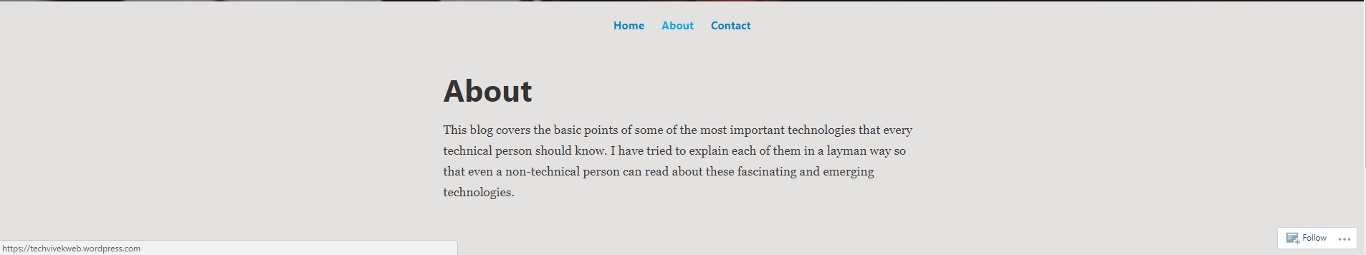

**Blog 1:**

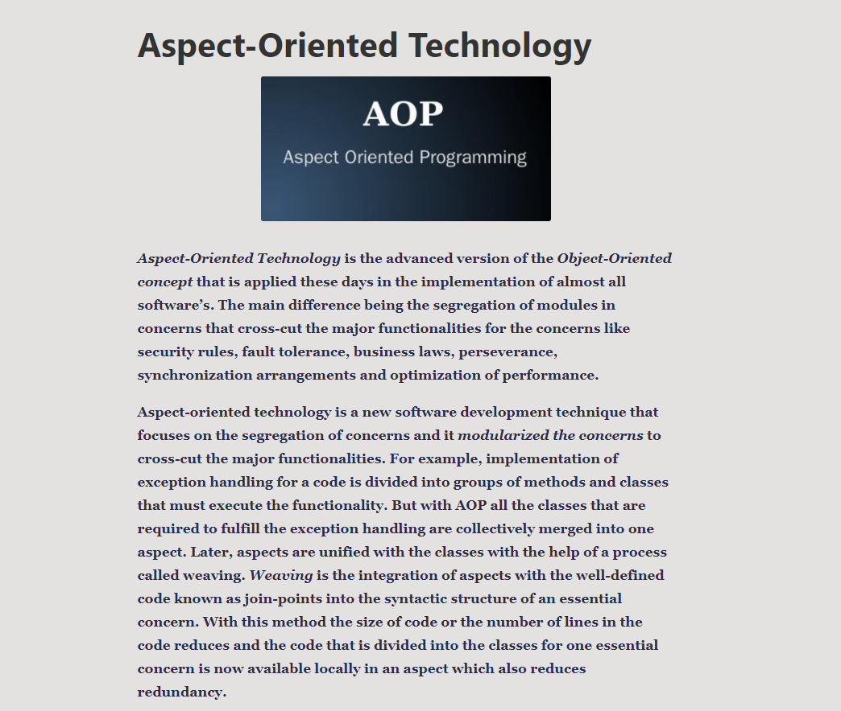

**Blog 2:**

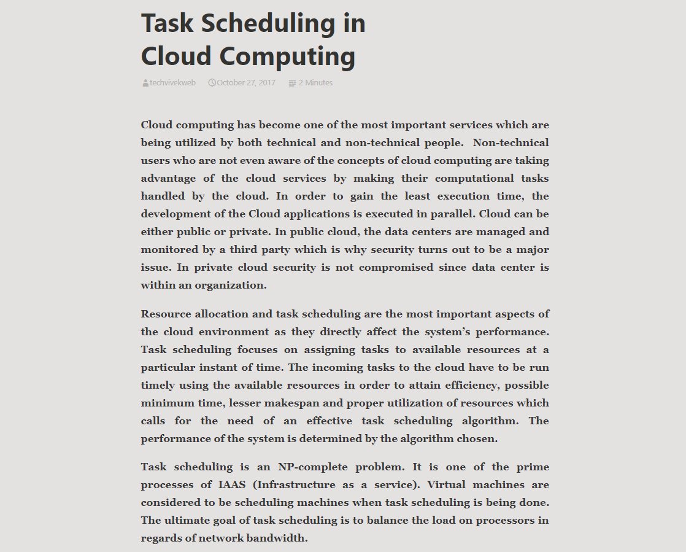

**Blog 3:**

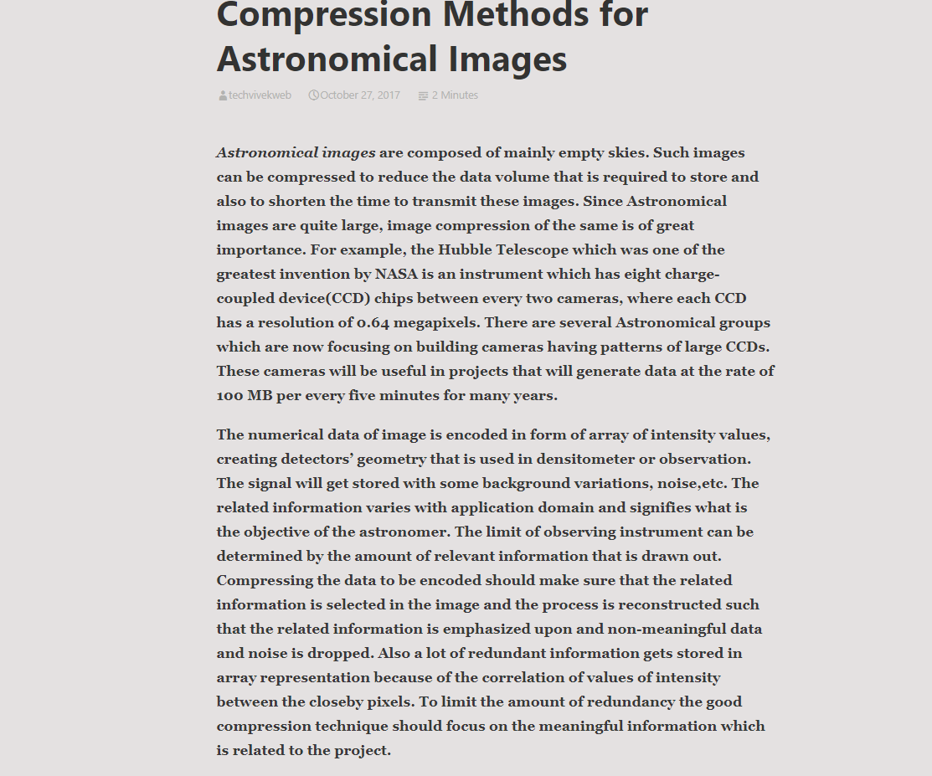

**Blog 4:**

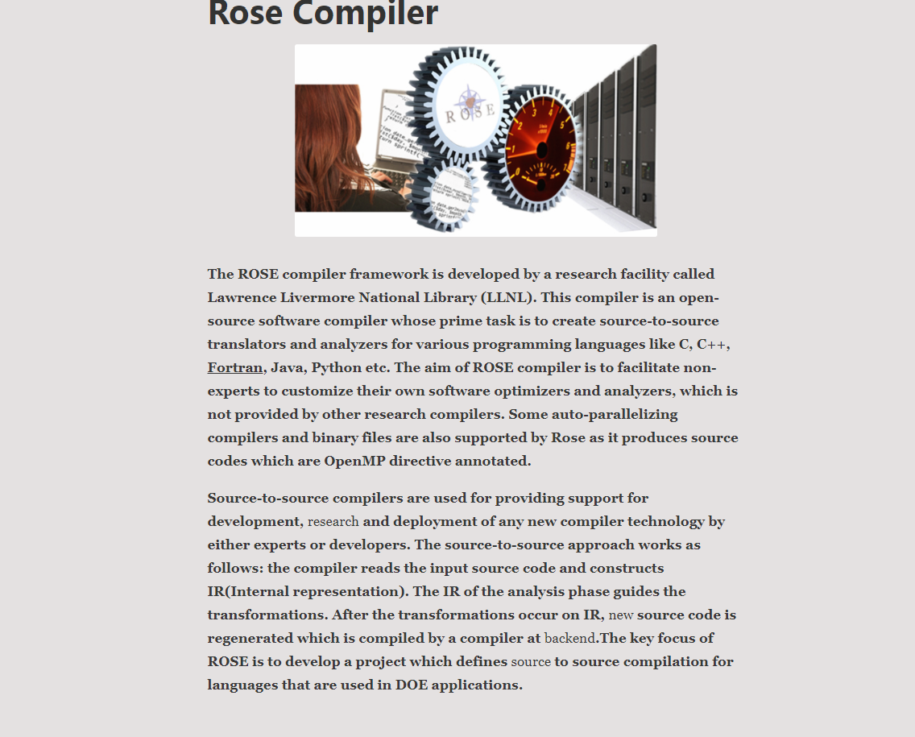

**Blog 5:**

