**Requirement:**

PyTorch

**Execution:**

Run main.py for executing the network with both compression ratios.

**Results:**

1. Model with 50% compression

Loss of the network on test images: 0.306610

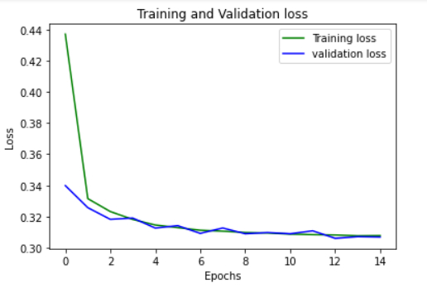

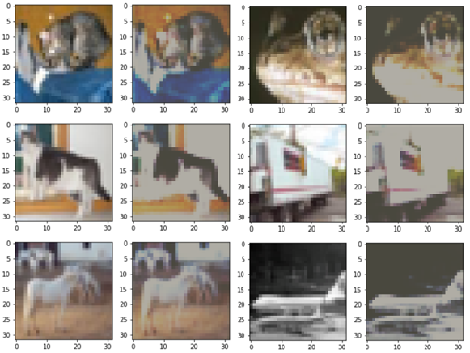

1. Model with 25% compression

Loss of the network on test images: 0.336761

