**Requirement:**

PyTorch

**Execution:**

Run main.py for executing the network with both normalization techniques

**Results:**

1. Zero mean and One standard deviation

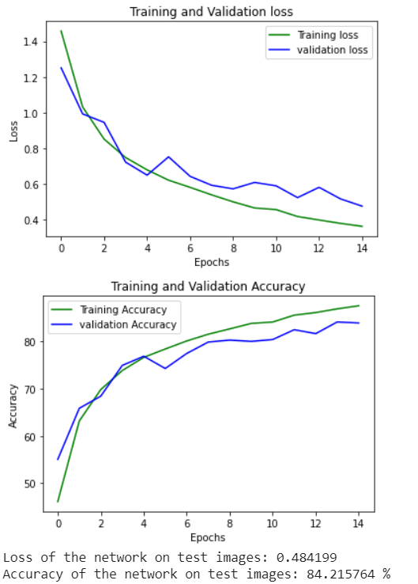

1. Images with input values between zero and one

