Task:

“Save the Queen” would be a level-1 individual competition. Robots shall participate individually and the winners or qualifiers shall be selected based on points earned. The event shall be played in 2 rounds. The 1st round will be a qualifying round and only the qualifying bots will play the 2nd round, which shall decide the ultimate winner. The speciications for bot, required mechanism and details of the arena are all explained below.

Bot Specifications:

The bots shall be tested for their GRIPPING and LIFTING mechanism. Bots shall be needed to grip rubix cubes of size 3*3 or 4*4.

1. Requirements to make a level-1 bot:
2. 12V DC motors - 4 in number, 1 for each wheel.
3. 4 wheels.
4. DPDT switch – 2 in number (One for bot’s movement, other one for gripping ang lifting mechanism ).
5. Chassis.
6. Connecting Wires.
7. Soldering Machine.
8. Nuts, Bolts, etc.
9. Pulleys and DC motors (as many as suited to your Gripping and Lifting mechanism).
10. Chassis:
    1. Chassis is the basic body/framework for your bot.
    2. Chassis can be made using wood/aluminium or any other material of your choice.

**Note: Choose a chassis that balances the weight of your bot. Heavy bots wont be able to climb slopes in the arena with ease and light bots wont be able to sustain weights of motors and mechanism. So consisder all this while designing your chassis. Take care to not make it too long or too wide which shall make it difficult to manoeuvre on the slope and in confined spaces.**

1. Gripping:
   1. Gripping or clamping would be needed to grip a rubix cube of 3*3 or 4*4.
   2. To prepare a clamp, you can use 2 aluminium squares coated on the inside with rubber(to ensure a good grip). These two squares can be connected to the shafts of the motors in such a way that when the corresponding switches are pressed, they move in opposite direction and clamps move inside and hold the block.
   3. Any other gripping mechanism can also be designed as per your wish that confines to the rules of a level-1 bot.
   4. **LINKS**:

<http://www.youtube.com/watch?feature=fvwrel&NR=1&v=HMQ4u9UlPSQ>

<http://www.grippers.com/>

1. Lifting:
   1. Lifting mechanism can make use of a pulley and a DC motor.
   2. This mechanism can be similar to that of drawing water from a well.
   3. Any other lifting mechanism can also be designed as per your wish that confines to the rules of a level-1 bot.
2. Power Supply:

DC Power supply of upto 18V will be provided for the event to each of the bots.Alternately, bots can also place a series of batteries on the chassis to provide a direct supply to the bot from chassis.In the latter case, the potential difference between any 2 points on the bot should not exceed 18V.

The gameplay for each arena and the design of each arena has been explained in the “Arena” section.

See images below for **CIRCUIT DIAGRAM,** **IMAGES :**

1. Chassis and wheels:

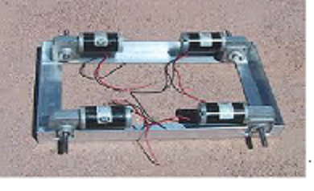

1. Circuit Diagram:

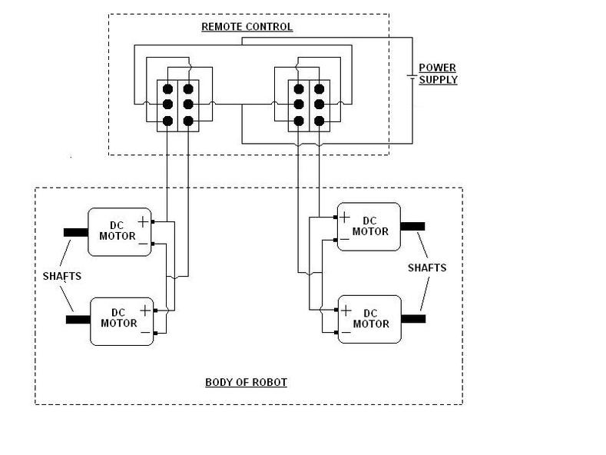

1. DPDT Switch:

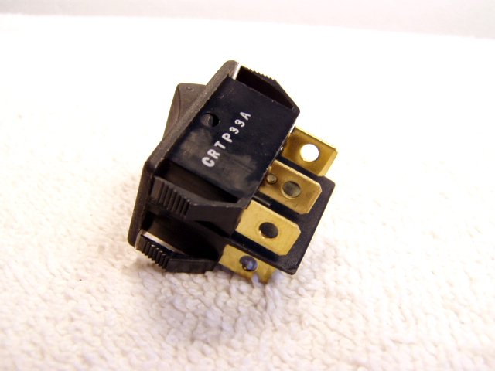

Selection Criteria:

The point system would be explained on the day of the event. Qualifiers from the first round shall get into the final round. Here again, the bot to score maximum number of points shall bw the winner.

**Note:** The decision of event-heads in cases of conflict shall be final.

Arena: