

**GYAN GANGA INSTITUTION OF TECHNOLOGY & SCIENCES,**

**JABALPUR(M.P.)**

**RAJIV GANDHI PRODYOGIKI VISHWAVIDYALAYA, BHOPAL(M.P.)**

**DEPARTMENT OF COMPUTER SCIENCE & ENGINEERING**

**CS-508 MAJOR PROJECT**

**SESSION(2018-22)**

**In partial fulfilment for the award of the degree of BACHELOR OF TECHNOLOGY in COMPUTER SCIENCE AND ENGINEERING**

FACIAL MASK DETECTION VERSION 2.0

**SUBMITTED BY:**

**NAME**  **ENROLLMENT NUMBER**

**PRASHANT MENDHE 0206CS181113**

**PRATEEK VISHWARKARMA 0206CS181115**

**VIVEK KUMAR SAHU 0206CS193D18**

**RAGHAV SUKHEJA 0206CS181120**

**NIKHIL MAHESH 0206CS181099**

**CERTIFICATE**

This is to certify that the Minor Project-II entitled “**FACE MASK RECOGNITION**” submitted by **Prashant Mendhe, Vivek Kumar Sahu, Raghav Sukheja, Prateek Vishwarkarma, Nikhil Mehish** has been carried out under my guidance & supervision. The project report is approved for submission towards partial fulfillment of the requirement for the award of degree of **BACHELOR OF TECHNOLOGY** in **COMPUTER SCIENCE AND ENGINEERING** from **RAJIV GANDHI PROUDYOGIKI VISHWA-VIDYALAYA, BHOPAL (M.P).**

|  |  |
| --- | --- |
| Prof. Amit Sahu  Guide  **Dept. of Computer Science and Engineering** | Dr. Ashok Verma  HoD  **Dept. of Computer Science and Engineering** |

**CERTIFICATE**

This is to certify that the Minor Project-II entitled “**FACE MASK RECOGNITION**” is submitted by **Prashant Mendhe, Vivek Kumar Sahu,Raghav Sukheja, Prateek Vishwarkarma, Nikhil Mahesh** for the partial fulfillment of the requirement for the award of degree of **BACHELOR OF TECHNOLOGY** in **COMPUTER SCIENCE AND ENGINEERING** from **RAJIV GANDHI PROUDYOGIKI VISHWAVIDYALAYA, BHOPAL (M.P).**

Internal Examiner External Examiner

Date: Date:

# 

# 

**DECLARATION**

We hereby declare that the project entitled **“FACE MASK RECOGNITION”** which is being submitted in partial fulfillment of the requirement for award of the Degree of Bachelor of Technology in Computer Science to **“RAJIV GANDHI PROUDYOGIKI VISHWAVIDYALAYA, BHOPAL (M.P.)”** is an authentic record of our own work done under the guidance of **Prof. ….., Department of Computer Science and Engineering,** **GYAN GANGA INSTITUTE OF TECHNOLOGY & SCIENCES, JABALPUR**.

The matter reported in this Project has not been submitted earlier for the award of any other degree.

**Date:**

**Place: JABALPUR**

**ACKNOWLEGDEMENT**

We sincerely express indebtedness to esteemed and revered guide **Prof. S.K.JAIN Sir of Department of Computer Science** for his invaluable guidance, supervision and encouragement throughout the work. Without his kind patronage and guidance the project would not have taken shape.

We take this opportunity to express deep sense of gratitude to **Dr. Ashok Verma, Head of Department of Computer Science** for his encouragement and kind approval. Also we thank him in providing the computer lab facility. We would like to express our sincere regards to him for advice and counseling from time to time.

We owe sincere thanks to all the faculties in Department of Computer Science and Engineering for their advice and counseling time to time.

**Names of team members**

**Prashant Mendhe**

**Vivek Kumar Sahu**

**Raghav Sukheja**

**Prateek Vishwarkarma**

**Nikhil Mahesh**

**NI**

**Date :**

**Place : JABALPUR**

**CONTENT**

* INTRODUCTION
* PURPOSE OF PROJECT
* BIOMETRICS
* FACIAL MASK RECOGNITION
* IMPLEMENTATION
* HOW IT WORKS
* APPLICATIONS
* CONCLUSION

**INTRODUCTION**

Everyday actions are increasingly being handled electronically, instead of pencil and paper or face to face.

This growth in electronic, transactions results in great demand for fast and accurate user identification and authentication.

Access codes for buildings, banks accounts and computer system often use PIN’s for identification and security check.

Using the proper PIN gain access ,but the user of the PIN is not verified. When credit and ATM cards are lost or stolen ,an unauthorized user can often come up with the correct personal codes.

Face mask recognition technology may solve this problem because due to COVID-19 pandemic this thing can help us to stop the spread of COVID-19.

**PURPOSE OF PROJECT**

The COVID-19 mask detector we are building here today could potentially be used to help ensure your safety and the safety of others.

Here we introduce a facemask detection model that is based on computer vision and deep learning. The proposed model can be integrated with Surveillance Cameras to impede the COVID-19 transmission by allowing the detection of people who are wearing face masks. The model is integration between deep learning and classical machine learning technique with OpenCV . We will achieve the highest accuracy and consume the least time in the process of training and detection.

**BIOMETRICS**

A biometric is a unique, measurable characteristic of a human being that can be used to automatically recognize an individual or verify an individual identity.

Biometric can be measure both physiological and behavioral characteristics.

Physiological Biometrics

This biometric is based on measurement of a part of a human body.

Behavioral Biometrics

This biometric is based on measurements and data derived from an action.

In Face Mask Recognition, we use face recognition technique so that to identify the person is wearing mask or not.

**FACE RECOGNITION**

* It requires no physical interaction on behalf of the user.
* It is accurate and allows for high enrollment and verification rates.
* It can use your existing hardware infrastructure, existing camaras and image capture devices will work with no problems.

In facial recognition there are two types of comparisons.

* VERIFICATION -> The system compares the given individuals with whom they stay they are gives a yes or no decision.
* IDENTIFICATION -> The system compares the given individuals to all the other individuals in the database and gives a ranked list of matches.

**CONDITIONS**

* All identification or authentication technologies operates using the following four stages.
* CAPTURE -> A physical or behavioral sample is captured by the system during enrollment and also in identification or verification process.
* EXTRACTION -> Unique data is extracted from the sample and a template is created.
* COMPARISOM -> The template is then compared with a new sample.
* MATCH/NO MATCH -> The system decides if the features extracted from the new samples are a match or a non-match.

**HARDWARE AND SOFTWARE REQUIRED**

* WINDOWS Operating system
* Webcam
* Jupyter open source web application
* RAM minimum 4GB
* Hard Disk minimum 10GB
* System Type 64bits OS

**System Requirement**

The major requirement for implementing this project using python programming language along with deep learning.

Machine learning , computer vision and also with python libraries. The architecture consists of mobile net as the backbone, it can be used fir high and low computation scenarios.

**LANGUAGE REQUIRED**

* Python
* Open CV

Python programming language.

* Python is the interpreted , object-oriented ,high-level programming language with dynamic semantics. Its high-level built in data structures ,combined with dynamic typing and dynamic binding, make it very attractive for rapid application development ,as well as for use as a scripting or glue language to connect existing components together.

OPEN CV

* Open CV is the most popular library for computer vision. Originally written in C/C++, it now provides bindings for python. Open CV uses machine learning algorithm to search for faces within a picture. Because faces are so complicated , there isn’t one simple test that will tell you if it found a face or not. Instead there are thousands of small patterns and features that must be matched. The algorithm breaks the task of identifying the face into thousands of smaller, bites-sized tasks, are also called classifiers.

**SOFTWARE MODEL**

**Agile Model**

* The meaning of agile means swift. Agile process model refers to a software development approach based on interactive development. Agile methods break task into smaller iterations. Phases of agile model are

1. **Requirement gathering**
2. **Design the requirement**
3. **Construction / iteration**
4. **Testing**
5. **Deployment**
6. **Feedback**

**FUNCTIONAL REQUIREMENTS**

* The system must have with_mask and without_mask dataset.
* The dataset must not re-use the same images in training and testing phases.
* The system must be correctly able to load the face mask classifier model.
* The system must be able to detect face masks on human faces on every frame .
* The results must be viewed by showing the probability along with the output of ‘MASK’ or ‘NO MASK’.

**NON-FUNCTIONAL REQUIREMENTS**

* The face should be localized by detecting the facial landmarks and the background must be ignored.
* The system will be implemented in Python script with an accuracy of the model .
* The user must not move his/her face out of camera’s sight in order to get correct results
* The must must be portable and can be applied to embedded devices with limited computational capacity(such as Jupyter notebook.)

**FLOW DIAGRAM**

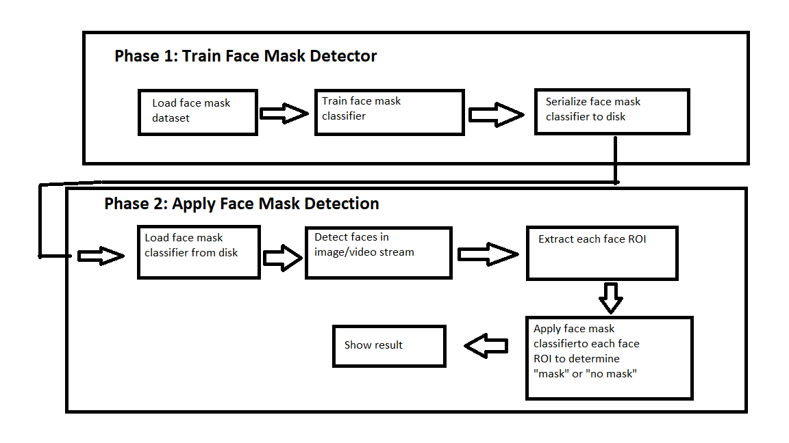

**USE CASE DIAGRAM**

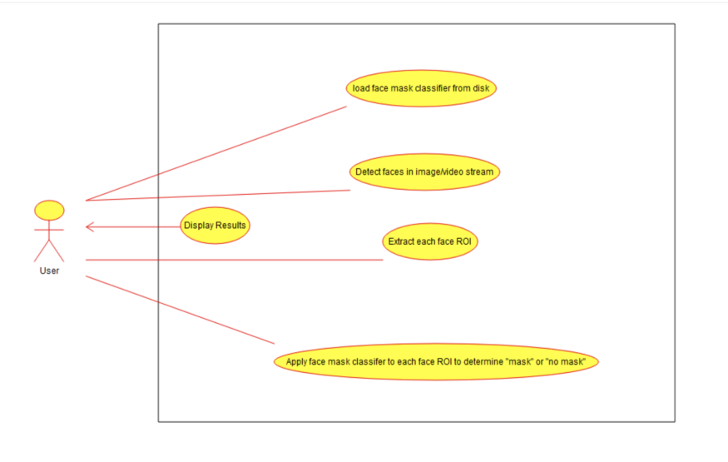

**DATASET**

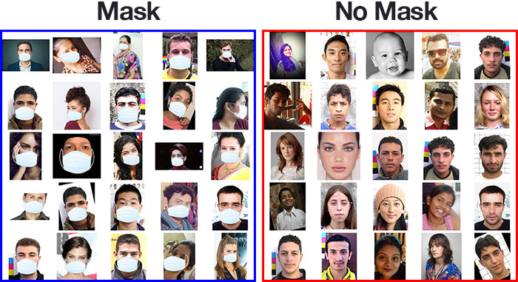

**IMPLEMENTATION**

The implementation of face mask recognition technology includes the following four stages.

* Image acquisition
* Image processing
* Distinctive characteristic location
* Template creation
* Template matching

**IMAGE ACQUISTION**

* Facial-scan technology can acquires face from almost any static camera or video system that generates images of sufficient quality and resolution.
* High quality enrollment is essential to eventual verification and identification enrollment images define and facial characteristics to be used in all future authentication events.

**IMAGE PROCESSING**

* Images are cropped such that the ovoid facial image remains, and color images are normally converted to black and white in order to facilitate initial comparisons based on grayscale characteristics.
* First the presence of face or faces in a scene must be detected. Once the face is detected, it must be localized and normalization process may be required to bring the dimensions of the live facial sample in alignment with the one on the template.

**DISTINCTIVE CHARACTERISTIC LOCATION**

* All facial-scan systems attempts to match visible facial features in a fashion similar to the way people recognize one another.
* The features most often utilized in facial scan systems and those least likely to change significantly over time upper ridges of the eye sockets , areas around the cheekbones ,side of the mouth ,nose shape and the position of major features relative to each other.

**TEMPLATE CREATION**

* Enrollment templates are normally created from a multiplicity of processed facial images.
* These templates can vary in size from less than 100 bytes, generated through certain vendors and to over 3k for templates.
* The 3k templates is by far the largest among technologies considered physiological biometrics.
* Larger templates are normally associated with behavioral biometrics.

**TEMPLATE MATCHING**

* It compares matched templates against enrollment templates.
* A series of images is acquired and scored against the enrollment , so that a user attempting 1:1 verification within a facial scan system may have 10 to 20 match attempts take place within 1 to 2 seconds

**IMPORTANCE OF WEARING MASK**

* When you wear a mask you protect others as well as yourself. Mask works best when everyone wear one.
* Manual monitoring is very difficult for officers to check whether the peoples are wearing mask or not . So in our technique we are using web cam to detect peoples faces and to prevent from virus transmission.
* We can keep peoples safe from our technique.
* A mask is not a substitute for social distancing . Mask should be still be worn in addition to staying at least 6 feet apart, especially when indoors around people who don’t live in your household.
* Mask should completely cover the nose and mouth and fit snugly against the sides of face without gaps.
* Masks should be worn any time you are travelling on a plane, bus, train, or other form of public transportation travelling into, within or out of the states .

**Code.**

import numpy as np

import cv2

with_mask = np.load('with_mask1.npy')

without_mask = np.load('without_mask1.npy')

with_mask.shape

without_mask.shape

with_mask =with_mask.reshape(200, 50 * 50 * 3)

without_mask =without_mask.reshape(200, 50 * 50 * 3)

with_mask.shape

without_mask.shape

x = np.r_[with_mask , without_mask]

labels = np.zeros(x.shape[0])

labels[200 :] = 1.0

names = {0 : 'MASK', 1 : 'NO MASK'}

from sklearn.svm import SVC

from sklearn.metrics import accuracy_score

from sklearn.model_selection import train_test_split

x_train, x_test, y_train, y_test = train_test_split(x, labels, test_size = 0.25)

x_train.shape

from sklearn.decomposition import PCA

pca = PCA(n_components = 3)

x_train = pca.fit_transform(x_train)

x_train[0]

x_train.shape

x_train, x_test, y_train, y_test = train_test_split(x, labels, test_size = 0.25)

svm = SVC()

svm.fit(x_train, y_train)

y_pred=svm.predict(x_test)

accuracy_score(y_test, y_pred)

haar_data = cv2.CascadeClassifier('D:/data/harcascade/haarcascade_frontalface_default.xml')

cap = cv2.VideoCapture(0)

d=[]

font = cv2.FONT_HERSHEY_COMPLEX

while True:

flag, img = cap.read()

if flag :

faces = haar_data.detectMultiScale(img)

for x,y,w,h in faces:

cv2.rectangle(img,(x,y),(x+w,y+h),(255,0,255),4)

face = img[y:y+h, x:x+w, :]

face = cv2.resize(face,(50,50))

face = face.reshape(1,-1)

pred = svm.predict(face)[0]

n = names[int(pred)]

cv2.putText(img,n,(x,y),font,1,(244,250,255),2)

print(n)

cv2.imshow('img',img)

if cv2.waitKey(2) == 27:

break

cap.release()

cv2.destroyAllWindows()

import cv2

import numpy as np

img1=cv2.imread('C:/Users/DELL/Pictures/Camera Roll/pic1.jpg')

img2=cv2.imread('C:/Users/DELL/Pictures/Camera Roll/pic2.jpg')

diff=cv2.subtract(img1,img2)

result = not np.any(diff)

if result is True:

print ("Good to Go")

else:

cv2.imwrite("result.jpg",diff)

print ("Challan has been generated")

s="fine is generated"

with open('E:\smart\prash.csv','r+') as f:

f.writelines({s})

**TEST CASES**

**WITH AND WITHOUT MASK FACE DETECTION**

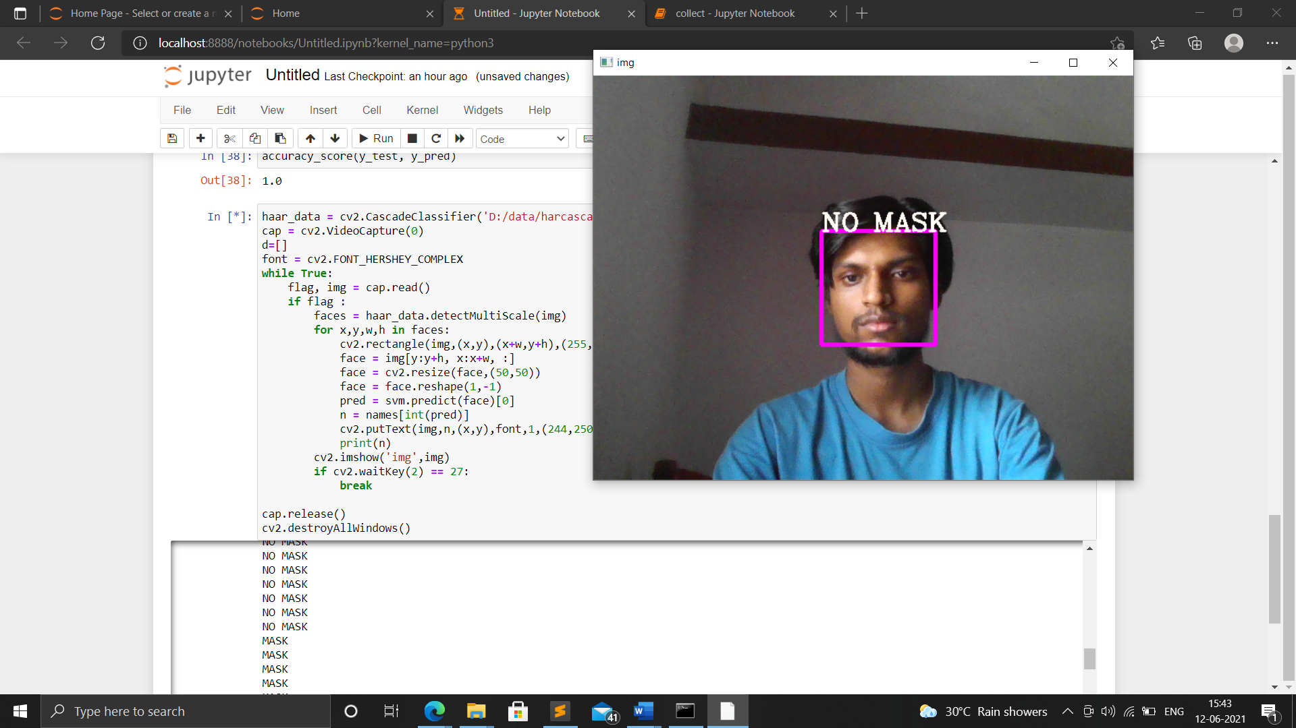

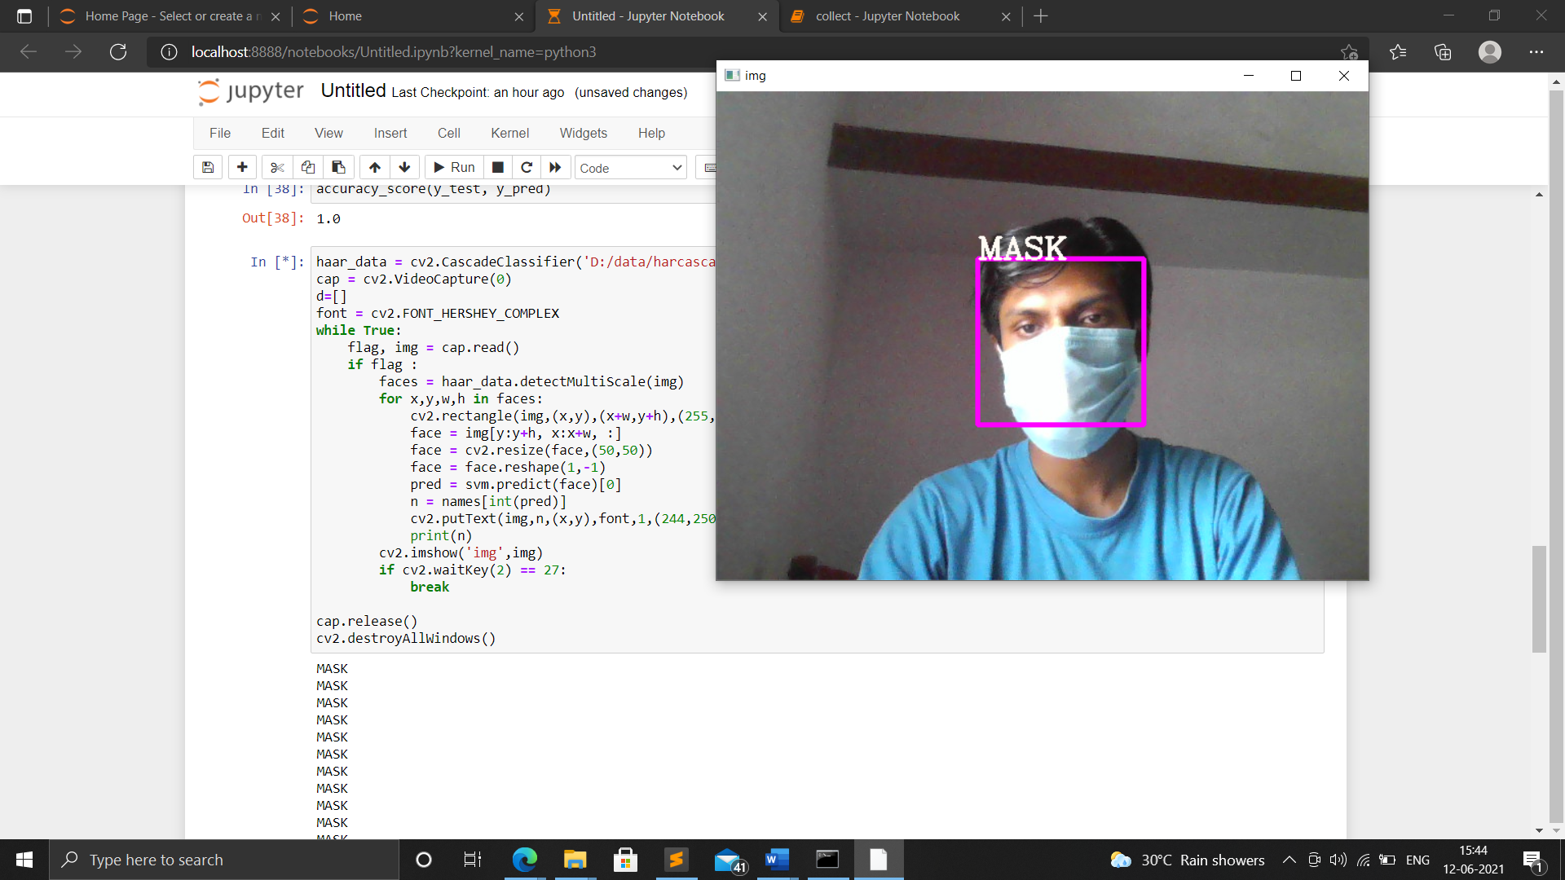

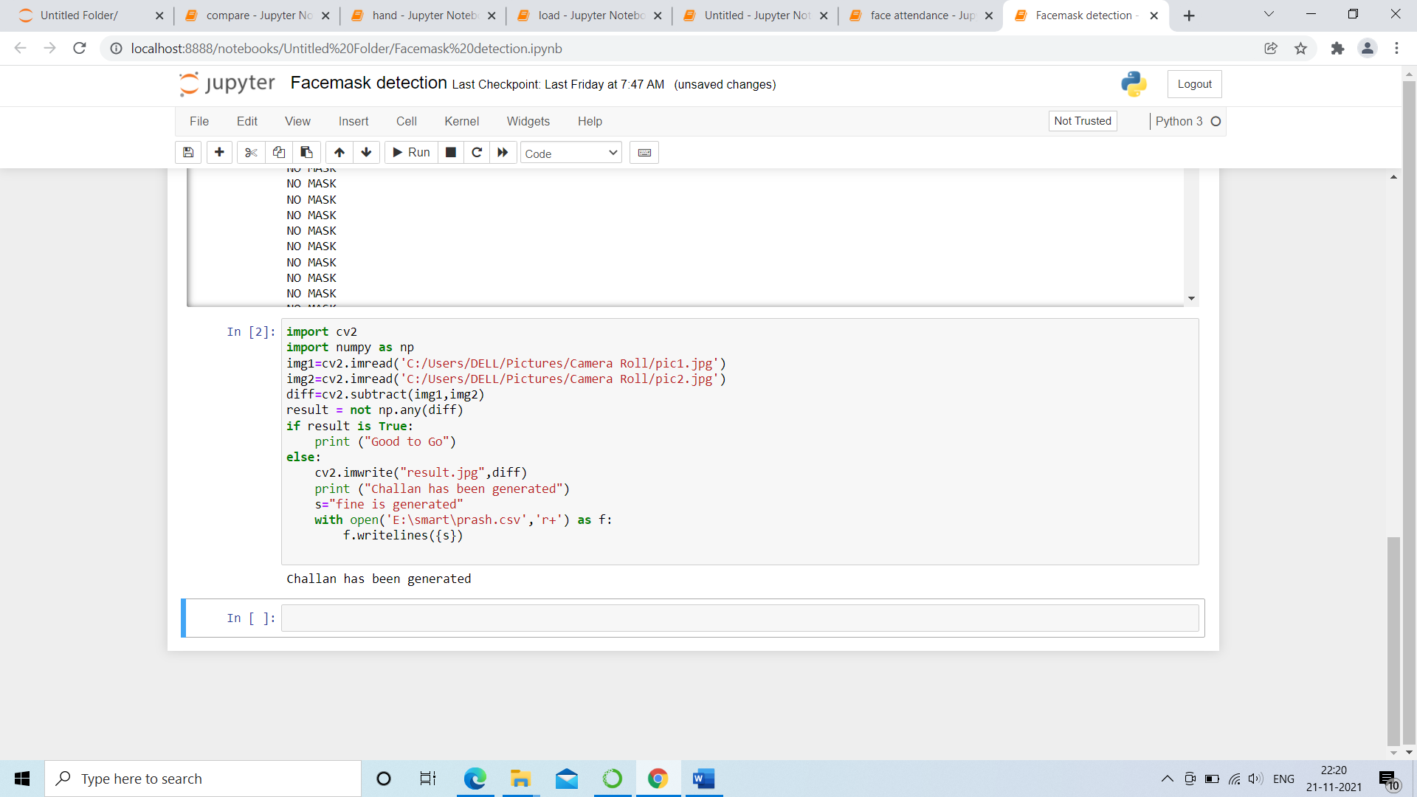

**CONCLUSION**

To mitigate the spread of COVID-19 pandemic, measures must be taken. We have modelled a face mask detector. To train validate and test the model, we used the dataset that consisted with-mask images as well as without-mask images. This face mask detector can be deployed in many areas like shopping malls, airports and other public places to avoid the spread of the disease by checking who is following basic rules and who is not.