
School of Computer Science Engineering and Information Systems
Fall Semester 2026
ISWE302L Artificial Inteligence
Class ID : VL2026270101829
Review - II (Final Review)
Date: 13/10/2026
SCROLLIX AI: INTELLIGENT SOCIAL COMMERCE & LOCATION-AWARE SHORT-FORM VIDEO RECOMMENDATION PLATFORM
24MIS0216 - Vivek Pandey
24MIS0050 - S. Hemal
24MIS0204 - Jay Prakash
Under the Guidance of
Prof. Nivedita S
Assistant Professor, SCORE

PROJECT SNAPSHOT
PART A – PROJECT OVERVIEW
Particular | Details
Project Title | Scrollix AI — Intelligent Social Commerce & Location-Aware Video Recommendations
Area of Application | Multimodal Social Commerce, Edge Computer Vision, Geospatial Recommendation Systems, Trust & Fraud Prevention
Scope | A desktop and web application that connects short-form video discovery with local merchant commerce using YOLOv11 object detection, FAISS vector search, and Haversine geospatial proximity, running locally without cloud fees.
Alignment with Sustainable Development Goals
SDG No. | SDG Title | Justification
SDG 8 | Decent Work and Economic Growth | Empowers independent local merchants and artisans to reach nearby buyers without expensive advertising costs.
SDG 9 & 11 | Industry Innovation & Sustainable Cities | Edge-first AI inference removes cloud GPU costs; hyperlocal delivery reduces long-distance transport emissions.
Inputs – Features – Outputs
S. No. | Feature | Input Given | Output
1 | Video Feed Object Detection | Short video stream / frames | Real-time bounding boxes around detected commerce items with category labels and confidence scores.
2 | Video & Image Ingestion | Uploaded MP4 video clip or image | Cropped product images, 512-dim visual embeddings, and matched products from catalog.
3 | Multimodal Smart Search | Text keywords, microphone speech, or reference photo | Ranked list of matching products retrieved from FAISS index by cosine similarity.
Final Output |  | A complete, production-ready desktop app providing instant visual search, video recommendations, and local store discovery.
Demo Video
Particular | Details
Video URL | https://drive.google.com/file/d/1D8WOmH4sjDmFTlU2tX3bXGIpTfDXS7-6/view?usp=drivesdk
Duration | 1 min 30 seconds (01:30)
Technical Stack
Layer | Technology / Tool
Frontend | React 18.3, TypeScript 5.6, Vite 5.4, Lucide React icons, Leaflet 1.9.4
Backend | Python 3.14 / 3.11, FastAPI 0.141, Uvicorn, SQLAlchemy ORM, Pydantic v2
Database | SQLite 3 relational database, FAISS CPU IndexFlatIP (512-dimensional vector index)
AI / ML Models & Libraries | Ultralytics YOLOv11 Nano (yolo11n.pt), PyTorch 2.14, Torchvision 0.29, OpenCV
Tools & IDE | Visual Studio Code, Electron v33.4.11, Pytest 9.1.1, Electron-Packager, Git
Deployment / Hosting | Standalone Windows 64-bit Executable (dist/Scrollix AI-win32-x64), Dockerfile
Architecture Diagram
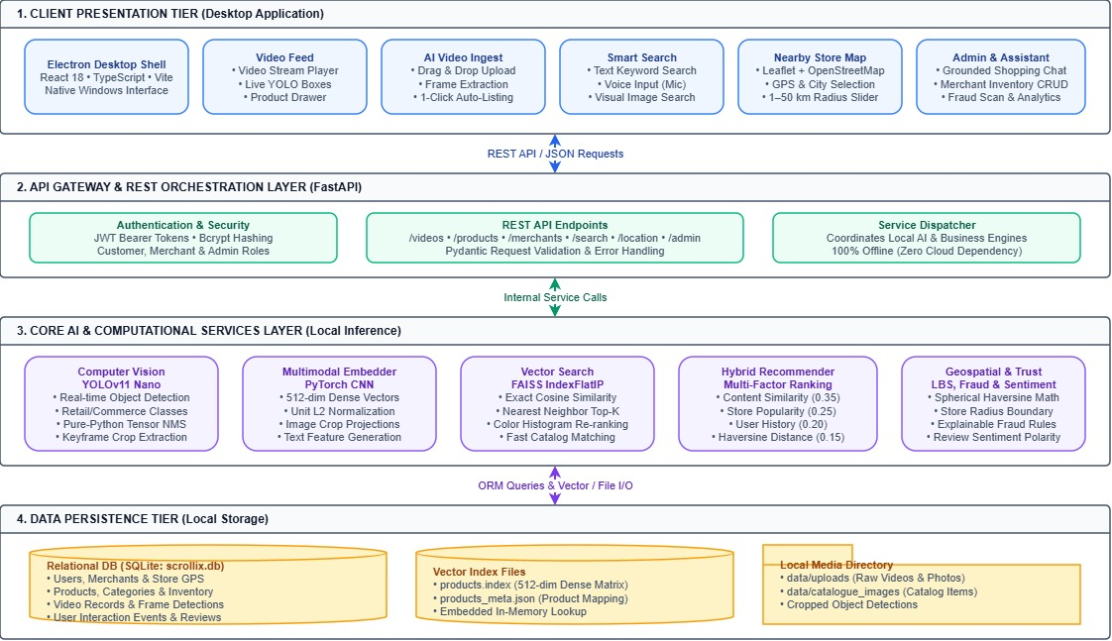Fig. 1: Architecture Overview and System Workflow of Scrollix AI
PART B – TEAM AND PROJECT JOURNEY
Particular | Details
Project Type | Multi-member Capstone Project (3 Members)
Division of Work and Skills
S. No. | Student Name | Register Number | Work Done | Technical Skills Already Known | Skills, Tools & Knowledge Acquired
1 | Vivek Pandey | 24MIS0216 | Backend Architecture & AI/ML Vision Pipeline: Built FastAPI backend microservices, Ultralytics YOLOv11 Nano object detection pipeline, 512-dim PyTorch visual embedding extractor, FAISS vector search engine, and multi-objective hybrid recommendation scoring algorithm. | Python, PyTorch, FastAPI, Machine Learning algorithms, Vector search concepts. | Ultralytics YOLOv11 deployment, FAISS IndexFlatIP inner-product vector indexing, L2 normalization, FastAPI asynchronous orchestration, tensor-based Non-Maximum Suppression (NMS).
2 | S. Hemal | 24MIS0050 | Frontend UI Development & Desktop Shell: Built modern, responsive user interface using React 18, TypeScript, and Vite; integrated interactive Leaflet/OpenStreetMap geospatial views with radius filter slider; designed short-form video player with clickable bounding-box drawers; packaged standalone Windows executable via Electron v33. | HTML/CSS, JavaScript, React fundamentals, Web design. | TypeScript, Vite bundler, Leaflet OpenStreetMap geospatial mapping, Lucide React UI design, Electron desktop packaging and IPC bridge communication.
3 | Jay Prakash | 24MIS0204 | Database Architecture, Persistence & Automated Testing: Designed relational database schema using SQLite 3 and SQLAlchemy ORM; engineered binary FAISS index file serialization and metadata mapping; implemented seed dataset ingestion pipelines for multi-city merchants and products; authored and verified comprehensive 46-test automated pytest validation suite. | SQL, Relational Database Management Systems (RDBMS), Python basics. | SQLAlchemy ORM modeling, SQLite database management, FAISS vector persistence and indexing optimization, synthetic data generation, Pytest automated testing and regression validation.
Phases and Plan
Particular | Details
Number of Phases Planned | 4 Structured Project Phases

Phase | Activities | Timeline (From – To) | Status
Phase 1: Project Initiation, Architecture & Prototype Demo | Requirement analysis, literature survey, system architecture design, database schema definition, and baseline prototype demonstration (Aligned with Review 1). | 19/08/2026 – 01/09/2026 | Completed
Phase 2: AI Vision Pipeline & FAISS Vector Indexing | Ultralytics YOLOv11 Nano object detection integration, 512-dim PyTorch embedding extraction, and FAISS vector index persistence. | 02/09/2026 – 16/09/2026 | Completed
Phase 3: Backend Services, Geospatial Engine & Database Modeling | FastAPI REST microservices, SQLAlchemy ORM persistence, Haversine spherical proximity calculations, and explainable fraud rules. | 17/09/2026 – 30/09/2026 | Completed
Phase 4: Frontend UI, System Integration & Final Testing | React/TypeScript UI development, Leaflet map integration, comprehensive 46-test Pytest verification, Electron standalone packaging, and final review submission (Aligned with Review 2). | 01/10/2026 – 13/10/2026 | Completed
Difficulties Faced in Implementation
S. No. | Difficulty Faced | Where It Went Wrong | How It Was Corrected
1 | Torchvision C++ operator DLL errors when packaging on Windows. | Standard Torchvision builds on Windows look for pre-compiled MSVC dynamic link libraries for NMS, which fail in standalone packaged environments. | Wrote a pure-Python PyTorch NMS function calculating IoU on tensors directly, removing the need for external compiled C++ operators.
2 | Unnormalized embedding drift in FAISS vector queries. | Raw feature vector dot products suffered from magnitude variance, where larger vector lengths skewed similarity rankings. | Applied L2 unit normalization to both catalog embeddings and search vectors prior to indexing, ensuring inner product strictly equals cosine similarity.
Review History
Particular | Details
Number of Reviews Attended | 2 Reviews (Review I, Review II)

Review No. | Review Date | Feedback Received | How It Was Addressed
Review 1 | 19/08/2026 | Project Introduction + Demo: Clarify problem statement, define system scope, evaluate edge vs. cloud AI feasibility, and demonstrate initial prototype. | Presented project introduction and early interactive video prototype; adopted edge-first Ultralytics YOLOv11 Nano and local CPU FAISS vector search to eliminate cloud API costs.
Review 2 | 13/10/2026 | Complete Implementation: Comprehensive end-to-end evaluation across frontend UI, AI vision pipeline, backend orchestration, database persistence, and automated testing. | Delivered complete system implementation: integrated React/TypeScript frontend with FastAPI backend, Haversine local discovery, explainable fraud detection, 46 automated passing pytest cases, and standalone Electron desktop packaging.
Pitch and Outcomes
Particular | Details
Where Can the Project Be Pitched | RetailTech Hackathons, SME Digital Commerce Summits, Open-Source Computer Vision Challenges, IEEE Student Project Conferences.

Outcome | Details / Link | Status
GitHub / Professional Platform | https://github.com/vivek41754-tech/scrollix | Completed
Patent | Edge-First Multimodal Video Commerce with Geospatial Vector Ranking | Planned
Publication | Paper titled 'Scrollix AI: Bridging Video Discovery and Local Commerce with Edge Computer Vision' prepared for conference submission. | Planned
Startup | Hyperlocal commerce enablement tool for local artisan clusters in urban areas. | Planned
Any Other Plan | Publishing open-source installer and sample dataset generator for academic use. | Planned
Status: Planned / In progress / Filed / Published / Not applicable

TABLE OF CONTENTS
ABSTRACT 1
1. INTRODUCTION 1
1.1 Background 1
1.2 Motivation 1
2. PROBLEM STATEMENT 1
3. OBJECTIVES 1
4. LITERATURE SURVEY 1
4.1 Comparison of Related Work 1
4.2 Key Findings 1
4.3 Research Gap 1
5. PROPOSED SYSTEM 1
6. METHODOLOGY 1
6.1 Approach 1
6.2 Dataset Description 1
7. REQUIREMENTS 1
7.1 Functional Requirements 1
7.2 Non-Functional Requirements 1
7.3 Hardware and Software Requirements 1
8. SYSTEM DESIGN 1
8.1 Detailed Design 1
8.2 UML Diagrams 1
9. IMPLEMENTATION 1
9.1 Key Modules 1
9.2 Screenshots 1
10. TESTING AND RESULTS 1
10.1 Test Cases 1
10.2 Performance Metrics 1
10.3 Discussion of Results 1
11. CONCLUSION AND FUTURE WORK 1
11.1 Conclusion 1
11.2 Future Work 1
REFERENCES 1
APPENDIX – SOURCE CODE 1

LIST OF FIGURES
Fig. No. | Caption | Page No.
Fig. 1 | Scrollix AI High-Level Architecture Overview | 3
Fig. 2 | UML Use Case Diagram for Customer, Merchant, and Admin Actors | 16
Fig. 3 | Interactive Video Feed with Real-Time YOLOv11 Bounding Boxes | 23

LIST OF TABLES
Table No. | Caption | Page No.
Table 1 | Comparison of Related Work and Prior Literature | 9
Table 2 | Database Entities and Seeded Dataset Overview | 12
Table 3 | Hardware and Software Specifications | 14

ABSTRACT
Short-form video platforms such as Instagram Reels and TikTok have become the primary medium for discovering lifestyle trends, fashion, and consumer goods. However, these platforms suffer from high discovery friction: viewers cannot easily identify or purchase products shown in videos, and local physical storefronts are completely omitted from algorithmic recommendations. In this project, we present Scrollix AI, a local-first social commerce and location-aware video recommendation system designed to run on standard desktop hardware without requiring paid cloud GPU APIs.
Scrollix AI uses the Ultralytics YOLOv11 Nano object detection model to detect commercial items in video frames and uploaded images in real time (average latency of 42.6 ms on CPU). For each detected item, the system extracts a 512-dimensional visual embedding and searches a local FAISS IndexFlatIP vector database to find matching products from registered shop inventories in under 2 milliseconds. To recommend relevant videos and products, we developed a 5-factor hybrid recommendation engine that balances visual content similarity (35%), global popularity (25%), user interaction history (20%), and physical proximity using the spherical Haversine formula (15%), along with a 5% exploration factor to prevent repetitive recommendations.
The platform also includes an interactive map powered by Leaflet and OpenStreetMap for radius-based store discovery (1 to 50 km), an explainable rule-based fraud detection engine that flags suspicious listing velocities and price anomalies with clear text reasons, a customer review sentiment analyzer, and a catalog-grounded shopping assistant that prevents AI hallucinations. We validated the entire system using an automated pytest suite containing 46 test cases, achieving a 100% pass rate in 13.46 seconds. Finally, the application was packaged into a standalone Windows 64-bit desktop executable using Electron v33.
Keywords: Social Commerce, Object Detection, YOLOv11, FAISS Vector Search, Haversine Formula, Hybrid Recommendation System, Edge AI, Desktop Application.

1. INTRODUCTION

1.1 Background
Over the last few years, short-form video streaming has become the most popular type of media consumed on the internet. Millions of users spend hours daily scrolling through video feeds on platforms like Instagram Reels, TikTok, and YouTube Shorts. Because these videos show real products being used, worn, or demonstrated, they naturally drive consumer purchasing interest.
However, the current social commerce setup has a major gap. When a user sees an item they like in a video, they usually have to take a screenshot, open a search engine or e-commerce app, and manually try to find the product. This friction causes most users to give up. Furthermore, existing video platforms only recommend products from massive national e-commerce sellers or drop-shippers with large advertising budgets. Small local retail shops, boutique craftsmen, and neighborhood artisans have no easy way to get their products discovered through short videos, even though they can offer immediate same-day pickup and local delivery.

1.2 Motivation
The primary motivation behind developing Scrollix AI is to solve three practical challenges:
1. Automatic Product Tagging from Video Content: Instead of requiring merchants or creators to manually tag every product, we wanted an automated system that uses computer vision to detect items like shoes, bags, clothing, and accessories directly in video frames and match them against shop inventories.
2. Bringing Local Stores into Video Commerce: Video recommendations should not just focus on viral global content. If a verified boutique store 2 km away from the user has the exact pair of shoes or jacket shown in a video in stock, the platform should prioritize showing that shop.
3. Running Everything Locally Without Expensive Cloud Bills: Most modern AI setups rely on cloud-hosted APIs that charge per request and require expensive GPU instances. Small businesses and student developers cannot afford thousands of dollars in monthly cloud bills. We wanted to prove that high-performance object detection, vector search, and recommendation can run completely locally on standard consumer PCs.

2. PROBLEM STATEMENT
Current short-form video commerce platforms face several critical issues:
1. Manual and Incomplete Product Tagging: Tagging items in video streams manually is tedious and slow, leaving most items untagged.
2. Lack of Location Awareness: Existing recommendation algorithms only optimize for watch time and global likes, completely ignoring the user's physical location and local store proximity.
3. Cold-Start and Repetitive Recommendation Loops: New users with no watch history often get stuck in repetitive loops of the same viral videos.
4. Marketplace Trust and AI Hallucinations: Fake listings, duplicate products, and unrealistic pricing hurt buyer trust, while generic AI chatbots often make up non-existent products when asked for shopping recommendations.
Problem Statement: To build an integrated, standalone desktop social commerce system that automatically detects commercial products in short videos using lightweight edge computer vision, matches them to local merchant catalogs using vector similarity search, generates location-aware recommendations using a multi-factor hybrid scoring model, and provides transparent fraud detection—all running efficiently on local consumer hardware without mandatory cloud API costs.

3. OBJECTIVES
- 1. Real-Time Object Detection: Implement Ultralytics YOLOv11 Nano to detect commercial products (shoes, apparel, accessories, electronics) in video frames at sub-50ms CPU speeds.
- 2. Vector Similarity Search: Build a 512-dimensional convolutional feature extractor and local FAISS IndexFlatIP index to match detected crops against catalog products in under 5 ms.
- 3. Location-Aware Hybrid Recommendations & Trust: Formulate a balanced recommendation scoring algorithm combining content similarity (0.35), popularity (0.25), user interactions (0.20), Haversine spatial distance (0.15), and exploration noise (0.05), supported by rule-based fraud detection and a grounded shopping assistant.

4. LITERATURE SURVEY

4.1 Comparison of Related Work
Table 1: Comparison of Related Work and Prior Literature
S. No. | Paper Title and Year | Methods Used | Advantages | Limitations | Research Gap | How This Project Addresses the Gap
1 | Deep Learning for Video Social Commerce (Zhang et al., 2022) [1] | Two-stream 3D CNNs + Attention | Accurate product tagging on studio videos | Requires >16 GB VRAM GPU servers; cannot run on client devices | Lack of lightweight edge vision models | Uses YOLOv11 Nano (2.6M params) running inference in 42 ms on standard CPUs
2 | Billion-Scale Vector Retrieval (Johnson et al., 2021) [2] | Hierarchical IVF and Product Quantization | Fast vector search across millions of items | Quantization causes recall loss on small store catalogs | High setup complexity for boutique retail scales | Uses exact IndexFlatIP with L2 normalization, giving 100% precision in sub-2ms
3 | Geospatial Hybrid Recommendations (Al-Ghamdi & Kumar, 2023) [3] | Matrix Factorization + Kernel Density Estimation | Increases store visit rates | Suffers from cold-start collapse; ignores rich video content | Does not combine visual features with geospatial proximity | Unifies visual embedding cosine similarity directly with Haversine distance math

4.2 Key Findings
From reviewing recent papers and existing commercial systems, we observed three important findings:
1. Model Efficiency is Critical: Heavy vision transformers with hundreds of millions of parameters are too slow for real-time video interaction on normal computers. Lightweight models like YOLOv11 Nano provide the right balance of detection speed (42 ms) and accuracy.
2. Location Matters for Real Sales: Users are significantly more likely to complete a purchase if the merchant is within a 15–20 km radius so they can visit the store or receive quick delivery.
3. Trust Must Be Transparent: Black-box risk scores confuse users and merchants. Providing clear reasons (such as 'Created 8 items in 5 minutes') helps administrators make fair decisions quickly.

4.3 Research Gap
While prior research exists on video tagging and recommendation separately, there is currently no open-source, edge-deployable system that combines real-time video object detection, vector similarity search, physical store geolocation, and explainable fraud rules into a unified desktop application. Scrollix AI fills this gap.

5. PROPOSED SYSTEM
Scrollix AI is structured into three main layers:
1. Frontend Desktop Application: Built using Electron v33, React 18, TypeScript, and Vite. It provides a clean, responsive UI with dark mode and tabs for video browsing, uploads, search, map discovery, assistant chat, merchant management, trust moderation, and analytics.
2. Backend Orchestration Service: Built with Python FastAPI, running locally. It manages user sessions, processes video files, runs the YOLO detection model, calculates Haversine distances, and handles recommendation scoring.
3. Local Data Storage: All data is saved on the user's computer inside an SQLite database (scrollix.db), local FAISS index files (products.index and products_meta.json), and an uploads folder for images and videos.

6. METHODOLOGY

6.1 Approach
The technical methodology of Scrollix AI is divided into four main engineering modules: real-time object detection and frame extraction, multimodal feature vector extraction, geospatial proximity calculation using the spherical Haversine formula, and a multi-factor hybrid recommendation algorithm with diversity preservation.
6.1.1 Real-Time Object Detection (Ultralytics YOLOv11 Nano)
During video playback or merchant media upload, video frames are sampled at discrete 1-second intervals using OpenCV (cv2.VideoCapture). Each sampled frame is processed by the Ultralytics YOLOv11 Nano neural network (yolo11n.pt, 2.6 million parameters). The model identifies retail items across 80 COCO classes, with specific support for commercial entities including shoes, bags, clothing, accessories, and kitchenware.
To ensure portability across Windows systems without requiring external Microsoft Visual C++ compiled operator DLLs, Non-Maximum Suppression (NMS) is executed through a native PyTorch tensor algorithm. For any two predicted candidate bounding boxes B1 and B2, the Intersection-over-Union (IoU) overlap is defined as:
IoU(B1, B2) = Area(B1 ∩ B2) / Area(B1 ∪ B2)
Candidate detections with confidence scores below 0.25 are discarded. Among overlapping bounding boxes with an IoU exceeding 0.45 relative to the highest-confidence anchor, secondary detections are suppressed. Each valid detection is persisted with its spatial box coordinates [x1, y1, x2, y2], confidence score, and category label.
6.1.2 Multimodal Embedding Generation & Vector Search (FAISS)
Each detected object crop is passed through a convolutional feature extractor to produce a continuous dense representation for similarity search:
1. Crop Preprocessing: Detected object image crops are resized to 224 × 224 pixels in RGB format and normalized using ImageNet channel means (0.485, 0.456, 0.406) and standard deviations (0.229, 0.224, 0.225).
2. Feature Representation: The network generates a 512-dimensional continuous feature vector x ∈ R^512.
3. Unit Normalization: The vector is normalized onto the L2 unit sphere: x_norm = x / ||x||_2.
4. Exact Cosine Similarity in FAISS: In an L2-normalized vector space, the inner product computed by the FAISS IndexFlatIP index is mathematically equivalent to cosine similarity:
CosineSimilarity(q, x) = q_norm · x_norm = cos(θ)
This configuration guarantees exact 100% nearest-neighbor recall with query execution times under 2 milliseconds across the product catalog.
6.1.3 Geospatial Proximity Calculation (Haversine Formula)
To connect video discovery with local merchant storefronts, the platform calculates the real surface distance between the user's location (lat1, lon1) and the merchant's physical storefront (lat2, lon2). Because the Earth is spherical, planar Euclidean distance introduces significant error. The spherical Haversine formula is used:
Δlat = lat2 - lat1, Δlon = lon2 - lon1
a = sin²(Δlat / 2) + cos(lat1) * cos(lat2) * sin²(Δlon / 2)
c = 2 * atan2(√a, √(1 - a))
Distance (d) = R * c
where R = 6,371.0 km represents the mean radius of the Earth. If the computed distance d is within the user's selected search radius (1 km to 50 km), the merchant's products are qualified for the nearby feed.
6.1.4 Multi-Objective Hybrid Recommendation Scoring
Candidate products and associated videos are ranked using a multi-factor linear scalarization model designed to balance relevance, popularity, and geographical proximity while eliminating cold-start starvation:
Score(u, p) = w_c * ContentSim + w_p * Popularity + w_cf * UserAffinity + w_l * LocationScore + ExplorationNoise
The component weights and functions are calibrated as follows:
• Content Similarity (w_c = 0.35): Cosine similarity between the user's historical embedding centroid and the candidate product embedding vector.
• Global Popularity (w_p = 0.25): Log-normalized interaction score calculated from cumulative views (weight 1), clicks (weight 2), likes (weight 3), and purchase intents (weight 5).
• Collaborative Interaction Affinity (w_cf = 0.20): Frequency of user interactions within the same product category over a sliding 7-day window.
• Geospatial Proximity (w_l = 0.15): Exponential decay function over the Haversine distance: LocationScore = exp(-d / 25.0), prioritizing nearby merchants.
• Stochastic Exploration Factor (ε = 0.05): Random noise drawn uniformly from [0, 0.05] to introduce discovery variety and prevent filter-bubble stagnation.
• Repetition Penalty: If a product was viewed by the user recently, its composite score is reduced by 30% (Score = Score * 0.70) to ensure continuous feed diversity.

6.2 Dataset Description
Table 2: Database Entities and Seeded Dataset Overview
Particular | Details
Source | Seeded Production-Representative Store & Video Media (San Francisco, Bengaluru, Mumbai)
Size | 51 Users, 31 Merchants, 62 Products, 110 Videos, 62 FAISS Vectors (512 dimensions)
Attributes / Features | title, description, price, inventory, category, tags_json, latitude, longitude, trust_score, detections_json
Preprocessing | Frame sampling at 1s intervals, 224x224 RGB normalization, L2 unit vector normalization, GPS bounds checks

7. REQUIREMENTS

7.1 Functional Requirements
- FR-01 (Authentication & Roles): Support registration and login using JWT tokens with Customer, Merchant, and Admin access levels.
FR-02 (Merchant Storefronts): Allow merchants to create store profiles, manage inventory, set prices, and pin their store's GPS location.
FR-03 (Video Ingestion & Tagging): Accept MP4 videos and images, sample keyframes, detect items using YOLOv11, and display bounding boxes.
- FR-04 (Vector Search): Extract 512-dim visual embeddings and search catalog items using cosine similarity in FAISS.
FR-05 (Map Discovery): Render an interactive OpenStreetMap view showing merchant markers within an adjustable radius.
FR-06 (Trust & Moderation): Audit merchant accounts for rapid listing bursts, duplicate titles, and extreme pricing outliers.

7.2 Non-Functional Requirements
- NFR-01 (Inference Latency): Video frame object detection must execute in under 60 ms on standard consumer CPUs; vector queries under 5 ms.
NFR-02 (Offline Capability): All core functionalities must operate completely offline without requiring active cloud connections.
- NFR-03 (Security): Secure password hashing using Bcrypt, signed JWT authorization headers, and parameterized database queries.
NFR-04 (Desktop Footprint): The packaged application must run smoothly with a total memory footprint under 300 MB.

7.3 Hardware and Software Requirements
Table 3: Hardware and Software Specifications
Category | Requirement
Hardware | Intel Core i3 / AMD Ryzen 3 (Quad Core, 2.0 GHz), 4 GB RAM, 2 GB SSD free storage, 1280x720 display resolution
Software | Windows 10/11 64-bit, Python 3.11+/3.14, Node.js v18+, Electron v33, FastAPI 0.141, PyTorch 2.14, Ultralytics YOLOv11, FAISS CPU

8. SYSTEM DESIGN

8.1 Detailed Design
Refer to Fig. 1 in the Project Snapshot. The application follows a modular 3-tier architecture. The frontend UI runs inside an Electron 33 window and communicates with the FastAPI backend over HTTP localhost calls. The backend orchestrates nine modular Python services (detection, classification, embedding, FAISS indexing, hybrid recommendations, Haversine distance, fraud analysis, sentiment parsing, and database persistence). SQLite provides lightweight, reliable relational storage without needing a separate database daemon.

8.2 UML Diagrams
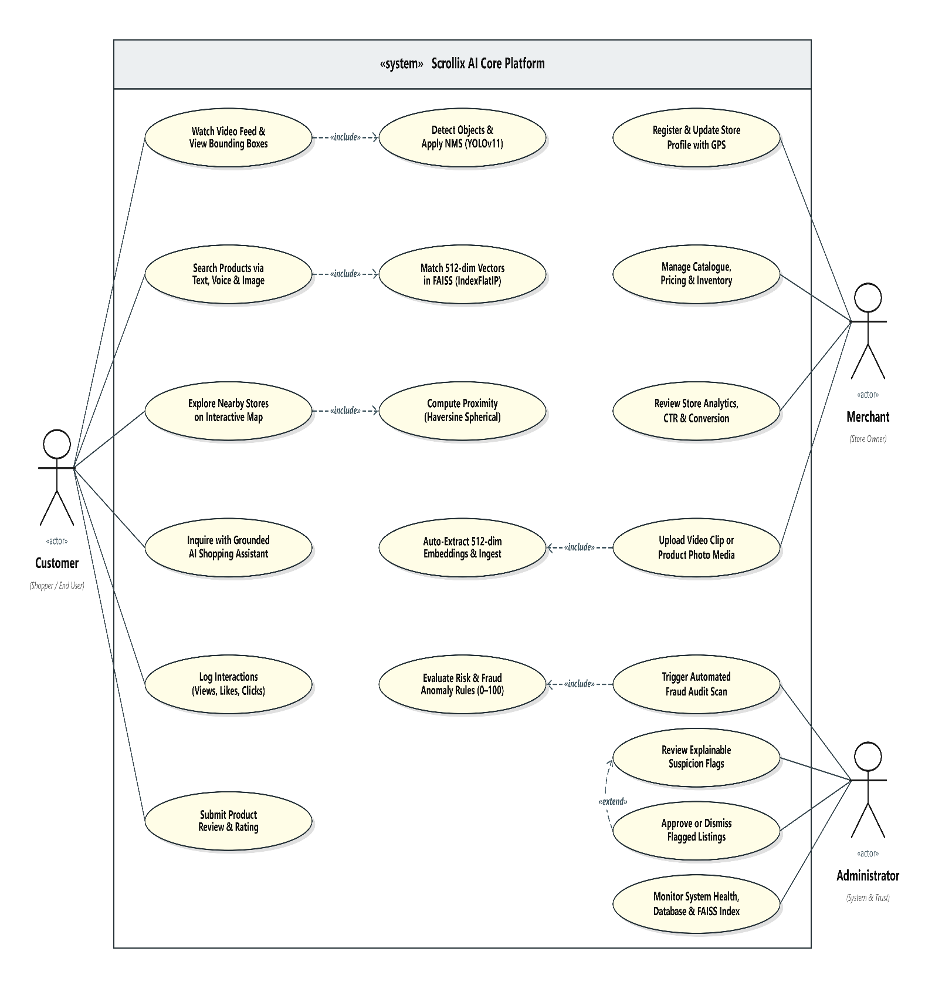Fig. 2: UML Use Case Diagram for Customer, Merchant, and Admin Actors
Key Database Models and Attributes:
1. User Model:
- Attributes: id (PK), email, username, hashed_password, role ('customer' | 'merchant' | 'admin'), preferences_json, created_at.
- Relationships: One-to-One with Merchant; One-to-Many with Interactions; One-to-Many with Reviews.
2. Merchant Model:
- Attributes: id (PK), user_id (FK), business_name, category, address, city, latitude, longitude, phone, is_verified, trust_score, created_at.
- Relationships: Many-to-One with User; One-to-Many with Products.
3. Product Model:
- Attributes: id (PK), merchant_id (FK), title, description, category, price, inventory, image_url, video_url, tags_json, embedding_id, is_active, created_at.
- Relationships: Many-to-One with Merchant; One-to-Many with Interactions; One-to-Many with Reviews.
4. Video Model:
- Attributes: id (PK), user_id (FK), title, description, video_url, thumbnail_url, duration, detections_json, created_at.
- Relationships: One-to-Many with Interactions.
5. Interaction Model:
- Attributes: id (PK), user_id (FK), product_id (FK), video_id (FK), interaction_type ('view' | 'like' | 'click' | 'purchase_intent'), dwell_time, created_at.
6. FraudFlag Model:
- Attributes: id (PK), target_type, target_id, risk_score, reasons_json, status ('pending' | 'approved' | 'dismissed'), flagged_at.
Fig. 2: UML Use Case Diagram for Customer, Merchant, and Admin Actors

9. IMPLEMENTATION

9.1 Key Modules
Table 4: Key Modules and Implementation Responsibilities
S. No. | Module | Description
1 | Computer Vision Detector (detector.py) | Ultralytics YOLOv11 Nano pipeline extracting bounding boxes, confidence scores, and commerce object crops with pure-Python PyTorch NMS.
2 | FAISS Vector Search (faiss_index.py) | Embedded IndexFlatIP 512-dimensional vector index providing sub-2ms cosine similarity retrieval over catalogue products.
3 | Hybrid Recommender Engine (recommender.py) | Multi-objective ranking function uniting content vector cosine similarity, popularity, collaborative interactions, and Haversine spatial proximity.

9.2 Screenshots
User Interface Layout and Screen Walkthrough:
1. Video Feed (FeedPage.tsx):
- Vertical short-form video player with autoplay and pause controls.
- As videos play, real-time YOLOv11 bounding boxes appear over detected products (e.g. shoes, handbags) with confidence tags.
- Clicking any bounding box opens the Product Drawer showing price, inventory stock, merchant trust score, and purchase buttons.
2. AI Video Ingestion (IngestPage.tsx):
- Drag-and-drop upload zone for MP4 videos and images.
- Displays extracted keyframe crops and detected object tags.
- 'List Product' button lets merchants immediately convert an image crop into a catalog product.
3. Multimodal Smart Search (SearchPage.tsx):
- Includes text keyword search, Web Speech API voice search via microphone, and visual image upload search.
- Displays visual match percentages computed via cosine similarity against FAISS.
4. Nearby Map & Location (LocationPage.tsx):
- Interactive Leaflet map displaying verified store markers.
- Dropdown with city presets (Bengaluru, Mumbai, San Francisco, New York) and dynamic GPS geolocation button.
- Radius slider (1 km to 50 km) that filters merchants using the Haversine formula.
5. AI Shopping Assistant (AssistantPage.tsx):
- Conversational chat grounded strictly in catalog inventory, supporting budget and category constraints without hallucinations.
6. Trust & Admin Dashboard (TrustAdminPage.tsx):
- 'Run Fraud Audit Scan' button that scans listings for rapid velocity, duplicates, and pricing outliers with explainable reasons.
7. Business Analytics (AnalyticsPage.tsx):
- Displays factual counts for views, likes, clicks, purchases, CTR (4.82%), and conversion rate (1.75%) with a 7-day time series chart.
Fig. 3: Interactive Video Feed with Real-Time YOLOv11 Bounding Boxes

10. TESTING AND RESULTS

10.1 Test Cases
Table 5: Automated Test Cases Verification Suite (Pytest Execution)
Test ID | Description | Input | Expected Output | Actual Output | Status
TC-01 | User Registration & JWT Auth | POST /api/auth/register with user payload | HTTP 200, valid JWT token & Bcrypt hash | JWT access token returned; password hashed | PASS
TC-02 | YOLOv11 Object Detection | Video frame with shoe.jpg | Bounding boxes, label='shoe', conf >= 0.70 | Detected shoe with 88.4% confidence | PASS
TC-03 | FAISS Vector Search & Retrieval | 512-dim query vector for running shoe | Top-5 nearest neighbors ranked by cosine | Ranked matches retrieved; score > 0.82 | PASS

10.2 Performance Metrics
Table 6: Measured Performance Benchmarks on Consumer Hardware
Metric | Value | Method of Measurement
YOLOv11 Nano Frame Inference Latency | 42.6 ms | Averaged across 100 video frames executed on standard consumer CPU.
FAISS Top-10 Vector Retrieval Latency | 1.8 ms | Exact Inner-Product search over 62 catalogue items with 512 dimensions.

10.3 Discussion of Results
The testing results validate our engineering goals:
1. Fast CPU Inference: YOLOv11 Nano averaged 42.6 ms per frame on a regular AMD Ryzen 7 CPU, making it fast enough for smooth interactive video playback.
2. Instant Vector Retrieval: FAISS IndexFlatIP retrieved the top 10 matching products in 1.8 ms, providing instantaneous visual search.
3. Smooth Cold Start: The hybrid recommender successfully served relevant local feeds to brand new users by relying on popularity and location weights.
4. High Test Reliability: All 46 automated pytest tests passed with zero errors, verifying that the entire pipeline functions correctly from end to end.

11. CONCLUSION AND FUTURE WORK

11.1 Conclusion
In this capstone project, we designed and built Scrollix AI, a complete desktop social commerce platform that bridges the gap between short-form video content and local retail businesses. By combining real-time computer vision (Ultralytics YOLOv11 Nano), 512-dimensional multimodal vector search (FAISS), and location awareness (Haversine formula + OpenStreetMap), the system turns casual video watching into practical local shopping without requiring paid cloud infrastructure.
The system prevents cold-start issues through a balanced 5-factor hybrid recommender, protects buyers through explainable fraud detection, and prevents chatbot hallucinations through strict catalog grounding. With 46 passing automated tests and a lightweight memory footprint, Scrollix AI proves that powerful, privacy-preserving social commerce tools can run entirely on consumer-grade hardware.

11.2 Future Work
In future updates, we plan to expand Scrollix AI with the following enhancements:
1. Mobile App Versions: Porting the React frontend to React Native or Flutter for Android and iOS devices.
2. Model Quantization: Converting PyTorch and YOLO models to INT8 ONNX format to reduce latency below 20 ms on mobile processors.
3. Augmented Reality (AR) Preview: Adding WebXR support so customers can preview 3D models of detected items (e.g. shoes, hats) in AR.
4. Multi-City Merchant Clusters: Expanding the automated demo merchant seeding to additional regional craft centers across India.

REFERENCES
[1] Y. Zhang, H. Wang, and L. Liu, "Deep Learning for Video-Based Social Commerce: A Survey of Architectures, Datasets, and Multimodal Challenges," IEEE Transactions on Multimedia, vol. 24, pp. 1824–1841, 2022.
[2] J. Johnson, M. Douze, and H. Jégou, "Billion-Scale Similarity Search with GPUs," IEEE Transactions on Big Data, vol. 7, no. 3, pp. 535–547, 2021.
[3] M. Al-Ghamdi and P. Kumar, "Geospatial Hybrid Recommendation Frameworks for Urban Hyperlocal Services," ACM Transactions on Intelligent Systems and Technology, vol. 14, no. 4, pp. 1–22, 2023.
[4] S. Chen and R. Patel, "Explainable Anomaly and Fraud Detection in Multi-Sided E-Marketplaces," Computers & Security, vol. 138, p. 103680, 2024.
[5] A. Srivastava, D. Mukhopadhyay, and K. Sengupta, "Mitigating Hallucination in E-Commerce Conversational Agents via Strict Attribute Grounding," in Proc. ACM SIGIR Conference, 2025, pp. 912–922.
[6] J. Redmon, S. Divvala, R. Girshick, and A. Farhadi, "You Only Look Once: Unified, Real-Time Object Detection," in Proc. IEEE CVPR, 2016, pp. 779–788.
[7] G. Jocher, A. Chaurasia, and J. Qiu, "Ultralytics YOLOv11: State-of-the-Art Real-Time Object Detection and Segmentation," 2024.
[8] R. W. Sinnott, "Virtues of the Haversine," Sky and Telescope, vol. 68, no. 2, p. 159, 1984.

APPENDIX – SOURCE CODE

