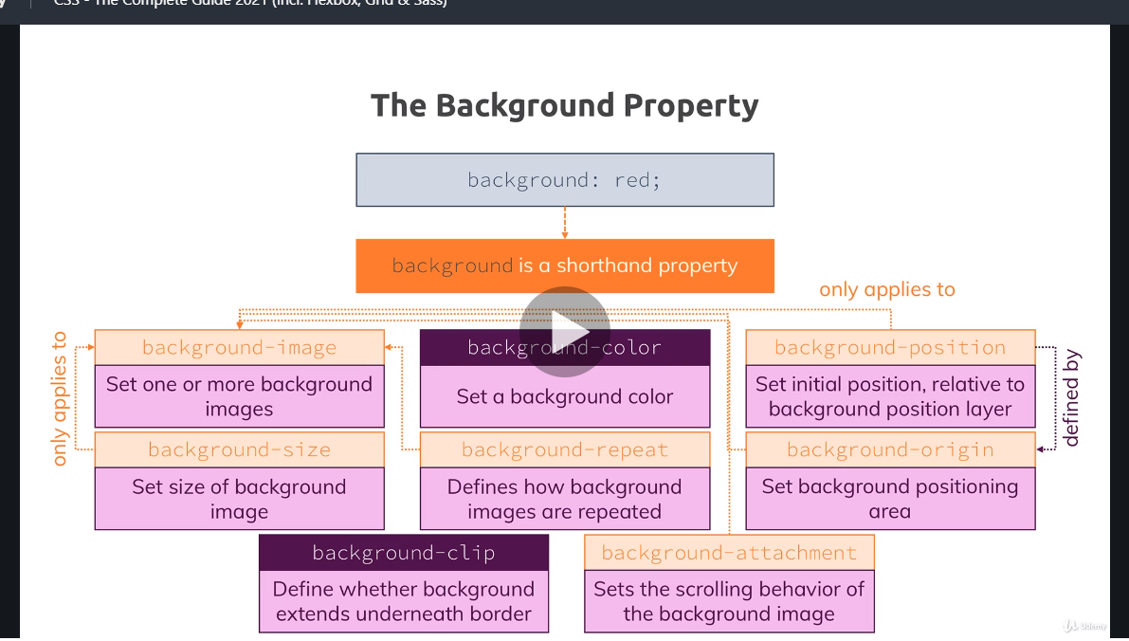

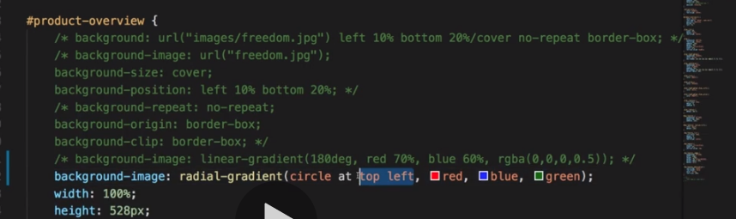

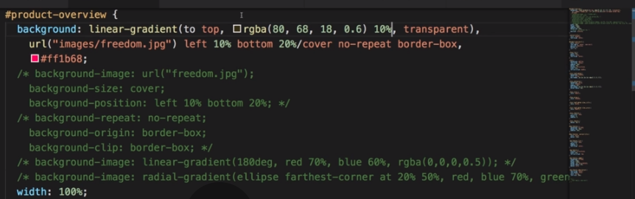

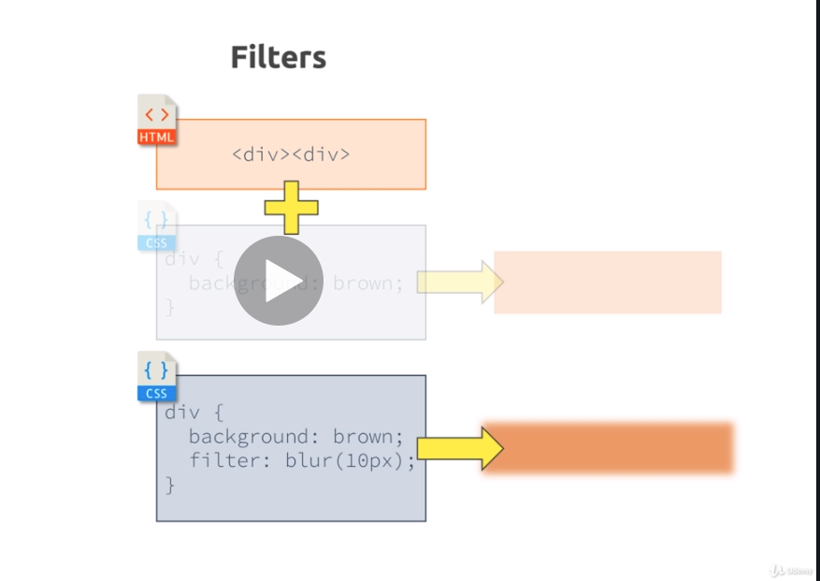

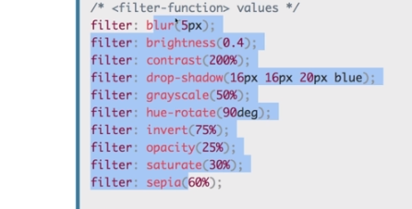

Styling-Images:

Stick to using .JPG for very detailed images that don’t feature text or other hard-edged graphics.

The .PNG, or Portable Network Graphic, tends to have a larger file size than the other two formats, but it also preserves hard edges and can handle a high amount of colors while keeping the load time fast enough to use online. Another interesting capability is that it can be saved on a transparency. This means we can utilize the important elements of an image without needing to change things like a background color if we placed it on transparency. This is a big reason why most major sites create their logo as a .PNG, so it doesn’t need to change whenever their site is updated. Best uses for .PNG include images that contain text, graphics with hard edges, and elements that require transparent backgrounds like logos.

The .GIF file format is essentially the faster loading cousin of .PNG with one catch—the image needs to be under exactly 256 colors. You should only use this file format for low-resolution images.  But elements like solid color buttons or banners are ideal as these will (usually) load faster than the .PNG version, while keeping all the cool features like transparencies and preserving hard edges. Another awesome feature that only .GIFs can utilize is animation. So you can create a graphic that utilizes a short looping or single play animation, which does not require any plug-ins since it’s only an image file.