**REPORT ON**

# “ON GOING SITE CONSTRUCTION WORK” [3360602]

**Prepared By: -**

|  |  |
| --- | --- |
| **Enrolment No** | **Name Of Student** |
| **196470306071** | **Patel Harshal B.** |



**DEPARTMENT OF CIVIL ENGINEERING**

**(N.B.A. Accredited)**

**TAPI DIPLOMA ENGINEERING COLLEGE, SURAT**

**AKNOWLEDGEMENT**

We hereby take the opportunity to express our profound gratitude and sincere thanks to our guide Mr.N.J.Patel & Mr.D.A.Mithaiwala for their valuable guidance and constant encouragement to complete this seminar report.

We also express our sincere thanks to our respected principal Prof. Y.S.Chaupare and Mr.M.P.Jariwala head of civil engineering Dept. for providing us facilities and inspiration in bringing out this seminar report.

We are also thankful to library for providing books to complete this seminar report successfully.

In last we also thankful to all our friends, who have helped us directly or indirectly.

For completion of this seminar report.

**NAME OF STUDENT**

**Patel Harshal** (196470306051)

# CERTIFICATE

**T**his is to certify that the seminar report on “ON GOING SITE CONSTRCUTION WORK” is prepared by the student of Class: 1961, Batch: C (Civil Engineering 6th semester, Term: 18/10/2021 to 31/03/2022) and submitted by them as perin the subject of C.Q.C.M the partial requirement for the diploma course in Civil Engineering as prescribed by the GTU.

PREPARED BY:

|  |  |
| --- | --- |
| **Enrollment no** | **Name of students** |
| **186470306071** | **Harshal Patel** |

**SIGNARTURE OF GUIDE:-**

**(D.A.Mitahiwala)**

**Site name: -** Emporio Textile Hub

**SCAFFLODING:-**

3

**Construction Quality Control and Monitoring (3360602)**

* Scaffolding, also called scaffold or staging, is a temporary structure used to support a work crew and materials to aid in the construction, maintenance and repair of buildings, bridges and all other man-made structures. Scaffolds are widely used on site to get access to heights and areas that would be otherwise hard to get to. 'Unsafe scaffolding has the potential to result in death or serious injury. Scaffolding is also used in adapted forms for formwork and shoring, grandstand seating, concert stages, access/viewing towers, exhibition stands, ski ramps, half pipes and art projects.

4

* + A base jack or plate which is a load-bearing base for the scaffold.
  + The standard, the upright component with connector joins.
  + The ledger, a horizontal brace.
  + Scaffold tie, used to tie in the scaffold to structures.
  + Brackets, used to extend the width of working platforms.

## 

4

## HAND MIXING:-

**Construction Quality Control and Monitoring (3360602)**

* Measured quantity of sand is spread evenly.
* The required quantity of cement is dumped on the sand and spread evenly.
* The sand and cement is then mixed intimately with spade, turning the mixture over and over again until it is of even colour throughout and free from streaks.
* The sad cement mixture is then spread out and measured quantity of coarse aggregate is spread on its top. Alternatively, the measured quantity of coarse aggregate is spread out and the sand cement mixture is then spread on its top.
* The whole mass should be mixed at least three times by shovelling and turning over by twist from centre to side, then back to the centre and again to the sides.
* A hollow is made in the middle of the mixed pile.
* Three quarters of the total quantity of water required should be added while the materials are turned in towards centre with spades. The remaining water is added by a water-can fitted with rose head, slowly turning the whole mixture over again until a uniform colour and consistency is obtained throughout the pile.
* 5 Percent extra cement shall be added than the specified for machine mixing, when hand mix cement concrete is produced.
* The Required PPEs (Personal Protective Equipment) shall be worn by the labours and mason while mixing and handling the concrete.
* The Mixing platform should be washed at the end of the day.

5

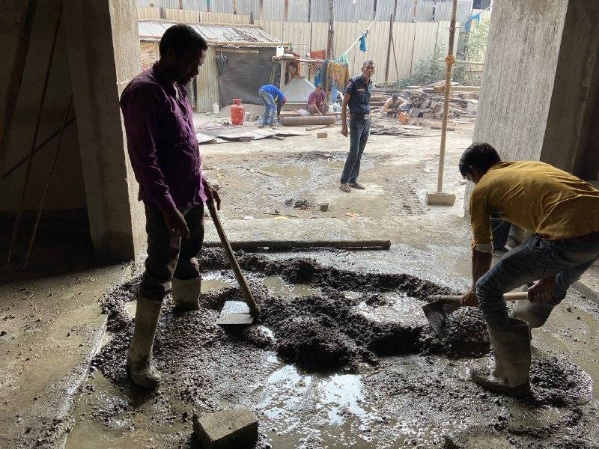

**Construction Quality Control and Monitoring (3360602)**