***“The Vaccine Boost: Quantifying the Impact of the COVID-19 Vaccine Rollout on Measures of Activity***

**Ojective of the analysis and how does panel data help in analyzing the objective of the study in a better manner.**

Objective of the project is to quantifying the impact of the covid 19 vaccine rollout on Measures of Activity.

Panel data is a type of data that professionals collect by observing particular variables over a period of time at a regular frequency. This data can help experts establish trends, make correlations and guide further analysis of the variables included in the panel data.

We have vaccination data of 2 years 2021 and 2022. Through this panel data we try to establish corelation between vaccination and other variables: inflation, population and google mobility to analyse trend between vaccination throughout the year 2021 - 2022 and economic activities(payment/expenditure).

**The data source(s) and variables used with their proper definition**

PAYMENT is the dependent variable which measures the total UPI transection held in different states and union territories of India in year 2021 and 2022(till May) in millions. Source of this data is NPCI state wise payment data 2021 and 2022 till May.

VACCINE is the explanatory variable which measures the number of vaccinations in different states and union territories of India in 2021 and 2022 till May. Source of this data is COWIN.

POPULATION is also an explanatory variable explains the effect of total population of different states and union territories of Indian in year 2021 and 2022 till May on payment. Source of Data is indiacensus.ne.

INFLATION is an explanatory variable measures the rise in average price of goods and services in different states and union territories of India in year 2021 and 2022(till May).

GOOGLE MOBILITY: Each Community Mobility Report is broken down by location and displays the change in visits to places like grocery stores and parks. Here we quantified the google mobility of different states and union territories of India in year 2021 and 2022(till May)

**Number of cross-section entities and any specific features they have:**

The cross-sectional entities in our case the number of states and union territories in India. That is 35(N=35). And Time period is 2 years(2021, 2022).

**Some graphical representation of the nature of variation of the data as may be interesting. Marks will be deducted if a cluttered graph is presented.**

Payment vs Inflation:2022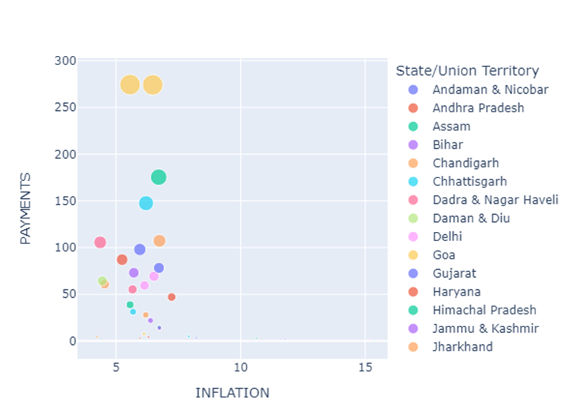

Payment vs Inflation:2021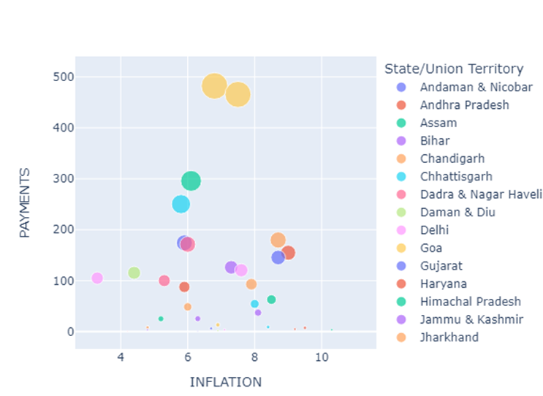

Payment vs stringency dummy:2022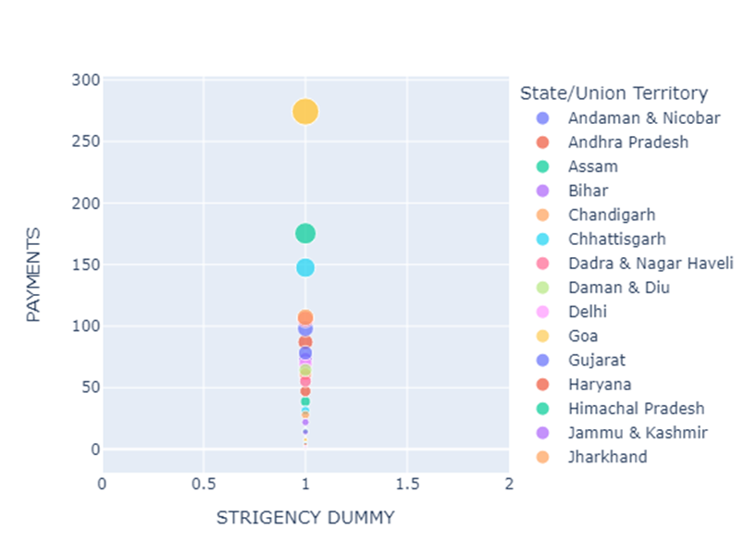

Payment vs stringency dummy:2021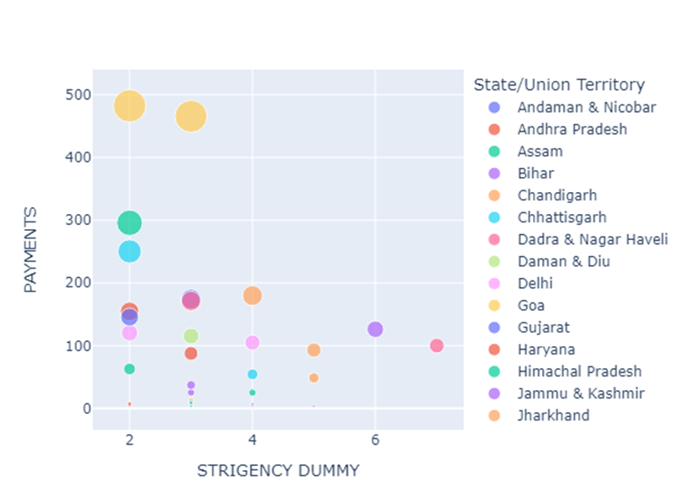

Payment vs google mobility:2022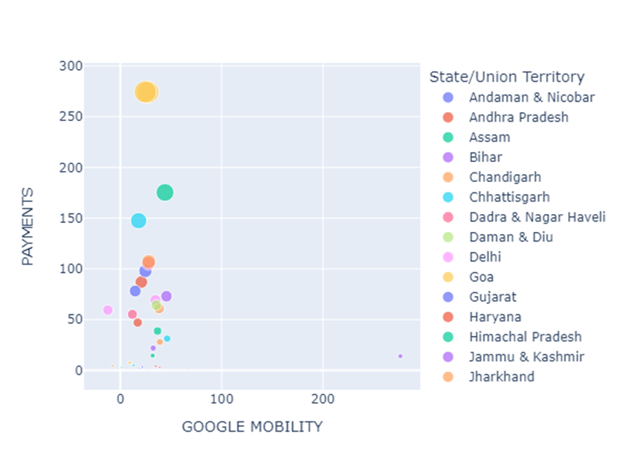

Payment vs google mobility:2021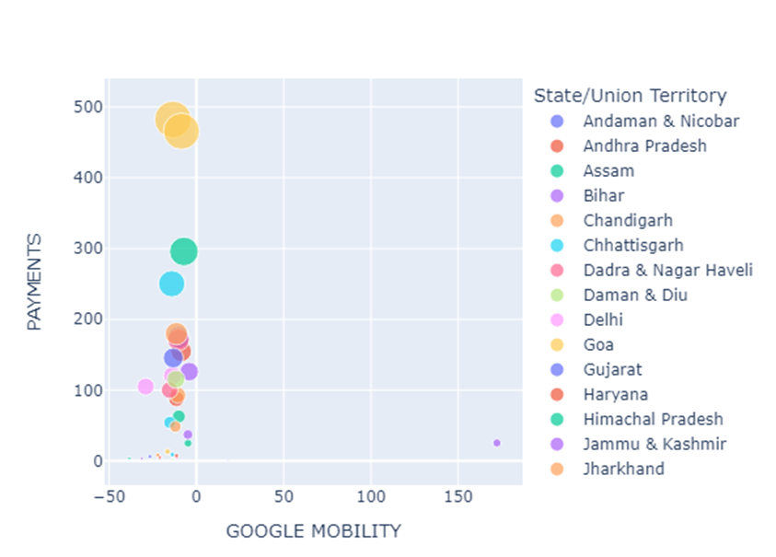

Payment vs vaccine:2022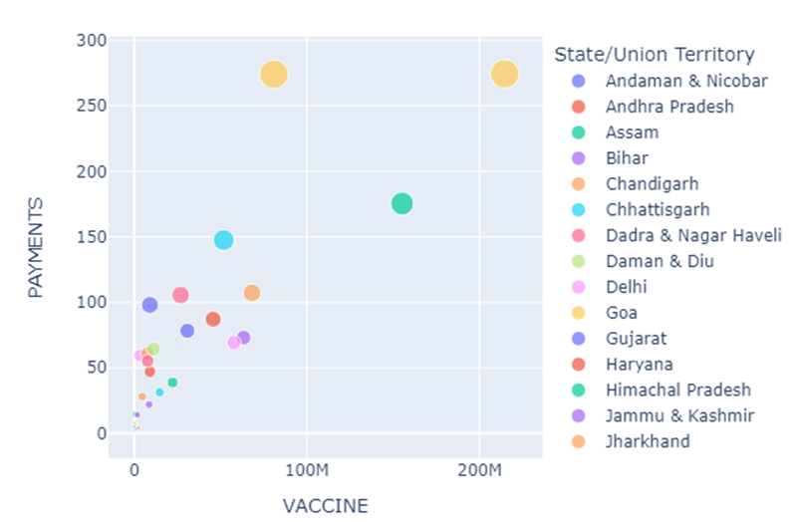

Payment vs vaccine:2021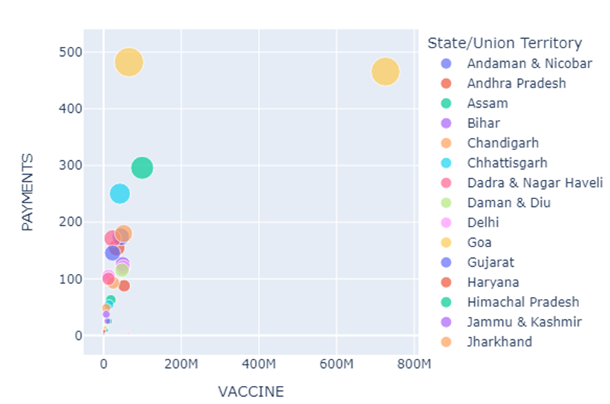

Payment vs population:2022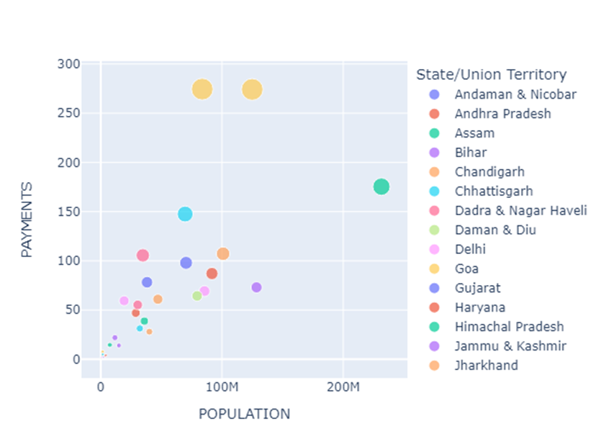

Payment vs population:2021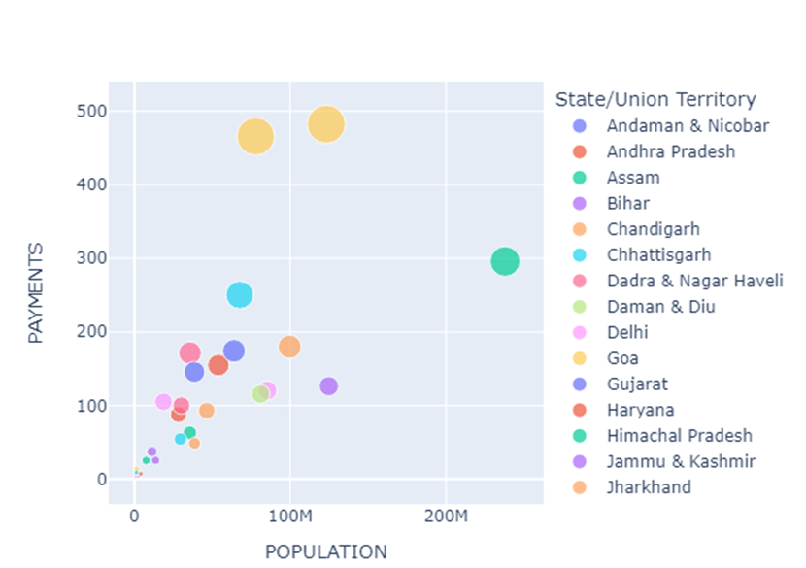

States vs payments:2022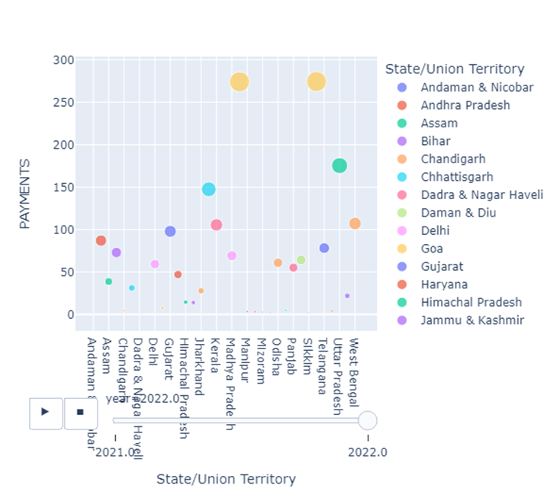

States vs payment:2021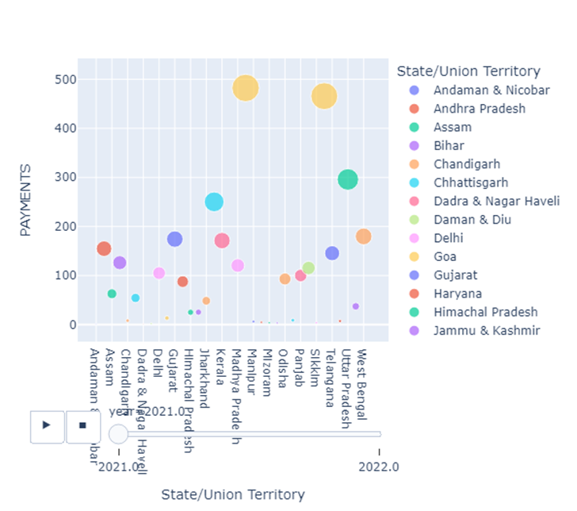

**Summary statistics**

|  |  |  |  |  |  |  |
| --- | --- | --- | --- | --- | --- | --- |
|  | PAYMENTS | INFLATION | VACCINE | POPULATION | STRINGENCY INDEX | GOOGLE MOBILITY |
| COUNT | 70.000 | 70.000 | 70.000 | 70.000 | 70.000 | 70.000 |
| MEAN | 76.386 | 6.926 | 34.79 | 39.967 | 2.171 | 11.775 |
| S.D. | 100.847 | 2.015 | 91.495 | 50.228 | 1.454 | 44.476 |
| MIN | 0.1 | 3.3 | 0.034 | 0.066 | 1 | -38.438 |
| 25% | 4.575 | 5.825 | 1.072 | 1.752 | 1 | -12.243 |
| 50% | 42.92 | 6.47 | 9.476 | 28.552 | 1.5 | -3.162 |
| 75% | 105.42 | 7.911 | 43.584 | 66.64 | 3 | 27.667 |
| MAX | 482.3 | 15.16 | 725.897 | 237.882 | 7 | 276.533 |

Total number of observation is 70.

**Payments(Dependent Variable):** Overall mean is 76.38 i.e in 2 years average statewise payment is 76.389 million rupees; standard deviation is 100.847 which is very high and means huge variation in data. Minimum payment is 0.1 million rupees and maximum is 217.53million rupees.

**Inflation:** Overall mean of inflation is 6.926% in 2years and statewise inflation data and standard deviation is 2.015 which is very small i.e most of the values are clustered around mean. Minimum inflation is 3.3% and maximum is 15.16%.

**Vaccine:** Overall mean of vaccine data around 2 years across states is 34.79 million doses and Standard deviation is 91.495 which means spread is very high and huge deviation. Minimum vaccine count is 0.069million doses and maximum is 1451.794million doses.

**Population:** Overall mean of population is 39.967million and standard deviation is 50.228 which indicates high variation in population data. Minimum population is 0.06 million and maximum is 237.882million.

**Stingency Index:** Overall mean is 2.17 and Standard deviation is 1.45 i.e are values are around 2.17. Maximum index value is 7 and minimum index is 1.

**Google Mobility:** Overall mean is 11.77 and Standard deviation is 44.47 which denotes high variation in data. Maximum mobility value is 276.533 and minimum value is -38.43. Less frequency of movement is better for pandemic spreading but worse for economy.

**Coefficient Estimates: Based on the objective of your analysis compare the results for the following models with and without time dummies**

In our analysis,

Dependent variable: Payment

Independent variable: INFLATION, VACCINE, POPULATION, STRIGENCY DUMMY, GOOGLE MOBILITY.

**a)** **POOLED MODEL:**

**WITH TIME DUMMY**

**PAYMENT = 113.36 - 3.5231(INFLATION) + 0.4989(VACCINE) + 1.0049(POPULATION) - 16.215(STRIGENCY DUMMY) - 0.1508(GOOGLE MOBILITY) - 66.218(YEARS_CAT_2022)+ uit**

**WITHOUT TIME DUMMY**

**PAYMENT = 33.241 – 2.2215(INFLATION) + 0.5181(VACCINATION) + 1.0829(POPULATION) + 1.1622(STRIGENCY DUMMY) – 0.2667(GOOGLE MOBILITY)+ui**

|  |  |  |
| --- | --- | --- |
| **DEPENDENT VARIABLE** | PAYMENT | PAYMENT |
| **ESTIMATOR** | Pooled OLS with dummy | Pooled OLS without dummy |
| **NUMBER OF OBSERVATIONS** | 70 | 70 |
| **R-SQUARED** | 0.7324 | 0.6987 |
| **F-STATISTIC** | 28.744 | 29.685 |
| **P-VALUE(F-STAT)** | 0.0000 | 0.0000 |
| **CONST** | 113.36  (2.7630) | 33.241  (1.0674) |
| **INFLATION** | -3.5231  (-1.0386) | -2.2215  (-0.6278) |
| **VACCINE** | 0.4989  (6.3550) | 0.5181  (6.2928) |
| **POPULATION** | 1.0049  (6.8829) | 1.0829  (6.2928) |
| **STRIGENCY DUMMY** | -16.215  (-2.0511) | 1.1622  (0.2231) |
| **GOOGLE MOBILITY** | -0.1508  (-0.9071) | -0.2667  (-1.5728) |
| **YEARS_CAT_2022** | -66.218  (-2.8180) |  |

On the regression without time dummy, R2 is 0.69 which is less than time dummy consideration case (0.73). P values are significant for both with and without time dummy regression. When we are considering year dummy coefficient of independent variables are decreasing slightly which is insignificant. So regression without time dummy is significant for our analysis.

**b)** **FE MODEL:**

|  |  |  |
| --- | --- | --- |
| **DEPENDENT VARIABLE** | PAYMENT | PAYMENT |
| **ESTIMATOR** | First Difference OLS with Time Dummy | First Difference OLS |
| **NUMBER OF OBSERVATIONS** | 35 | 35 |
| **R-SQUARED** | 0.5590 | 0.4902 |
| **F-STATISTIC** | 6.1264 | 5.7693 |
| **P-VALUE(F-STAT)** | 0.0003 | 0.0008 |
| **INFLATION** | 2.0314  (0.6089) | 3.1780  (0.9135) |
| **VACCINE** | 0.2448  (2.6381) | 0.2639  (2.7023) |
| **POPULATION** | -0.5266  (-0.4094) | -0.9714  (-0.7238) |
| **STRIGENCY DUMMY** | -8.7992  (-1.2508) | 0.3094  (0.0525) |
| **GOOGLE MOBILITY** | 0.0631  (0.1274) | -0.7109  (-2.0023) |
| **YEARS_CAT_2022** | -58.480  (-2.1269) |  |

**WITH TIME DUMMY**

**PAYMENT = 2.0314(INFLATION) + 0.2448(VACCINATION) – 0.5266(POPULATION) - 8.7992(STRIGENCY DUMMY) + 0.0631(GOOGLE MOBILITY) - 58.480((YEARS_CAT_2022)+uit**

**WITHOUT TIME DUMMY**

**PAYMENT = 3.1780(INFLATION) + 0.2639(VACCINATION) – 0.9714(POPULATION)+ 0.3094(STRIGENCY DUMMY) - 0.7109(GOOGLE MOBILITY)+uit**

Coefficients are not significant(lower T stat) for FE model in both with and without time dummy. Also R2 is very low in both cases( with time dummy 0.55 and without 0.49). So the FE model is not significant for our analysis since most of the coefficients are insignificant.

**c)** **RE MODEL:**

|  |  |  |
| --- | --- | --- |
| **DEPENDENT VARIABLE** | **PAYMENT** | **PAYMENT** |
| **ESTIMATOR** | **Random Effects** | **Random Effects** |
| **NUMBER OF OBSERVATIONS** | **70** | **70** |
| **R-SQUARED** | **0.6591** | **0.6137** |
| **F-STATISTIC** | **20.304** | **20.331** |
| **P-VALUE(F-STAT)** | **0.0000** | **0.0000** |
| **CONST** | **76.974 (2.1377)** | **1.7979 (0.0623)** |
| **INFLATION** | **0.2012 (0.0701)** | **1.7581 (0.5714)** |
| **VACCINE** | **0.3877 (5.2231)** | **0.4197 (5.2637)** |
| **POPULATION** | **1.2960 (6.0635)** | **1.1099 (5.9178)** |
| **STRIGENCY DUMMY** | **-12.649 (-1.9711)** | **3.5854 (0.8371)** |
| **GOOGLE MOBILITY** | **-0.1152 (-0.5655)** | **-0.3684 (-1.8828)** |
| **YEARS_CAT_2022** | **-60.895 (-3.2218)** |  |

**WITH TIME DUMMY**

**PAYMENT = 76.974 + 0.2012(INFLATION) + 0.3877(VACCINATION) + 1.2960(POPULATION) + 12.649(STRIGENCY DUMMY) - 0.1152(GOOGLE MOBILITY) –60.895((YEARS_CAT_2022)+ϵi+uit**

**WITHOUT TIME DUMMY**

**PAYMENT = 1.7979 + 1.7581(INFLATION) + 0.4197(VACCINATION) + 1.1099(POPULATION) + 3.5854(STRIGENCY DUMMY) - 0.3684(GOOGLE MOBILITY)+ϵi+uit**

In this regression R2 values are high (with time dummy .65 and without .61). With Time dummy coefficients of important variables(inflation, population, stringency dummy) are more significant than without dummy. So RE model with time dummy is significant for our study.

**d)**

|  |  |  |  |  |  |  |
| --- | --- | --- | --- | --- | --- | --- |
|  | Pooled OLS with Time Dummy | Pooled OLS without Time Dummy | FE with Time Dummy | FE without Time Dummy | RE with Time Dummy | RE without Time Dummy |
| F Stat | 28.744 | 29.685 | 6.126 | 5.769 | 20.304 | 20.331 |

The time dummies are jointly and individually significant which can be confirmed with the

values reflected by the table given above. F-stat values for pooled, FE and RE models are 28.744,

6.126 and 20.304 respectively, which we can see are very high.

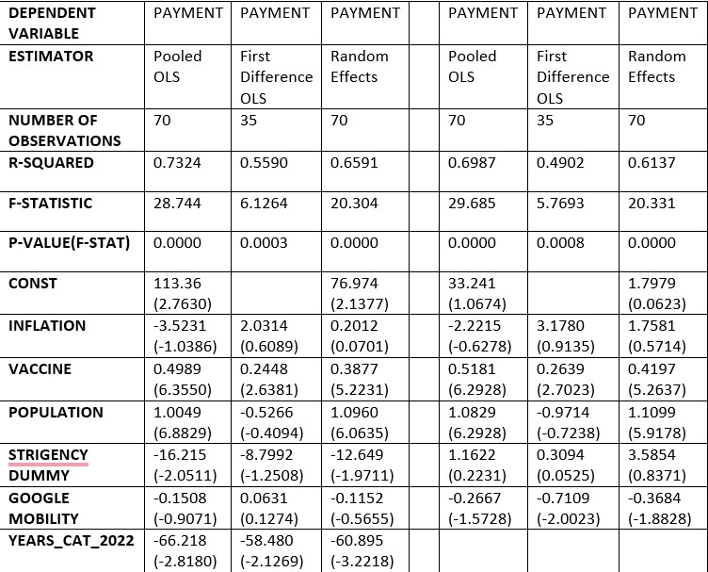

**e)**

R2 value is high for **Pooled OLS** with time dummy but coefficients are more significant for without time dummy Pooled OLS model. F stat values are high for both cases.

R2 values are low in case of both **FE model** and coefficient of inflation, population are insignificant since T stat is very low. F stat values are significant but very low.

R2 values are pretty higher in RE model than FE model and coefficients are significant for with time dummy case. Both with and without time dummy cases are statistically significance since F stat is high.

In comparison of Pooled OLS & FE model, Pooled OLS is better for analysis; RE model & FE model, RE model is better; Pooled OLS & RE model, RE model better in case of with time dummy and Pooled OLS is better in without time dummy case.

**f)**

Most relevant variable is Vaccine, 1 dose increase in vaccine increases payments by 0.51rupees(million) in pooled OLS without Time Dummy model.

**Section 3.2**

**(9) Tests of Hypotheses: In all the model comparisons below, present the results along with the appropriate**

**test of hypothesis for the best fitting model with and without time dummies.**

**a. Pooled with FE**

**b. Pooled with RE**

**c. FE with RE**

**d. Comment on the final results by linking it to the objective of the study**.

**Test statistic**:

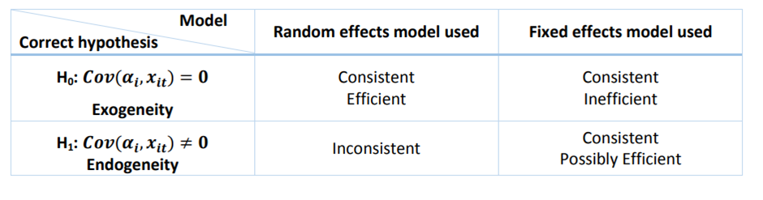

( 𝜷 𝑅𝐸 − 𝜷 𝐹𝐸 )**′** (𝑉𝑎𝑟𝜷 𝑅𝐸 − 𝑉𝑎𝑟 𝜷 𝐹𝐸)**−1** (𝜷 𝑅𝐸 − 𝜷 𝐹𝐸 )

where 𝜷 𝑅𝐸 and 𝜷 𝐹𝐸 are the vectors of coefficient estimates for the random and fixed effects model respectively. This statistic is **𝜒** 2 (𝑘) distributed under the null hypothesis. The degrees of freedom 𝑘 equal the number of factors

Hausman test result with time dummy

Hausman statistic value for the model : 3.7318816618597976

Hausman statistic value at 95% level of sig 12.591587243743977

null hypothesis not rejected

appropriate model is Random effect model

Hausman test result without time dummy

Hausman statistic value for the model:5.988254582360044

Hausman statistic value at 95% level of sig.: 11.070497693516351

null hypothesis not rejected

appropriate model is Random effect model

POOLED VS RE MODEL

(pooled OLS)

(Random Effect Model)

With time dummy

LMBP_stat 11.74047206171636

p_val 0.06801539372767663

Random model

Without time dummy

LMBP_stat 12.9747667090804

p_val 0.04343840809386891

Null Hypothesis is not rejected

pooled OLS

**POOLED VS FE MODEL**

(pooled OLS)

(fixed effect model)

Hypothesis is carries out by using F test using RSS from respective models i.e restricted and unrestricted model

n- no. of observations , k- no. of variables

f_test_p_value :0.8929422699380132

null hypothesis that time dummy are eqaul to zero is rejected

fixed effect model is appropriate over pooled ols