|  |  |
| --- | --- |
| **Feature** | **Description** |
| Login/Registration | Users should be able to create an account for your application  and log into their account once they’ve registered. |
| User Profile | Each user should have a user profile. At a bare minimum, it  should contain the user’s first name, last name, email address  and graduation year. |
| Course Rater | A tool for students to rate courses at Pace as well as the  professors that teach the course. |
| Event Viewer | A place to post and view upcoming events on Pace’s campus. |
| Course Registration (Our feature idea) | A place from where students can register for the courses of upcoming semester. |

**Architecture:**

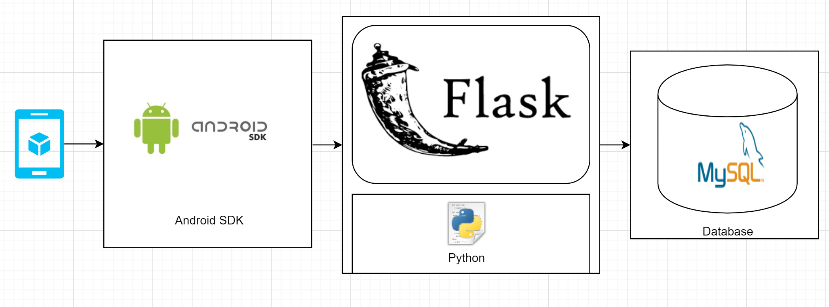

**Database Design:**

Attached is the file of database design.

