

Safety Plan Lane Assistance

**Document Version: 1.0**

**Template Version 1.0, Released on 2017-06-21**



# Document history

|  |  |  |  |
| --- | --- | --- | --- |
| Date | Version | Editor | Description |
| 22 May 2018 | 1.0 | Vivekkumar Mehta | First version of safety plan |
|  |  |  |  |
|  |  |  |  |
|  |  |  |  |
|  |  |  |  |

# Table of Contents

Document history

Table of Contents

Introduction

Purpose of the Safety Plan

Scope of the Project

Deliverables of the Project

Item Definition

Goals and Measures

Goals

Measures

Safety Culture

Safety Lifecycle Tailoring

Roles

Development Interface Agreement

Confirmation Measures

# Introduction

## Purpose of the Safety Plan

Safety plan guides how to achieve a safe system. Safety plan also provides a reference when modifying a system. The safety plan forces us to define roles then outline the steps we will take to achieve functional safety. Structured safety plan sets timelines and deadlines which helps to complete project on time.

## Scope of the Project

For the lane assistance project, the following safety lifecycle phases are in scope:

Concept phase

Product Development at the System Level

Product Development at the Software Level

The following phases are out of scope:

Product Development at the Hardware Level

Production and Operation

## Deliverables of the Project

The deliverables of the project are:

Safety Plan

Hazard Analysis and Risk Assessment

Functional Safety Concept

Technical Safety Concept

Software Safety Requirements and Architecture

# Item Definition

The Item being discussed is Lane assistance system. The System’s lane departure warning function vibrates steering wheel if driver changes lane without giving lane change signal.

A lane assistance system generally has two functions:

* lane departure warning
* lane keeping assistance

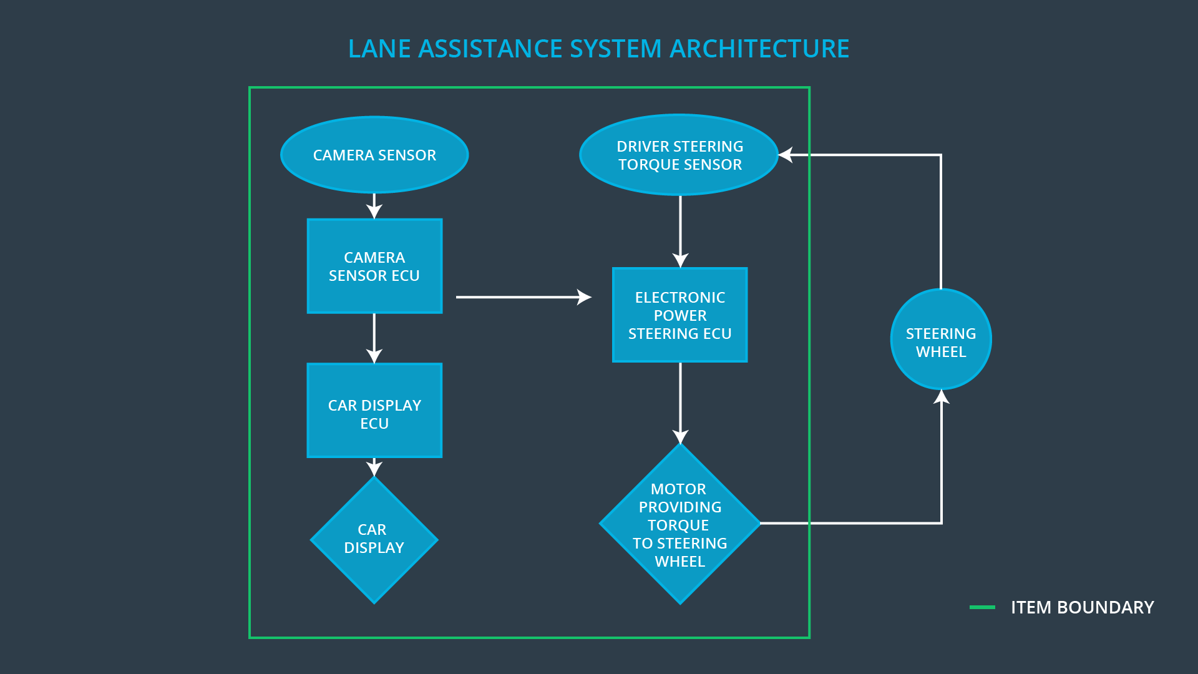

If a driver departs a lane without using a turn signal, the system assumes that the driver has become distracted and did not mean to leave the lane. The system will vibrate the steering (lane departure warning) and also move the steering wheel back towards the lane center (lane keeping assistance). Location of the car with respect to lane will be detected by camera sensor subsystem. Driver steering torque system will give input to steering ECU. Car display subsystem will provide visual information to driver. While all these subsystems are part of the item, steering wheel is outside the item.

# Goals and Measures

## Goals

Goal of the project is to achieve a safe and reliable components of Lane assistance system according to ISO 26262. ISO 26262 compliance is not legally required. But most if not all automotive companies and automotive parts suppliers strive to make their products compliant with the standard. The standard provides a methodical, state-of-the-art framework for ensuring a safe electrical/electronic system.

## Measures

|  |  |  |
| --- | --- | --- |
| Measures and Activities | Responsibility | Timeline |
| Follow safety processes | All Team Members | Constantly |
| Create and sustain a safety culture | All Team Members | Constantly |
| Coordinate and document the planned safety activities | Safety Manager | Constantly |
| Allocate resources with adequate functional safety competency | Project Manager | Within 2 weeks of start of project |
| Tailor the safety lifecycle | Safety Manager | Within 4 weeks of start of project |
| Plan the safety activities of the safety lifecycle | Safety Manager | Within 4 weeks of start of project |
| Perform regular functional safety audits | Safety Auditor | Once every 2 months |
| Perform functional safety pre-assessment prior to audit by external functional safety assessor | Safety Manager | 3 months prior to main assessment |
| Perform functional safety assessment | Safety Assessor | Conclusion of functional safety activities |

# Safety Culture

Here are some characteristics of a good safety culture:

* **High priority**: safety has the highest priority among competing constraints like cost and productivity
* **Accountability**: processes ensure accountability such that design decisions are traceable back to the people and teams who made the decisions
* **Rewards**: the organization motivates and supports the achievement of functional safety
* **Penalties**: the organization penalizes shortcuts that jeopardize safety or quality
* **Independence**: teams who design and develop a product should be independent from the teams who audit the work
* **Well defined processes**: company design and management processes should be clearly defined
* **Resources**: projects have necessary resources including people with appropriate skills
* **Diversity**: intellectual diversity is sought after, valued and integrated into processes
* **Communication**: communication channels encourage disclosure of problems

An organization should develop clear policies and strategies to support the development, production, and operation of safe systems. Good safety culture, put safety as the highest priority over competing constraints, like cost and productivity. Without a good safety culture, functional safety is difficult to achieve.

# Safety Lifecycle Tailoring

For the lane assistance project, the following safety lifecycle phases are in scope:

* Concept phase
* Product Development at the System Level
* Product Development at the Software Level

The following phases are out of scope:

* Product Development at the Hardware Level
* Production and Operation

# 

# Roles

|  |  |
| --- | --- |
| Role | Org |
| Functional Safety Manager- Item Level | OEM |
| Functional Safety Engineer- Item Level | OEM |
| Project Manager - Item Level | OEM |
| Functional Safety Manager- Component Level | Tier-1 |
| Functional Safety Engineer- Component Level | Tier-1 |
| Functional Safety Auditor | OEM or external |
| Functional Safety Assessor | OEM or external |

# Development Interface Agreement

A DIA (development interface agreement) defines the roles and responsibilities between OEM and tier-1 involved in developing a product. All involved parties need to agree on the contents of the DIA before the project begins.

The DIA also specifies what evidence and work products each party will provide to prove that work was done according to the agreement.

The ultimate goal is to ensure that all parties are developing safe vehicles in compliance with ISO 26262.

Here are major sections of a DIA:

* Appointment of customer and supplier safety managers
* Joint tailoring of the safety lifecycle
* Activities and processes to be performed by the customer; activities and processes to be performed by the supplier
* Information and work products to be exchanged
* Parties or persons responsible for each activity in design and production
* Any supporting processes or tools to ensure compatibility between customer and supplier technologies

# Confirmation Measures

Confirmation measures serve two purposes:

* that a functional safety project conforms to ISO 26262, and
* that the project really does make the vehicle safer.

The people who carry out confirmation measures need to be independent from the people who actually developed the project.

**Confirmation review**

Ensures that the project complies with ISO 26262. As the product is designed and developed, an independent person would review the work to make sure ISO 26262 is being followed.

**Functional safety audit**

Checking to make sure that the actual implementation of the project conforms to the safety plan is called a functional safety audit.

**Functional safety assessment**

Confirming that plans, designs and developed products actually achieve functional safety is called a functional safety assessment.