AIM: Database information of CodeHacker

1. settings.py

DataBase Name = sqlite3

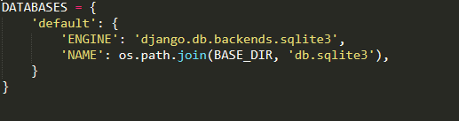

2. Profile.manage.py

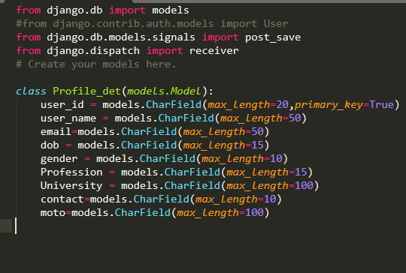

* This is Profile table of Profile module which store all details of user .

3. leaderboard.models.py

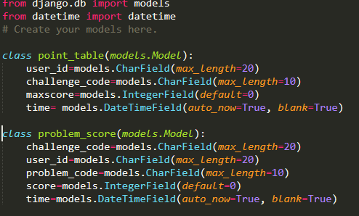

* point_table store total point of user of participate challenges where maxscore is sum of all problem score of any challenge solved by user
* problem_score store total point of particular problem where problem_score is total point gain by user of that problem and time is describe last submission time of user of that problem

4.online_judge.models.py

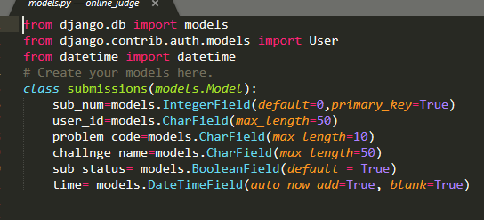

* submission table store all details of submission
* sub_num id of submission,when submission happen sub_num increase by 1
* problem_code is, all problem have unique code
* same as problem_code ,all challenge have unique code that is sote in challenge_code
* sub_states describe status of submission , means submission is accepted or not
* time store time of that submission ,and “auto_now_add =True” store system time automatically when details of that submission is saved.

5. Login.models.py

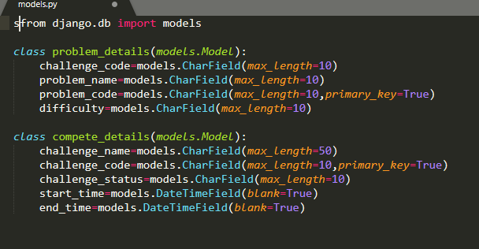

* compete_details store details of challenge which is added by admin
* challenge_status describe challenge is presenet ,future or past…when challenge is added by admin that time is always future ,but after that make present and then past .
* start_time is time challenge stating time and ending time
* problem_details store details of problem which is added bu admin
* which give details of problem,e.g. problem difficulty ,problem is adden in which challenge etc..