**Chatserver**

This document gives a technical overlay of the application.

**Technology used**: Node js, js.

**Github repo for the code:** https://github.com/vivek87799/chat_server.git

For information on running the application please read the README.md file attached along with the code.

**Directory structure:**

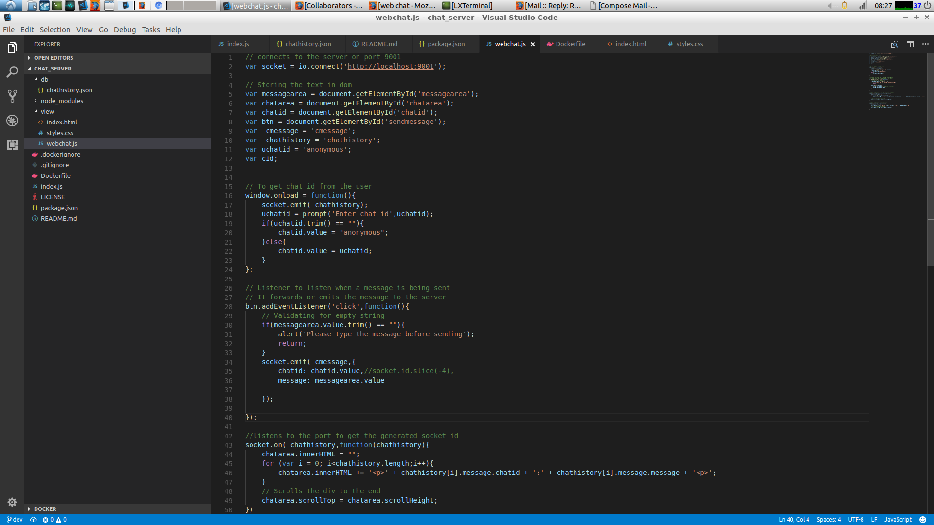

* The index.js is the main file that gets served when the application starts.
* The chat history is stored in a Json file under the db directory.
* The view is served from the view folder.

**Index.js**

* On init the chat history is read from the JSON file chathistory.json.
* Listens for connection in the specified port.
* Receives message from the client and stores it in the json file and also forwards the message to all the clients attached.

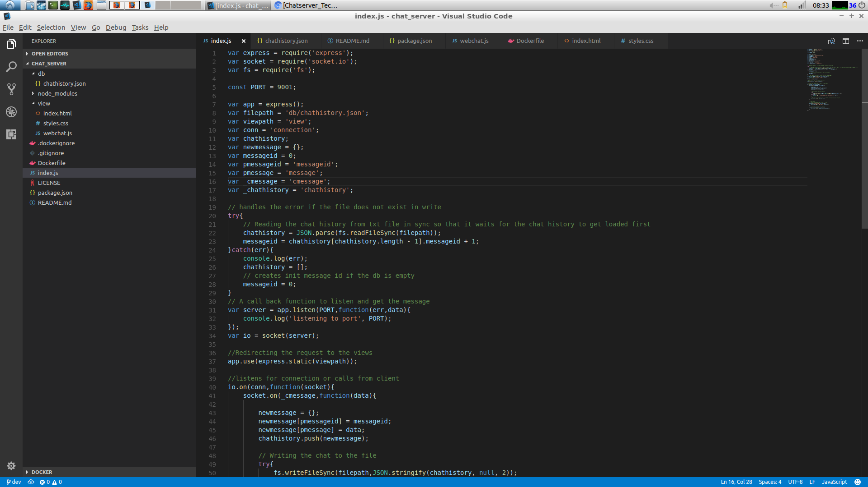

**Webchat.js**

It handles the js operation on the UI and also communicates to the server via socket.io using the port 9001

**Chathistory.json**

The chat messages are stored in a persistent state to the JSON file in the below structure.

{

"messageid": 0,

"message": {

"chatid": "",

"message": ""

}

}