Creating a admin client to manipulate user
Original

Update

Save client id and secret

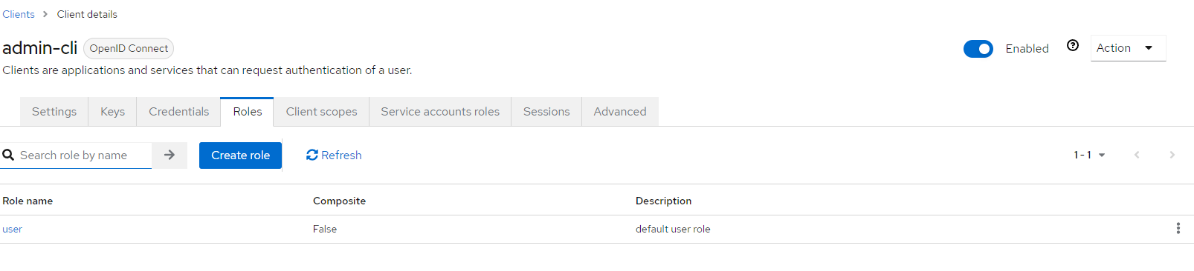
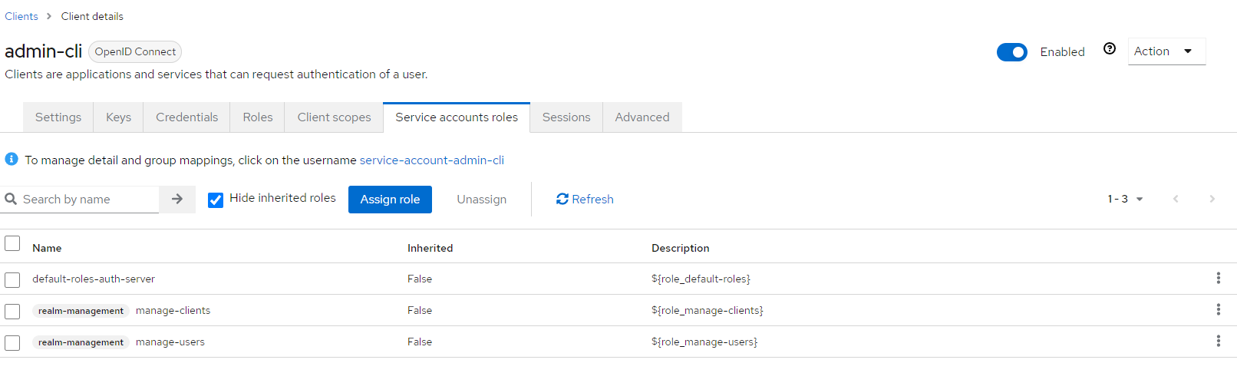

Send request request and get token
