USER SERVICE ENV

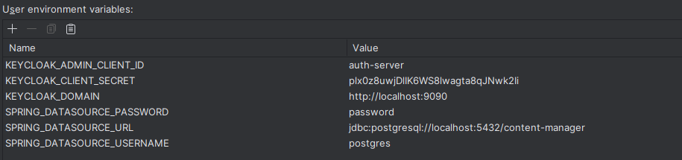

GATE WAY SERVICE ENV

