After creating a public-client

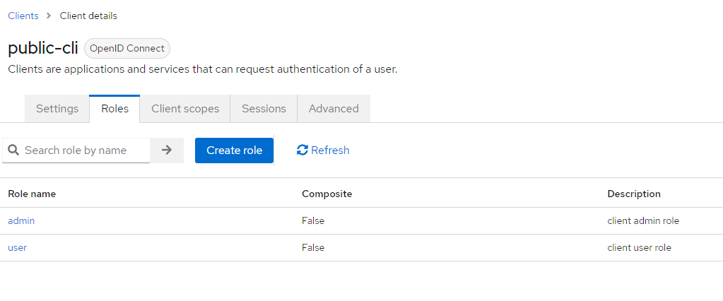
Create client roles

Go to the realm role and map these client roles

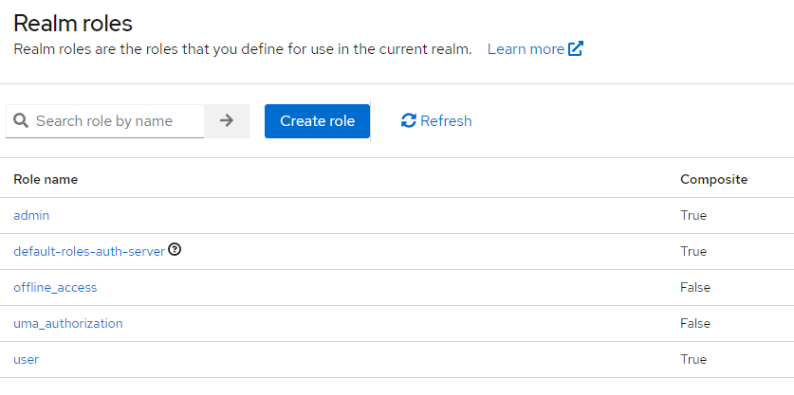
How to map roles?

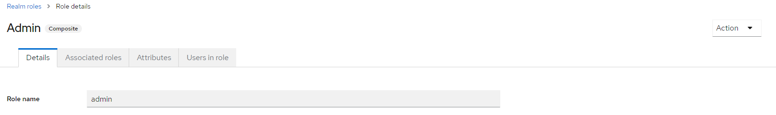
click on action (add associated roles)

filter by client and select admin client as admin role

Repeate same for user role

Adding default role as user on user registration

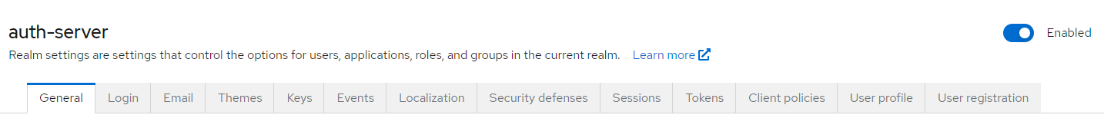
Go to realm setting select user-registration
assign newly created realm role user ( which is mapped to public-cli)

