The Influence of Digital Marketing Campaigns on
Customer Engagement in the Indian Ed-Tech
Industry

Table of Contents
Chapter 1: Introduction 6
1.1 Background 6
1.2 Research Rationale 7
1.3 Problem Statement 7
1.4 Research Aim 8
1.5 Objectives 8
1.6 Research Questions 8
1.7 Research Hypotheses 8
1.8 Scope and Significance 9
1.9 Brief of Research Methodology 9
1.10 Dissertation Structure 9
Chapter 2: Literature Review 10
2.1 Perception of the customers towards the digital marketing campaign in the educational sector 10
2.2 Impact of digital marketing strategy on conversion of customers 12
2.3 Role of digital marketing in influencing the perception of the customers 14
2.4 Analysing the consequences of the absence or presence of a digital marketing campaign in edtech firms. 16
2.5 Theoretical Underpinning 18
2.6 Research Gap 21
Chapter 3: Methodology 22
3.1 Research Onion 22
3.2 Research Philosophy 23
3.3 Research Approach 23
3.4 Research Design 24
3.5 Research Strategy 25
3.6 Research Choice 25
3.7 Data Collection 25
3.8 Data Analysis 27
3.9 Inclusion and Exclusion criteria 29
3.10 Research Ethics 29
3.11 Timeline 29
Reference List 31

List of Figures
Figure 1.1: Main Channel of Digital Marketing in organisations 5
Figure 1.2: Dissertation Structure 8
Figure 2.1: Customer Perception and Satisfaction 9
Figure 2.2: Different Digital Marketing Approaches 12
Figure 2.3: AI in Digital Marketing 13
Figure 2.4: Factors influencing perception of customers 14
Figure 2.5: Absence or Presence of Digital Marketing 16
Figure 2.6: Relationship Marketing Theory 18
Figure 2.7: AIDA Model 19
Figure 3.1: Research Onion 21
Figure 3.2: Research Philosophy 22
Figure 3.3: Research Approach 23
Figure 3.4: Research Design 23
Figure 3.5: Research Design 25
Figure 3.6: Thematic Analysis 27

List of Tables
Table 3.1: Inclusion and Exclusion Criteria 29
Table 3.2: Research TimeLine 30

Chapter 1: Introduction

1.1 Background
A digital marketing campaign is a strategic, data-driven and personalised effort to promote online learning through courses, learning platforms and tutorials to target learners, institutions and parents (Zou et al., 2025). Researchers have found that digital marketing has an effective impact on the Indian education sector, including brand awareness, reach, an instant feedback system, and easy access (Gondane and Pawar, 2021). Different channels of digital marketing campaign that are preferred by organisations include marketing through social media, local network, websites and mobile applications (Refer to Figure 1.1) (Al-Ababneh, 2020). In education settings, technology creates educational experiences that allow individual student needs, foster motivation and engagement (Du Plooy, Casteleijn and Franzsen, 2024).
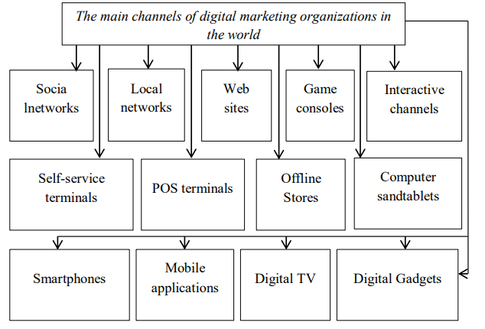

Figure 1.1: Main Channel of Digital Marketing in organisations
(Source: Al-Ababneh, 2020)
Based on recent reports, approximately 26.8% of Indian youth under the age group of 15- and 24-year-old use Internet to discover and search information for a new product (Sharma, 2024). Additionally, they also use digital payment methods to carry out online transactions and email marketing as a part of marketing campaign. However, still there are regions in India that lack equal access to digital capabilities such as there is a limited level of digital structural development found in the state of Meghalaya. In comparison to other states such as Tripura, Uttar Pradesh and Chhattisgarh that has higher level of digital skills and this difference shows internet access is not equal at all the regions of India. Therefore, the study is aimed at determining the impact of digital marketing messaging in engaging the users in the edtech enterprises.

1.2 Research Rationale
The research rationale is centered on the need to understand the effectiveness of the digital marketing campaign. The campaign includes content marketing, personalised advertisements, and social media marketing to drive user engagement, brand loyalty and user retention in the fierce competition in the Indian Ed-Tech Industry (Bhattacharjee and Balakrishnan, 2025). The existing research has a gap in understanding the driving engagement & retention in the digital marketing campaign in the Indian Ed-Tech Industry. Therefore, the study conducts a secondary qualitative data analysis to analyse how the digital marketing campaign optimises customer acquisition, leveraging the effective digital channels to convert passive viewers to paying users.

1.3 Problem Statement
The edtech industry of India is witnessing substantial growth in recent days due to heavy use of smartphones and preference for flexible learning. The current Indian edtech market is valued at USD 3.63 billion as of 2025. Furthermore, this market is rapidly expanding with an estimated expectation that it would grow to around USD 33.31 billion by 2034 (Imarcgroup, 2026). The digital marketing communications that are carried through different social media channels, such as YouTube, Facebook and TikTok, have been very effective in targeting the desired customers by edtech firms. Nevertheless, it has been noted that learners enrol in these courses but often fail to complete them. For instance, the reports of 2023 depicted that students are preferring to engage in on-site learning courses, even with the post-pandemic expansion of online and hybrid learning. This insight outlines that customer retention remains a significant challenge in the Indian edtech industry. This is due to high dropout rates or low enrolment, which negatively impact the long-term sustainability of the business. Additionally, another critical challenge prevalent in the Indian edtech industry is issues related to the digital divide, price sensitivity, and the diverse demographics of learners. A major reason for the digital divide in India is the lack of proper infrastructure for offering quality Internet services. The completion of free education courses is higher compared to paid ones, indicating the price sensitivity as another factor to enrol into edtech platforms (Shen & Liu, 2022). Thus, the study is aimed at understanding the effectiveness of digital marketing campaigns in improving the customer engagement rates for the edtech companies in India. The research is going to resolve the above-recognised challenges by assessing the role of digital marketing campaigns in enhancing conversion rates for the edtech platforms. Through this investigation, the research aimed at addressing the recognised challenges while contributing to the sustainability of the edtech platforms in India.

1.4 Research Aim
The study intends to scrutinise the influences of the digital marketing campaign across the Indian ed-tech industry to evaluate its significance on Indian consumer engagement and retention.

1.5 Objectives
- To identify the main perception of the Indian consumer base and the consideration of the digital marketing tactics in their educational purpose.
- To assess the effectiveness of digital marketing strategies in the conversion of potential customers to actual users in Indian edtech institutions.
- To analyse the role of this marketing approach in influencing the perception of the customers.
- To understand the role of the presence or absence of digital marketing tools in influencing the engagement of students in the edtech industry.

1.6 Research Questions
RQ1: What are the main perceptions, needs and demands of the Indian consumer base, and how do they consider the digital marketing tactics for educational purposes?
RQ2: What is the impact of digital marketing on the ed-tech industry to boost Indian consumer conversion rates?
RQ3: What is the role of a digital marketing campaign in influencing the perception and awareness of edtech startups?
RQ4: How can the Indian ed-tech industry boost in the global competitive market and engage customers through a digital marketing campaign?

1.7 Research Hypotheses
H0.1: Null Hypothesis: Digital marketing tactics do not have a significant impact on consumer engagement across the Indian ed-tech industry.
H1.1: Alternative Hypothesis: Digital marketing tactics have a significant impact on consumer engagement across the Indian ed-tech industry.
H0.2: Digital marketing tactics do not have a profound effect on customer perceptions and brand awareness across the Indian ed-tech industry.
H1.2: Digital marketing tactics have a positive effect on customer perceptions and brand awareness across the Indian ed-tech industry.
H0.3: Digital campaigns do not have an impact on consumer conversion in the Indian online education platforms.
H1.3: Digital campaigns have an impact on consumer conversion in the Indian online education platforms.

1.8 Scope and Significance
The study has a geographical focus on India with Tier 1, Tier 2, Tier 3 cities to critically analyse the digital educational standards. In addition, the study targets the students (K-12), competitive exam aspirants and higher education degree holders to understand their acceptance of participating in online learning. As the study uses the qualitative research method, it evaluates the user’s brand sentiments by gathering insights from the secondary research. This research's significance lies in providing strategic decision-making to policymakers for ed-tech firms across different regions by getting the key insights.

1.9 Brief of Research Methodology
The secondary qualitative method was used to gain key insights into the influences of digital campaigns on the Indian ed-tech industry. Thematic data analysis is used to analyse the vast extracted data by creating meaningful themes that align with the research objectives and research questions. The novel six-phase process, which was proposed by Braun & Clarke used to seamlessly code data and generate themes (Zairul, 2025). It is ideal to re-examine data to answer the new questions and offer a deep understanding without the need to collect primary data.

1.10 Dissertation Structure
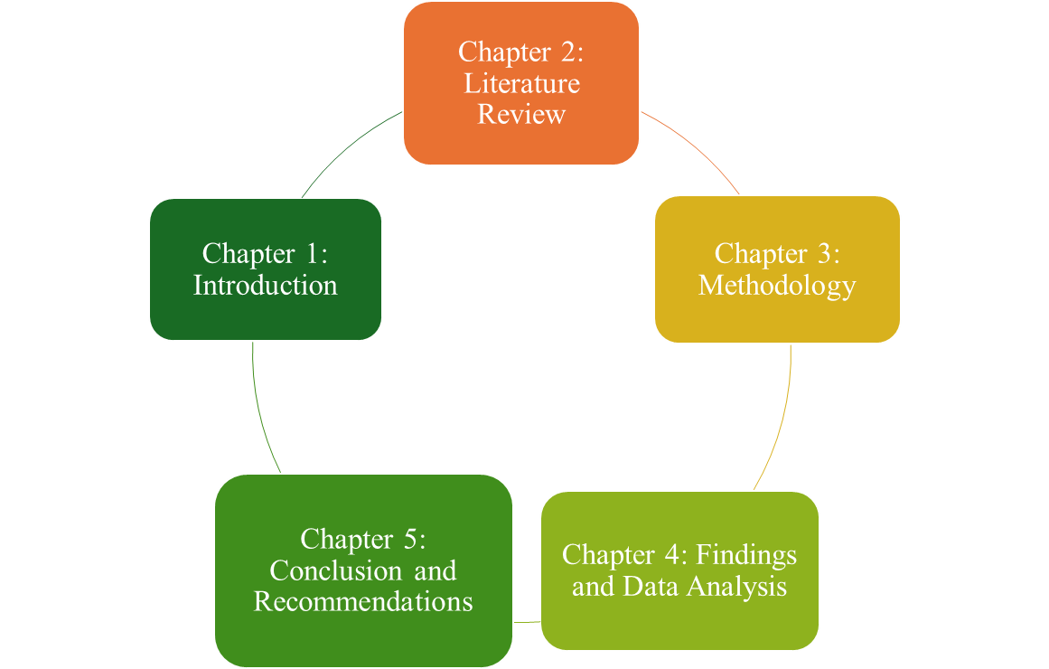

Figure 1.2: Dissertation Structure

Chapter 2: Literature Review

2.1 Perception of the customers towards the digital marketing campaign in the educational sector
An effective digital marketing campaign is crucial to reach a diverse range of audiences in the edtech industry. As highlighted by Santoki et al. (2024), marketing teams in edtech startups are implementing predictive analytics to improve the effectiveness of the marketing campaign. AI-driven predictive analytics uses historical data to understand the requirement for specific products and tailor course content accordingly. However, it was also argued that the use of this tech-enabled approach in marketing offers several challenges related to data security and privacy. For instance, if the data utilised for personalisation of course material is not handled sensitively, it can lead to breaches of data privacy concerns and violations of data protection regulations. On the other hand, Sethi, Saxena and Singh (2023) studied the influence of website traffic on the behaviour of the investors in India and the US. It has been demonstrated that monthly visitors of customers improve the decision of the investors to invest in the edtech businesses.
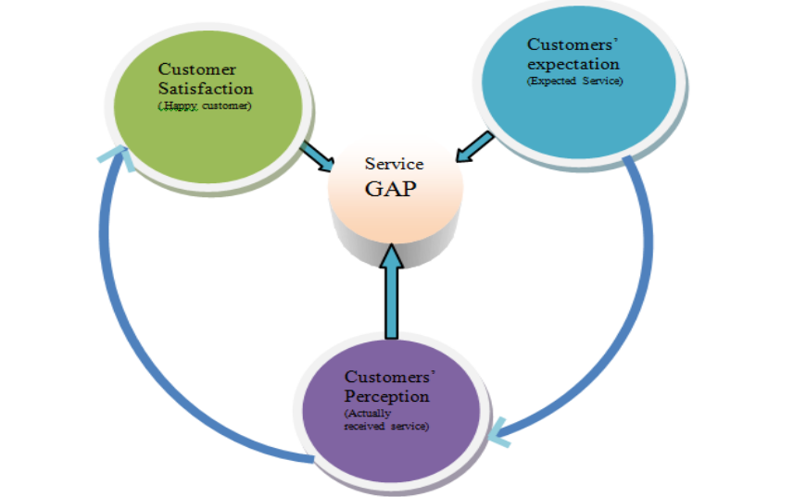

Figure 2.1: Customer Perception and Satisfaction
(Source: Hossain and Nagai, 2019)
Juhaidi (2024) studied the influence of social media marketing campaigns on higher educational institutions and revealed that platforms such as Instagram and Facebook offer the chance to attract new learners over the internet. It was obtained that after the pandemic outbreak, the social media platforms have been highly preferred by the students as a part of the communication process. It has been reported that the total number of social media users worldwide reached around 60.6% of the total population of the world by July 2023. Thus, promotion of educational products over this platform offered the scope to improve the rate of conversion. For instance, when the marketing team posts advertisements and captions such as ‘Hurry up and register!’ and ‘students winning in a contest’, it improves the scope of engagement and conversion. However, the main challenge in this regard was to gain a competitive edge, as millions of educational institutions promote their products daily.
On the contrary, Williamson and Hogan (2021) evaluated that digital technologies enabled organisations to carry on teaching, thereby addressing the gap of equity and access in education. It was important to acknowledge that in the situation of the COVID-19 pandemic, virtual classrooms, online learning platforms, and digital learning management systems allowed students from underserved areas to gain access to education. However, some consumers also argued that overreliance on digital education reduced the scope of face-to-face interaction between teachers and students, which could negatively impact the motivation and engagement level of the students.
According to Vieira et al. (2019), digital marketing strategies are highly relevant and effective in emerging markets, as consumers massively depend on online channels for customer satisfaction and decision-making (Refer to Figure 2.1). Different digital marketing channels have been used by the organisation, including SEO and social media campaigns, to gain the attention of the aspirants. Bharti, Khatri and Duralia (2024) also mentioned that the purchase intent of modern consumers is influenced by digital interaction and peer review. Digital channels allow organisations to create engaging and educational content that positively supports decision-making among consumers. In contrast, Tseng (2023) stated that trust and credibility play an essential role in the integration of online educational services. Recommendations provided by family members, peer networks and institutional reputational, rather than digital advertisements, are the key metric of trust.
The above perspective provides a different analysis from the view of Bharti, Khatri and Duralia (2024), who investigated the role of trust and social influences in the context of digital consumer engagement. Another contrasting view is highlighted by Rooney et al. (2021), who argued that digital marketing strategies needed to consider the diversity of the consumer base and provide the content as per their preferences and requirements. The author noted that differences in language, levels of income, digital literacy and geographic location were used to determine how consumers responded to online marketing. For instance, Urban customers may actively engage with sophisticated digital campaigns, rural customers may need simpler communication strategies and localised content. The above argument significantly contrasts with a more generalised view about the effectiveness of the Digital Marketing concept that highlighted structural inequalities within the Indian digital market in the EdTech sector.
Furthermore, Baltezarevic (2023) highlighted that effective development of digital marketing in the educational sector mainly needed interactive communication rather than traditional promotional messages about the organisation. The digital marketing campaign, which is carried out through informative content, webinars, tutorials and educational blogs, helps learners to evaluate the learning experience more effectively. Hence, from the above discussion, it was obtained that the perception of the customers is influenced by several factors such as trust, data privacy, technological accessibility and demographic differences.

2.2 Impact of digital marketing strategy on conversion of customers
The edtech companies have experienced rapid growth due to an increase in internet penetration, the use of smartphones and demand for flexible learning. Conversion rate is basically the measure utilised in the business domain to analyse the relationship between the performance of the website and marketing goals (Sampath, 2024). Though the use of these metrics enables businesses to understand the effectiveness of their marketing strategy in improving visibility online, generating traffic and gaining expected ‘Return on Interest’ (ROI). Purnomo et al., (2023) highlighted that the main objective of a digital marketing strategy is to target consumers online to generate profitable conversions. The Search Engine Optimisation (SEO) involves using relevant keywords, quality content creation and approaches to improve the chances of appearing on the first page of the search results.
This approach, which includes optimisation of marketing campaigns using relevant keywords, ensures that the campaign appears only in front of people who are potentially interested in the products of the company. In the context of commercial platforms, the video marketing method is advantageous in increasing the rate of conversions to e-commerce platforms. However, it is important to acknowledge that digital marketing campaigns need to comply with recent marketing trends to stay ahead amid the prevailing trends in the digital marketing strategy to yield better financial results.
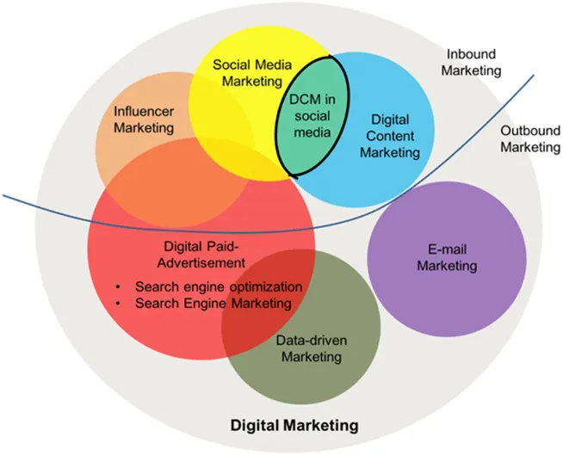

Figure 2.2: Different Digital Marketing Approaches
(Source: Li et al., 2023)
In a similar stance, Nahorna et al., (2023) argued that video marketing is effective enough to increase the rate of conversion, but it is costly to implement in business. Furthermore, Live Chat is a type of marketing approach employed to boost engagement by directly interacting with customers, thereby reaching more consumers and increasing the scope of sales conversion. Furthermore, influencer marketing is an approach that enables the space to reach a larger number of customers by boosting the credibility of the brand, thereby improving the scope for sales conversion (Refer to Figure 2.2). Sunarso and Mustafa (2023) highlighted that the integration of visual storytelling plays a vital factor in engaging customers with the brand and boosting brand credibility, instead of just using it to boost conversion rates.
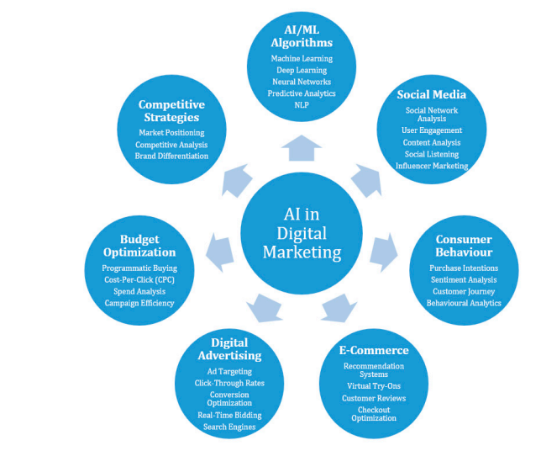

Figure 2.3: AI in Digital Marketing
(Source: Ziakis and Vlachopoulou, 2023)
On the other hand, Santoki et al., (2024) analysed the influence of marketing management in the promotion of educational content. The study discussed the role of innovative marketing strategies, such as predictive analytics and tailoring personalised educational content for the students (Refer to Figure 2.3). However, the study also shed light on the challenges of Artificial Intelligence (AI) driven predictive analytics in marketing. It has been obtained that data privacy concerns associated with the use of AI-driven algorithms are data privacy complexities and limited transparency in the use of AI algorithms. Besides the innovation in marketing strategies, the integration of AI in course development and the latest technologies after the pandemic, such as Zoom and Google Meet, to deliver lectures was new to the teachers. The teachers were not trained to adopt these new technologies in the wake of the sudden lockdown during the surge of the virus in 2020 (Celeste & De Gregorio, 2023). The structural obstacles, such as an old setup for delivering lectures and a lack of funding, also negatively impact the conversion rates for the online educational content.

2.3 Role of digital marketing in influencing the perception of the customers
According to Goyal and Jain (2023) digital marketing strategies drive the customers to engage with the product of the brand. When customers see repeated ads of a brand, this makes them recognise the brand and form the first stage of perception towards the brand. However, excessive advertisements make customers feel irritated and develop negative perceptions towards them. In the above study, it has been found that digital marketing campaigns conducted by startups such as Unacademy, Byju's, and others through YouTube, Facebook and Instagram significantly helped in improving the perception of the customers. On the other hand, Santoki et al., (2024) studied the challenges and innovations in the process of using digital marketing strategies to promote content. It has been determined that the use of predictive analytics offers advantages such as tailoring course content based on individual preferences and needs. However, if the personal data of the customers utilised is not handled properly, it can also erode the trust in the brand in the long term.
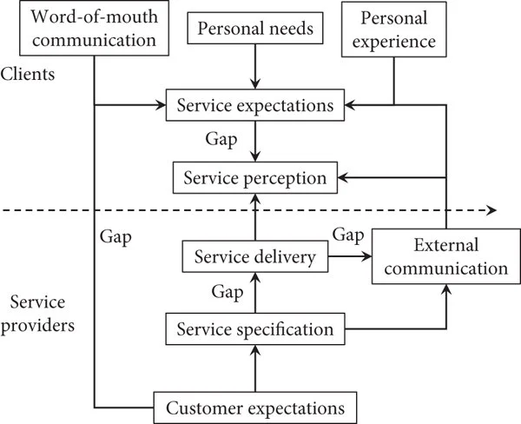

Figure 2.4: Factors influencing perception of customers
(Source: Geng, 2022).
Mukhtar, Mohan and Chandra (2023) examined the influence of digital marketing campaigns on the loyalty and behaviour of the customers. The study found that consumers often perceive less-known brands as less trustworthy and risky. Thus, external factors such as the information on the website and internal factors such as the shopping experience shape the purchase desire of the end users (Refer to Figure 2.4). Content Marketing as a part of a digital marketing approach includes several strategies such as tutorials on product use, positive recommendations, and online information, making the buying journey of the customer more satisfactory. However, some scholars also argued that raising awareness on the product is not adequate to build long-term bonds with the clients. Establishing an emotional bond with the brand was also found to be important to improve brand perception among the customers. The brands that fail to create an emotional bond with shoppers fail to build deeper loyalty that ultimately leads to decreased Customer Lifetime Value (CLV). Hien and Nhu (2022) highlighted that a marketing campaign that has been built using attractive images quickly catches the attention of the customer with the product. Search Engine Advertising serves as an important communication channel between companies and users. Thus, the higher the visibility of the marketing campaign on the search, the greater the scope to get the attention of the customers and gain access to the purchase intention. Another important aspect studied by Yang et al., (2022) is that it is true that digital marketing campaigns have been very valuable in increasing awareness of the brand and driving engagement. Positive online reviews of product features serve as a promotional strategy to reach new customers. However, if digital marketing is not tailored properly, it also leads to creating negative perceptions about the brand and messages are sometimes perceived as misleading and intrusive. Additionally, the digital marketing communication that exaggerates the features of the product but fails to meet the expectations of the users significantly damages the credibility of the brand and reduces the trust of the customers. Thus, from the above, it was implied that a digital marketing campaign significantly influences the perception of the customers by improving visibility of the brand, improving engagement and offering a personalised experience. However, the effectiveness of this strategy depends upon responsible communication, ethical data usage and the ability of the brand to create meaningful connections with shoppers.

2.4 Analysing the consequences of the absence or presence of a digital marketing campaign in edtech firms.
The rapid growth of the edtech industry globally has significantly increased the importance of digital marketing tools for attracting and engaging learners. The academic literature highlighted that the implementation of tools such as social media marketing, Search Engine Optimisation and content marketing plays an essential role in influencing the engagement of students with online learning platforms. In this case, Mialkovska et al., (2025) mentioned that the digital platform allows organisations to significantly communicate with potential learners directly via their personalised messages, targeted advertisement strategies and uploading relevant and interactive content on social media. As per their perspective, the presence of digital marketing channels prompts edtech organisations to develop effective connections with students by serving more effective educational services and learning opportunities. Similarly, Dragseth (2020) evaluated that social media platforms and online communities play an effective role in developing engagement among students, as they allow organisations to share their educational content directly with students.
In comparison, other articles suggested that the presence of only digital marketing tools does not guarantee higher engagement and success. Pascucci, Savelli and Gistri (2023) argued that while digital technologies can support communication in marketing, the effectiveness mainly depends on how effectively they are implemented by the organisation. The author also expressed that poorly designed campaigns by organisations or excessive promotional content implementation can lead to reduced user engagement and result in information overload. This diverse perspective contrasts with the earlier view that highlighted the effectiveness of digital marketing technologies, the importance of effective strategic planning and the quality of content. On the other hand, Makrydakis (2021) concentrated on the absence of digital marketing tools, as others highlighted that organisations that lack the use of digital communication channels may face complications in reaching modern students, specifically younger audiences. As per their research, the absence of tools, including SEO and social media marketing by edtech organisations, can reduce the visibility among learners about the educational platforms, limiting awareness among students and participation as well. The above view argues that digital presence is important for managing more competitive advantages in the online educational environment (Refer to Figure 2.5).
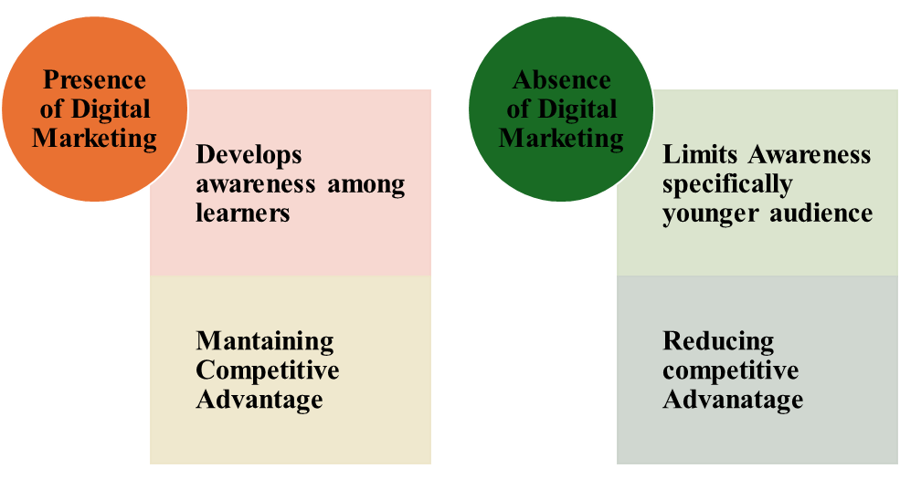

Figure 2.5: Absence or Presence of Digital Marketing
(Source: Author)
Furthermore, Oumaima and Lamari (2024) mentioned that students, when exposed to interactive learning forums such as discussion platforms, webinars, and learning communities. It significantly boosts their perception to engage with the respective edtech brands. Thus, the above perspective highlights the importance of social media in generating attraction-based marketing strategies. Hence, from the secondary literature analysis, it was obtained that some scholars have emphasised the importance of an online marketing plan in increasing awareness. Yet, some scholars have studied that the success of an online marketing plan is influenced by factors such as strategic implementation and overall learning formative experiences.

2.5 Theoretical Underpinning
Relationship Marketing Theory
Relationship Marketing Theory is one concept popular in Customer Relationship Management (CRM) that focuses upon long-term loyalty of the customers and engagement rather than short-term goals such as acquisition of customers and individual sales (Refer to Figure 2.6). The importance of this theoretical concept lies in the fact that it helps sales executives to understand the way organisations work in close contact with the current customers. This theoretical approach also helps organisations to understand the way shoppers use the services and products of the brand. It has been found that organisations use different types of marketing tactics to increase their customer base, such as loyalty programs, gift cards and social media posts. However, the main challenge that hinders the success of the Relationship Marketing Approach includes limited training of the employees, lack of interest of the customers and personalising marketing campaigns based on individual needs of the customers.
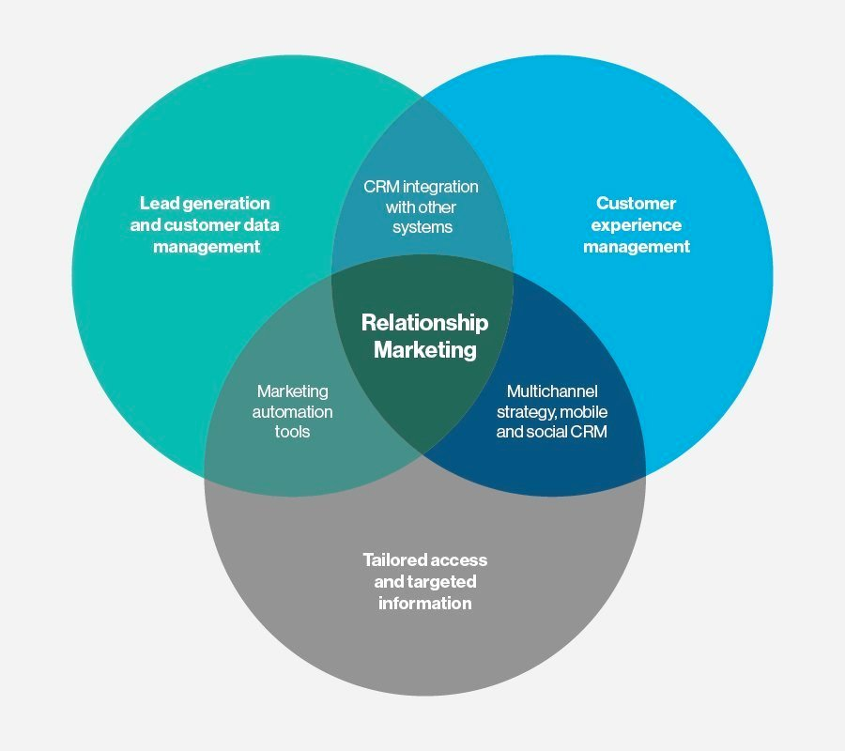

Figure 2.6: Relationship Marketing Theory
(Source: Aberle, 2024)
The application of this theoretical understanding is suitable in the selected research topic as digital marketing strategy edtech companies in India focus upon building strong relationships with their customers. Edtech companies use a number of strategies such as mobile app notifications, personalised apps, customised course recommendations and learning reminders to keep learners engaged. Marketing Campaigns emphasise strengths such as the quality of instructors and the flexibility of online learning to acquire customers. The ongoing communication influences the perception of the customers by reinforcing the usefulness and credibility of the edtech services. The main focus of this research was to investigate the challenges edtech firms face in retaining customers due to changes in their preferences. Through this theoretical understanding, the retention of customers and maintaining long-term participation in the educational program have been emphasised to build long-term relationships with them.
AIDA Model
The main components of this model are, namely, Awareness, Interest, Desire, Action and Retention (Refer to Figure 2.7). This model is widely adopted in the field of marketing to trace the journey of the buyers through the lens of the identified four stages (Hung, Fu and Silalahi, 2025). The Awareness funnel emphasises the way to make marketers aware of their marketing campaign. Interest, which is the second phase of the model, focuses upon building a strong relationship with the customers by sharing necessary information about the products and services. The third stage of the model focuses on examining the key influential factors that motivate customers to shop and make them appear more desirable to them. The fourth stage underscores the importance of actionable strategies that facilitate meaningful communication with the targeted audience (Chahed et al., 2023). The fifth stage is basically a call to action where sales executives strategically put clear action to take for the purchasers through ‘Call to Book’ and ‘Call to Reserve’. In edtech firms, marketing campaigns are usually shared through Instagram, YouTube and Facebook to create awareness among the learners. Demo classes are used to build interest among the customers and give more information about the educational products to the interested buyers. Hall of Fame or Success stories are integrated into the marketing campaign to create motivation among the potential shoppers targeting a similar professional goal in their careers.
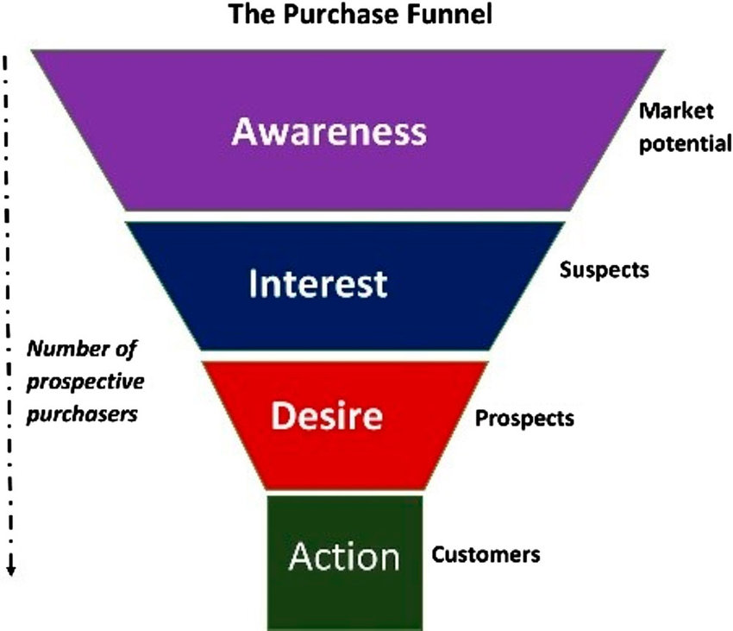

Figure 2.7: AIDA Model
(Source: De Wilde, 2020)
The application of the AIDA framework in the context of the research topic is suitable as it offers a structured framework to understand the behaviour of the shoppers. Edtech platforms use social media platforms to capture the attention of the buyers, maintain interest, share success stories to build desire and offer possible enrolment offers to encourage action. However, the absence of digital tools for the edtech educational firms might break down the process of communication, thereby minimising engagement with the educational products. Thus, through the application of this model in the objectives of the research, it could become easy to demonstrate the way digital marketing campaigns shape the perception of customers, and increase engagement through enrolment opportunities.

2.6 Research Gap
It is important to note from the above literature review that many studies have focused on studying the impact of digital marketing on different sectors such as e-commerce, tourism, retail and general online services. However, the impact of digital marketing in improving the customer conversion rates, specifically in the Indian edtech industry, is under-researched. Furthermore, previous studies have only investigated the different marketing strategies utilised in the edtech industry to raise awareness. Yet, limited studies have been found that have explored the role of different marketing approaches in moving customers from awareness to action. This research is going to fill this void by exploring the recognised gaps and understanding the potential benefit of this marketing approach in driving both customer engagement and conversion. The way marketing campaigns are effective in the edtech sector has a unique characteristic as customers are not only buying a product, but they are investing in knowledge, skill and long-term career development. Thus, by focusing on this sector, the research contributes to new insights into the way marketing communication influences the decision of the learners to engage with online educational platforms.

Chapter 3: Methodology

3.1 Research Onion
The research onion by Saunders is a paradigm that comprises six important layers, such as philosophy, approach to research, data collection method, data analysis, time horizon and research strategy. This particular framework has been utilised to determine the overall research design for the study that could be valuable in answering the research questions and hypothesis (Saunders, Lewis and Thornhill, 2015). This framework technique has been applied in this section to prepare the methodology section for the current study, though with different logical decisions.
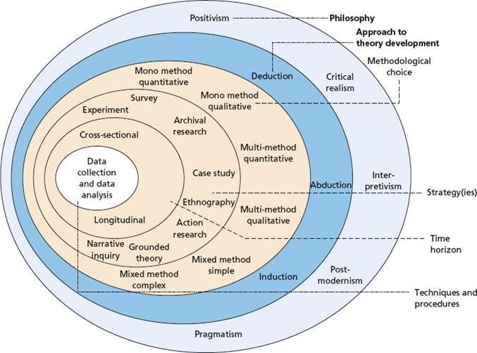

Figure 3.1: Research Onion
(Source: Mbedzi et al., 2020)
This has been advantageous in justifying the data collection approach adopted to understand the role of digital marketing solutions in influencing the purchase decision perception of the customers. However, it is important to note that the research framework has not been helpful with some research traditions, such as participatory research. Instead, the research framework has been more suitable for social science research, offering an in-depth analysis of the research problem (Ikram & Kenayathulla, 2022). Thus, this framework has been proposed to investigate customer retention for edtech companies in India.

3.2 Research Philosophy
It has been obtained that interpretivism research philosophy is accepted in the field of education to analyse multiple perspectives. This is because the scholars using interpretivism research philosophy use this philosophical approach to gain access to shared meanings, consciousness, instruments and language. Furthermore, this method helps gain an understanding of the research problem by investigating the meanings associated with human behaviour (Ikram & Kenayathulla, 2022). Nevertheless, the limitation of this research philosophy is that it does not provide quantifiable results, unlike scientific research contexts.
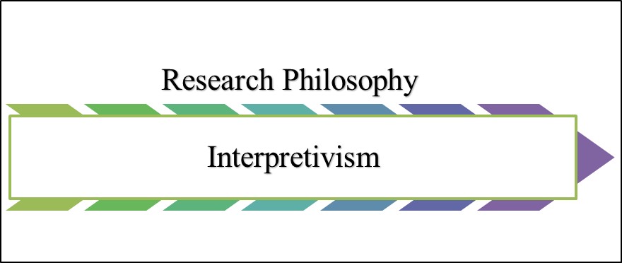

Figure 3.2: Research Philosophy
(Source: Author)
As mentioned by Lyu (2024), interpretivism research philosophy highlights that the interpretive behaviour is actually shaped by expectations, past ideas, and behaviour with ongoing exposure to new ideas. Thus, through an investigation of numerous research works, it has been possible to understand the role of digital marketing in shaping purchase decisions for online courses in Indian edtech firms.

3.3 Research Approach
A deductive reasoning approach has been chosen to test the hypothesis developed for this research work (Hall, Savas-Hall and Shaw, 2023). As stated, the deductive research approach utilises a general idea or theoretical framework to reach a specific conclusion. Based on this, if the starting assumptions for any hypothesis are true, the logic must be correct, and the conclusions must be true. Thus, if the observations collected during the secondary data collection support the assumptions. Specifically, in relation to digital marketing and the success of edtech platforms in acquiring more customers, the conclusions are considered to be true.


Figure 3.3: Research Approach
(Source: Author)
However, it has been obtained that, unlike the inductive research approach, which develops a theory, the deductive research approach tests a theory. In the concerned study, the hypotheses were against the AIDA model to investigate the role of digital marketing campaigns in influencing the behaviour of customers with respect to edtech firms in India.

3.4 Research Design
Exploratory research designs are widely employed to understand the new concepts of the research, exploring ideas and recognising the relationship between variables and relationships. Exploratory research methods are iterative, helping researchers recognise patterns and identify new research questions (Aithal & Aithal, 2024). Furthermore, the benefits of this research method are that it is a flexible and open-ended approach that allows researchers to clearly define a problem when the objective is to collect preliminary insights to analyse the context of the problem.
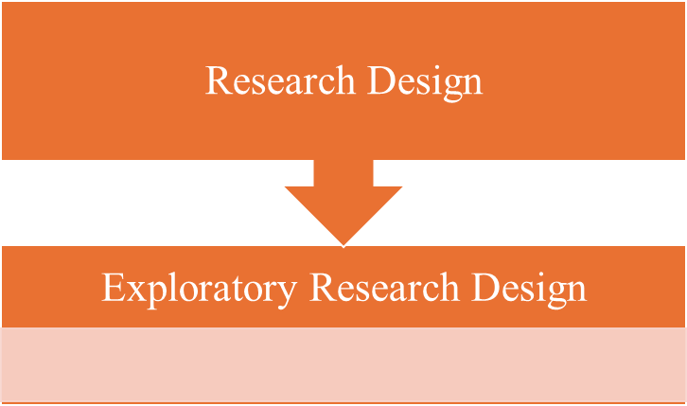

Figure 3.4: Research Design
(Source: Author)
There are several methods to carry out an explanatory research approach, such as pilot studies, literature reviews, and qualitative techniques. Hence, the research has utilised literature review and qualitative techniques to determine the main perception of the Indian customer base and the role of digital marketing techniques in educational purposes.

3.5 Research Strategy
The present study has emphasised a secondary qualitative research strategy to examine the role of digital marketing strategy in influencing the purchase perception behaviour of the customers in edtech firms of India. It has been noted that this research study has been useful for exploring the contexts, dependability, and confirmability of the research (Riazi, Rezvani, and Ghanbar, 2023). The main criteria for assessing the quality of qualitative research findings are detailed explanations, transparency, critical evaluation, and comprehensive research.
Thus, the current study has comprehensively focused upon transparency and criticality by examining other articles of the research work to ensure the quality standards in qualitative research works. It has been argued that qualitative research works play a crucial role by integrating the factors of trustworthiness

3.6 Research Choice
The study has followed a mono-method research choice to express the importance of the absence or presence of digital marketing tools in influencing the engagement level of students in the edtech industry. It has been noted by Ishak et al. (2023) that time and budget constraints are the main reason that leads researchers to consider methods during their data collection procedure. In this approach, data is mainly collected from a single source to obtain a reliable response for the concerned research question. This method is well-suited to a qualitative data collection approach aimed at answering the research question, using secondary articles that highlight the digital marketing role in the development of the edtech industry. However, it has been argued that this method often lacks depth as it involves accumulating information only from one source (Nyakane, 2022). Nevertheless, due to the short time available to conduct this research, this choice was made to analyse the way digital marketing strategy shapes the online course purchase decision among aspiring Indian students.

3.7 Data Collection
The type of data collection commonly preferred in research projects includes qualitative data collection and quantitative data collection (Creswell & Creswell, 2017). The qualitative data collection involves collecting information from data that was already collected by other people to investigate different problems. Unlike quantitative data collection, which involves collecting data from individuals' personal experiences in the interview or survey process. The research has gathered information from secondary sources such as Forbes, BBC, and The Hindu. Furthermore, the journal published since 2020, focusing on the importance of digital marketing to impact the purchase decision of the Indian customers, was considered to conduct this research work. The journals with a proper DOI number and accessible without any paid subscription were utilised to gather relevant information for the research objectives.
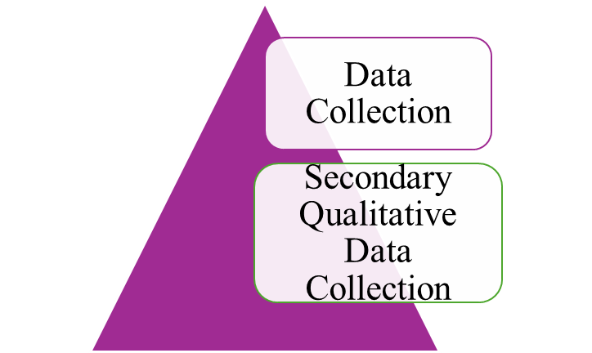

Figure 3.5: Research Design
(Source: Author)
The main advantages of this data collection method are that it does not include collecting data by recruiting participants, similar to the survey method. This, in turn, saves a lot of time as it does not require ethical approval from the research committee, which contributes to faster progression of the research. Furthermore, in the secondary research, as the data is already available, it makes the research work faster, allowing researchers to move directly to the analysis rather than spending time surveying participants.
However, quantitative data collection is a type of reflective expression that allows individuals to express themselves and their experience regarding a particular situation (Williams, Woolliams and Spiro, 2020). The research has only collected information that offers an understanding of the importance of digital marketing for edtech companies in India. The articles focusing on other countries, such as the UK, the US and others were avoided to help policy makers and edtech startups understand the relationship between digital marketing and edtech firms.
A Google Scholar search or online search was conducted using relevant keywords to retrieve articles related to the research topic. For instance, the use of the OR keyword is done to search for articles with synonymous keywords such as digital marketing OR Social media marketing. The use of the AND keyword was done to prioritise both the keywords, such as India and Digital Marketing, to find suitable studies in the context of the research topic. Additionally, the use of the ‘NOT’ keyword was done to find an article with one keyword but excluding the other one. For instance, Social Media Marketing AND politics to exclude articles that were focused on political marketing. This approach in the data collection process was important to reduce bias in the search process and proceed with a systematic manner in the data collection process.

3.8 Data Analysis
Thematic data analysis techniques were utilised to frame themes from the collected data (Anakok et al., 2025). The main steps involved in thematic analysis include familiarisation with data, coding, generating initial themes, developing and reviewing themes, refining themes and writing up the themes. It has been argued by Anakok et al. (2025) that the nature of thematic analysis is iterative and time-consuming, which reduces the intensity of coding and generation of themes. Despite this, the approach is widely followed in the research work to recognise patterns, themes and insights across a diverse range of information (Ahmed et al., 2025). It has been noted that this data analysis process involves certain challenges such as data inconsistencies, difficulty in balancing thematic depth with breadth, reflexivity and transparency.
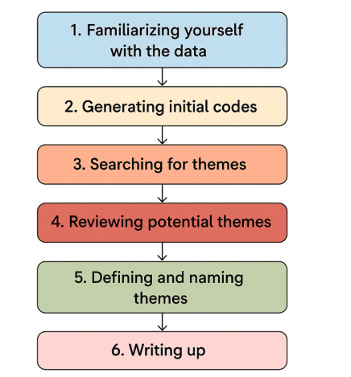

Figure 3.6: Thematic Analysis
(Source: Ahmed et al., 2025)
Nevertheless, the iterative nature of the thematic analysis enables researchers to capture depth and richness in the qualitative data collection process. The cautionary steps that researchers must follow in the thematic analysis process involve balancing clarity and depth while presenting themes, managing word limits and ensuring the engagement of the readers. The application of this analysis method has been advantageous in uncovering important themes related to marketing patterns, such as social media campaigns, influencer marketing, email marketing, and content marketing. This approach has also been advantageous in revealing valuable themes related to the role of identified marketing methods in offering convenience and flexibility. It was important to highlight that the digital marketing approach is mainly dependent upon emotional appeals and persuasive language that might have been helpful in analysing the ways messages were structured and utilised to influence the engagement with the customers. This approach has been justified to gain explanation beyond quantitative metrics, such as click-through rates, in order to obtain rich interpretive insights.

3.9 Inclusion and Exclusion criteria
Inclusion Criteria | Exclusion Criteria
The study has considered only journal articles published in English. | Articles published in a language other than English were excluded.
Examples of Edtech companies operating in India were only considered | Edtech firms operating outside India were not included as case examples.
News articles and journals published since 2020 were analysed | Journals and news articles published before 2020 were excluded.

Table 3.1: Inclusion and Exclusion Criteria

3.10 Research Ethics
The research has adhered strictly to the Digital Personal Data Protection Act, 2023, in India. This act requires that personal data be handled lawfully and only for specific purposes. This is because the act is responsible for regulating the way researchers collect, process and store digital data (Government of India, 2023). Thus, while collecting data from relevant secondary sources, only the necessary data specific to the research purpose was collected. In secondary data collection, data is usually obtained from secondary sources. Even though the research did not utilise any personal data, only credible sources were considered, thereby avoiding reliance on personal data collection to gather information on digital marketing and its impact on customer perceptions. The research has ensured compliance with the above regulations, including when collecting data from secondary sources, to align with current legal and ethical frameworks in India.

3.11 Timeline
Chapter Name | W0 | W1 | W2 | W3 | W4 | W5 | W6 | W7 | W8 | W9 | W10 | W11 | W12
Introduction
Literature Review
Methodology
Data Analysis
Conclusion and Recommendations
Final Submission

Table 3.2: Research TimeLine

Reference List
Aberle, L. (2024). What Is Relationship Marketing? - Definition from WhatIs.com. [online] SearchCustomerExperience. Available at: https://www.techtarget.com/searchcustomerexperience/definition/relationship-marketing [Accessed 6 Mar. 2026].
Ahmed, S.K., Mohammed, R.A., Nashwan, A.J., Ibrahim, R.H., Abdalla, A.Q., Ameen, B.M.M. and Khdhir, R.M., (2025). Using thematic analysis in qualitative research. Journal of Medicine, Surgery, and Public Health, 6, p.100198. DOI: https://doi.org/10.1016/j.glmedi.2025.100198
Aithal, P.S. and Aithal, S., (2024). Redefining experimental, empirical, and exploratory research in AI era. Poornaprajna International Journal of Emerging Technologies (PIJET), 1(1), pp.90-136. DOI: https://doi.org/10.64818/PIJET.3107.8486.0004
Al-Ababneh, H.A., (2020). MODERN TRENDS OF DIGITAL MARKETING DEVELOPMENT IN THE WORLD. PalArch's Journal of Archaeology of Egypt/Egyptology, 17(8). https://www.researchgate.net/publication/348135563_MODERN_TRENDS_OF_DIGITAL_MARKETING_DEVELOPMENT_IN_THE_WORLD
Anakok, I., Katz, A., Chew, K.J. and Matusovich, H., (2025). Leveraging generative text models and natural language processing to perform traditional thematic data analysis. International Journal of Qualitative Methods, 24, p.16094069251338898. DOI: 10.1177/16094069251338898
Baltezarevic, V., (2023). The role of digital marketing in the education sector. Isarc International Science And Art Research, pp.142-49. https://www.researchgate.net/profile/Vesna-Baltezarevic/publication/368984212_THE_ROLE_OF_DIGITAL_MARKETING_IN_THE_EDUCATION_SECTOR/links/64026c5257495059456029fd/THE-ROLE-OF-DIGITAL-MARKETING-IN-THE-EDUCATION-SECTOR.pdf
Bharti, R., Khatri, U. and Duralia, O.A., (2024). Examining the role of digital marketing in shaping consumer communication and behavior. Feedback International Journal of Communication, 1(4), pp.192-201. DOI:10.62569/fijc.v1i4.76
Bhattacharjee, P.K. and Balakrishnan, C., (2025). AN ANALYSIS OF MARKETING STRATEGIES USED BY ED-TECH BUSINESSES TO INCREASE ONLINE SALES AND BRAND VISIBILITY. Lex Localis, 23(10), pp.998-1012. DOI:10.52152/801205
Celeste, E. and De Gregorio, G., (2023). Towards a right to digital education? Constitutional challenges of edtech. J. Intell. Prop. Info. Tech. & Elec. Com. L., 14, p.234. https://ciencia.ucp.pt/ws/files/74581699/74501809.pdf
Chahed, H., Usman, M., Chatterjee, A., Bayram, F., Chaudhary, R., Brunstrom, A., Taheri, J., Ahmed, B.S. and Kassler, A., (2023). AIDA—A holistic AI-driven networking and processing framework for industrial IoT applications. Internet of Things, 22, p.100805. DOI: https://doi.org/10.1016/j.iot.2023.100805
Creswell, J.W. and Creswell, J.D., (2017). Research design: Qualitative, quantitative, and mixed methods approaches. Sage publications.
De Wilde, M., (2020). A care-infused market tale: on (not) maintaining relationships of trust in energy retrofit products. Journal of Cultural Economy, 13(5), pp.561-578. DOI:10.1080/17530350.2020.1741016
Dragseth, M.R., (2020). Building student engagement through social media. Journal of Political Science Education, 16(2), pp.243-256. DOI: https://doi.org/10.1080/15512169.2018.1550421
Du Plooy, E., Casteleijn, D. and Franzsen, D., (2024). Personalized adaptive learning in higher education: A scoping review of key characteristics and impact on academic performance and engagement. Heliyon, 10(21). DOI: https://doi.org/10.1016/j.heliyon.2024.e39630
Gondane, V. and Pawar, M., (2021). A study on Impact of Digital Marketing Strategies on Education Sector with reference to Nagpur, India. Ilkogretim Online, 20(1). DOI: 10.17051/ilkonline.2021.01.283
Government of India (2023). MINISTRY OF LAW AND JUSTICE. [online] Available at: https://www.meity.gov.in/static/uploads/2024/06/2bf1f0e9f04e6fb4f8fef35e82c42aa5.pdf [Accessed 8 Mar. 2026].
Goyal, A. and Jain, B., (2023). Impact of Digital Marketing on Consumer Behavior towards Edtech Startups. International Journal For Multidisciplinary Research, 5(6), pp.0-11. DOI:10.36948/ijfmr.2023.v05i06.8595
Hall, J.R., Savas-Hall, S. and Shaw, E.H., (2023). A deductive approach to a systematic review of entrepreneurship literature. Management Review Quarterly, 73(3), pp.987-1016. DOI: https://doi.org/10.1007/s11301-022-00266-9
Hien, N.N. and Nhu, T.N.H., (2022). The effect of digital marketing transformation trends on consumers’ purchase intention in B2B businesses: The moderating role of brand awareness. Cogent Business & Management, 9(1), p.2105285. DOI:10.1080/23311975.2022.2105285
Hung, C.N., Fu, C.J. and Silalahi, A.D.K., (2025). Integrating dance with the AIDA framework: Advancing sustainable behaviors through dynamic marketing communications for environmental sustainability. Heliyon, 11(10). DOI: https://doi.org/10.1016/j.heliyon.2025.e42958
Ikram, M. and Kenayathulla, H.B., (2022). Out of touch: comparing and contrasting positivism and interpretivism in social science. Asian Journal of Research in Education and Social Sciences, 4(2), pp.39-49. DOI: https://doi.org/10.55057/ajress.2022.4.2.4
Imarcgroup (2026). India Edtech Market Size, Top Companies & Forecast [2032]. [online] www.imarcgroup.com. Available at: https://www.imarcgroup.com/india-edtech-market [Accessed 13 Feb. 2026].
Ishak, N.A., Naqshbandi, M.M. and Islam, M.Z., (2023). Sage Research Methods: Business.DOI: https://doi.org/10.4135/9781529669169
Juhaidi, A., (2024). Social media marketing of Islamic higher education institution in Indonesia: a marketing mix perspective. Cogent Business & Management, 11(1), p.2374864. DOI: 10.1080/23311975.2024.2374864
Lyu, Y., (2024). Shifting research paradigms in educational research: From positivism to interpretivism. Science, Technology and Social Development Proceedings Series, 2, pp.11-4. DOI:10.70088/bmq18v35
Makrydakis, N.S., (2021). The role of digital marketing in public higher education organizations in attracting younger generations. Expert Journal of Marketing, 9(1). https://www.academia.edu/download/108760849/EJM_904makrydakis28-38.pdf
Mbedzi, M.D., van der Poll, H.M. and van der Poll, J.A., (2020). Enhancing a decision-making framework to address environmental impacts of the South African coalmining industry. Energies, 13(18), p.4897. DOI:10.37247/ADERES2EDN.2.2021.14
Mialkovska, L., Zabiiaka, I., Lorvi, I., Visyn, V., Haponchuk, O. and Hubina, А., (2025). Digital Marketing Communications Strategies and Social Media within a Competitive Educational Landscape: Experiences from Europe. OIDA International Journal of Sustainable Development, 18(10), pp.103-114. DOI:10.32996/jbms.2023.5.4.12
Mukhtar, S., Mohan, A.C. and Chandra, D., (2023). Exploring the influence of digital marketing on consumer behavior and loyalty. International Journal of Research-Granthaalayah, 11(9), pp.1-18. DOI: 10.29121/granthaalayah.v11.i9.2023.5308
Nahorna, O., Makohonchuk, N., Chebanova, T. and Havrylets, O., (2023). Using internet marketing to increase website conversion: challenges of effectiveness of different tools and techniques. DOI: http://doi.org/10.32702/2307-2105.2023.5.31
Newton, D. (2025). Students Are Backing Away From Online College. [online] Forbes. Available at: https://www.forbes.com/sites/dereknewton/2025/04/16/students-are-backing-away-from-online-college/ [Accessed 13 Feb. 2026].
Nyakane, T.V., (2022). The strategic plan implementation in the public sector: the case of a provincial government department in the Free State (Doctoral dissertation, University of the Free State).
Oumaima, J. and Lamari, S., (2024). Customer experience in the digital transformation era: Insights on personalization, digital marketing, and customer relationship management. International Journal of Economics, Management and Finance (IJEMF), 3(2), pp.52-69.DOI:10.32996/jbms.2023.5.4.12
Pascucci, F., Savelli, E. and Gistri, G., (2023). How digital technologies reshape marketing: evidence from a qualitative investigation. Italian Journal of Marketing, 2023(1), pp.27-58.DOI:10.1007/s43039-023-00063-6
Purnomo, Y.J., (2023). Digital marketing strategy to increase sales conversion on e-commerce platforms. Journal of Contemporary Administration and Management (ADMAN), 1(2), pp.54-62. DOI: https://doi.org/10.61100/adman.v1i2.23
Riazi, A.M., Rezvani, R. and Ghanbar, H., (2023). Trustworthiness in L2 writing research: A review and analysis of qualitative articles in the Journal of Second Language Writing. Research Methods in Applied Linguistics, 2(3), p.100065. DOI: https://doi.org/10.1016/j.rmal.2023.100065
Rooney, T., Krolikowska, E. and Bruce, H.L., (2021). Rethinking relationship marketing as consumer led and technology driven: propositions for research and practice. Journal of Relationship Marketing, 20(1), pp.42-61. DOI: https://doi.org/10.1080/15332667.2020.1717276
Sampath, L., (2024). Digital marketing metrics and ROI analysis: Evaluating effectiveness and value. Journal of Research in Business and Management, 12(8), pp.64-68. DOI:10.35629/3002-12086468
Santoki, A.A., Pawaskar, S., Painoli, A.K., Rajput, M., Mohanbhai, D.D. and Mishra, M., (2024). Marketing Management in Ed-tech: Innovations and Challenges in Promoting Educational Technologies. Marketing Management, 4(3). DOI:10.52783/jier.v4i3.1679
Saunders, M., Lewis, P. and Thornhill, A., (2015). Research methods for business students (7th New ed). Research methods for business students.
Sethi, S., Saxena, S. and Singh, M., (2023). A nexus of market web traffic and investor's behavior in the EdTech market: evidence of performance from US and India. Benchmarking: An International Journal, 30(9), pp.3150-3167. DOI: https://doi.org/10.1108/BIJ-05-2022-0317
Sharma, S. (2024) Only 26.8% of Indian youth in the academic age group have internet browsing skills: Can this impact quality education? - Times of India, The Times of India. Available at: https://timesofindia.indiatimes.com/education/news/only-26-8-of-indian-youth-in-the-academic-age-group-have-internet-browsing-skills-can-this-impact-quality-education/articleshow/114280250.cms [Accessed 13 Feb. 2026].
Shen, X. and Liu, J., (2022). Analysis of factors affecting user willingness to use virtual online education platforms. International Journal of Emerging Technologies in Learning (iJET), 17(1), pp.74-89. DOI:10.3991/ijet.v17i01.28713
Sunarso, B. and Mustafa, F., (2023). Analysing the role of visual content in increasing attraction and conversion in MSME digital marketing. Journal of Contemporary Administration and Management (ADMAN), 1(3), pp.193-200. DOI: https://doi.org/10.61100/adman.v1i3.79
Tseng, H.T., (2023). Shaping path of trust: the role of information credibility, social support, information sharing and perceived privacy risk in social commerce. Information Technology & People, 36(2), pp.683-700. DOI:10.1108/ITP-07-2021-0564
Vieira, V.A., de Almeida, M.I.S., Agnihotri, R., da Silva, N.S.D.A.C. and Arunachalam, S., (2019). In pursuit of an effective B2B digital marketing strategy in an emerging market. Journal of the Academy of Marketing Science, 47(6), pp.1085-1108. DOI: https://doi.org/10.1007/s11747-019-00687-1
Williams, K., Woolliams, M. and Spiro, J., (2020). Reflective writing. Bloomsbury Publishing.
Williamson, B. and Hogan, A., (2021). Pandemic privatisation in higher education: Edtech and university reform. https://eprints.qut.edu.au/216578/1/76301373.pdf
Yang, Q., Hayat, N., Al Mamun, A., Makhbul, Z.K.M. and Zainol, N.R., (2022). Sustainable customer retention through social media marketing activities using hybrid SEM-neural network approach. Plos one, 17(3), p.e0264899. DOI: https://doi.org/10.1371/journal.pone.0264899
Zairul, M., (2025). Mastering thematic analysis: A step-by-step guide for beginners with tips for systematic analysis using ATLAS. ti 25. International Journal of Qualitative Methods, 24, p.16094069251384401. DOI: https://doi.org/10.1177/16094069251384401
Zou, Y., Kuek, F., Feng, W. and Cheng, X., (2025). Digital learning in the 21st century: Trends, challenges, and innovations in technology integration. Frontiers in Education, 10, 1562391. DOI: https://doi.org/10.3389/feduc.2025.1562391

