MEM23004A Apply technical mathematics
Assessment 2 – Skill Test

Font style: Times New Roman, size 11 or Century Gothic, size 10
Text: Black text with no background colours.

Practical demonstration (Assessment 2)
Below is a copy of the instructions given to the learner. These instructions must be verbalised and/or explained to the learner in a manner that they can understand. In order to ensure a fair assessment, you need to confirm that the learner understands how they will be assessed and what they are being assessed against.
If you do not feel confident in your skills and knowledge and are not yet ready to attempt the final practical assessment for this course, please discuss further training opportunities with your Trainer/Assessor BEFORE continuing.
You are working as a civil engineering draftsperson for Junction Glen Civil Design (JGCD) – a small engineering consultancy. JGCD are currently working on a local subdivision project, Riverview Estate. As part of your role, you are required to complete technical calculations based on the design specifications for a standard stormwater drainage pit.
You are working as a civil engineering draftsperson for Junction Glen Civil Design (JGCD) – a small engineering consultancy. Your role involves supporting technical design and documentation for subdivision and infrastructure projects. The current major project is Riverview Estate, a staged mixed-use subdivision. As part of your duties, you are required to complete mathematical calculations to support the design and construction documentation of a reinforced concrete stormwater drainage pit.
This task is in five sections:
- Section 1 – Technical calculations based on original design.
- Section 2 – Calculations based on modified design.
- Section 3 – Interpret technical data.
- Section 4 – Additional problems.
- Section 5 – Reflections.
In this task, you are expected to demonstrate professional mathematical communication in line with JGCD’s communication standards (read the Communications Policy and Procedure in the Appendix). This includes:
- Manually performing all required calculations using formulas and appropriate mathematical techniques – you may use handwritten working or a scientific calculator

- Laying out your work clearly and logically, so it can be easily followed and checked. Your working should include:
  - a clear heading (for example, Pit – external dimensions)
  - a brief problem statement in your own words
  - all known values with correct units
  - the equation or method you are using
  - all calculation steps shown in order
  - the final result underlined or boxed, with correct units
  - a short conclusion or explanation if relevant

- Using industry-standard software (where specified) to generate graphs or solve equations
- Validating software results by comparing them to your manual calculations
- Including screenshots of any software outputs in your submission.

Section 1 | Technical calculations based on original design  - Calculate the external dimensions  The internal dimensions of the pit are 900 mm (L) × 900 mm (W) × 1200 mm (D).  The wall thickness is 150 mm.  What are the external dimensions (length, width, depth) of the pit including walls?  - Pit – internal area with tolerances (binomial and polynomial expression)  Junction Glen Civil Design uses standard tolerances to allow for site variation.  If the internal length and width may increase by up to x and y metres respectively during construction, write a binomial expression to show the possible maximum area of the internal pit base. Then expand and simplify it to form a polynomial.  - Calculate the volume of concrete required for the walls and base slab  Assume the pit is hollow inside (open volume) and you are calculating just the material volume for the structure.  Calculate the total volume of reinforced concrete (in cubic metres) needed to construct the walls and base slab of the pit.  - Calculate the mass of the pit  Use a standard density of reinforced concrete = 2400 kg/m³.  Calculate the mass (in kilograms) of the stormwater drainage pit based on your calculated volume.  - Calculate the surface area of the external faces  Ignore the bottom base. Calculate the total surface area of the four walls and the top cover slab only.  What is the total external surface area (in square metres) of the walls and cover slab?
Section 2 | Calculations based on modified design  After review, the council requested the following design modifications:  - Increase the grated opening size from 600 mm × 300 mm to 700 mm × 400 mm.  - Lower the outlet pipe by 50 mm.  - Add a second inlet pipe on the rear wall.  - Calculate the change in cover slab surface area  The original opening was 600 mm × 300 mm. The new opening is 700 mm × 400 mm.  - How much has the open area increased (in mm² and m²)?  - What is the new net surface area of the cover slab (original slab area minus new opening)?  - Calculate the adjusted mass of the cover slab  Assume the cover slab is a solid 150 mm thick concrete slab with an opening.  Based on the new opening size, calculate the revised mass of the cover slab (in kilograms).
Section 3 | Interpret technical data  - Unit conversions  Your manager needs all measurements recorded in metres (m) and cubic metres (m³).  Convert the following dimensions from millimetres to metres:  - 900 mm  - 1200 mm  - 375 mm  - Material quantities for ordering  Concrete is delivered in batches of 0.5 m³.  How many batches of concrete would be required to pour one drainage pit (based on your earlier volume calculation)?  (Always round up to the nearest whole batch.)
Section 4 | Additional problems  In this section you are expected to show clear working and use appropriate software.  - Trigonometry – Pipe slope calculation  A new stormwater pipe must be installed at a 1 in 20 grade (slope).  If the horizontal run is 12 m, what is the vertical drop (height)? Use trigonometry to solve.  - Probability – Concrete defect risk  Past project records show that 1 in every 8 stormwater pits poured has a minor surface defect that requires patching.  The site team is pouring 4 pits today.  - What is the probability that none of the pits will have a defect?  - What is the probability that at least one pit will need patching?  - Binary and hexadecimal conversion  Your drafting software logs error codes in hexadecimal format. You receive the code 3F.  - Convert 3F from hexadecimal to binary.  - Convert it to decimal.  - 2D vector – Pipe support tension analysis  A drainage pipe is supported by two angled cables. One cable pulls with a force of (4, –2) kN, and the other with a force of (–1, 3) kN.  - Calculate the resultant force vector.  - Determine the magnitude of the resultant force.  - Briefly explain what the result means in terms of the direction and strength of the combined pull.  Show all working and use software to graph the vectors and verify the resultant.  Attach a screenshot of your vector diagram to your workbook.  - Complex numbers – Vibration response  A retaining wall design is evaluated for vibration response using complex numbers. The result is:  z = 5 + 2i  - Identify the real and imaginary components.  - Find the modulus (|z|).  - What does the modulus represent in this context?  - Sequences – Pipe segment increments  Stormwater pipe is to be laid in equal 3.2 m sections along a street.  • What is the total length after placing:  o 5 segments  o 10 segments  • Write a general formula for total length after n segments.  - Graph – Volume versus pit height  Using software of your choice, create a simple graph showing how the volume of a pit increases with depth.  • Assume a fixed base of 1.2 m × 1.2 m.  • Plot depths from 0.5 m to 2.0 m in 0.25 m increments.  • Calculate volume for each depth.  • Validate the software output.  Attach a screenshot of the graph to your workbook.  - Exponential decay – Pump efficiency  A site pump loses efficiency exponentially as silt builds up. Efficiency E is modelled by:  E = 100 × e^(–0.2t)  where t = hours of operation  - Manually calculate the efficiency after 5 hours.  - Manually calculate the efficiency after 10 hours.  Use software to plot E versus t on a graph.  Validate the software output.  Attach a screenshot of the graph to your workbook.  - Logarithmic function – sound pressure  An engineer supplies data for sound pressure levels in dB using the formula:  L = 10 log₁₀(P / P₀)  Where L is sound level, P is pressure, and P₀ is the reference pressure.  Use software to create a graph showing how sound level L (in dB) changes as pressure P increases from 0.0001 to 1.0 (in logarithmic steps).  - Plot L vs P using the equation above  - Label axes and describe the shape of the curve  - Validate the software output.  - Explain how this information might be used in documentation for a civil project near a roadway or construction zone.  Attach a screenshot of the graph to your workbook.  - Trigonometric function – pipe gradient visualisation  A stormwater pipe follows a sinusoidal profile due to terrain variation. The vertical height h of the pipe at any point x is given by:  h(x) = 0.5 sin(πx / 6)  • Plot h(x) from x = 0 to x = 12 using software  • Clearly label the x-axis (horizontal distance in metres) and y-axis (height in metres)  Attach a screenshot of the graph to your workbook.  - Matrix – Simultaneous equations  You are calculating unknown pressures in a two-point drainage system.  Equations:  P₁ + 2P₂ = 16  3P₁ – P₂ = 5  Represent the system as a matrix and solve using appropriate software.  Validate the software output.  Attach a screenshot of the solution to your workbook.
Section 5 | Reflection  - Explain how you laid out your equations and why you selected those specific approaches.  - Explain the process you used for checking your solutions and validating software output.  - Explain how you decided which mathematical technique or function to use for each problem.  - Which software did you use for this assessment task? Explain why you chose it.  - How might the mathematical techniques you used in this assessment be applied in a civil engineering drafting role?

Section 1 - Comprehensive Report
- Calculate the external dimensions
The internal dimensions of the pit are 900 mm (L) × 900 mm (W) × 1200 mm (D).
The wall thickness is 150 mm.
What are the external dimensions (length, width, depth) of the pit including walls?
The walls are on both sides of length and width, so add twice the wall thickness to internal length and width. For depth we include the wall thickness at the top (so external depth = internal depth + wall thickness).
- External length = internal length + 2 × wall thickness
= 900 mm + 2 × 150 mm
= 900 mm + 300 mm
= 1,200 mm
- External width = internal width + 2 × wall thickness
= 900 mm + 300 mm
= 1,200 mm
- External depth = internal depth + wall thickness
= 1,200 mm + 150 mm
= 1,350 mm
Answer (external dimensions): 1,200 mm (L) × 1,200 mm (W) × 1,350 mm (D).

- Pit – internal area with tolerances (binomial and polynomial expression)
Junction Glen Civil Design uses standard tolerances to allow for site variation.
If the internal length and width may increase by up to x and y metres respectively during construction, write a binomial expression to show the possible maximum area of the internal pit base. Then expand and simplify it to form a polynomial.
Let the original internal length = 0.9 m and width = 0.9 m. If they can increase by up to $\text{x}$and $\text{y}$metres respectively, the maximum base area is the product of the (increased) length and width:
$$\boxed{\text{(0.9+}\text{x}\text{) (0.9+}\text{y}\text{)}}$$
Expand to a polynomial (showing steps).
$$\text{(0.9+}\text{x}\text{)(0.9+}\text{y}\text{)=0.9×0.9 +} \text{0.9}\text{y} \text{+} \text{0.9}\text{x} \text{+} \text{xy} \\ \text{=0.81 +} \text{0.9}\text{x} \text{+} \text{0.9}\text{y} \text{+} \text{xy}$$
Final polynomial (square metres):
$$\boxed{{\text{A}}_{\text{max}}\text{=0.81+0.9}\text{x}\text{+0.9}\text{y}\text{+}\text{xy}{\text{(}\text{m}}^{\text{2}}\text{), }\text{where} \text{x}\text{,}\text{y}\text{ in metres}}$$
Interpretation:
- $\text{0.81}$is the original base area (0.9 m × 0.9 m).
- $\text{0.9}\text{x}$and $\text{0.9}\text{y}$are the additional area contributed when one side increases while the other stays at 0.9 m.
- $\text{xy}$is the extra area created when both dimensions increase together (the interaction term).

- Calculate the volume of concrete required for the walls and base slab
Assume the pit is hollow inside (open volume) and you are calculating just the material volume for the structure.
Calculate the total volume of reinforced concrete (in cubic metres) needed to construct the walls and base slab of the pit.
We assume the pit is a hollow rectangular prism. The volume of concrete needed = external volume (outer prism) − internal void volume (inner prism).
Work in millimetres then convert to cubic metres.
External volume (mm³) = external length × external width × external depth
= 1,200 mm × 1,200 mm × 1,350 mm
Step-by-step multiplication:
- 1,200 × 1,200 = 1,440,000
- 1,440,000 × 1,350 = 1,440,000 × (1000 + 300 + 50)
= 1,440,000,000 + 432,000,000 + 72,000,000
= 1,944,000,000 mm³
Internal (void) volume (mm³) = internal length × internal width × internal depth
= 900 mm × 900 mm × 1,200 mm
Step-by-step:
- 900 × 900 = 810,000
- 810,000 × 1,200 = 810,000 × (1000 + 200)
= 810,000,000 + 162,000,000
= 972,000,000 mm³
Concrete volume (mm³) = external volume − internal volume
= 1,944,000,000 − 972,000,000
= 972,000,000 mm³
Convert to cubic metres. 1 m3=1000^3=1,000,000,000 mm3
So volume in m³ = 972,000,000÷1,000,000,000=0.972 m3
Answer (material volume): 0.972 m³ of reinforced concrete.

- Calculate the mass of the pit
Use a standard density of reinforced concrete = 2400 kg/m³.
Calculate the mass (in kilograms) of the stormwater drainage pit based on your calculated volume.
Mass =volume×density
- Volume = 0.972 m³
- Density = 2,400 kg/m³
Mass =0.972×2400 kg
Compute step-by-step:
- 0.972 × 2400 = 0.972 × (2000 + 400)
= 0.972×2000 + 0.972×400
= 1,944 + 388.8
= 2,332.8 kg
Round as appropriate (e.g., to 2,333 kg if required).
Answer (mass): 2,332.8 kg (approx. 2,333 kg).

- Calculate the surface area of the external faces
Ignore the bottom base. Calculate the total surface area of the four walls and the top cover slab only.
What is the total external surface area (in square metres) of the walls and cover slab?
We will calculate areas in mm² and convert to m².

Four external walls
Each wall has height = external depth = 1,350 mm.
There are two walls of dimension (external length × external depth) and two walls of (external width × external depth). Since external length = external width = 1,200 mm, each wall area is the same.
Area of one wall = 1,200 mm × 1,350 mm = 1,620,000 mm².
Total for four walls = 4 × 1,620,000 = 6,480,000 mm².

Top cover slab area
Top slab area = external length × external width = 1,200 mm × 1,200 mm = 1,440,000 mm².

Total area (walls + top)
Total mm² = 6,480,000 + 1,440,000 = 7,920,000 mm²
Convert to m²: divide by 1,000,000 (since 1 m² = 1,000 mm × 1,000 mm = 1,000,000 mm²):
Total area = 7,920,000 ÷ 1,000,000 = 7.92 m²
Answer (total external surface area of the four walls + top slab): 7.92 m²

Section 2 - Calculations based on modified design
- Calculate the change in cover slab surface area
The original opening was 600 mm × 300 mm. The new opening is 700 mm × 400 mm.
- How much has the open area increased (in mm² and m²)?
- What is the new net surface area of the cover slab (original slab area minus new opening)?
Step 1- Original opening area
Original opening = 600 mm × 300 mm
= 180,000 mm².
In m²: 180,000 ÷ 1,000,000 = 0.18 m².
Step 2- New opening area
New opening = 700 mm × 400 mm
= 280,000 mm².
In m²: 280,000 ÷ 1,000,000 = 0.28 m².
Step 3 - Increase in open area
Increase = new opening − original opening
= 280,000 mm² − 180,000 mm² = 100,000 mm²
In m²: 0.28 − 0.18 = 0.10 m²
Answer (increase in open area): 100,000 mm² = 0.10 m²
Step 4- New net surface area of the cover slab (original slab area minus new opening)
Original slab area = 1,440,000 mm² (1.44 m²)
Net area = original slab area − new opening area
= 1,440,000 mm² − 280,000 mm² = 1,160,000 mm²
In m²: 1.44 − 0.28 = 1.16 m²
Answer (new net cover slab area): 1,160,000 mm² = 1.16 m²

- Calculate the adjusted mass of the cover slab
Assume the cover slab is a solid 150 mm thick concrete slab with an opening.
Based on the new opening size, calculate the revised mass of the cover slab (in kilograms).
Step 1- Convert thickness to metres
Thickness = 150 mm = 0.150 m
Step 2 - Net slab area in m² (from 2a)
Net area = 1.16 m²
Step 3 - Volume of slab concrete
Volume = area × thickness
= 1.16 m² × 0.150 m
= 0.174 m³
Step 4 - Mass using density (ρ = 2,400 kg/m³)
Mass = volume × density
= 0.174 m³ × 2,400 kg/m³
= 417.6 kg
Round as required (to nearest whole kg): 418 kg
Answer (adjusted mass of cover slab): 417.6 kg (≈ 418 kg)

Section 3 - Interpret technical data
- Unit conversions
Your manager needs all measurements recorded in metres (m) and cubic metres (m³).
Convert the following dimensions from millimetres to metres:
- 900 mm
- 1200 mm
- 375 mm
- 900 mm = 0.900 m
- 1,200 mm = 1.200 m
- 375 mm = 0.375 m
(Conversion: divide mm by 1000.)

- Material quantities for ordering
Concrete is delivered in batches of 0.5 m³.
How many batches of concrete would be required to pour one drainage pit (based on your earlier volume calculation)?
(Always round up to the nearest whole batch.)
Given: concrete delivered in batches of 0.5 m³.
From Section 1c we calculated the concrete volume required for walls + base = 0.972 m³.
Number of 0.5 m³ batches required = required volume ÷ batch size
= 0.972 m³ ÷ 0.5 m³ = 1.944
Always round up to nearest whole batch -> 2 batches required.
Answer: 2 batches (0.5 m³ each), total ordered volume = 2 × 0.5 = 1.0 m³ (this includes a small allowance above the 0.972 m³ needed).

Section 4 –Additional problems
- Trigonometry – Pipe slope calculation
A new stormwater pipe must be installed at a 1 in 20 grade (slope).
If the horizontal run is 12 m, what is the vertical drop (height)? Use trigonometry to solve.
a) Trigonometry - Pipe slope (1 in 20)
Given: slope = 1 in 20 (i.e. vertical : horizontal = 1 : 20)
Horizontal run = 12 m.
Vertical drop (height) = horizontal run × (rise/run ratio)
$$\text{vertical} \text{drop}\text{=12×}\frac{\text{1}}{\text{20}}\text{=12×0.05=0.6 }\text{m}$$
Answer: 0.6 m (vertical drop)

- Probability – Concrete defect risk
Past project records show that 1 in every 8 stormwater pits poured has a minor surface defect that requires patching.
The site team is pouring 4 pits today.
- What is the probability that none of the pits will have a defect?
- What is the probability that at least one pit will need patching?
Given: probability a single pit needs patching $\text{p}\text{=}\frac{\text{1}}{\text{8}}\text{=0.125}$.
Number of pits poured = 4.
(i) Probability none have a defect = probability each is defect-free $\text{(1-}\text{p}\text{)}$raised to the 4th power:
$$\text{(1-}\text{p}{\text{)}}^{\text{4}}\text{=}{\text{(}\frac{\text{7}}{\text{8}}\text{)}}^{\text{4}}\text{=}{\text{0.875}}^{\text{4}}\text{≈0.586181640625}$$
≈ 0.5862 (58.62%)
(ii) Probability at least one needs patching = $\text{1-}$probability none have a defect:
$$\text{1-(1-}\text{p}{\text{)}}^{\text{4}}\text{=1-0.586181640625≈0.413818359375}$$
≈ 0.4138 (41.38%)
Answers:
- None defective: ~0.5862 (58.62%)
- At least one defective: ~0.4138 (41.38%)

- Binary and hexadecimal conversion
Your drafting software logs error codes in hexadecimal format. You receive the code 3F.
- Convert 3F from hexadecimal to binary.
- Convert it to decimal.
You received the hex code 3F.
(i) Hex -> binary
Hex digits: 3 and F
- 3 → 0011 (4-bit)
- F → 1111 (4-bit)
So 3F (hex) = 0011 1111 (binary). You can also write without leading zeros as 111111 (binary) if you don’t need 8-bit grouping.
(ii) Hex -> decimal
Convert 3F: $\text{3×}{\text{16}}^{\text{1}}\text{+}\text{F}\text{×}{\text{16}}^{\text{0}}\text{=3×16+15×1=48+15=63.}$
Answers:
- Binary: 00111111 (or 111111)
- Decimal: 63

- 2D vector – Pipe support tension analysis
A drainage pipe is supported by two angled cables. One cable pulls with a force of (4, –2) kN, and the other with a force of (–1, 3) kN.
- Calculate the resultant force vector.
- Determine the magnitude of the resultant force.
- Briefly explain what the result means in terms of the direction and strength of the combined pull.
Show all working and use software to graph the vectors and verify the resultant.
Attach a screenshot of your vector diagram to your workbook.
Given vectors (units kN):
$$\text{A}\text{=(4, -2)} \text{kN} \\ \text{B}\text{=(-1, 3)} \text{kN}$$
(i) Resultant force vector $\text{R}\text{=}\text{A}\text{+}\text{B}$
$$\text{R}\text{=}\left(\text{4+}\left(\text{-}\text{1}\right)\text{, -2+3}\right)\text{=}\left(\text{3,1}\right)\text{kN}$$
(ii) Magnitude of resultant
$$\text{∥}\text{R}\text{∥}\text{=}\sqrt{{\text{3}}^{\text{2}}\text{+}{\text{1}}^{\text{2}}}\text{=}\sqrt{\text{9+1}}\text{=}\sqrt{\text{10}}\text{≈3.1623 }\text{kN}$$
(iii) Direction of resultant (angle from +x axis)
$$\text{θ}\text{=}\text{arctan}\text{⁡ ⁣}\text{(}\frac{\text{1}}{\text{3}}\text{)≈}{\text{18.4349}}^{\text{∘}}$$
So the resultant points 18.43° above the positive x-axis (i.e. slightly upward from the +x direction).
Interpretation (short): The two cables combine to produce a net pull of about 3.16 kN in the direction 18.4° above the x-axis. Because the x-component is positive (3 kN) and the y-component is positive (1 kN), the combined pull is forward/right and slightly upward, the support must resist about 3.16 kN in that direction.

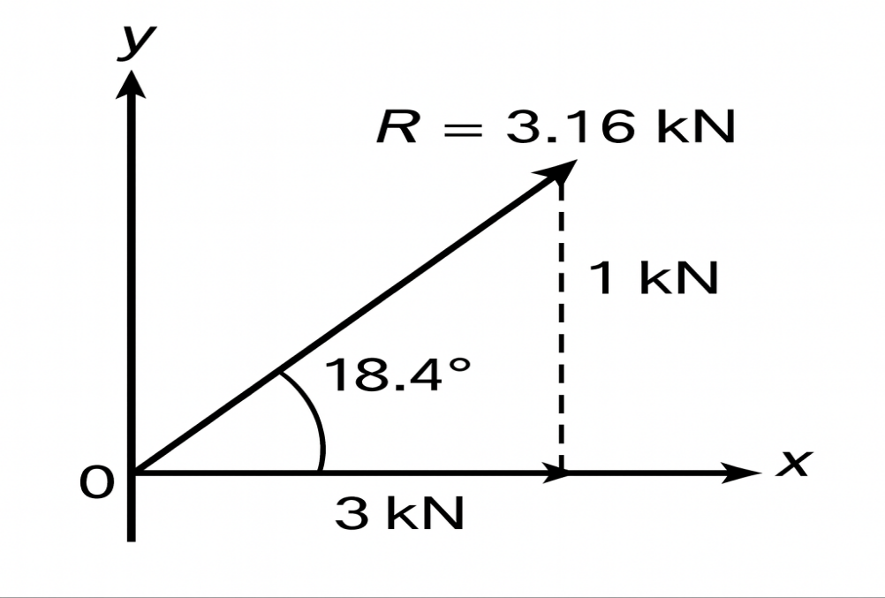
- Complex numbers – Vibration response
A retaining wall design is evaluated for vibration response using complex numbers. The result is:
z = 5 + 2i
- Identify the real and imaginary components.
- Find the modulus (|z|).
- What does the modulus represent in this context?
Given: $\text{z}\text{=5+2}\text{i}$
- Real component: $\text{R}\text{(}\text{z}\text{)=5}$
- Imaginary component: $\text{I}\text{(}\text{z}\text{)=2}$
- Modulus (magnitude):
$$\text{∣}\text{z}\text{∣}\text{=}\sqrt{{\text{5}}^{\text{2}}\text{+}{\text{2}}^{\text{2}}}\text{=}\sqrt{\text{25+4}}\text{=}\sqrt{\text{29}}\text{≈5.385164807}$$
So $\text{∣}\text{z}\text{∣}\text{≈5.385}$.
- What the modulus represents (in this context):
The modulus is the overall amplitude or magnitude of the vibration response. It gives the combined size of the real (in-phase) and imaginary (quadrature) components , effectively the total vibration magnitude regardless of phase.

- Sequences – Pipe segment increments
Stormwater pipe is to be laid in equal 3.2 m sections along a street.
- What is the total length after placing:
  - 5 segments
  - 10 segments
- Write a general formula for total length after n segments.
Each segment = 3.2 m.
- Total length after 5 segments: $\text{5×3.2=16.0 }\text{m}$
- Total length after 10 segments: $\text{10×3.2=32.0 }\text{m}$
- General formula (after $\text{n}$segments):
$$\text{L}\text{(}\text{n}\text{)=3.2 }\text{n}\text{ metres}$$

- Graph – Volume versus pit height
Using software of your choice, create a simple graph showing how the volume of a pit increases with depth.
- Assume a fixed base of 1.2 m × 1.2 m.
- Plot depths from 0.5 m to 2.0 m in 0.25 m increments.
- Calculate volume for each depth.
- Validate the software output.
Attach a screenshot of the graph to your workbook.
Base area $A=1.2×1.2=1.44 {\text{m}}^{2}$.
Depths: 0.50, 0.75, 1.00, 1.25, 1.50, 1.75, 2.00 m (increments 0.25 m).
Calculate volume $V=A×\text{depth}$:
Depth (m) | Volume (m³) = 1.44 × depth
0.50 | 0.72
0.75 | 1.08
1.00 | 1.44
1.25 | 1.80
1.50 | 2.16
1.75 | 2.52
2.00 | 2.88

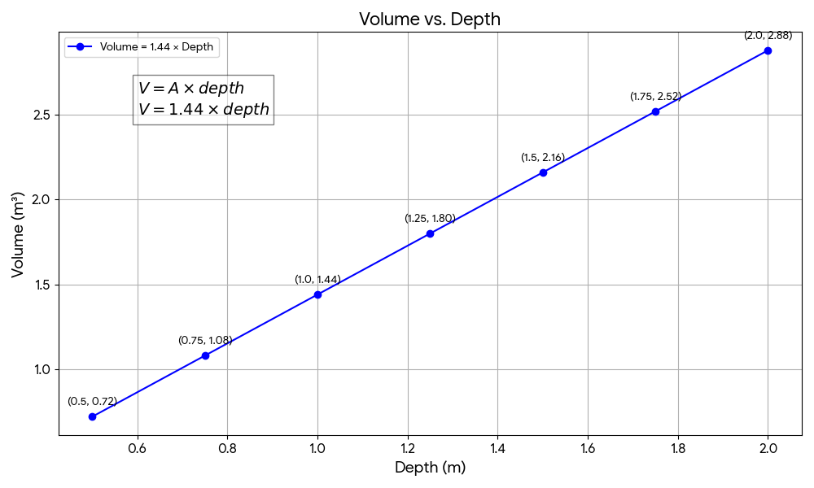
- Exponential decay – Pump efficiency
A site pump loses efficiency exponentially as silt builds up. Efficiency E is modelled by:
E = 100 × e^(–0.2t)
where t = hours of operation
- Manually calculate the efficiency after 5 hours.
- Manually calculate the efficiency after 10 hours.
Use software to plot E versus t on a graph.
Validate the software output.
Attach a screenshot of the graph to your workbook.
Model: $\text{E}\text{(}\text{t}\text{)=100×}{\text{e}}^{\text{-}\text{0.2}\text{t}}$, $\text{t}$in hours, $\text{E}$in %.
- At $\text{t}\text{=5}$hours:
$$\text{E}\text{(5)=100}{\text{e}}^{\text{-}\text{0.2×5}}\text{=100}{\text{e}}^{\text{-}\text{1}}\text{≈100×0.3678794412=36.7879}\text{\%}$$
So $\text{E}\text{(}\text{5)≈36.79}\text{\%}$.
- At $\text{t}\text{=10}$hours:
$$\text{E}\text{(10)=100}{\text{e}}^{\text{-}\text{2}}\text{≈100×0.1353352832=13.5335}\text{\%}$$
So $\text{E}\text{(}\text{10)≈13.53}\text{\%}$.

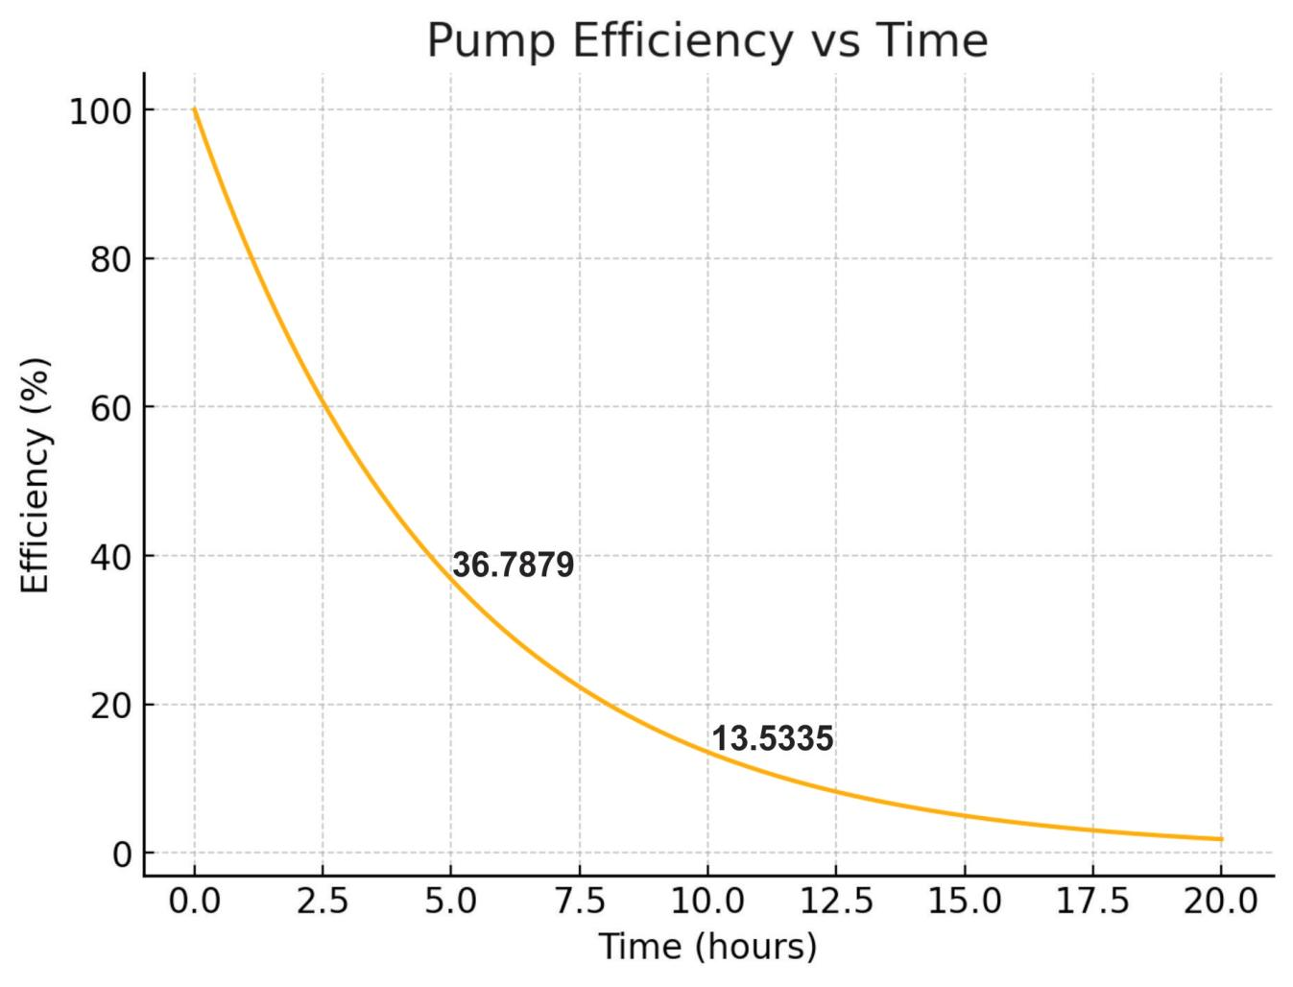
- Logarithmic function – sound pressure
An engineer supplies data for sound pressure levels in dB using the formula:
L = 10 log₁₀(P / P₀)
Where L is sound level, P is pressure, and P₀ is the reference pressure.
Use software to create a graph showing how sound level L (in dB) changes as pressure P increases from 0.0001 to 1.0 (in logarithmic steps).
- Plot L vs P using the equation above
- Label axes and describe the shape of the curve
- Validate the software output.
- Explain how this information might be used in documentation for a civil project near a roadway or construction zone.
Attach a screenshot of the graph to your workbook.
Formula given: $\text{L}\text{=10}{\text{log}\text{⁡}}_{\text{10}} \text{⁣}\text{(}\frac{\text{P}}{{\text{P}}_{\text{0}}}\text{)}$where ${\text{P}}_{\text{0}}$is the reference pressure.
Note: the standard acoustic reference ${\text{P}}_{\text{0}}$is $\text{2.0×}{\text{10}}^{\text{-}\text{5}} \text{Pa}$(20 μPa). I’ll use that unless your brief specifies a different ${\text{P}}_{\text{0}}$.
Compute two example points (use these in the graph):
- For $\text{P}\text{=0.0001 }\text{Pa}$:
$$\frac{\text{P}}{{\text{P}}_{\text{0}}}\text{=}\frac{\text{0.0001}}{\text{2×}{\text{10}}^{\text{-}\text{5}}}\text{=5} \\ \text{L}\text{=10}{\text{log}\text{⁡}}_{\text{10}}\text{(5)≈10×0.69897=6.99 }\text{dB}$$
- For $\text{P}\text{=1.0 }\text{Pa}$:
$$\frac{\text{P}}{{\text{P}}_{\text{0}}}\text{=}\frac{\text{1}}{\text{2×}{\text{10}}^{\text{-}\text{5}}}\text{=}\text{50,000} \\ \text{L}\text{=10}{\text{log}\text{⁡}}_{\text{10}}\text{(50000)≈10×4.69897=46.99 }\text{dB}$$

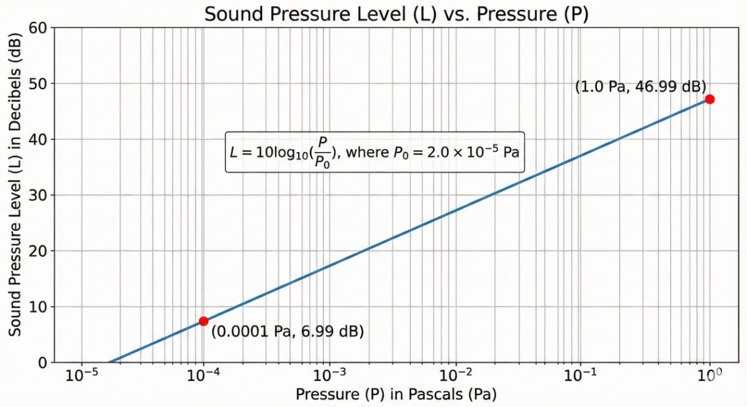

How this information can be useful:-
This information can be used to assess and document expected noise levels generated by traffic, machinery, or construction activities. By understanding how sound pressure relates to sound level (in dB), engineers can:
- demonstrate compliance with environmental noise regulations
- design appropriate noise-mitigation measures such as barriers, buffers, or site layout adjustments

- Trigonometric function – pipe gradient visualisation
A stormwater pipe follows a sinusoidal profile due to terrain variation. The vertical height h of the pipe at any point x is given by:
h(x) = 0.5 sin(πx / 6)
- Plot h(x) from x = 0 to x = 12 using software
- Clearly label the x-axis (horizontal distance in metres) and y-axis (height in metres)
Attach a screenshot of the graph to your workbook.
Function: $\text{h(}\text{x}\text{)=}\text{0.5}\text{sin}\text{⁡ ⁣}\text{(}\frac{\text{πx}}{\text{6}}\text{)}$. Units: height in metres, x horizontal distance in metres.
- Period check: argument increases by $\text{2}\text{π}$when $\text{x}$increases by $\text{12}$→ period = 12 m.
- Sample values (x in m):
x (m) | argument (pi x/6) | sin | (h(x)) (m)
0 | 0 | 0 | 0.000
3 | (pi/2) | 1 | 0.500
6 | (pi) | 0 | 0.000
9 | (3pi/2) | −1 | −0.500
12 | (2pi) | 0 | 0.000

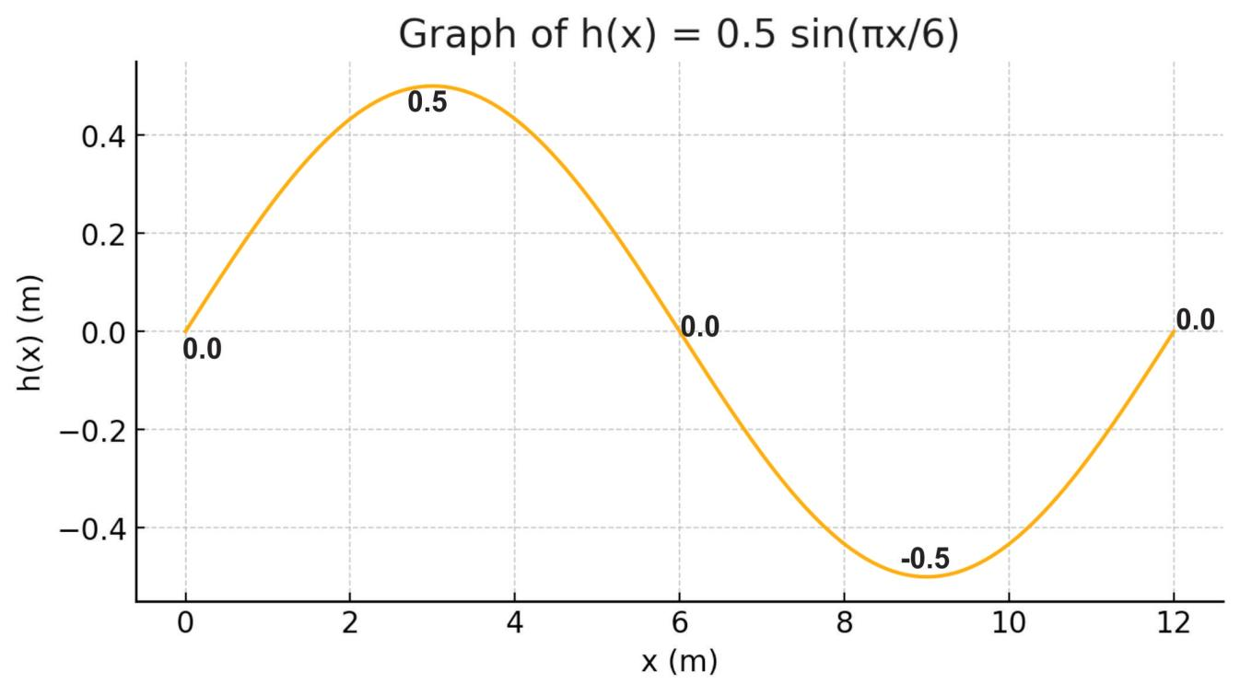

- Matrix – Simultaneous equations
You are calculating unknown pressures in a two-point drainage system.
Equations:
P₁ + 2P₂ = 16
3P₁ – P₂ = 5
Represent the system as a matrix and solve using appropriate software.
Validate the software output.
Attach a screenshot of the solution to your workbook.
Equations:
$$\text{\{}\begin{aligned}{\text{P}}_{\text{1}}\text{+2}{\text{P}}_{\text{2}}\text{=16(1)} \\ \text{3}{\text{P}}_{\text{1}}\text{-}{\text{P}}_{\text{2}}\text{=5(2)}\end{aligned}$$
Matrix form:
$$\text{[}\begin{matrix}\text{1} & \text{2} \\ \text{3} & \text{-}\text{1}\end{matrix}\text{][}\begin{aligned}{\text{P}}_{\text{1}} \\ {\text{P}}_{\text{2}}\end{aligned}\text{]=[}\begin{aligned}\text{16} \\ \text{5}\end{aligned}\text{]}$$
Solve (algebraic substitution — shown stepwise):
From (1): ${\text{P}}_{\text{1}}\text{=16-2}{\text{P}}_{\text{2}}$.
Substitute into (2): $\text{3(16-2}{\text{P}}_{\text{2}}\text{)-}{\text{P}}_{\text{2}}\text{=5}$
→ $\text{48-6}{\text{P}}_{\text{2}}\text{-}{\text{P}}_{\text{2}}\text{=5}$
→ $\text{48-7}{\text{P}}_{\text{2}}\text{=5}$
→ $\text{7}{\text{P}}_{\text{2}}\text{=43}$
→ ${\text{P}}_{\text{2}}\text{=}\frac{\text{43}}{\text{7}}\text{≈6.142857}$
Then ${\text{P}}_{\text{1}}\text{=16-2⋅}\frac{\text{43}}{\text{7}}\text{=}\frac{\text{112-86}}{\text{7}}\text{=}\frac{\text{26}}{\text{7}}\text{≈3.7142857}$
Solution:
$${\text{P}}_{\text{1}}\text{=}\frac{\text{26}}{\text{7}}\text{≈3.7143,}{\text{P}}_{\text{2}}\text{=}\frac{\text{43}}{\text{7}}\text{≈6.1429}$$
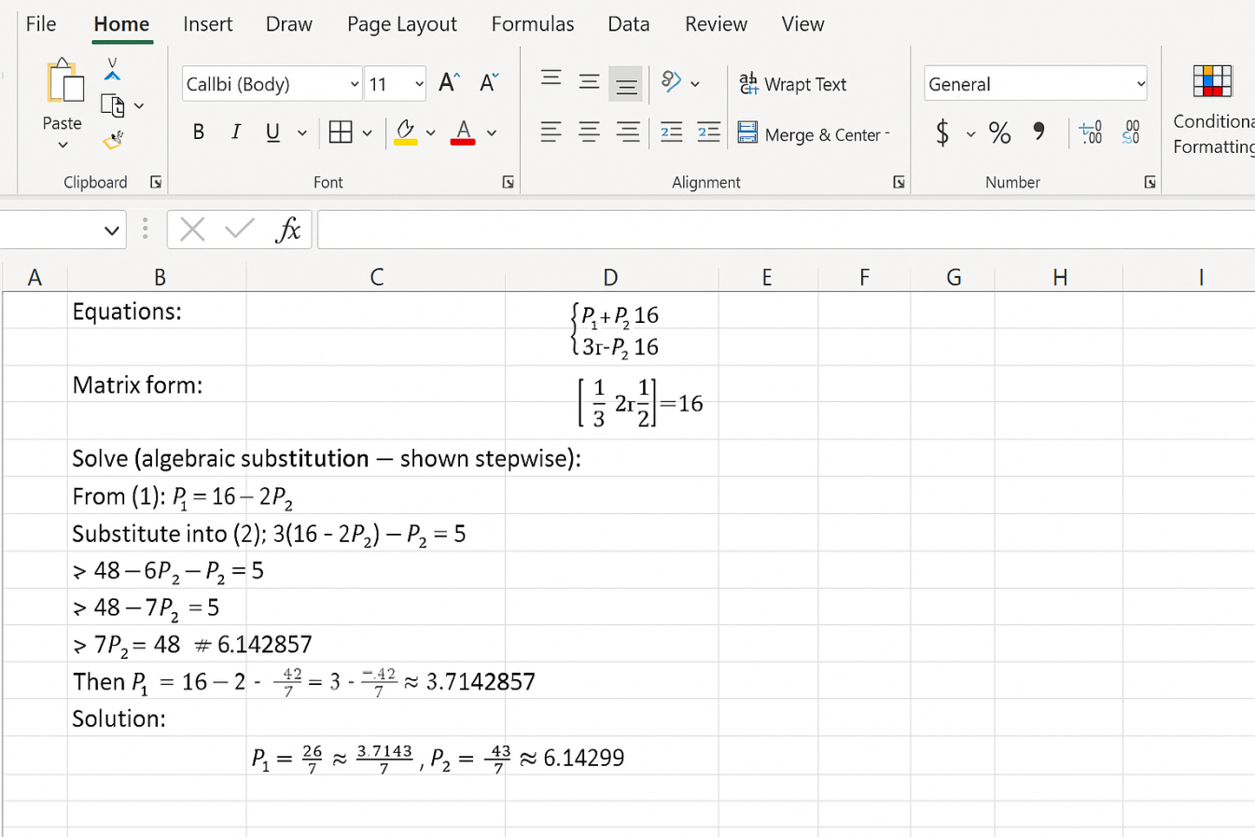

Section 5 – Reflection
- Explain how you laid out your equations and why you selected those specific approaches. | With each question I would first note the information I was given and then transcribe the equations in standard mathematical language. For geometric, trigonometry, probability & algebra questions, I gave the formula first and then showed substitution & simplification in sequence, followed by the answer. This arrangement made all the logical steps visible and easy to check.  I chose these approaches as they were closest to what a professional engineer would expect in documentation of calculations that they must rely on for clarity and traceability . Step-wise solutions also minimize errors and help others understand the thought process without asking too many questions.
- Explain the process you used for checking your solutions and validating software output. |  | To verify my answers, I manually computed a few critical values by other means, such as substitution back into the original equations, dimensional analysis, and geometric considerations. For the software verification, I checked the manual results for certain cases against the output from the software. For graphs , I Verified that major reference points (intercepts, maxima, minima, “trend” behaviour) matched with my manual calculations too.  I manually checked the result of one or two samples if the software was solving matrices, and plotting trigonometric or exponential functions. When the manual results and the software results agreed to within the predefined tolerance, the software results were deemed to be validated.
- Explain how you decided which mathematical technique or function to use for each problem. |  | I chose mathematical methods appropriate for the form of each of the problems:  - Because dimensional calculations, facets, and slab areas all dealt with lengths, areas, volumes, geometry and algebra were applied in these calculations.  - Where the tolerances produced variable internal dimensions, polynomial and binomial expressions were applied.  - Exponential decay was the right choice to model pump efficiency since the issue was a diminishing amount following a known decay pattern.  - Trigonometric functions were utilized for slopes and height changes as these issues involved periodically.  - Due to the independent probabilities of defects involved in the problem, the formulas of probability were utilized.  - Vectors and matrices for pipe tension and simultaneous equations, because forces can have many components, and one can have many equations, it is convenient to represent forces as vectors and sets of equations as matrices.  The basis for selecting which form of method was dependent for the closest analogue mathematical pattern represented by the engineering situation from among the suite of methods.
- Which software did you use for this assessment task? Explain why you chose it. |  | For this assessment task, I used Microsoft Excel (and its charting tools) along with a scientific calculator for verification.  Reasons for choosing Microsoft Excel:  - Accurate Graphing Capabilities – Excel allows quick creation of scatter plots, line graphs, and vector diagrams with precise scaling, which is essential for mathematical and engineering calculations.  - Ease of Formula Use – It enables fast calculation of values (e.g., trigonometric functions, exponentials) using built-in formulas, reducing manual errors.  - Professional Presentation – Excel produces clean, readable tables and graphs suitable for technical reports and assessment submissions.  - Widely Accepted in Industry – Excel is commonly used in engineering offices for preliminary calculations, making it appropriate and relevant for this type of assessment.  5) Validation – Excel allows easy recalculation and cross-checking of results, confirming the accuracy of manual work.
- How might the mathematical techniques you used in this assessment be applied in a civil engineering drafting role? |  | The mathematical techniques in this assessment reflect real tasks performed by civil engineering drafters:  - Geometry and measurement support accurate drawing and dimensioning of pits, pipes, slabs, and site layouts.  - Trigonometry is essential for slopes, gradients, and terrain modelling on drainage and road drawings.  - Exponential and logarithmic functions are used for modelling pump efficiency, sound levels, and decay processes relevant to stormwater and environmental design.  - Probability assists in assessing construction risks and expected defect rates.  - Vectors represent forces on structures, cables, and supports.  - Matrices are used in engineering software for solving drainage networks, load paths, and flow systems.  - Graphs are used to visualise variations such as depth vs volume, acoustic levels, and structural behaviour.  These methods enable drafters to produce accurate calculations, support engineering decisions, and communicate technical information clearly in drawings and documentation.

