BIRLA INSTITUTE OF TECHNOLOGY & SCIENCE, PILANI
Work Integrated Learning Programmes
AIMLCZG546
Software Engineering for Machine Learning
ASSIGNMENT II
Implementation, Code Quality and Quality Assurance
ChurnGuard
Telecom customer churn prediction and retention support
BITS ID | Name | Contribution | %
2025aa05877 | Vivek Kumar Aggarwal | Architecture and modularisation | 100%
2025ab05013 | Nishant Choudhary | Reliability and code quality | 100%
2025aa05544 | Sumanth T P | API and deployment readiness | 100%
2025aa05974 | Ravi Raj Ladha | Quality assurance and model metrics | 100%

Group 49 | Submission date: 15 August 2026

Executive Summary
ChurnGuard is a small production-style machine-learning system for telecom churn. It reads customer records, checks the data contract, creates features, trains a calibrated random-forest model, and serves the result through a FastAPI service. The output is not only a class label. It includes a churn probability, a risk band, and a retention action that a business team can use.
We treated the notebook as a place to explain and verify the work. The reusable implementation lives in the Python package. This keeps the notebook readable while making the same training and prediction code available to tests, scripts, CI, and the API.
Assignment ask | Evidence in this submission | Location
1. Modular implementation | Data, features, model, evaluation, prediction, and API modules | p. 5
2. Research vs production | Notebook baseline compared with the packaged pipeline | p. 6
3. Error handling and logs | Typed exceptions and logged demonstrations in five modules | pp. 7-8
4. Formatting and linting | Before example plus clean isort, Black, and flake8 run | p. 9
5. REST API | Four endpoints with OpenAPI documentation | pp. 10-11
6. Two or more test types | Unit, data-contract, ML behavioural, and integration tests | p. 12
7. Training and inference tests | Learning, reproducibility, robustness, and invariance checks | pp. 13-14
8. Model and data metrics | Model metrics, missingness, schema, ranges, and PSI | pp. 15-22
9. Experimentation and security | Shadow/canary/A-B plan plus boundary controls | p. 23

Verified result: 5,000 records were processed; 98 tests passed; statement coverage was 90%; the holdout ROC-AUC was 0.7893; and all configured model and data gates passed.
Source code: github.com/vivekag1990/telecom-churngaurd

Project Context and System Flow
Customer churn is not a balanced prediction problem. In our training split, about 26.7% of customers churned. A model that always predicts 'stay' would therefore look acceptable on accuracy while being useless to a retention team. We designed the system around ranking, probability quality, and controlled actions rather than accuracy alone.
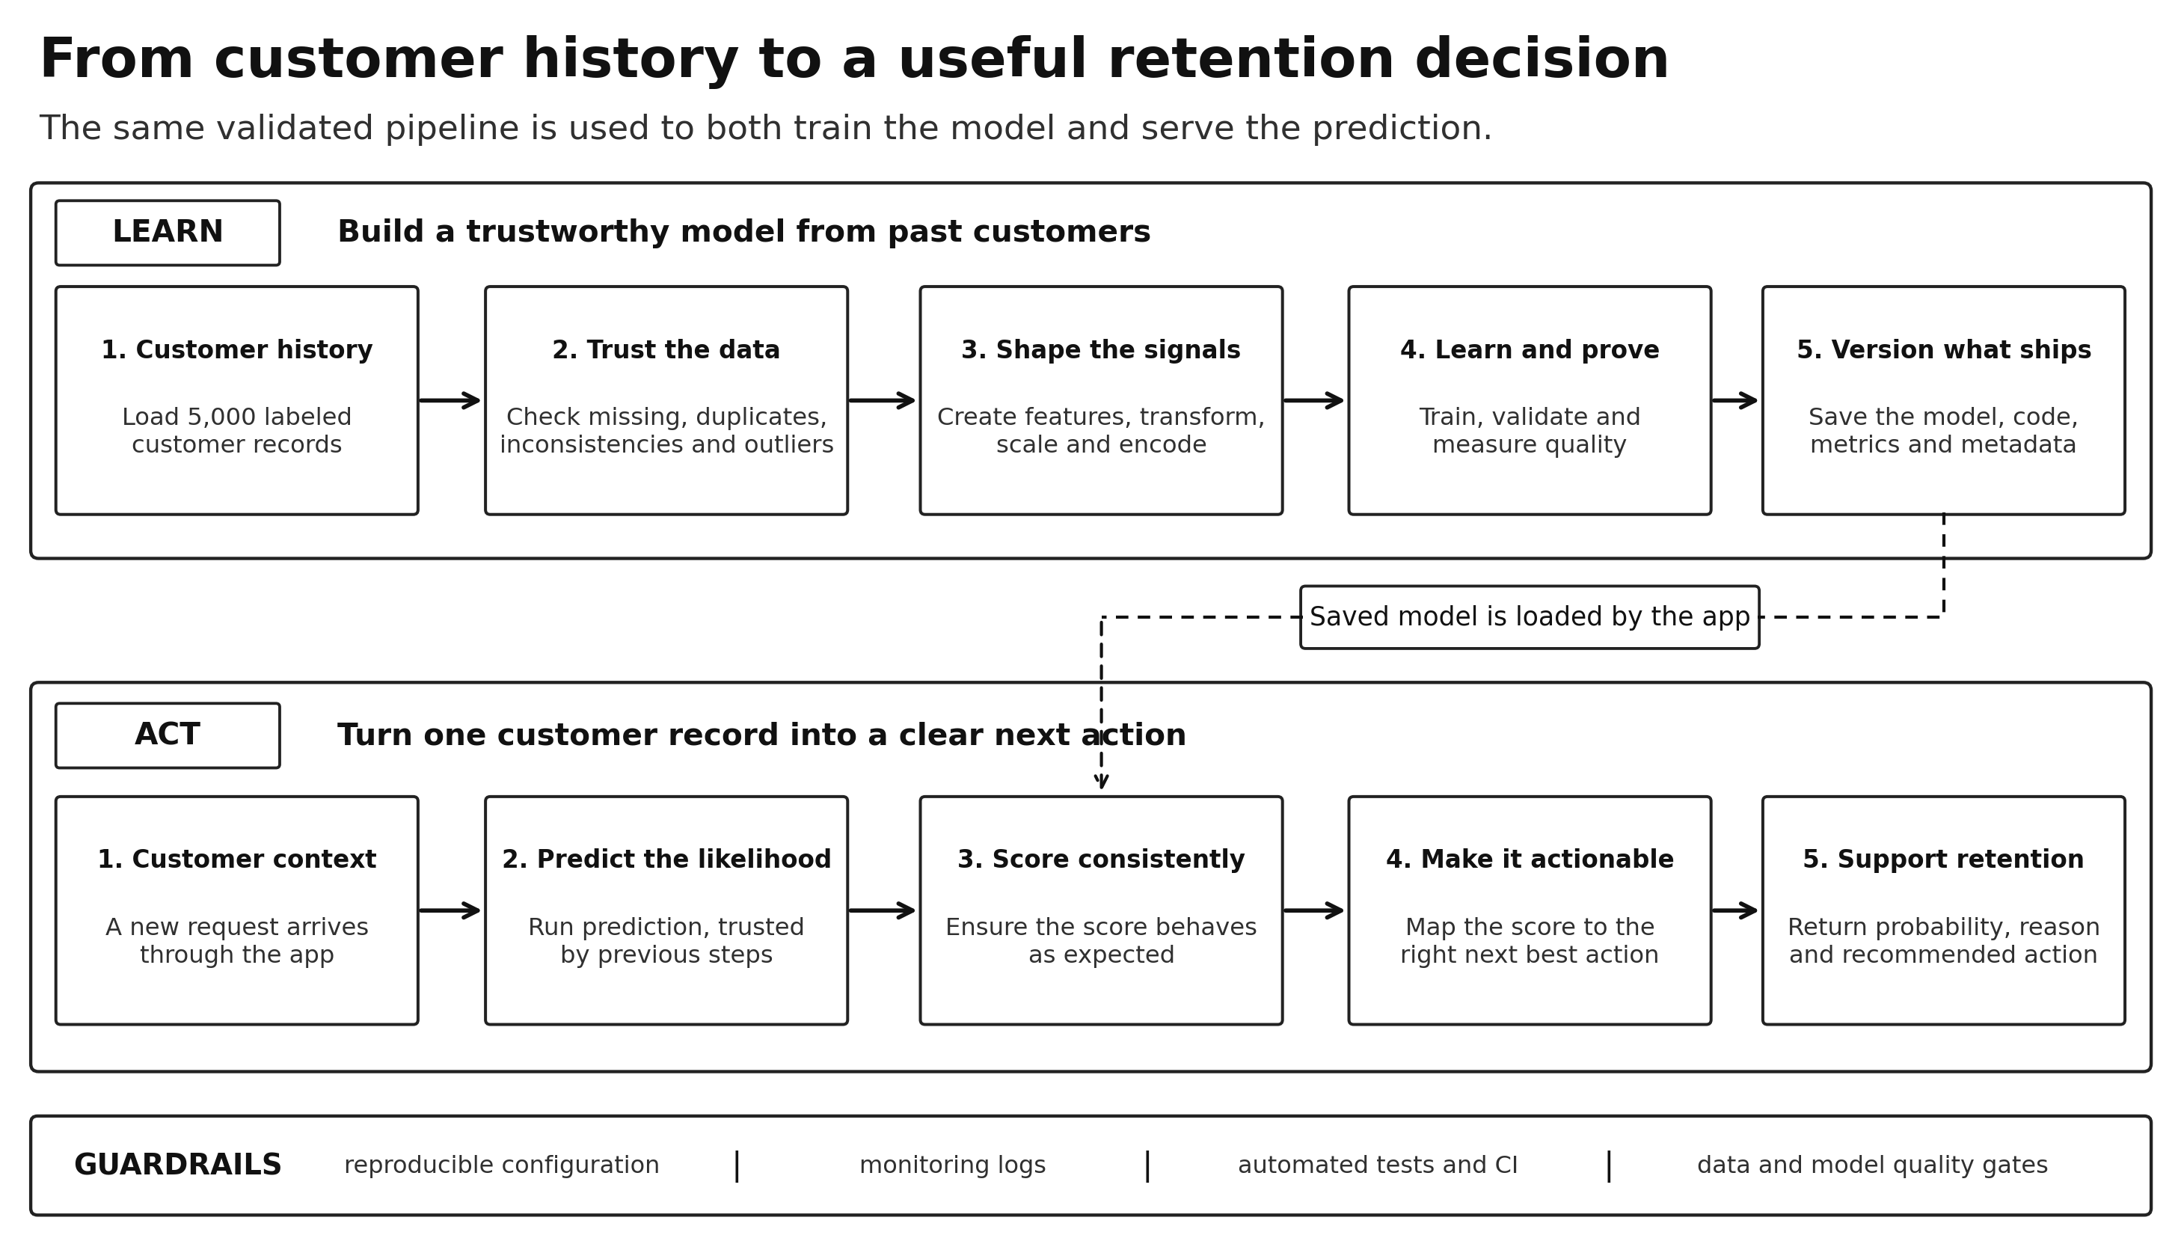
Figure 1. Two connected journeys: learning from customer history and turning a new record into a retention action.

How the two journeys stay connected
- Historical customer records are checked before they are allowed to teach the model.
- One repeatable pipeline creates features, fills gaps, encodes categories, and scales values.
- The trained model is calibrated and measured before it can become a versioned artefact.
- That artefact carries its metrics and metadata into the API, keeping training and serving traceable.
- For a new customer, the API checks the request, reuses the fitted pipeline, and turns risk into a clear action.
Why this layout matters: Each stage has one clear job. When a check fails, we know which part owns the problem; when a stage is changed, the surrounding stages can be tested without rewriting the full project.

Dataset, Configuration and Reproducibility
The project uses a deterministic 5,000-row telecom dataset. Ten input fields describe tenure, charges, support usage, internet service, payment behaviour, and contract choices. The customer identifier is returned to the caller but is not used as a model feature. This prevents an arbitrary identifier from influencing the score.
Input group | Fields | Handling
Numeric | tenure, monthly/total charges, tickets, monthly GB | Range checks, median imputation, scaling
Categorical | contract, internet, payment, support, paperless | Allowed-value checks, mode imputation, one-hot encoding
Identifier | customer_id | Echoed in responses; excluded from model features
Target | churn | Stratified split and binary evaluation

Actual code - src/churnguard/config.py
@dataclass(frozen=True)
class ModelConfig:
test_size: float = 0.2
random_state: int = 42
n_estimators: int = 300
max_depth: int = 12
min_samples_leaf: int = 8
class_weight: str = "balanced"
decision_threshold: float = _env_float(
"CHURN_DECISION_THRESHOLD", 0.35
)
The random seed fixes the split, the random forest, and the cross-validation shuffling. Dependencies are locked through uv, and the notebook uses the same project environment. The saved model also records the code version, input fields, hyperparameters, training time, threshold, split summary, and evaluation metrics. These details make a result traceable instead of relying on memory or notebook state.
Artefact | Why it is saved
churn_model.joblib | Complete fitted pipeline and model metadata
reference_profile.json | Training distributions used for later PSI checks
model_metrics.json | Holdout, cross-validation, and data-quality results
churnguard.log | Time-stamped operational record of each run

Objective 1: Implementation and Code Sharing

Task 1 - Modular, object-oriented and functional implementation
We used a mix of styles instead of forcing everything into classes. Data sources, the trainer, the fitted feature transformer, and the predictor keep state and are represented as classes. Small calculations such as annualised support tickets or average spend per month are plain functions. This makes the code easier to read and gives each part the simplest useful form.
Module | Main responsibility | Reason for separation
data/ingestion.py | Load and split data | File concerns do not leak into modelling
data/validation.py | Enforce the data contract | Bad data stops before training
features/engineering.py | Create and preprocess features | Same logic is reused at inference
models/trainer.py | Fit, evaluate, and persist | Training workflow stays testable
models/predictor.py | Serve probabilities and actions | API code stays thin
api/ | HTTP validation and routes | Transport concerns stay at the boundary

Actual code - src/churnguard/data/ingestion.py and models/trainer.py
class DataSource(ABC):
@abstractmethod
def load(self) -> pd.DataFrame:
"""Return the raw dataset."""
pipeline = Pipeline(
[
("features", ChurnFeatureEngineer()),
("preprocess", build_preprocessor()),
("classifier", classifier),
]
)
The DataSource interface lets tests use an in-memory frame while normal runs use CSV input. The trainer does not need to know where the data came from. The scikit-learn pipeline is equally important: it saves the transformation steps together with the classifier. A request cannot accidentally bypass imputation, encoding, feature ordering, or calibration.
Result: The training log confirms a three-stage pipeline and shows 10 input columns becoming 15 engineered columns before preprocessing. The exact fitted object is then reused by the API.

Task 2 - Research code compared with production code
The first notebook version answered a research question: is there enough signal in the data to train a useful classifier? It loaded a CSV, filled missing values, created dummy variables, split the data, and fitted a random forest. That is reasonable for a quick experiment, but it depends on the order in which cells are run and it leaves preprocessing outside the saved estimator.
Concern | Research notebook | Production implementation
Purpose | Fast feasibility check | Repeatable training and serving
Data access | Relative CSV path | DataSource interface with typed failures
Missing values | All nulls replaced with zero | Median or most-frequent value by type
Encoding | Dummy columns created before the split | Encoder fitted inside the pipeline
Feature logic | Notebook statements | Named pure functions and transformer
Configuration | Values inside cells | Frozen central settings and environment override
Persistence | Classifier only | Pipeline, metrics, metadata, and threshold
Verification | Manual rerun | Automated lint, tests, data gates, and model gates

Actual research code - output/Group49.ipynb
df = pd.read_csv("../data/raw/telco_churn.csv")
df = df.fillna(0)
X = pd.get_dummies(df.drop(["churn", "customer_id"], axis=1))
X_train, X_test, y_train, y_test = train_test_split(
X, y, test_size=0.2, random_state=42, stratify=y
)
Actual production code - src/churnguard/features/engineering.py
numeric_pipeline = Pipeline([
("impute", SimpleImputer(strategy="median")),
("scale", StandardScaler()),
])
categorical_pipeline = Pipeline([
("impute", SimpleImputer(strategy="most_frequent")),
("encode", OneHotEncoder(handle_unknown="ignore",
sparse_output=False)),
])
The production version is longer because it deals with failure, repeatability, and reuse. The extra code is not added for decoration. It prevents a category seen only after deployment from breaking inference, keeps the transformation order fixed, and makes the same model callable from tests and HTTP routes.

Task 3 - Error handling and logging
We added explicit failure handling in more than the required three critical modules. The rule is simple: the module that understands a failure checks it, writes a useful log entry, and raises a domain exception. Callers do not have to interpret low-level pandas, joblib, or scikit-learn errors.
Module | Examples of rejected input | Raised exception
Ingestion | Missing file, empty CSV, parser error, absent columns | DataIngestionError
Validation | Wrong type/category, range breach, missingness, PSI | SchemaValidationError
Feature engineering | Missing source field or transform before fit | FeatureEngineeringError
Training | Row mismatch, one target class, fit/save order | ModelTrainingError
Prediction | Missing/corrupt model, empty batch, missing fields | ModelNotLoadedError / InferenceError

Actual code - src/churnguard/data/ingestion.py
if not self.path.exists():
logger.error("Data file not found: %s", self.path)
raise DataIngestionError(f"Data file not found: {self.path}")
try:
frame = pd.read_csv(self.path)
except pd.errors.EmptyDataError as exc:
logger.error("Data file %s is empty", self.path)
raise DataIngestionError(
f"Data file is empty: {self.path}"
) from exc
Actual code - src/churnguard/models/predictor.py
if frame.empty:
raise InferenceError("Received an empty batch")
missing = [c for c in SETTINGS.all_features if c not in frame]
if missing:
logger.error("Inference payload missing features: %s", missing)
raise InferenceError(f"Missing required features: {missing}")

Logging levels used
- INFO describes normal progress such as row counts, split size, model version, and latency.
- WARNING records recoverable conditions, such as a small amount of missing data that will be imputed.
- ERROR records a stopped operation with the path, field, or rule that caused the failure.
The API converts these internal exceptions into stable HTTP responses. For example, a missing model is a 503 readiness problem, while a bad request field is rejected before inference with 422. The caller receives a useful status without seeing a raw stack trace.

Task 3 - Failure-path evidence and observations
We ran a separate demonstration script so that the error paths are visible without deliberately breaking the main training command. The script tries a missing file, an empty file, missing columns, a one-class target, schema and range violations, a training row mismatch, an unloaded predictor, and a payload with missing fields.
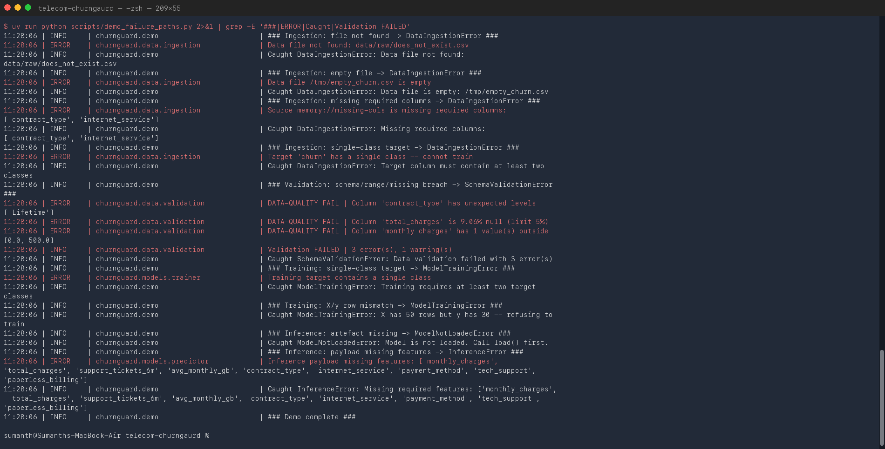
Figure 2. Actual macOS Terminal run of the handled ingestion, validation, training, and inference failures.

What we confirmed
- Every expected failure was caught as a ChurnGuard domain exception; the demo itself completed with status 0.
- The log names the owning module, so a missing CSV is distinguishable from an invalid inference payload.
- Validation reported three errors together instead of stopping after the first bad field.
- The system refused to train when X and y had different row counts or when the target had one class.
Practical value: These checks turn silent data or model mistakes into clear operational failures. A scheduled job can stop, alert the owner, and preserve the last valid artefact instead of publishing a broken model.

Task 4 - Formatting and linting before and after
The repository uses isort for import order, Black for formatting, and flake8 for style and common coding mistakes. To keep the comparison reproducible, the original untidy example is retained under reports/lint_demo. It is evidence only and is not imported by the application.
Actual before/after excerpt - reports/lint_demo/retention_utils_*.py
# Before
import json,os
DISCOUNT_TABLE={"LOW":0,"MEDIUM":10,"HIGH":20,"CRITICAL":35}
# After
import logging
logger = logging.getLogger(__name__)
DISCOUNT_TABLE: dict[str, int] = {
"LOW": 0, "MEDIUM": 10, "HIGH": 20, "CRITICAL": 35,
}
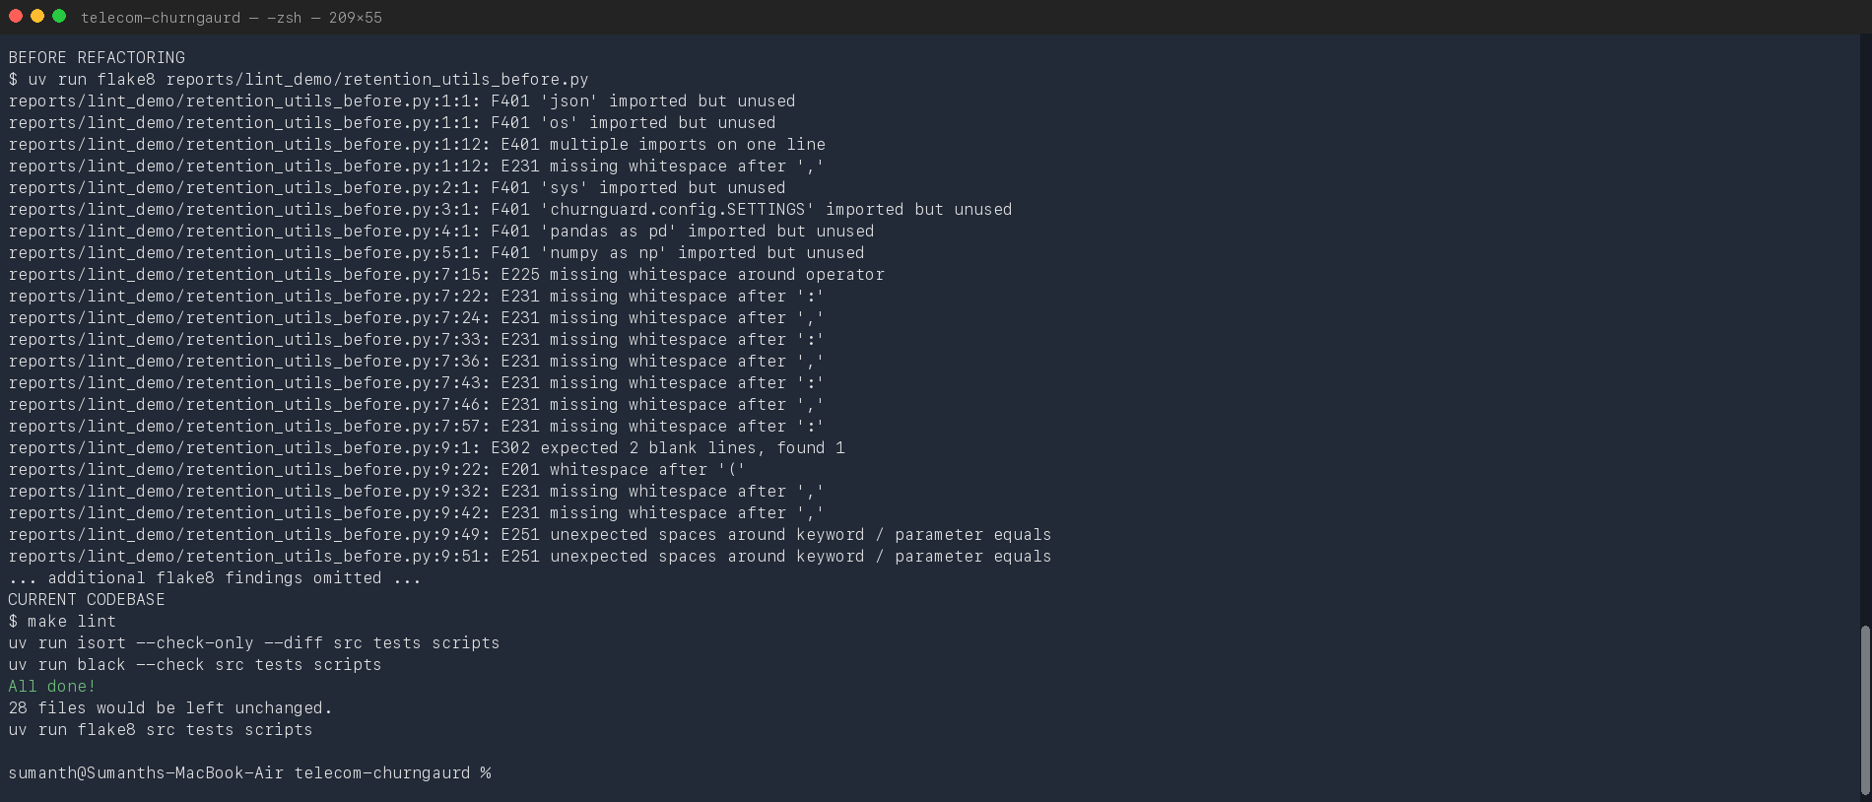
Figure 3. Actual Terminal output: representative flake8 findings before cleanup and a clean current codebase.
The before file shows real findings: combined imports, unused imports, missing whitespace, and missing blank lines. The current run checks 28 source, test, and script files. Black reports that all 28 would remain unchanged, while isort and flake8 return no findings.
Actual CI gate - .github/workflows/ci.yml
- name: Lint (isort / black / flake8)
run: |
isort --check-only src tests scripts
black --check src tests scripts
flake8 src tests scripts
Meaning: Formatting is automatic and repeatable. Review time can focus on behaviour because spacing and import order are settled by tools, and CI stops a change that reintroduces the same issues.

Task 5 - REST API design
FastAPI exposes the model as a small versioned service. We kept operational checks separate from inference: the health route answers whether a model is loaded, the model-info route describes the active artefact, and the prediction routes score one or several customers.
Method | Path | Use | Normal status
GET | /health | Liveness and model readiness | 200
GET | /v1/model/info | Version, inputs, threshold, metrics | 200
POST | /v1/predict | Score one validated customer | 200
POST | /v1/predict/batch | Score between 1 and 500 customers | 200

Actual API code - src/churnguard/api/main.py
@app.post(
"/v1/predict",
response_model=PredictionResponse,
status_code=status.HTTP_200_OK,
)
async def predict(customer: CustomerFeatures) -> PredictionResponse:
if not predictor.is_loaded:
raise ModelNotLoadedError("No model loaded")
result = predictor.predict_one(customer.model_dump())
return PredictionResponse(**result.to_dict())
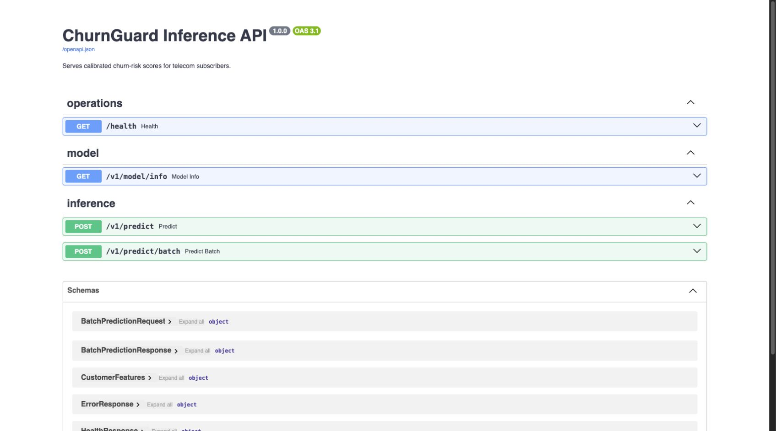
Figure 4. Live OpenAPI page generated from the ChurnGuard FastAPI routes and Pydantic schemas.
The documentation is generated from the running application, so it stays linked to the actual request and response models. It also gives a reviewer a direct way to inspect and try the four endpoints.

Task 5 - Request validation and API evidence
The HTTP layer validates a request before creating a DataFrame or calling the model. Numeric fields have reasonable bounds, categorical values are limited to known options, extra fields are rejected, and a batch is capped at 500 records. This makes an invalid request fail early with a precise field-level message.
Actual request contract - src/churnguard/api/schemas.py
class CustomerFeatures(BaseModel):
model_config = ConfigDict(extra="forbid")
tenure_months: Annotated[int, Field(ge=0, le=120)]
monthly_charges: Annotated[float, Field(ge=0.0, le=500.0)]
contract_type: Literal[
"Month-to-month", "One year", "Two year"
]
class BatchPredictionRequest(BaseModel):
customers: Annotated[
list[CustomerFeatures], Field(min_length=1, max_length=500)
]
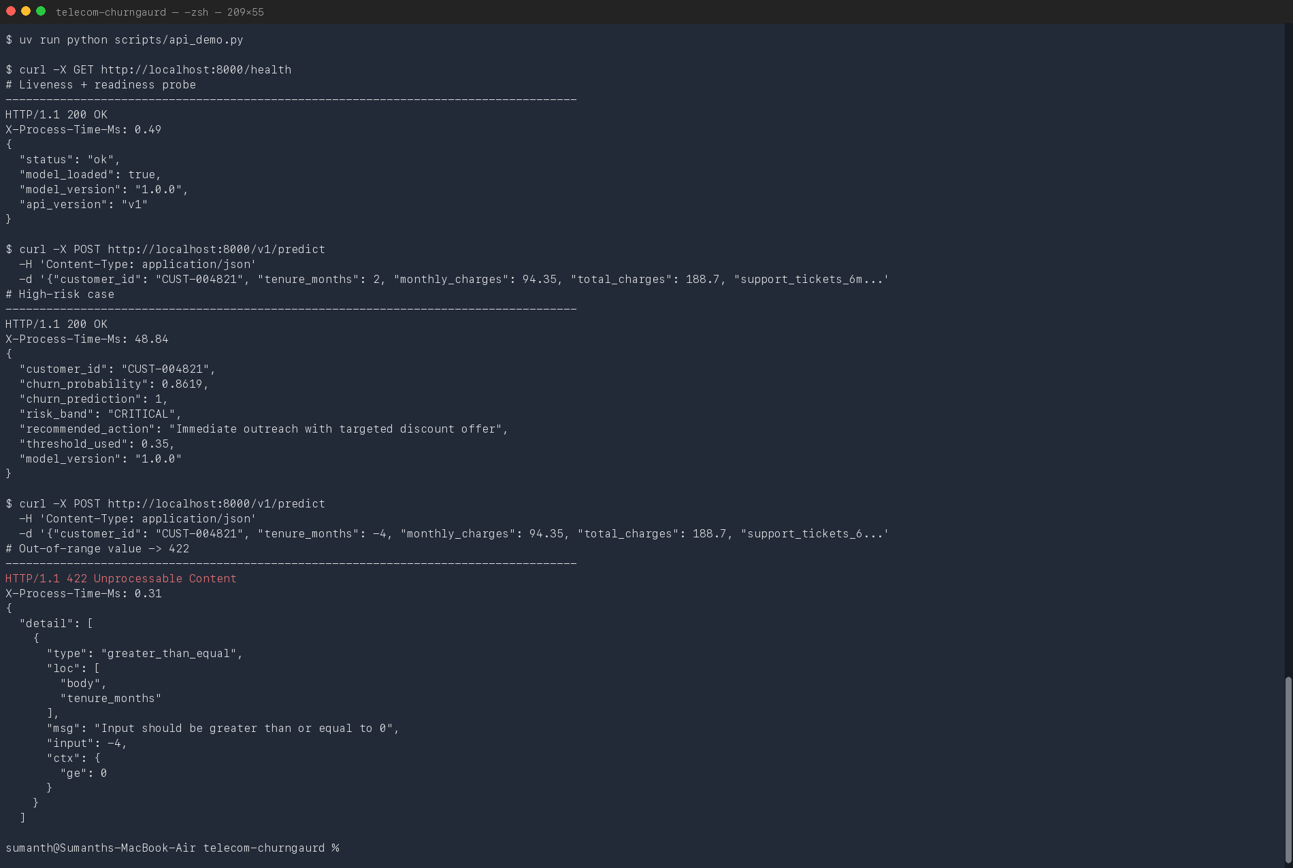
Figure 5. Actual Terminal requests: health check, high-risk prediction, and rejection of negative tenure.
The health request returned a loaded version 1.0.0 model. The high-risk example received a probability of 0.8619, crossed the 0.35 decision threshold, entered the CRITICAL band, and received an immediate-outreach recommendation. A second request used tenure -4; FastAPI rejected it with HTTP 422 before inference. The X-Process-Time-Ms header also confirms that request timing is recorded at the service boundary.

Objective 2: Quality Assurance

Task 6 - Test types used in the project
The assignment asks for at least two test types. We implemented four because different failures require different levels of evidence. A feature calculation should be tested without starting the API, while an HTTP status should be checked through the complete request path.
Test type | Scope | Examples
Unit | One function or small class | Feature arithmetic, band boundaries, source behaviour
Data contract | Dataset assumptions | Columns, types, categories, nulls, ranges, and PSI
ML behavioural | Properties of a fitted model | Learning, reproducibility, invariance, directions
Integration | FastAPI request through prediction | Health, OpenAPI, status codes, batch agreement

Actual data-contract test - tests/test_data_validation.py
def test_unexpected_category_level_is_caught(self, raw_frame):
broken = raw_frame.copy()
broken.loc[broken.index[0], "contract_type"] = "Lifetime"
report = DataValidator().validate(broken)
assert not report.passed
assert any("Lifetime" in error for error in report.errors)
Actual API integration test - tests/test_api_integration.py
def test_out_of_range_value_returns_422(
self, client, valid_payload
):
response = client.post(
"/v1/predict",
json={**valid_payload, "tenure_months": -5},
)
assert response.status_code == 422
The first test proves that the data validator catches a category that the model was not designed to accept. The second sends a real HTTP request through the FastAPI test client. Together they cover both the batch training contract and the public service contract.

How the suite is organised
- Shared fixtures build one deterministic split and one temporary model artefact for reuse.
- Small tests remain isolated; only integration tests go through routes and schemas.
- Assertions include expected error messages, not only whether an exception occurred.

Task 7 - Tests for model training
A training function can execute successfully and still produce a useless model. Our training tests therefore check behaviour, not only object creation. We ask whether the model can learn a small batch, whether added capacity lowers training loss, whether true labels beat shuffled labels, and whether the same seed gives the same probabilities.
Training check | What it protects against
Expected pipeline stages | A preprocessing or classifier stage being dropped
Small-batch overfit >= 0.98 | A pipeline that cannot learn even an easy training sample
Loss falls with capacity | Broken probability training or feature flow
Real labels beat shuffled labels | A score caused by leakage or chance
Same seed, same output | Non-reproducible builds
Release gates pass | Saving a model below the agreed quality floor
Artefact round-trip | Missing pipeline steps or model metadata after saving

Actual learning test - tests/test_model_training.py
pipeline.fit(x_small, y_small)
train_accuracy = pipeline.score(x_small, y_small)
assert train_accuracy >= 0.98, (
f"Cannot memorise 60 rows (acc={train_accuracy:.3f})"
)
Capacity-test excerpt - tests/test_model_training.py
losses = []
for n_estimators in (1, 5, 25, 100):
...
pipeline.fit(split.x_train, split.y_train)
probabilities = pipeline.predict_proba(split.x_train)[:, 1]
losses.append(log_loss(
split.y_train, probabilities, labels=[0, 1]
))
assert losses[-1] < losses[0]
assert losses == sorted(losses, reverse=True)
The overfit test is a diagnostic, not a production objective. On only 60 rows, a flexible forest should be able to fit the labels. In the capacity check, training log loss fell from 4.433369 to 0.150294, 0.130241, and 0.128518 as the forest increased from 1 to 5, 25, and 100 trees. The separate shuffled-label test checks that the real model clearly beats data where the feature-target relationship has been destroyed.
Training conclusion: The pipeline demonstrated learning, reproducibility, and persistence. The final holdout gates were also enforced before the model artefact was written.

Task 7 - Tests for inference and service behaviour
Inference tests focus on properties that must remain true for every request. Probabilities must be finite and between zero and one; row order, column order, and batch size must not change a customer's result; and the binary decision must agree with the configured threshold.
Actual invariance and direction tests - tests/test_model_inference.py
batched = predictor.predict_proba(sample)
individually = np.array([
predictor.predict_proba(sample.iloc[[i]])[0]
for i in range(len(sample))
])
np.testing.assert_allclose(batched, individually, rtol=1e-9)
low = sample.assign(support_tickets_6m=0)
high = sample.assign(support_tickets_6m=10)
assert predictor.predict_proba(high).mean() > (
predictor.predict_proba(low).mean()
)
We also included directional checks as a guardrail. Across a controlled sample, more support tickets should raise average risk, longer tenure should lower it, a two-year contract should be safer than month-to-month, and technical support should lower risk. These tests do not prove fairness or causation. They are regression checks for obvious reversals in a domain pattern already present in the data.
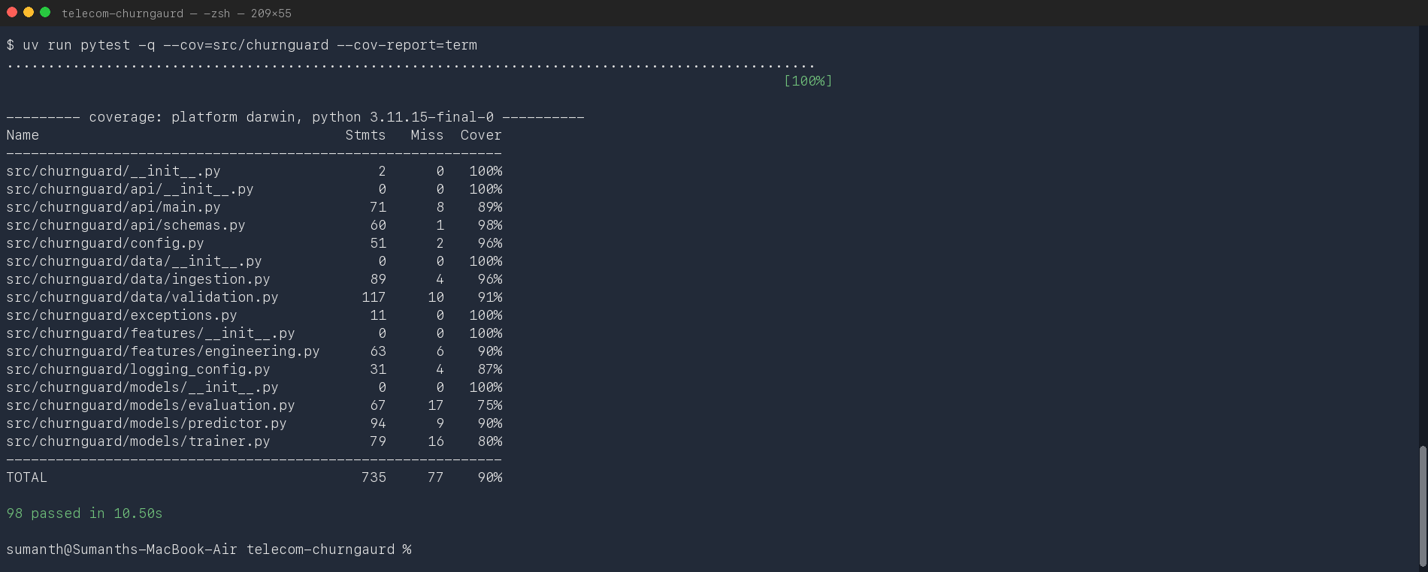
Figure 6. Actual Terminal test run: 98 passed and 90% statement coverage.
All 98 tests passed in 10.50 seconds. Coverage is 90% across 735 statements. Evaluation has the lowest module coverage at 75%, followed by training at 80%; these are useful targets for future edge-case tests. The core schema, feature, ingestion, predictor, and API modules are at or above 89%.

Task 8 - Evaluation method and model metrics
We kept 1,000 records aside as a final holdout set and trained on 4,000 records. Stratification produced a training churn rate of 0.2665 and a test churn rate of 0.2670. This close match makes the holdout comparison less sensitive to class-ratio changes. We also ran five-fold stratified cross-validation on the training data to check that the result was not dependent on one split.
Metric | Value | Plain-language reading
Accuracy | 0.7580 | 758 of every 1,000 holdout decisions were correct
Precision | 0.5439 | About 54% of flagged customers actually churned
Recall | 0.5805 | About 58% of actual churners were found
F1 | 0.5616 | Single balance of precision and recall; gate >= 0.55
ROC-AUC | 0.7893 | Useful ordering of churners above non-churners; gate >= 0.75
Brier score | 0.1518 | Mean squared probability error; gate <= 0.20
ECE | 0.0185 | Average gap between predicted and observed risk bins
5-fold ROC-AUC | 0.7917 +/- 0.0152 | Similar ranking performance across training folds

Actual metric calculation - src/churnguard/models/evaluation.py
metrics = ModelMetrics(
accuracy=float(accuracy_score(y_true, y_pred)),
precision=float(precision_score(y_true, y_pred,
zero_division=0)),
recall=float(recall_score(y_true, y_pred, zero_division=0)),
f1=float(f1_score(y_true, y_pred, zero_division=0)),
roc_auc=float(roc_auc_score(y_true, y_prob)),
brier=float(brier_score_loss(y_true, y_prob)),
ece=expected_calibration_error(y_true, y_prob),
)
Accuracy is reported but is not the main decision metric because non-churners are the majority. ROC-AUC checks ranking without fixing one threshold. F1 checks the precision-recall balance at the chosen threshold. Brier score and ECE check whether a probability such as 0.70 can be treated as a meaningful risk level. The combination gives a more complete view than any single number.

Task 8 - Confusion matrix and threshold choice
At threshold 0.35, the holdout confusion matrix contains 603 true negatives, 130 false positives, 112 false negatives, and 155 true positives. In business terms, 285 customers would be sent to a retention action and 155 of them are true churners. The model misses 112 churners, so the threshold is a business trade-off, not a purely technical constant.
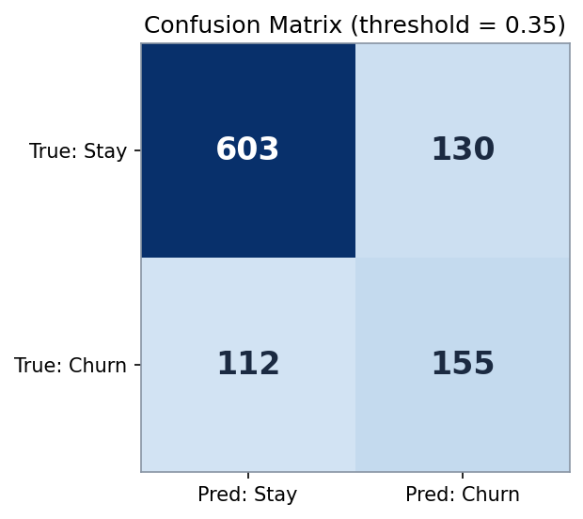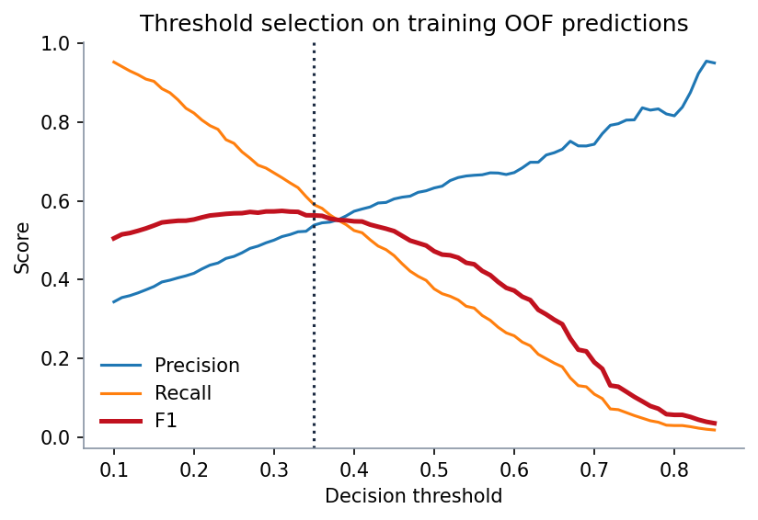
Figure 7. Holdout confusion matrix at 0.35 (left) and training-only OOF threshold sweep (right).
Threshold | Precision | Recall | F1 | Reading
0.31 | 0.5091 | 0.6585 | 0.5742 | Best training OOF F1; more customers contacted
0.35 | 0.5381 | 0.5901 | 0.5629 | Configured setting; higher precision

The sweep uses five-fold out-of-fold predictions from the 4,000 training records, so the 1,000-record final holdout remains untouched. F1 is highest at 0.31. We retained 0.35 because it improves precision while keeping training OOF F1 close to the maximum. The final holdout metrics are then reported once at 0.35. A commercial threshold should also include offer cost, retained value, and retention-team capacity.
Actual OOF sweep - scripts/make_figures.py
threshold_cv = StratifiedKFold(
n_splits=5, shuffle=True, random_state=42
)
oof_probabilities = cross_val_predict(
ChurnModelTrainer().build_pipeline(),
split.x_train,
split.y_train,
cv=threshold_cv,
method="predict_proba",
n_jobs=1,
)[:, 1]
sweep = _threshold_sweep(
split.y_train.to_numpy(), oof_probabilities
)
Decision: The threshold is kept in configuration and returned by the API, so it can be reviewed and changed without hiding the operating point from downstream users.

Task 8 - Ranking and probability calibration
The ROC curve measures ranking across every possible decision threshold. The curve stays above the random diagonal through the useful range and produces an AUC of 0.7893. This means the model has meaningful separation, although it is not strong enough to justify automatic high-cost action without safeguards.
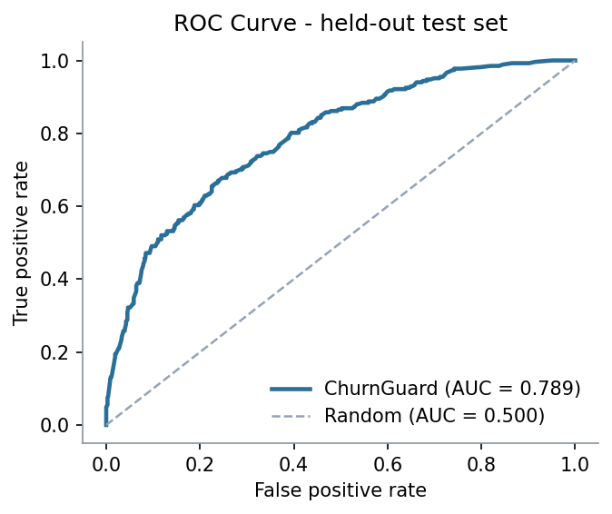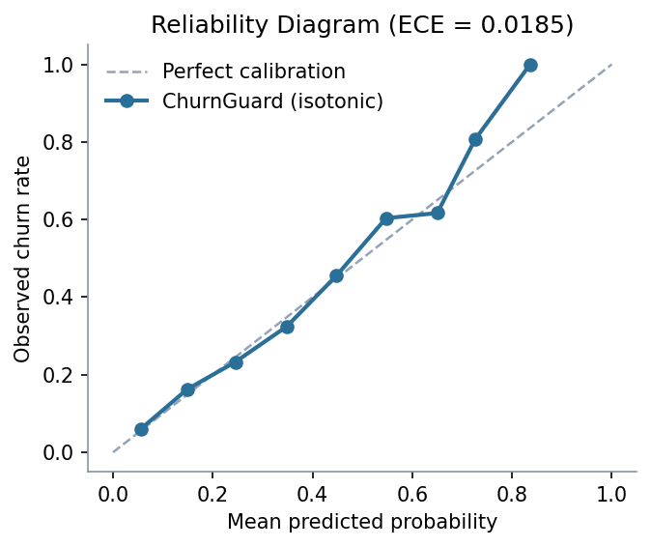
Figure 8. ROC discrimination on the holdout set (left) and probability reliability (right).

Why calibration was added
Random-forest vote fractions are not always reliable probabilities. We wrapped the forest in CalibratedClassifierCV with isotonic calibration. The reliability diagram then compares the average predicted probability in each populated bin with the churn rate actually observed in that bin.
Actual calibration code - src/churnguard/models/trainer.py
forest = RandomForestClassifier(
n_estimators=300,
max_depth=12,
min_samples_leaf=8,
class_weight="balanced",
random_state=42,
n_jobs=-1,
)
classifier = CalibratedClassifierCV(
forest, method="isotonic", cv=3
)
The reliability line is close to the ideal diagonal and ECE is 0.0185. The Brier score of 0.1518 also passes its 0.20 gate. Together these results support using the score for broad risk bands. The highest-risk region contains few customers, so its calibration is less certain and should be monitored as real outcomes arrive.
Reading the two plots together: ROC-AUC says the model orders risk reasonably well; calibration says the reported probabilities are close to observed rates. We need both because a model can rank well and still report misleading probabilities.

Task 8 - Data-quality metrics and drift
Model metrics are only useful when the incoming data still follows the contract. ChurnGuard records row count and missingness, checks numeric bounds and category values, and compares numeric distributions with the saved training reference using Population Stability Index (PSI).
Data check | Observed result | Configured response
Rows | 5,000 | Recorded for run traceability
Schema and ranges | Passed | Any violation fails validation
Overall missingness | 0.18% | Recorded across model inputs
total_charges missing | 1.20% | Warning and median imputation; gate is 5%
avg_monthly_gb missing | 0.60% | Warning and median imputation; gate is 5%
Maximum stored PSI | 0.0005 | Pass; failure threshold is 0.20

Actual drift check - src/churnguard/data/validation.py
psi = population_stability_index(
np.asarray(reference_values),
frame[column].to_numpy(),
)
report.metrics[f"psi__{column}"] = round(psi, 4)
if psi > limit:
report.add_error(
f"Feature '{column}' drifted: PSI={psi:.3f} > {limit:.2f}"
)
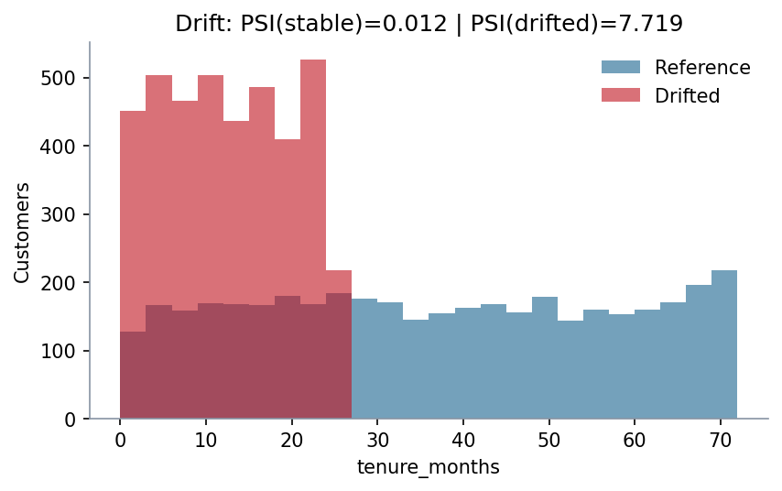
Figure 9. PSI demonstration for stable traffic and a deliberately shifted tenure distribution.
The stored maximum PSI of 0.0005 comes from the standard validation run against the saved reference profile. The separate plotted detector demonstration compares training tenure with holdout tenure, producing PSI 0.0118. Reducing tenure in a copy of the data raises PSI to 7.7190 and fails the 0.20 gate. The large shift is intentional because it makes the failure behaviour easy to verify.

Task 8 - From probabilities to retention workload
A probability is useful to a data scientist, but an operations team needs a manageable action. ChurnGuard therefore maps each score to one of four risk bands. These bands are separate from the 0.35 binary threshold: the threshold is used for the model decision, while the bands describe the intensity of follow-up.
Band | Probability | Action | Holdout count
LOW | < 0.30 | Monitor quarterly | 651
MEDIUM | 0.30 to < 0.60 | Nurture campaign and plan review | 251
HIGH | 0.60 to < 0.85 | Retention agent within seven days | 96
CRITICAL | >= 0.85 | Immediate targeted outreach | 2

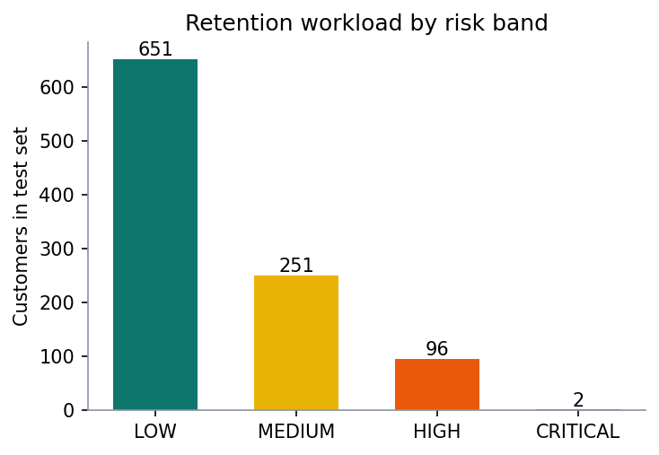
Figure 10. Holdout workload across the four retention risk bands.
Actual action mapping - src/churnguard/models/predictor.py
RISK_BANDS = (
(0.30, "LOW", "No action - monitor quarterly"),
(0.60, "MEDIUM", "Add to nurture campaign; offer plan review"),
(0.85, "HIGH", "Assign retention agent within 7 days"),
(1.01, "CRITICAL", "Immediate outreach with targeted discount offer"),
)
The holdout produces a realistic funnel: most customers are LOW risk, 251 are MEDIUM, 96 are HIGH, and only two are CRITICAL. This prevents the strongest offer from being sent to everyone. The exact boundaries are business assumptions for the assignment and should be reviewed against campaign capacity and realised value.

Task 8 - End-to-end training and quality-gate evidence
The training command joins the separate checks into one controlled run. It validates the data, creates the stratified split, writes a new reference profile, performs cross-validation, fits the final pipeline, evaluates the holdout set, checks the quality gates, and only then saves the model and metrics.
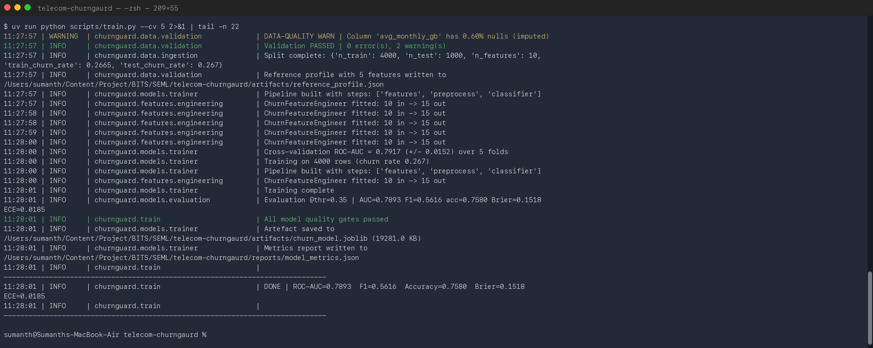
Figure 11. Actual Terminal output for validation, five-fold cross-validation, final training, and release gates.
Terminal evidence | Observed result
Data validation | Passed with two recoverable missing-value warnings
Split | 4,000 training rows and 1,000 test rows with matched churn rates
Cross-validation | ROC-AUC 0.7917 +/- 0.0152 over five folds
Holdout | AUC 0.7893, F1 0.5616, accuracy 0.7580
Probability quality | Brier 0.1518 and ECE 0.0185
Release decision | All gates passed; artefact and metrics were written

The cross-validation mean and final holdout AUC are close, which is reassuring because the model did not depend on one unusually favourable split. The command exits before saving when a required gate fails, so a scheduled training job cannot silently replace the approved artefact with a weaker result.
Quality-gate conclusion: The model, probability, and data checks all passed in the same reproducible run. The output files therefore represent an approved run rather than a partially completed experiment.

Task 9 - Production experimentation and security
We would not replace an existing retention process in one step. The safer path is to separate technical validation from customer-impact testing. Each stage has a clear traffic scope and a rollback rule.
Stage | Traffic and action | What we measure | Advance when
Shadow | Copy requests; no action | Errors, latency, drift, score agreement | Service and data gates remain green
Canary | Small live percentage | Same checks plus operational load | No regression versus control
A/B test | Random eligible cohorts | Retention lift, contact rate, offer cost | Net value and guardrails improve
Rollout | Increase in steps | All previous measures by segment | Each step passes a fixed review window

Proposed automatic rollback signals
- HTTP error rate or p95 latency rises above the agreed service limit.
- A schema, missingness, range, or PSI gate fails on current traffic.
- The score distribution changes sharply or the flagged share exceeds team capacity.
- Delayed labels show a material decline in discrimination, calibration, or retention value.

Security consideration
The implemented boundary controls reduce malformed or oversized input: extra fields are forbidden, values are bounded, categories are enumerated, customer IDs reject control characters, and batches are limited to 500. These controls also reduce accidental log injection and memory pressure.
Actual boundary controls - src/churnguard/api/schemas.py
@field_validator("customer_id")
@classmethod
def reject_control_characters(cls, value):
if value is not None and any(ord(ch) < 32 for ch in value):
raise ValueError(
"customer_id must not contain control characters"
)
return value
customers: Annotated[
list[CustomerFeatures], Field(min_length=1, max_length=500)
]
Before an external deployment, the service still needs authentication, TLS termination, rate limiting, request-size limits at the gateway, restricted service-account access to model and customer data, secret management, and an audit trail. These are deployment controls and are not claimed as implemented by the sample local API.
Experiment rule: Offline metrics decide whether a model is safe to test. Only a controlled live experiment can show whether it improves retention after accounting for contact effort and offer cost.

Limitations, Improvements and Conclusion

Current limitations
- The dataset is synthetic. The software workflow is realistic, but the metric values are not evidence of performance on a live telecom population.
- The threshold uses training-only out-of-fold predictions, but its final business value still needs validation against campaign cost, capacity, and retention outcomes.
- No live retention outcome, offer cost, or treatment effect is available, so the recommended actions are operational examples rather than proven interventions.
- Fairness has not been evaluated because protected attributes are not included. A deployment would still need segmented error and calibration reviews for relevant groups.
- The local API validates input but does not itself implement authentication, gateway rate limiting, TLS, or a production secrets system.

Most useful next improvements
Priority | Improvement | Reason
1 | Validate on real, time-ordered customer data | Measure drift and leakage under a realistic split
2 | Choose threshold using campaign economics | Balance retained value, offer cost, and staff capacity
3 | Add outcome monitoring and calibration refresh | Detect decay after deployment
4 | Add authentication and gateway controls | Protect customer data and service availability
5 | Expand evaluation and training edge-case tests | Raise coverage in the two lowest-covered modules

Conclusion
The assignment is complete across both objectives. The project moves from a notebook experiment to a modular package with data checks, typed failures, repeatable formatting, a documented REST API, four kinds of tests, model and data metrics, and a production experiment plan. The final run passed 98 tests, achieved 90% statement coverage, and cleared the configured model and data gates.
The main result is not simply the ROC-AUC value. The stronger result is that the score is produced by one traceable pipeline, checked at each boundary, served with its model version and threshold, and supported by tests that cover both ordinary and failure behaviour. The stated limitations keep the conclusion realistic: ChurnGuard is ready as an assignment-quality production prototype, not as an unmonitored live decision system.
Final assessment: All nine asks are addressed in the code, notebook, evidence, and report. Both submission files should be provided together from the output directory: Group49.docx and Group49.ipynb.

Appendix A: Repository, Reproduction and Contributions
Every code excerpt in this report comes from the repository below. The repository contains the full source, tests, executed notebook, CI workflow, Dockerfile, stored metrics, figure script, and terminal demo scripts.
GitHub repository: ChurnGuard source repository
Reproducibility snapshot: Python 3.11.15 | Git HEAD at verification: 18ad2e47ef5b1ca3a78654cfa5dea14c5e59176e | Dependencies locked in uv.lock

Reproduction commands
Command | Expected result
uv sync | Install the locked Python environment
uv run python scripts/generate_data.py | Create the deterministic 5,000-row dataset
uv run python scripts/train.py --cv 5 | Validate, train, evaluate, gate, and save artefacts
make lint | isort, Black, and flake8 complete without findings
make test | Run the complete pytest suite with coverage
make figures | Regenerate holdout plots and the training-only OOF threshold sweep
make notebook | Execute the notebook and write output/Group49.ipynb
make serve | Start the API; open http://localhost:8000/docs

Group 49 contribution record
BITS ID | Member | Primary responsibility | %
2025aa05877 | Vivek Kumar Aggarwal | Architecture and modularisation | 100%
2025ab05013 | Nishant Choudhary | Reliability and code quality | 100%
2025aa05544 | Sumanth T P | API and deployment readiness | 100%
2025aa05974 | Ravi Raj Ladha | Quality assurance and model metrics | 100%

As required by BITS, each member records 100% participation. The responsibility column shows the area each member primarily coordinated; it is not a split of the overall contribution.

Submission and evidence
- Final report: output/Group49.docx
- Executed notebook: output/Group49.ipynb
- Terminal evidence was rerun in the project environment on 12 August 2026.
- Figures can be regenerated with scripts/make_figures.py; no result image is hand-entered.
Submission check: Open the Word report once after download, and submit it together with the single Group 49 notebook. No second notebook is required.

