HDFS NameNode High Availability

In HDFS single point of failure was always present that had an impact on HDFSs' availability. Hadoop introduced its own high availability feature to ease this problem.The HDFS NameNode HA feature enables us to run redundant NameNodes in the same cluster in an Active/Passive configuration with a hot standby. This eliminates the NameNode as a potential single point of failure (SPOF) in an HDFS cluster.
The total availability of the HDFS cluster were impacted in two major ways:

1)Unplanned event -like machine crash, the cluster would be unavailable until an operator restarted the NameNode.
2)Planned maintenance events- such as software or hardware upgrades on the NameNode machine would result in periods of cluster downtime.

Detailed Architecture:-

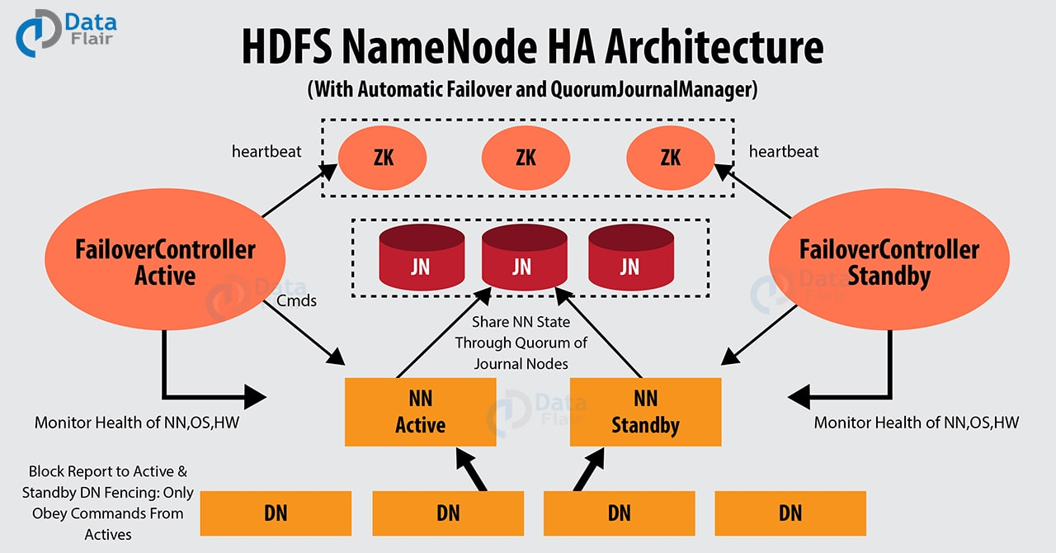

Hardware Resources:-

- NameNode machines: The machines where you run Active and Standby NameNodes, should have exactly the same hardware.

- JournalNode machines: The machines where you run the JournalNodes. (There must be at least three JournalNode daemons, because edit log modifications must be written to a majority of JNs.)

- ZooKeeper machines: For automated failover functionality, there must be an existing ZooKeeper cluster available.

Journal Nodes :-For HA standby namenode communicates and synchronizes with the active namenode.We should run an odd number of JNs, (i.e. 3, 5, 7, etc.). Note that when running with N JournalNodes, the system can tolerate at most (N - 1) / 2 failures and continue to function normal.At least 3 required.

NameNode:The NameNode makes all decisions regarding replication of blocks. It periodically receives a Heartbeat and a Blockreport from each of the DataNodes in the cluster.
NameNodes in the same cluster in an active/passive configuration with a hot standby.
- Active NameNode – It handles all client operations in the cluster.
- Passive NameNode – It is a standby namenode, which has similar data as active NameNode. It acts as a slave, maintains enough state to provide a fast failover, if necessary.
The minimum number of NameNodes for HA is two, but we can configure more. Its suggested to not exceed 5 - with a recommended 3 NameNodes - due to communication overheads.

In above architecture HA cluster has two separate machines are configured as NameNodes. In a working cluster, one of the NameNode machine is in the Active state, and the other is in the Standby state.
The Active NameNode is responsible for all client operations in the cluster, while the Standby acts as a slave. The Standby machine maintains enough state to provide a fast failover -(if required).Failover meaning thereby, switching to a redundant or standby system automatically upon abnormal termination of the previously active system or server.

For Standby node to keep synchronizing with the Active node, both nodes communicate with a group of separate daemons called JournalNodes (JNs). When the Active node performs any namespace modification, the Active node durably logs a modification record to a majority of these JNs.
The Standby node reads the edits from the JNs and continuously watches the JNs for changes to the edit log. Once the Standby Node observes the edits, it applies these edits to its own namespace. When using QJM, JournalNodes acts the shared editlog storage. In a failover event, the Standby ensures that it has read all of the edits from the Jounal Nodes before promoting itself to the Active state. (This mechanism ensures that the namespace state is fully synchronized before a failover completes.) Secondary NameNode is not required in HA configuration because the Standby node also performs the tasks of the Secondary NameNode.ZKFC will make sure that only one Namenode should be active at a time

To provide a fast failover, it is also necessary that the Standby node have up-to-date information on the location of blocks in your cluster. To get accurate information about the block locations, DataNodes are configured with the location of both of the NameNodes, and send block location information and heartbeats to both NameNode machines.

In HA cluster only one of the NameNodes should be Active at a time. Failure to do so, would cause the namespace state to quickly diverge between the two NameNode machines thus causing potential data loss. (This situation is called a split-brain scenario.)
During failover, the NameNode, that is to chosen to become active, takes over the role of writing to the JournalNodes. This process prevents the other NameNode from continuing in the Active state and thus lets the new Active node proceed with the failover safely.

Role of Journal Nodes & How it works :-Role of Journal nodes is to keep both the Namenodes in sync and avoid hdfs split brain scenario by allowing only Active NN to write into journals. Epoc number concept is used by JNs for the same. Journal nodes are distributed system to store edits. Active Namenode as a client writes edits to journal nodes and commit only when its replicated to all the journal nodes in a distributed system. When any namespace modification is performed by the Active node, it durably logs a record of the modification to a majority of these JNs. Standby NameNode constantly monitors edit logs at journal nodes and updates its namespace accordingly. Also to prevent the split-brain scenario, the JournalNodes allow only one NameNode to be a writer at a time.

ZKFC will make sure that only one Namenode should be active at a time.In the event of failover, standby NameNode will ensure that its namespace is completely updated according to edit logs before it is changes to Active state. Thus namespace is fully synchronized before a failover. To provide a fast failover, the standby node must have up-to-date information about the location of data blocks in the cluster. For this to happen, IP address of both the namenode is available to all the datanodes and they send block location information and heartbeats to both NameNode.
Why QJM in HA?
Namenode maintains entire file system in memory we call it as memory fs -image also an edit log, where every time Namenode modifies/updates in file system it records that change in edit logs. From which we can reconstruct the whole in memory fs-image from the edit log.
This is the reason we need to have a backup of namenode edit log. There are many option but the best solution offered by hadoop is QJM i.e Quorum Journal Manager. But first it is essential to know what Quorum is. Quorum is a generic term used in clustering where we say a particular cluster is stable. Quorum gives a list of machines and helps to determine the health of the cluster.

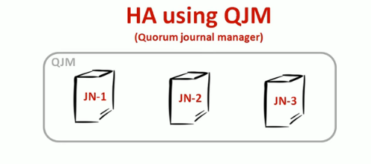
QJM is lightweight so we can pick any three computers may be envolved in hadoop/ existing cluster.No dedicated m/c required.
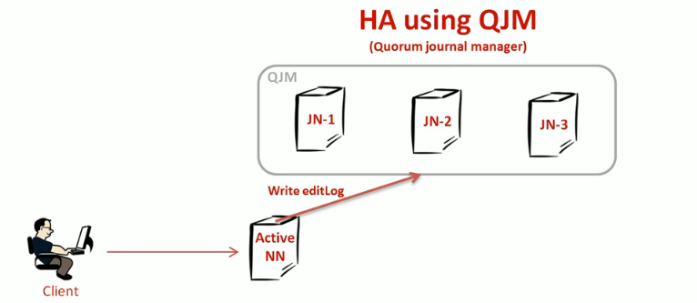

-Configure NN to write edit logs.
-Logs to QJM rather to local disc.

*Why 3 journal node in QJM.
==>Edit log is so critical that we can’t have the backup of it only at one.This will allow the system to tolerate the failure of a single machine. You may also run more than 3 JournalNodes, but in order to actually increase the number of failures the system can tolerate, we should run an odd number of JNs, (i.e. 3, 5, 7, etc.).
Note that when running with N JournalNodes, the system can tolerate at most (N - 1) / 2 failures and continue to function normally.If 3 JNs are used meaning 1 failure of JN is tolerable which fits in (N-1) / 2.Similarly , if 7 JNs are present it can continue to function with 3 JN failures and majority of them will be running successfully. This also shows that the edit logs must be present in majority of JNs for proper functioning of backup.

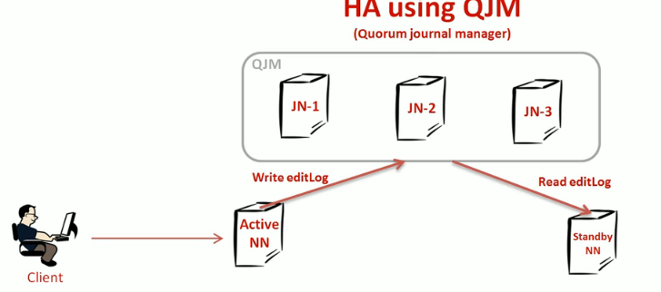

-Configure standby node to read edit logs.

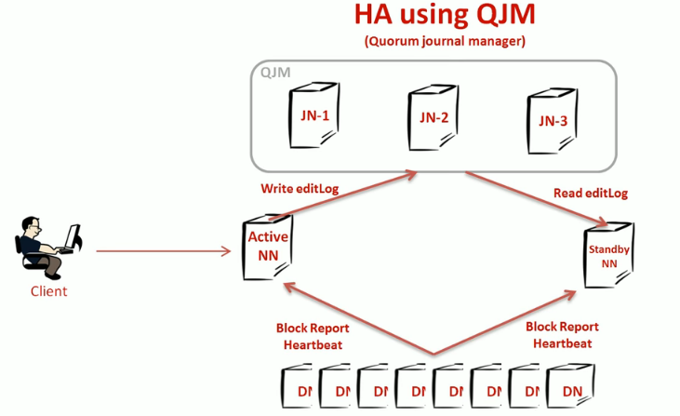

-Datanode comes to picture which send block location information and heartbeats to both NameNode machines.
-Block report(contains health info for the block maintained by the data nodes) and heartbeat fo connection information.
-IP address of both the namenode is available to all the datanodes
*How Standby NN knows Active NN fail and needs to takeover the Active NN role.

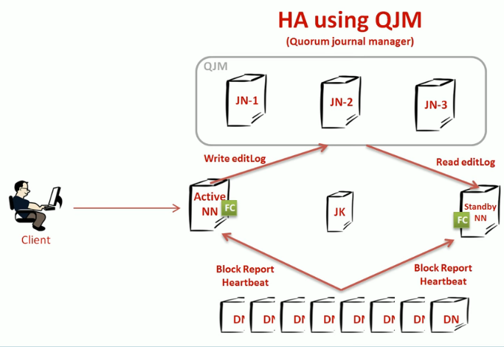
==>Achieved by placing a ZooKeeper and two failover Controller(Zookeeper failOver Controller) in each namenode.
ZKFC is responsible for-- Health Monitoring(by response of NN) , Zookeeper session management(by managing a znode lock), zookeeper-based election(by checking which are unlocked).

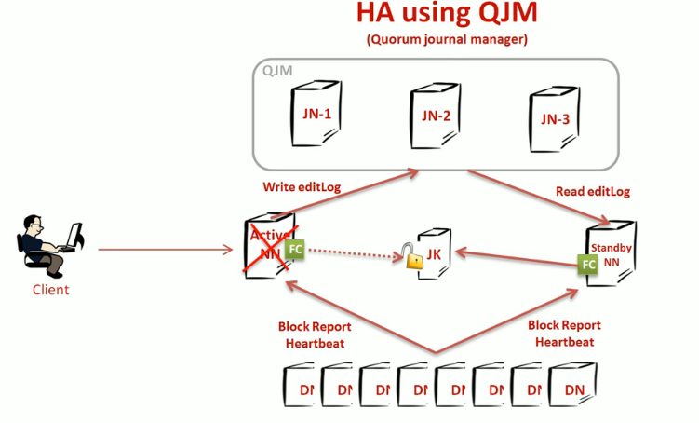
-ANN (Active NameNode) zkfc maintains a log in Zookeeper

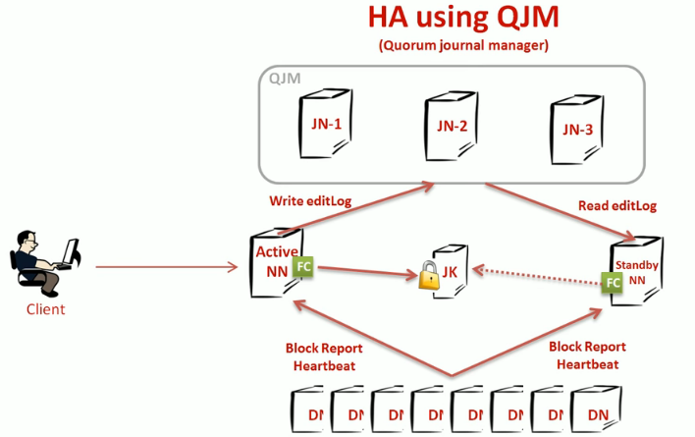
-SBNN(StandBy NameNode) keeps trying to get the logs. But since active node already maintains it the standby never gets that log.

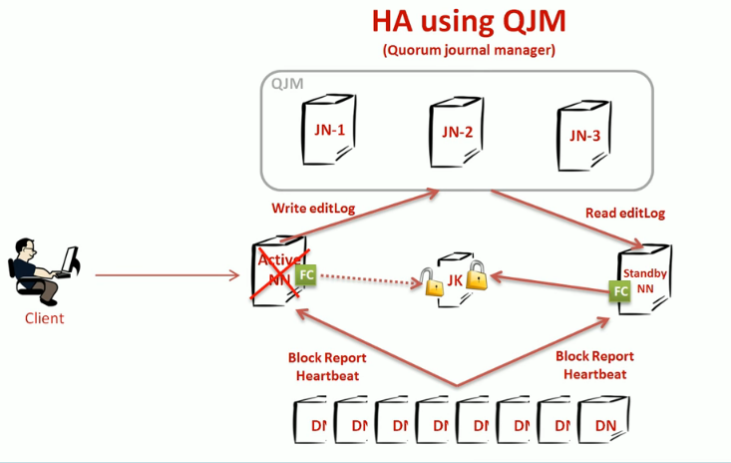
--In case active fails or crashes the log acquired by Active NN expires and standby NN success to get the log..As soon as gets the log, standby changes its’ transition to Active NN.

Standby NN is the backup for the Active NameNode.Active NameNode responsibility is taken by Standby NN.
Steps :-
- In Ambari Web, select Services > HDFS > Summary.
- Click Service Actions, then click Enable NameNode HA.
- The Enable HA wizard launches. This wizard describes the set of automated and manual steps you must take to set up NameNode high availability.
- On the Get Started page, type in a Nameservice ID and click Next.

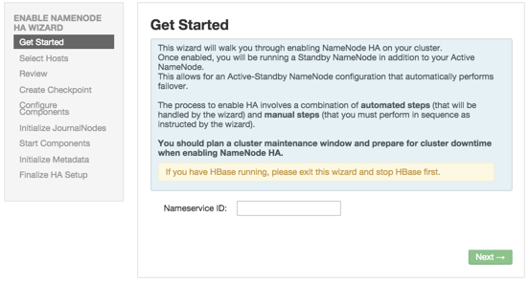
5.On the Select Hosts page, select a host for the additional NameNode and the JournalNodes, and then Next: 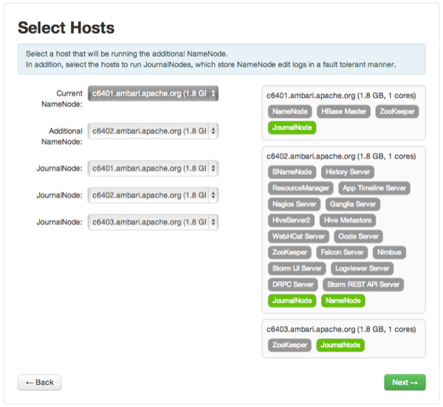

6)on the Review page, confirm your host selections and click Next:
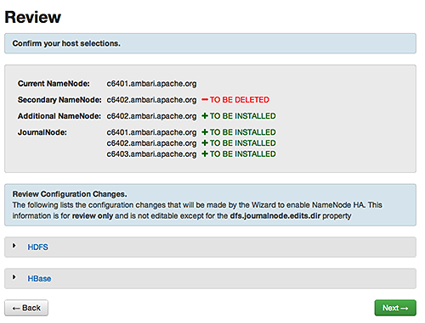

7)Follow the directions on the Manual Steps Required: Create Checkpoint on NameNode page, and then click Next:
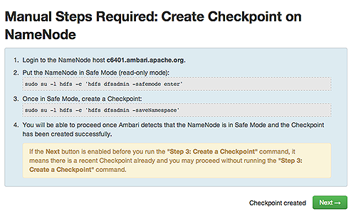
You must log in to your current NameNode host and run the commands to put your NameNode into safe mode and create a checkpoint.
8) When Ambari detects success and the message on the bottom of the window changes to Checkpoint created, click Next.

9)On the Configure Components page, monitor the configuration progress bars, then click Next:
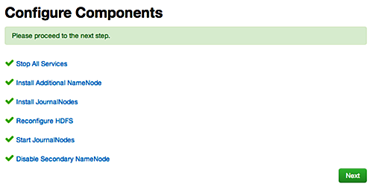

10) Follow the instructions on the Manual Steps Required: Initialize JournalNodes page and then click Next:
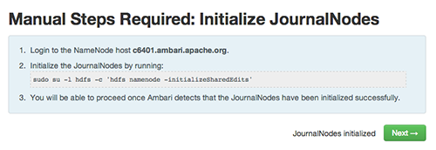
You must log in to your current NameNode host to run the command to initialize the JournalNodes.

11)When Ambari detects success and the message on the bottom of the window changes to JournalNodes initialized, click Next.

12)On the Start Components page, monitor the progress bars as the ZooKeeper servers and NameNode start; then click Next:
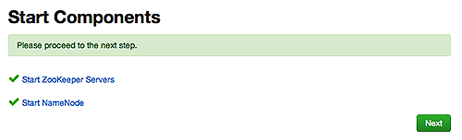
13) On the Manual Steps Required: Initialize NameNode HA Metadata page : Complete each step, using the instructions on the page, and then click Next.
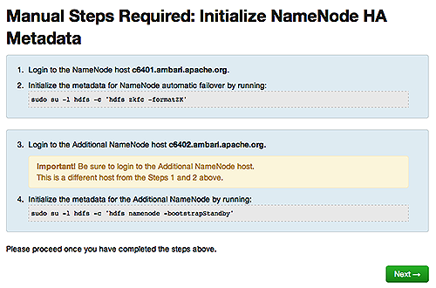
For this step, you must log in to both the current NameNode and the additional NameNode. Make sure you are logged in to the correct host for each command. Click OK to confirm, after you complete each command.

14) On the Finalize HA Setup page, monitor the progress bars as the wizard completes HA setup, then click Done to finish the wizard.
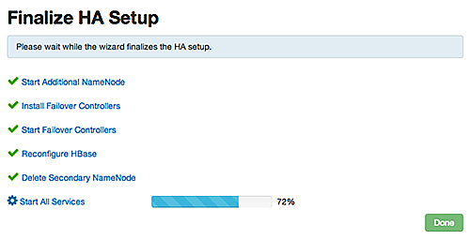
After the Ambari Web UI reloads, you may see some alert notifications. Wait a few minutes until all the services restart.

15)Restart any components using Ambari Web, if necessary.
16)Adjust the ZooKeeper Failover Controller retries setting for your environment:
  - Browse to Services > HDFS > Configs > Advanced core-site.
  - Set ha.failover-controller.active-standby-elector.zk.op.retries=120.

Some Configuration Details:-

To name a few below following bold configuration are present in the xml of hdfs conf.
To configure HA NameNodes, we must add several configuration options to our hdfs-site.xml configuration file.

Path:- vi /etc/hadoop/conf/hdfs-site.xml

dfs.nameservices- the logical name for this new nameservice.This name will be used both for configuration and as the authority component of absolute HDFS paths in the cluster.
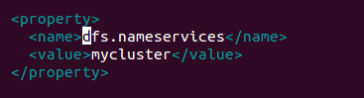
dfs.ha.namenodes.[nameservice ID] --UNIQUE identifiers for each NameNode inthe nameservice. This will be used by DataNodes to determine all the NN in cluster.. For example, if you used “mycluster” as the nameservice ID previously, and you wanted to use “nn1”, “nn2” and “nn3” as the individual IDs of the NameNodes(minimum two for HA), you would configure this as such:
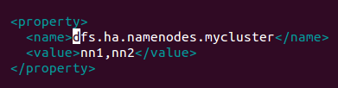

dfs.namenode.rpc-address.[nameservice ID].[name node ID] --the fully-qualified RPC address for each NameNode to listen on

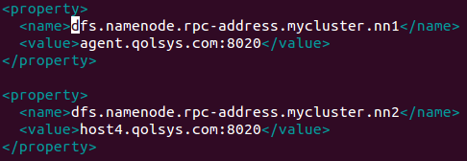

dfs.namenode.http-address.[nameservice ID].[name node ID]--the fully-qualified HTTP address for each NameNode to listen on

