Networking Lab Assignment – IIT2013197

WIRESHARK INTRO ASSIGNMENT

1. The various protocols that appear in the window on performing step 7 are:
- ARP(Address Resolution Protocol)
- DHCP(Dynamic Host Configuration Protocol)
- DHCPv6(Dynamic Host Configuration Protocol version 6)
- HTTP(Hyper Text Transfer Protocol)
- LLMNR
- MDNS
- NBNS
- OSPF
- SSDP
- TCP

2. The HTTP GET message was sent from my system at the time 15:31:15.594864000 and the time the OK message was received is 15:31:15.596616000. So the time taken from when the HTTP GET message was sent until the HTTP OK reply was received is 0.001752 seconds.

3. The Internet address (or the I.P. address) of gaia.cs.umass.edu is 128.119.245.12. The Internet address(or the I.P. address) of my computer is 172.20.33.169.

WIRESHARK HTTP ASSIGNMENT

1. Server as well as browser running HTTP 1.1
2. It can accept languages en-US and en.
3. IP of gaia.cs.umass.edu: 128.119.245.12.
My IP: 172.20.33.166.
4. Status code: 200.
5. The HTML file was last modifies on Fri, 24 July 2015 05:59:01 GMT
6. 128 bytes of content are being returned. The content involves only the HTTP response body and not the headers.
7. There are header elements
8. No. There is no “IF-MODIFIED-SINCE”.
9. Yes. Firstly, we can see that the content-type sent is text/html which means that the data that is sent is HTML data. Also, after the HTTP message, we can see the line-based text data: text/html which contains the entire HTML data that is sent.
10. Yes. There is a line saying “IF-MODIFIED-SINCE”. The “IF-MODIFIED-SINCE” has a vaue of Fri, 24 Jul 2015 05:59:01 GMT. This line is followed by a line “If-None-Match”. It has the value "173-51b98b3588a31".
11.The status code is 304, the phrase returned is Not Modified.
No . It doesnt explicilty send back the html data. It checks whether the data has been modifies since the last time it was loaded. Since it hasn't been modifies(which is represented by the Status Code 304) , the browser actually shows the information stored in the cache. So, the browser doesnt explicitly receive the entire HTML data.

12. A single HTTP GET request message was sent by my browser.
13. 2 data containing TCP segments were required.
14. Status Code: 200. Response Phrase: OK
15. No.

16. 4 HTTP GET requests were sent by the browser. These are:
(i) GET http://gaia.cs.umass.edu/wireshark-labs/HTTP-wireshark-file4.html HTTP/1.1
(ii)GET http://www.pearsonhighered.com/assets/hip/us/hip_us_pearsonhighered/images/pearson_logo.gif HTTP/1.1
(iii)GET http://manic.cs.umass.edu/~kurose/cover_5th_ed.jpg HTTP/1.1
(iv)GET http://caite.cs.umass.edu/~kurose/cover_5th_ed.jpg HTTP/1.1
17. The browser downloads the images in parallel. This is because the GET requests were sent even before the OK response for the first image was recieved. So, the images are downloaded in parallel.

18. Status Code: 401. Response Phrase: Authorization Requires.
19. The new field included is the authorization field.

WIRESHARK DNS ASSIGNMENT

1. iitk.ac.in 202.3.77.184

2. oxford university:
ox.ac.uk nameserver = dns1.ox.ac.uk.
ox.ac.uk nameserver = dns2.ox.ac.uk.
ox.ac.uk nameserver = dns0.ox.ac.uk.
ox.ac.uk nameserver = ns2.ja.net.

3. nslookup mail.yahoo.com dns0.ox.ac.uk

4. UDP (User Datagram Protocol)

5. Destination Port of Query: 53

Source Port of Response: 53

6. IP: 172.31.1.21 (DNS Server of the college)

also same as in the configuration of my machine

7. Standard Query

No, no answers in this

8. There are 2 answers provided. These are:

(i)www.ietf.org: type A, class IN, addr 132.151.6.75
Name: www.ietf.org
Type: A (Host Address) (1)
Class: IN (0x0001)
Time to live: 1678
Data length: 4
Address: 132.151.6.75 (132.151.6.75)
(ii)www.ietf.org: type A, class IN, addr 65.246.255.51
Name: www.ietf.org
Type: A (Host Address) (1)
Class: IN (0x0001)
Time to live: 1678
Data length: 4

9. Yes, it is the same
10. Yes, it does
11. Destination Port of Query message: 53
Source Port of DNS response message: 53
12. IP: 172.31.1.21
Yes, it is local DNS Server of the college
13. Standard Query
No, it doesn't contain any answers
14. Name: mit.edu
Type: A (Host Address)
Class: IN (0x0001)
Time to live: 20 seconds
Data length: 4
Addr: 23.214.122.74 (23.214.122.74)
15.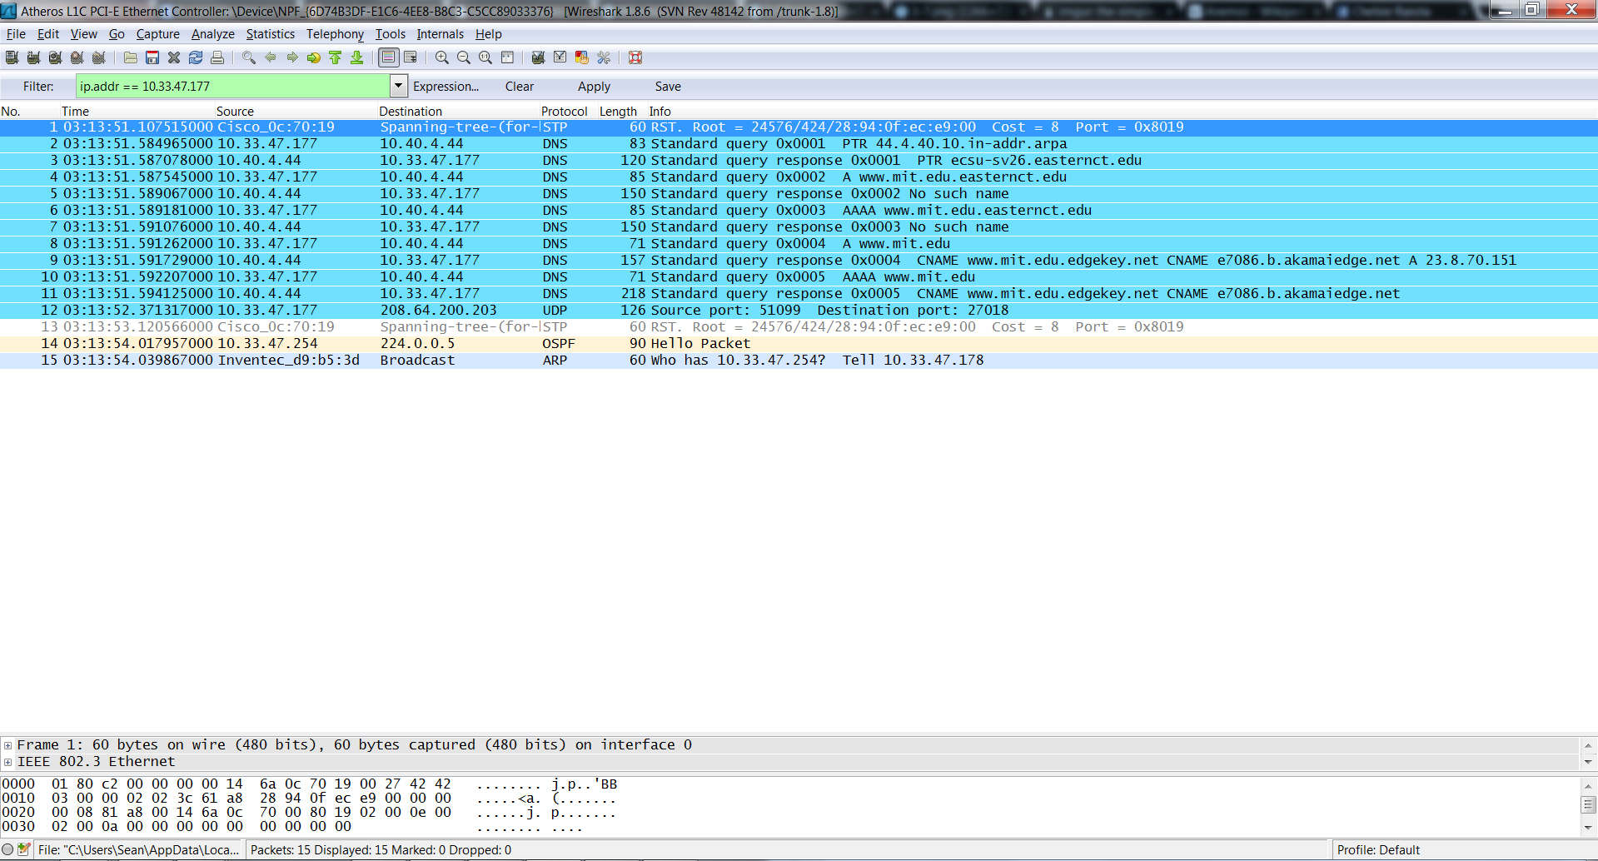

16. IP: 172.31.1.21

Yes, it is the local DNS server of the college

17. Standard Query

No, the query message doesn't contain any answers

18. Yes, it provides names of MIT nameservers

Name servers: usw2.akam.net

asia1.akam.net

asia2.akam.net

use2.akam.net

No, it didn't provide the IP address of the

nameservers 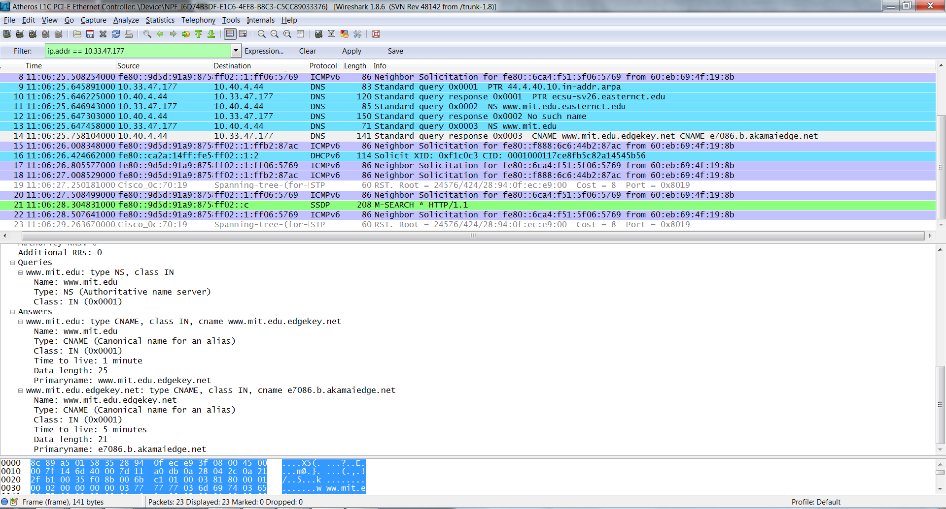

20. The DNS query message is sent to 18.72.0.3 which is not the same as my local DNS server.This IP address corresponds to www.aiit.or.kr.
21. It’s a standard type A query that doesn’t contain any answers.
22. One answer s provided in the DNS response message. It contains the following: Answers www.aiit.or.kr: type A, class inet, addr 218.36.94.200
Name: www.aiit.or.kr
Type: Host address
Class: inet
Time to live: 1 hour
Data length: 4
Addr: 218.36.94.200

23. 