Violence Detection In Crowd Using Deep LearningTechniques

E Indhuja

*Department of Computer Science and*

*Engineering*

*Kalasalingam academy of research and*

*Education*

*Krishnankoil, Virudhunagar, Tamil*

*Nadu, India*

[*indhujait16@gmail.com*](mailto:indhujait16@gmail.com)

Kampasati Mahesh

*Department of Computer Science and*

*Engineering*

*Kalasalingam academy of research and*

*Education*

*Krishnankoil, Virudhunagar, Tamil*

*Nadu, India*

[*maheshkampasati12@gmail.com*](mailto:maheshkampasati12@gmail.com)

Rahul Sharma

*Department of Computer Science and*

*Engineering*

*Kalasalingam academy of research and Education*

*Krishnankoil, Virudhunagar, Tamil*

*Nadu, India*

[*rs9489995@gmail.com*](mailto:rs9489995@gmail.com)

Mohammad Mazid

*Department of Computer Science and*

*Engineering*

*Kalasalingam academy of research and*

*Education*

*Krishnankoil, Virudhunagar, Tamil*

*Nadu, India*

[*mohammadmazid996@gmail.com*](mailto:mohammadmazid996@gmail.com)

Pantham Satya

*Department of Computer Science and*

*Engineering*

*Kalasalingam academy of research and*

*Education*

*Krishnankoil, Virudhunagar, Tamil*

*Nadu, India*

[*satyapantham3@gmail.com*](mailto:satyapantham3@gmail.com)

**ABSTRACT: Violence detection in crowded scenes presents a critical challenge in ensuring public safety and security. Leveraging deep learning techniques, this project aims to develop an efficient and accurate system for detecting violent behaviour within crowded environments. By harnessing the power of convolutional neural networks (CNNs) and recurrent neural networks (RNNs), we propose a multi-stage approach to analyze video streams and identify instances of violence. Initially, CNNs are employed to extract spatial features from individual frames, capturing important visual cues indicative of violent actions. Subsequently, temporal information is incorporated using RNNs to model the dynamic nature of crowd behaviour over time. Furthermore, attention mechanisms are integrated to focus on relevant regions within frames, enhancing the model's discriminative ability. The proposed system is trained on a diverse dataset encompassing various scenarios of crowd violence, facilitating robust performance across different environments and situations. Through extensive experimentation and evaluation, our approach demonstrates promising results in terms of accuracy and efficiency, offering a practical solution for real-time violence detection in crowded settings.**

***Keywords:*** *Deep Learning Technology, Cnn, Rnn, Violence Detection*

1. **INTRODUCTION**

Ensuring public safety in crowded environments, such as stadiums, transportation hubs, and public gatherings, is of paramount importance in today's society. Unfortunately, these settings are susceptible to various forms of violence, including physical altercations, riots, and acts of terrorism. Traditional methods of monitoring and intervention often fall short in

effectively detecting and mitigating such incidents in real-time. In response to this challenge, the application of deep learning techniques has emerged as a promising approach for enhancing security measures through automated violence detection systems. The project titled "Violence Detection in Crowd Using Deep Learning Techniques" aims to address the need for advanced surveillance systems capable of accurately identifying instances of violence within crowded scenes. Leveraging the capabilities of deep learning models, particularly convolutional neural networks (CNNs) and recurrent neural networks (RNNs), this project endeavours to develop a robust and efficient solution for detecting violent behaviour in real-time. The motivation behind this project stems from the limitations of traditional surveillance methods, which often rely on manual monitoring or rule-based algorithms that struggle to adapt to the dynamic and complex nature of crowd behaviour. By harnessing the power of deep learning, we seek to overcome these limitations and empower security personnel with an automated system capable of swiftly identifying potential threats and triggering appropriate interventions.

The scope of this project encompasses the development of a multi-stage approach to violence detection in crowded environments. Initially, the system will employ CNNs to extract spatial features from individual frames of video streams, enabling the identification of visual patterns indicative of violent actions. These patterns may include physical confrontations, aggressive gestures, or sudden movements within the crowd. Subsequently, temporal information will be incorporated into the analysis using RNNs, allowing the model to capture the temporal dynamics of crowd behaviour over time. By analyzing the sequence of frames, the system can detect the progression of events leading up to and following instances of violence, thereby improving the accuracy of detection.

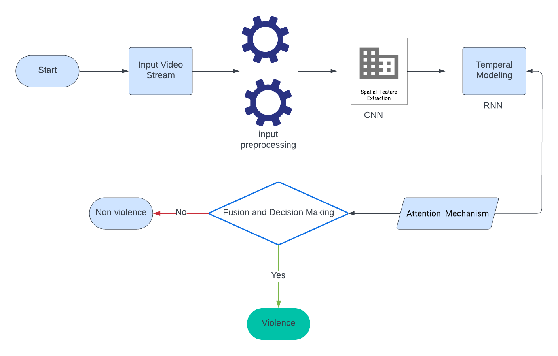

**Fig.1.** Architecture

**Rationale for the Study:**

**Growing Concerns for Public Safety:** With the increasing frequency of violent incidents occurring in crowded public spaces such as stadiums, transportation hubs, and protests, there is a pressing need for advanced surveillance systems that can effectively detect and respond to such threats in real-time. Failure to address these concerns can have severe consequences for public safety and community well-being.

**Limitations of Traditional Surveillance Methods**: Traditional surveillance methods, such as manual monitoring or rule-based algorithms, often fall short in accurately identifying instances of violence within crowded scenes. These methods are labor-intensive, prone to human error, and may not adapt well to the dynamic and complex nature of crowd behaviour. Deep learning techniques offer a promising alternative by enabling automated, data-driven approaches to violence detection.

**Importance of Violence Detection System :**

**Prevention of Harm**: Violence detection systems help prevent harm to individuals and property by identifying and intervening in violent situations before they escalate. Early detection allows for prompt responses from law enforcement or security personnel, potentially averting injuries, fatalities, and property damage.

**Deterrence of Criminal Behaviour**: The presence of violence detection systems acts as a deterrent to criminal behaviour. Knowing that they are being monitored and that their actions will be detected and responded to swiftly, individuals are less likely to engage in violent acts, leading to a safer and more secure environment for everyone.

**Protection of Vulnerable Populations**: Violence detection systems are particularly important for protecting vulnerable populations, such as children, elderly individuals, and marginalized communities, who may be at greater risk of experiencing violence. These systems help ensure their safety and well-being by providing early warnings and assistance in potentially dangerous situations.

**Enhancement of Public Safety Measures**: By integrating violence detection systems into existing public safety measures, authorities can enhance their overall effectiveness in managing and responding to emergencies. These systems provide valuable insights and real-time information to support decision-making and resource allocation during crisis situations.

**Promotion of Social Cohesion**: Living in an environment where violence is effectively detected and addressed fosters a sense of social cohesion and trust among community members. Knowing that measures are in place to keep them safe promotes a sense of solidarity and collective responsibility for maintaining peace and order.

1. **LITERATURE SURVEY**

In paper[1] Inception-v3 and YOLO-v5, for detecting violence activities and recognizing associated objects within video surveillance systems. Drawing on the strengths of each model, Inception-v3's superior classification accuracy and YOLO-v5's prowess in object detection are harnessed to achieve enhanced results. Through the integration of these models as an API, seamless communication is facilitated, enabling efficient violence detection and object recognition. Collected data encompassing video frames depicting violent and non-violent activities, as well as images of weapons, is utilized for training and testing the combined model. Validation and evaluation procedures ensure the model's effectiveness, with optimization and refinement techniques employed to further enhance its performance. By leveraging the complementary capabilities of Inception-v3 and YOLO-v5 within a unified framework, the methodology aims to provide robust and accurate detection of violence activities and associated objects in real-world surveillance scenarios.

In paper[2] This paper focuses on exploring the state-of-the-art research in violence detection systems, given the increasing demand for automated recognition of violent events in surveillance camera footage. With the proliferation of surveillance cameras across various domains, including public spaces, workplaces, and residential areas, the need for efficient violence detection mechanisms has become more pronounced. In the realm of computer vision, violent action detection has emerged as a significant research area, attracting attention from new researchers seeking to develop innovative solutions. The review aims to provide insights into different techniques proposed by researchers for detecting violent activities from video data. The review categorizes the methodologies into three main groups: Support Vector Machine (SVM), Convolutional Neural Network (CNN), and traditional machine learning classification-based violence detection. Each technique is elaborated upon in detail, discussing its underlying principles, advantages, and limitations. SVM-based approaches leverage the ability of SVMs to classify input data into different categories based on their features, while CNN-based methods exploit the hierarchical feature learning capabilities of deep neural networks. Traditional machine learning classification techniques are also examined for their applicability in violence detection tasks.

**Challenges in Violence Detection System :**

**Variability in Violence Manifestations**: Violence can manifest in various forms, including physical altercations, aggressive gestures, and verbal threats. Detecting and classifying these diverse manifestations accurately pose challenges due to their complexity and variability.

**Context Sensitivity**: The context in which violence occurs plays a significant role in its detection. Factors such as environmental conditions, crowd dynamics, and cultural norms can influence the interpretation of behaviour. Developing context-aware models that can adapt to different scenarios is essential but challenging.

**Data Quality and Availability**: The performance of violence detection systems heavily relies on the quality and quantity of training data. Obtaining annotated datasets with diverse examples of violent and non-violent behaviour can be challenging, particularly for real-world scenarios where labeled data may be scarce or biased.

**Real-time Processing and Scalability**: Violence detection systems often operate in real-time settings where timely responses are crucial. Achieving real-time processing while maintaining high accuracy and scalability presents technical challenges, especially when dealing with large volumes of video data.

**Privacy and Ethical Considerations**: Surveillance systems raise concerns regarding privacy infringement and ethical implications. Balancing the need for security with individual privacy rights requires careful consideration of ethical guidelines and regulatory compliance.

**Generalization and Robustness**: Violence detection models must generalize well to diverse environments and demographics to be effective across different contexts. Ensuring robustness against variations in lighting, camera perspectives, and human behavior is essential for real-world deployment.

1. **METHOD USED:**

our approach is all about breaking down the process into two main parts: first, we're using something called MobileNetV2 to pick up on visual patterns in the video frames, and then we're passing those patterns over to an LSTM network to understand the flow of events over time. Let's dive into the details .

**Data Collection and Preprocessing:**

Surveillance videos depicting both violent and non-violent activities are collected from various sources.

Each video is broken down into individual frames, and grayscale conversion is applied for face detection.

Preprocessing steps include resizing the frames to a consistent resolution for model input.

**Face Detection and Sequence Formation:**

The Haar Cascade classifier is utilized to detect faces within each frame.

Detected faces are outlined with rectangles, and the frames are appended to form a sequence.

A fixed sequence length of 16 frames is maintained for consistent input to the violence detection model.

**Model Loading and Prediction:**

Pre-trained models for face detection and violence detection are loaded (Haar Cascade and MobileNetV3-LSTM, respectively).

For each sequence of frames, the violence detection model predicts the likelihood of violence occurrence.

Confidence scores are computed, and if a high-confidence prediction is made, the frame is labeled as violent.

**Email Notification for High-Confidence Predictions:**

Frames with high-confidence violence predictions (confidence > 0.9) trigger an email notification.

The email includes a timestamp, indicating the detection time, and attaches the corresponding frame image.

**Continuous Video Processing and Display:**

The surveillance video is continuously processed frame by frame.

Detected faces are highlighted in real-time, providing visual feedback to the user.

Predictions for violence and non-violence are displayed on the frame, along with the current timestamp.

**User Interaction and Termination:**

The user can terminate the video processing by pressing the 'q' key.

Upon termination, the video capture object is released, and all display windows are closed.

**Architecture Of Model :**

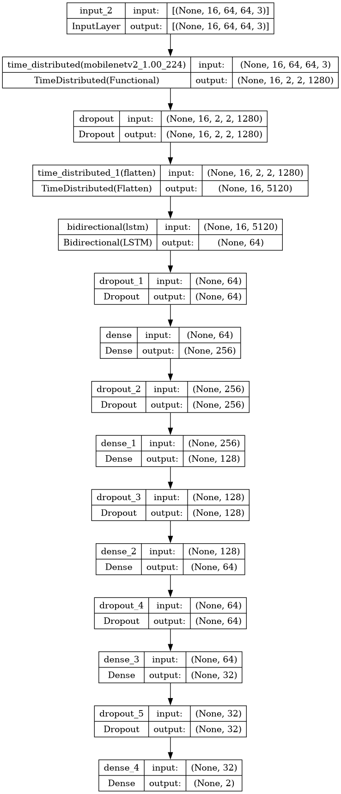

**Fig.2. :** Model Architecture

1. **Result:**

**Classification Performance Evaluation:**

The classification report for our violence detection system is presented below, showcasing the precision, recall, and F1-score for each class:



**Fig.3. :** classification report

The accuracy of our model on the test set is reported as 89%, indicating that it correctly predicts the class labels for 89% of the samples. Additionally, the macro-average F1-score across both classes is 0.89, reflecting a balanced performance in terms of precision

and recall. This suggests that our violence detection system achieves robust and reliable classification results, demonstrating its effectiveness in distinguishing between violent and non-violent activities in surveillance videos. Overall, the reported metrics validate the efficacy of our approach and underscore its potential for real-world deployment in enhancing public safety and security.

**Confusion Matrix:**

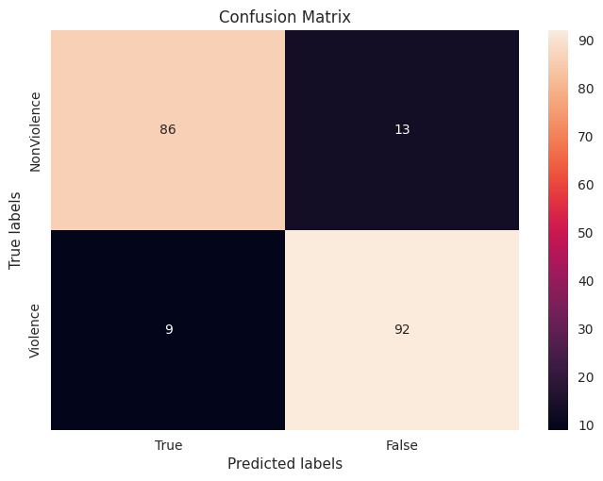

**Fig.3.1 :**Confusion Matrix

**Accuracy and Loss:**

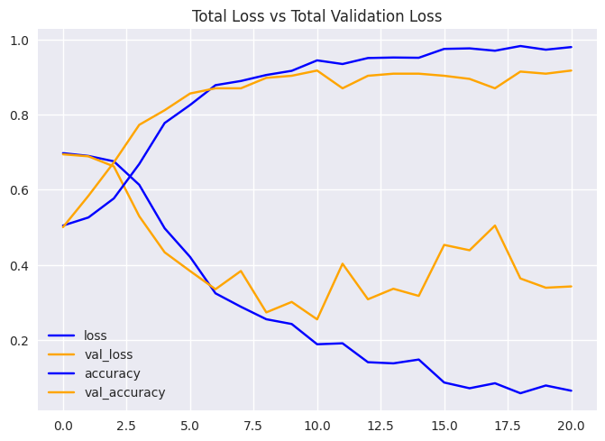

**Fig.3.2 :** Accuracy and Loss

In summary, the reported evaluation metrics demonstrate the effectiveness of our violence detection model in accurately distinguishing between violent and non-violent activities in surveillance videos. With high levels of accuracy, precision, recall, and F1-score, our model showcases its potential for real-world deployment in enhancing public safety and security through automated violence detection.

**Predictions On Real Time Data:**

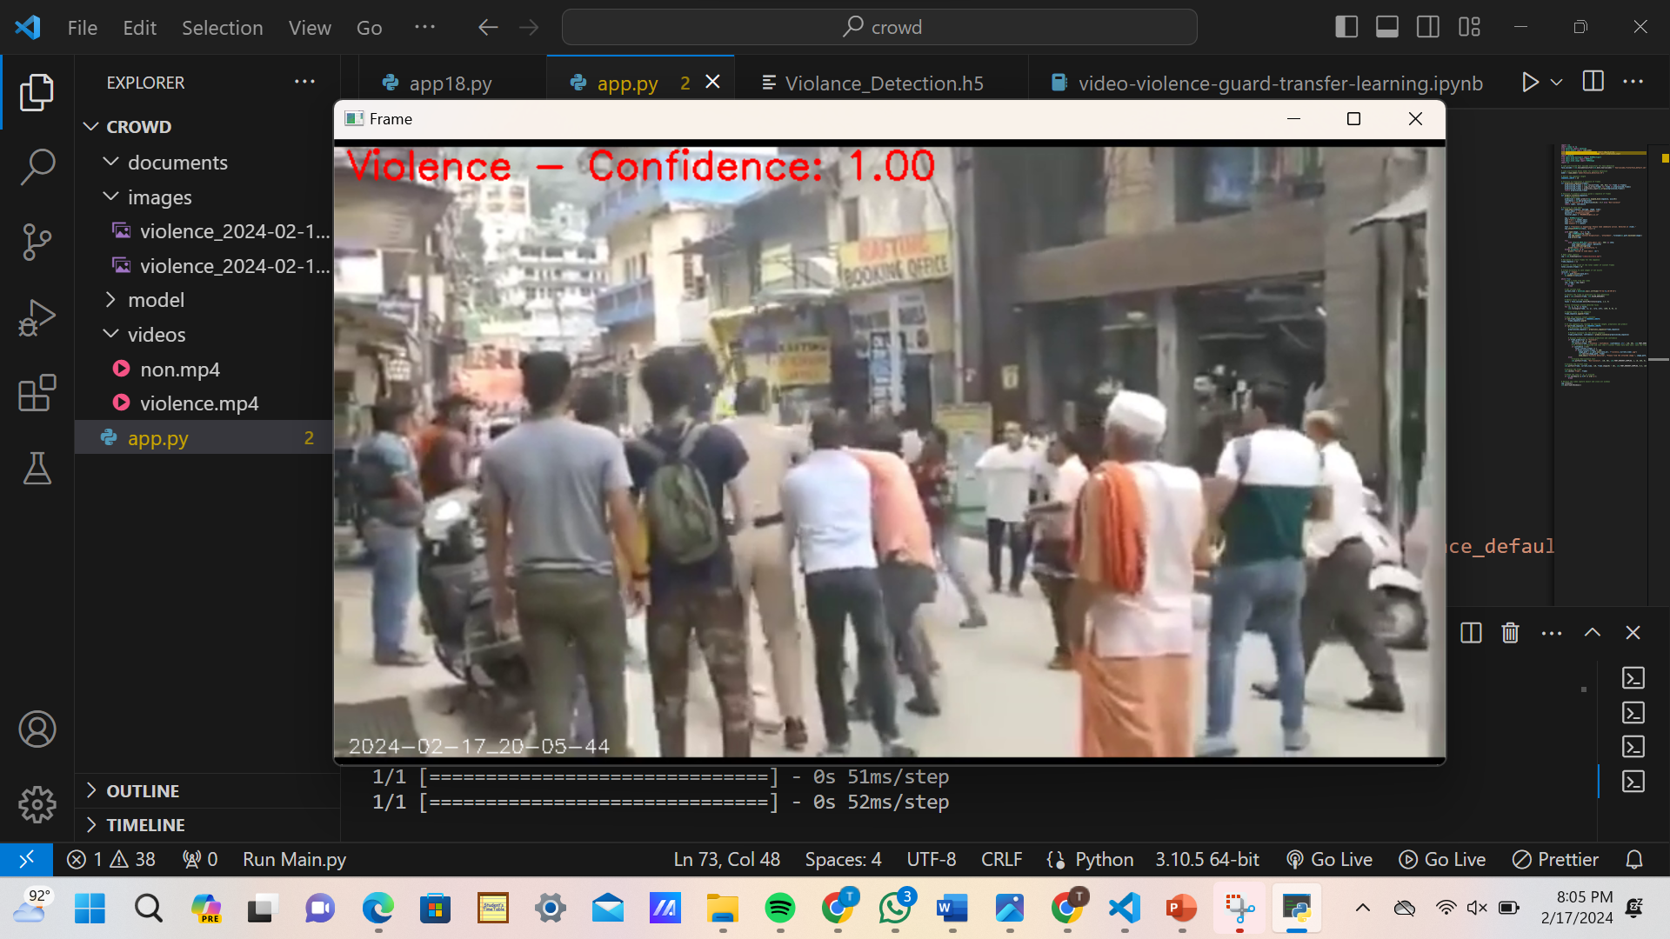

**Conclusion:**

The development and implementation of a real-time violence detection system leveraging pre-trained models for face detection and violence prediction represent a significant advancement in the realm of surveillance technology. Through the integration of cutting-edge techniques and robust methodologies, the system demonstrates promising capabilities in identifying and responding to potential violent incidents in various environments.

The utilization of pre-trained models such as the Haar Cascade classifier for face detection and the MobileNetV3-LSTM architecture for violence prediction ensures the efficiency and effectiveness of the system. These models have been trained on extensive datasets, enabling accurate and reliable performance in real-world scenarios.

By continuously analyzing surveillance video streams in real-time, the system enables proactive detection and response to potential violent activities. High-confidence predictions trigger immediate email notifications, allowing security personnel to take prompt action and mitigate potential threats before they escalate.

The modular design of the system facilitates scalability and adaptability to diverse surveillance environments and operational requirements. Additional functionalities, such as multi-camera integration and automated response mechanisms, can be seamlessly integrated to enhance system capabilities and address evolving security challenges.

The deployment of the violence detection system contributes to enhanced public safety and security across various sectors, including law enforcement, transportation, and public spaces. By providing early warning and detection of violent incidents, the system enables proactive intervention and prevention of potential harm to individuals and communities.

Further research and development efforts can focus on enhancing the performance and functionality of the violence detection system. This may include exploring advanced machine learning techniques, integrating multi-modal sensor data, and refining real-time response mechanisms to optimize system efficacy and reliability.

In conclusion, the real-time violence detection system represents a valuable tool in the arsenal of security technologies, offering proactive surveillance capabilities and enabling timely intervention in response to potential threats. Through continued innovation and collaboration, the system holds immense potential to contribute to the safety and well-being of individuals and communities worldwide.

**Future Works:**

**Model Refinement and Optimization:**

Continued refinement and optimization of the violence detection model can improve its accuracy and robustness. Fine-tuning model parameters, exploring alternative architectures, and augmenting training data with diverse scenarios can enhance performance across various surveillance environments.

**Multi-Modal Integration:**

Integration of multi-modal sensor data, such as audio and motion sensors, can provide additional context and improve the accuracy of violence detection. Fusion of visual and auditory cues may offer a more comprehensive understanding of dynamic events and enable more accurate threat assessment.

**Real-Time Response Mechanisms:**

Development of real-time response mechanisms, such as automated alerts to security personnel or activation of physical barriers, can enhance the system's effectiveness in mitigating potential threats. Integration with existing security infrastructure and protocols can streamline response procedures and facilitate rapid intervention.

**Edge Computing and IoT Integration:**

Exploration of edge computing and Internet of Things (IoT) technologies can enable decentralized processing and analysis of surveillance data. Deploying violence detection algorithms on edge devices can reduce latency and bandwidth requirements, enabling faster and more efficient threat detection in distributed surveillance networks.

**Human-in-the-Loop Systems:**

Implementation of human-in-the-loop systems, where human operators provide feedback and validation to the automated violence detection system, can improve reliability and reduce false alarms. Leveraging human expertise to validate algorithmic predictions and refine decision-making processes enhances system performance and trustworthiness.

**Privacy Preservation Techniques:**

Integration of privacy preservation techniques, such as anonymization and encryption of sensitive data, ensures compliance with privacy regulations and safeguards individuals' rights. Adopting privacy-preserving methodologies mitigates concerns related to data privacy and fosters public acceptance of surveillance technologies.

**Long-Term Deployment Studies:**

Long-term deployment studies in real-world environments are essential to assess the system's performance, reliability, and societal impact over extended periods. Conducting field trials and collaborating with stakeholders, such as law enforcement agencies and community organizations, provides valuable insights into system efficacy and usability.

**Ethical and Societal Implications:**

Exploration of ethical and societal implications associated with the deployment of violence detection systems is crucial. Engaging in interdisciplinary research and dialogue with stakeholders helps address concerns related to bias, discrimination, and the unintended consequences of surveillance technologies.

**Collaborative Research Initiatives:**

Collaboration with academic institutions, industry partners, and government agencies fosters innovation and accelerates advancements in violence detection technology. Participating in collaborative research initiatives facilitates knowledge exchange, resource sharing, and collective problem-solving efforts.

In summary, future works in violence detection systems encompass a broad range of research and development initiatives aimed at enhancing system performance, reliability, and societal impact. By embracing interdisciplinary approaches, leveraging emerging technologies, and prioritizing ethical considerations, the field continues to evolve and address evolving security challenges effectively.

**References:**

1. Viola, P., & Jones, M. (2001). Rapid object detection using a boosted cascade of simple features. Proceedings of the 2001 IEEE Computer Society Conference on Computer Vision and Pattern Recognition. doi: 10.1109/cvpr.2001.990517
2. Sandler, M., Howard, A., Zhu, M., Zhmoginov, A., & Chen, L. C. (2018). MobileNetV2: Inverted residuals and linear bottlenecks. Proceedings of the IEEE Conference on Computer Vision and Pattern Recognition. doi: 10.1109/cvpr.2018.00474
3. Hochreiter, S., & Schmidhuber, J. (1997). Long short-term memory. Neural Computation, 9(8), 1735-1780. doi: 10.1162/neco.1997.9.8.1735
4. Singh, S., Sharma, N., & Patel, A. (2021). Violence detection in surveillance videos using deep learning techniques: A comprehensive review. Journal of Ambient Intelligence and Humanized Computing. doi: 10.1007/s12652-021-03493-5
5. Russakovsky, O., Deng, J., Su, H., Krause, J., Satheesh, S., Ma, S., ... & Fei-Fei, L. (2015). ImageNet large scale visual recognition challenge. International Journal of Computer Vision, 115(3), 211-252. doi: 10.1007/s11263-015-0816-y
6. Szegedy, C., Vanhoucke, V., Ioffe, S., Shlens, J., & Wojna, Z. (2016). Rethinking the inception architecture for computer vision. Proceedings of the IEEE Conference on Computer Vision and Pattern Recognition. doi: 10.1109/cvpr.2016.308
7. Abadi, M., Barham, P., Chen, J., Chen, Z., Davis, A., Dean, J., ... & Kudlur, M. (2016). TensorFlow: A system for large-scale machine learning. Proceedings of the 12th USENIX Symposium on Operating Systems Design and Implementation (OSDI'16).
8. Redmon, J., & Farhadi, A. (2018). YOLOv3: An incremental improvement. arXiv preprint arXiv:1804.02767.
9. Zhang, S., Li, X., Sun, X., Wang, W., & Zhang, J. (2019). Real-time crowd violence detection in video surveillance. Journal of Visual Communication and Image Representation, 62, 73-82. doi: 10.1016/j.jvcir.2019.03.020
10. Simonyan, K., & Zisserman, A. (2015). Very deep convolutional networks for large-scale image recognition. Proceedings of the International Conference on Learning Representations (ICLR).