# **Database Querying**

## Given the Contacts table below, write a SQL statement to get all contacts that have both email and phone values populated

### **Query :**

select * from Contacts

where email is not null and phone is not null;



## Given the Users table below, write a SQL statement to get the count of users per groupId

### **Query :**

select groupid, count(groupId) groupId_Count

from Users

group by groupid

order by 1;

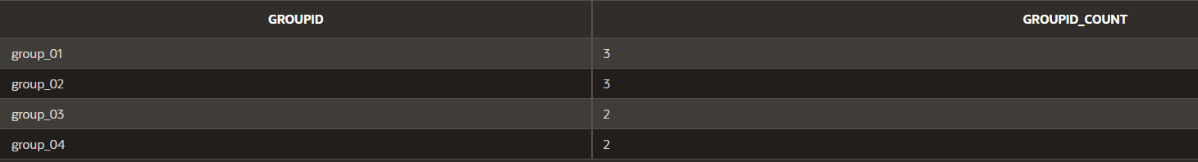

## Given the Customers and Orders table below, write a SQL statement to get the customerName, orderId and orderDate in a single dataset

### **Query :**

select cust.customerName, ord.orderId, ord.orderDate

from Customers cust,Orders ord

where cust.id = ord.customerId

order by cust.id;

