**//Use the rest countries API url -> https://restcountries.eu/rest/v2/all and display all the country flags in console**

**Code:**

var xhr = new XMLHttpRequest();

xhr.open("GET", "https://raw.githubusercontent.com/rvsp/restcountries-json-data/master/res-countries.json");

xhr.onload = function () {

    if (xhr.status >= 200 && xhr.status < 300) {

        var t = JSON.parse(this.response);

        //Display Flags

        let data1 = t.filter(t=>t.flag).map(t=>t.flag);

        console.log(data1);

    }

    else {

        console.log("Data is not available");

    }

};

xhr.send();

**Output:**

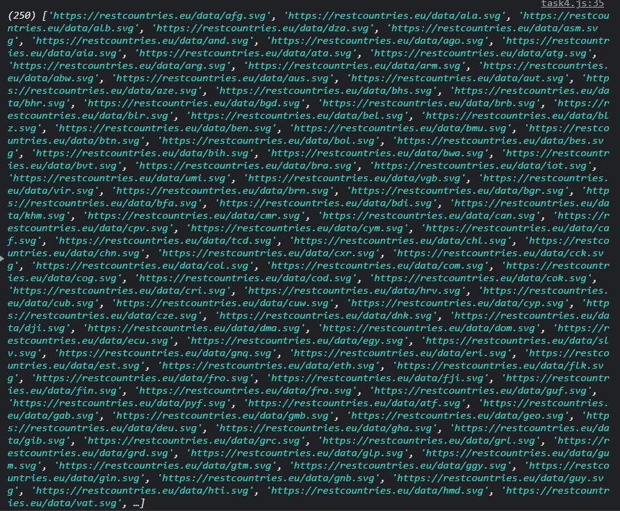

**Use the same rest countries and print all countries name, region, sub-region and population**

**Code**:

var xhr = new XMLHttpRequest();

xhr.open("GET", "https://raw.githubusercontent.com/rvsp/restcountries-json-data/master/res-countries.json");

xhr.onload = function () {

    if (xhr.status >= 200 && xhr.status < 300) {

        var t = JSON.parse(this.response);

        //countries name, region, sub region and population

        t.forEach(element => {

            console.log(

                `Name :${element.name},Region:${element.region},subregion:${element.subregion},Populatioon:${element.population}`)

        });

    }

    else {

        console.log("Data is not available");

    }

};

xhr.send();

**Output:**

