**GUVI: Zen Class — Part 1: Find the culprits and nail them — debugging javascript**

**Find the culprit**

fix.html

<!DOCTYPE html>  
<html>  
<body>  
 <script>  
 alert( “I’m JavaScript!’);  
 </script>  
 Whats the error in this ?  
</body>  
</html>

Output:

<!DOCTYPE html>

<html>

<body>

<script>

alert( "I’m JavaScript!");

</script>

Whats the error in this ?

</body>

</html>

**Find the culprit and invoke the alert**

fix.html

<!DOCTYPE html>  
<html>  
<body>  
 <script src=”script.js”></script>  
</body>  
</html>

scripts.js

alert(“I’m invoked!”);

Output:

fix.html

<!DOCTYPE html>  
<html>  
<body>  
 <script src=”scripts.js”></script>  
</body>  
</html>

scripts.js

alert(“I’m invoked!”);

**Explain the below how it works**

explain.html

<!DOCTYPE html>  
<html>  
<body>  
 <script src=”script.js”></script>  
</body>  
</html>

script.js

alert("I'm JavaScript!");  
alert('Hello') // this line is not having semicolon  
alert(`Wor  
 ld`)  
alert(3 +  
1  
+ 2); // this is multiple line code and its working

Output:

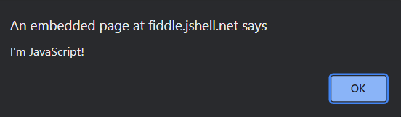

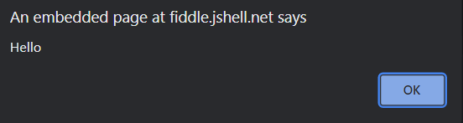

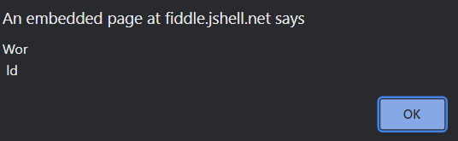

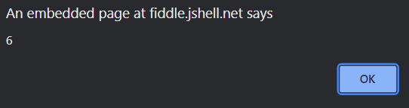

**Fix the below to alert**Guvi geek

fix.html

<!DOCTYPE html>  
<html>  
<body>  
 <script src=”script.js”></script>  
</body>  
</html>

script.js

let admin=9, fname=10.5;   
fname = "Guvi";  
lname = "geek"  
admin = fname+lname;alert( admin ); // "Guvi geek"

Output:

<!DOCTYPE html>  
<html>  
<body>  
 <script src=”script.js”></script>  
</body>  
</html>

script.js

let admin=9, fname=10.5;   
fname = "Guvi";  
lname = "geek"  
admin = fname+” ”+lname;

alert( admin ); // "Guvi geek"

**Fix the below to alert**hello Guvi geek

fix.html

<!DOCTYPE html>  
<html>  
<body>  
 <script src=”script.js”></script>  
</body>  
</html>

script.js

let fname=10.5;   
fname = "Guvi";  
lname = "geek"let name = fname+lname;alert( 'hello ${name}' );

Output:

fix.html

<!DOCTYPE html>  
<html>  
<body>  
 <script src=”script.js”></script>  
</body>  
</html>

script.js

let fname=10.5;

fname = "Guvi";

lname = "geek";

let name = fname+" "+lname;

alert( `hello ${name}` );

**Fix the below to alert sum of two numbers**

fix.html

<!DOCTYPE html>  
<html>  
<body>  
 <script src=”script.js”></script>  
</body>  
</html>

script.js

let a = prompt("First number?");  
let b = prompt("Second number?");  
alert(a + b);

Output:

fix.html

<!DOCTYPE html>  
<html>  
<body>  
 <script src=”script.js”></script>  
</body>  
</html>

script.js

let a = prompt("First number?");

let b = prompt("Second number?");

alert(Number(a) + Number(b));

**If you run the below script you will get “**Code is Blasted**”**

**Explain Why the Code is blasted and how to diffuse it and get “**Diffused**”.**

fix.html

<!DOCTYPE html>  
<html>  
<body>  
 <script src=”script.js”></script>  
</body>  
</html>

script.js

var a = "2" > "12";//Don't touch below this  
if (a) {  
 console.log("Code is Blasted")  
}  
else  
{  
 console.log("Diffused")   
}

Output:

<!DOCTYPE html>  
<html>  
<body>  
 <script src=”script.js”></script>  
</body>  
</html>

script.js

var a = "2" < "12";//Don't touch below this  
if (a) {  
 console.log("Code is Blasted")  
}  
else  
{  
 console.log("Diffused")

**Reason:**

Strings are compared [lexicographically](http://en.wikipedia.org/wiki/Lexicographical_order). Since the first two characters are the same it checks the third character to check the greater than condition.

And O is greater than E so reverse the condition to make it false and print **Diffused**

//tw o

//tw elve

**How to get the success in console.**

fix.html

<!DOCTYPE html>  
<html>  
<body>  
 <script src=”script.js”></script>  
</body>  
</html>

script.js

let a = prompt("Enter a number?");//Don't modify any code below thisif (a) {  
 console.log( 'OMG it works for any number inc 0' );  
}  
else  
{  
 console.log( "Success" );  
}

Output:

script.js

let a = Number(prompt("Enter a number?"));//use zero to print success

//Don't modify any code below this

if (a) {

console.log( 'OMG it works for any number inc 0' );

}

else

{

console.log( "Success" );

}

**How to get the correct score in console.**

fix.html

<!DOCTYPE html>  
<html>  
<body>  
 <script src=”script.js”></script>  
</body>  
</html>

script.js

let value = prompt('How many runs you scored in this ball');  
if (value === 4) {  
 console.log("You hit a Four");  
} else if (value === 6) {  
 console.log("You hit a Six");  
} else {  
 console.log("I couldn't figure out");  
}

Output:

let value = Number(prompt('How many runs you scored in this ball'))

if (value === 4) {

console.log("You hit a Four");

} else if (value === 6) {

console.log("You hit a Six");

} else {

console.log("I couldn't figure out");

}

**Fix the code to welcome the Employee**

fix.html

<!DOCTYPE html>  
<html>  
<body>  
 <script src=”script.js”></script>  
</body>  
</html>

script.js

let login = 'Employee';  
let message = (login == 'Employee') ? :  
 (login == 'Director') ? 'Greetings' :  
 (login == '') ? 'No login' :  
 '';console.log(message);

**Output:**

let login = 'Employee';

let message = (login == 'Employee') ? 'Welcome':(login == 'Director') ? 'Greetings' :(login == '') ? 'No login' :'';

console.log(message);

**Fix the code to welcome the boss**

fix.html

<!DOCTYPE html>  
<html>  
<body>  
 <script src=”script.js”></script>  
</body>  
</html>

script.js

// You cant change the value of the msg  
let message;if (null || 2 || undefined )  
{  
 let message = "welcome boss";  
}  
else  
{  
 let message = "Go away";  
}  
 console.log(message);

Output:

// You cant change the value of the msg

let message;

if (null || 2 || undefined )

{

message = "welcome boss";

}

else

{

message = "Go away";

}

console.log(message);

**Fix the code to welcome the boss**

fix.html

<!DOCTYPE html>  
<html>  
<body>  
 <script src=”script.js”></script>  
</body>  
</html>

script.js

let message;  
let lock = 2;//Dont change any code below this if (null || lock || undefined )  
{  
 message = "Go away";  
}  
else  
{  
 message = "welcome";  
}  
 console.log(message);

Output:

let message;

let lock = 0;

//Dont change any code below this

if (null || lock || undefined )

{

message = "Go away";

}

else

{

message = "welcome";

}

console.log(message);

**Fix the code to welcome the boss**

fix.html

<!DOCTYPE html>  
<html>  
<body>  
 <script src=”script.js”></script>  
</body>  
</html>

script.js

let message;  
let lock = 2;//Dont change any code below thisif (lock && " " || undefined )  
{  
 message = "Go away";  
}  
else  
{  
 message = "welcome";  
}  
console.log(message);

Output:

let message;

let lock = 0;

//Dont change any code below this

if (lock && " " || undefined )

{

message = "Go away";

}

else

{

message = "welcome";

}

console.log(message);

**Change the code to print**

3

2

1

fix.html

<!DOCTYPE html>  
<html>  
<body>  
 <script src=”script.js”></script>  
</body>  
</html>

script.js

//You can change only 2 characterslet i = 3;while (i) {  
 console.log( --i );  
}

Output:

//You can change only 2 characters

let i = 3;

while (i) {

console.log( i-- );

}

**Change the code to print 1 to 10 in 4 lines**

fix.html

<!DOCTYPE html>  
<html>  
<body>  
 <script src=”script.js”></script>  
</body>  
</html>

script.js

let num = 1  
console.log(num)  
num += 1  
console.log(num)  
num += 1  
console.log(num)  
num += 1  
console.log(num)  
num += 1  
console.log(num)  
num += 1  
console.log(num)  
num += 1  
console.log(num)  
num += 1  
console.log(num)  
num += 1  
console.log(num)  
num += 1  
console.log(num)

Output:

for(let num= 1;num<=10;num++)

{

console.log(num)

}

**Change the code to print even numbers**

fix.html

<!DOCTYPE html>  
<html>  
<body>  
 <script src=”script.js”></script>  
</body>  
</html>

script.js

//You are allowed to modify only one character for (let num = 2; num <= 20; num += 1) {  
 console.log(num)  
}

Output:

for (let num = 2; num <= 20; num += 2) {

console.log(num)

}

**Change the code to print all the gifts**

fix.html

<!DOCTYPE html>  
<html>  
<body>  
 <script src=”script.js”></script>  
</body>  
</html>

script.js

let gifts = ["teddy bear", "drone", "doll"];for (let i = 0; i < 3; i++) {  
 console.log('Wrapped ${'gifts[i]'} and added a bow!');  
}

Output:

let gifts = ["teddy bear", "drone", "doll"];

for (let i = 0; i < 3; i++) {

console.log(`Wrapped ${gifts[i]} and added a bow!`);

}

**Fix the code to disarm the bomb.**

fix.html

<!DOCTYPE html>  
<html>  
<body>  
 <script src=”script.js”></script>  
</body>  
</html>

script.js

let countdown = 100;while (countdown > 0) {  
 countdown--;  
 if(countdown == 0)  
 {  
 console.log("bomb triggered");  
 }  
}

Output:

let countdown = 100;

while (countdown > 0) {

if(countdown == 0)

{

console.log("bomb triggered");

}

countdown--;

}

Whats the msg printed and why?

var lemein = “0”;  
var lemeout = 0;  
var msg = “”;if (lemein) {  
 msg += “hi”;  
 }if (lemeout) {  
 msg += ‘Hello’;  
}console.log(msg);

Output:

var lemein = "0";

var lemeout = 0;

var msg = "";

if (lemein)

{

msg += "hi";

}

if (lemeout)

{

msg += 'Hello';

}

console.log(msg);

* “0” is String and its Truthy value and it returns true when encountered in a Boolean context.
* 0 is the Falsy value in JavaScript and it always returns false which terminates the second if condition.