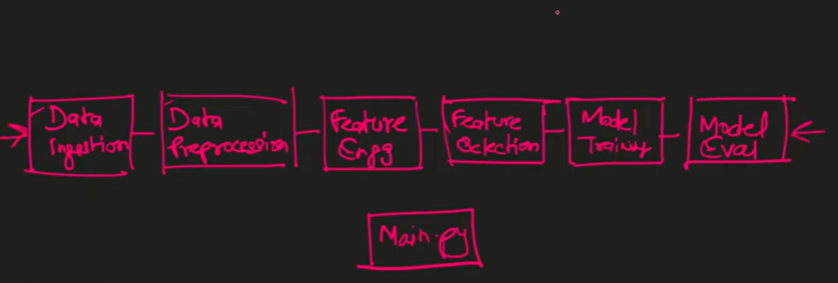

Architecture of a Machine Learning Pipeline
Let me show you the architecture of a machine learning pipeline, because as a Data Scientist or an MLOps Engineer, when you build an architecture, you should know how it looks.
A typical pipeline has different components.
1. Data Ingestion
The first module is Data Ingestion.
2. Data Pre-processing
Next is Data Pre-processing. EDA may also happen here, but let’s keep it simple.
This is where you clean the data — handling null values, outliers, fixing distributions, etc
3. Feature Engineering
Then comes Feature Engineering — understanding existing features and creating new ones.
A very important component.
4. Feature Selection
After feature engineering, you perform Feature Selection.
You apply multiple methods and statistical techniques to select the best features.
5. Model Training
Next comes Model Training.
I’ll note that here as another separate module.
6. Model Evaluation
Finally, we have Model Evaluation — where the trained model is evaluated using various metrics.
Understanding Components as Modules
"Component" — it’s just a fancy word for a module or a Python file.
Each module is a Python file containing a class with many methods and attributes.
Connecting All Modules
These classes or modules are imported into a final file — usually main.py or pipeline.py — where everything is executed end-to-end.

How the Pipeline Works in Practice
This pipeline isn’t static. Many things keep changing over time.
For example, the Data Ingestion module pulls data from a data store (S3 bucket, MongoDB, etc.).
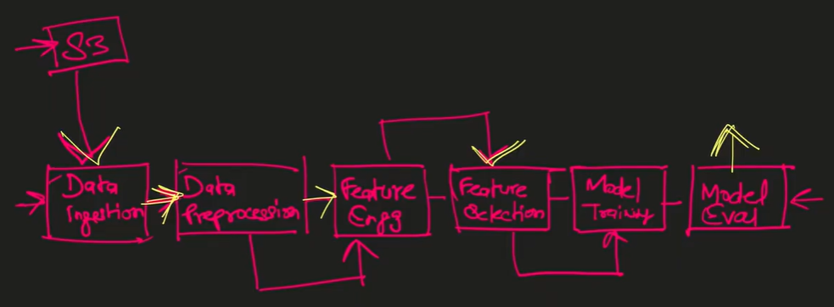
Data Source Example
Imagine your organization stores data in an S3 bucket.
Your Data Ingestion module logs in, fetches the required file, and brings it to your local machine or server.
Understanding Artifacts
Each module produces an artifact, which means the output of that module.
Examples:
- Data Ingestion artifact → raw data fetched from S3
- Pre-processing artifact → cleaned, transformed data
- Feature Engineering artifact → dataframe with engineered features
Why Artifacts Change Over Time
The pipeline is never static. As experiments change, so do artifacts.
If your data engineering team updates S3 data → your data ingestion artifact changes.
Examples of Changing Artifact
If your previous model performance was not satisfactory:
- You try new preprocessing techniques (e.g., switch from z-score to IQR).
- You try new feature engineering methods.
These create new artifacts, affecting model training and evaluation.

Importance of Versioning
Suppose you run 8–10 experiments, each producing different data, artifacts, models, and metrics.
Later, if performance drops and you want to roll back to a previous version — you can’t do it unless you version your data and artifacts.
Thus, Data Versioning becomes essential.
Versioning All Types of Data
We don’t just version tabular data.
We version everything — including evaluation metrics JSON files.
If your senior asks
“Last time, what was our precision/recall?”
You wouldn’t know unless you saved that version.
Why Experiments Need Version Control
You need historical output to show:
- all experiments
- all metrics
- all feature-engineering outputs
- all versions of data
Only then can you choose the best option based on business needs.
Nature of a Data Scientist’s Role
As a Data Scientist, there is no fixed solution. Everything is experimentation. Every experiment changes the data, which must be saved.
This is why Data Versioning is necessary.

From “Why” to “What”
Let’s discuss WHAT data versioning is.
What is Data Versioning?
Just like Git tracks code versions, we use DVC (Data Version Control) to track data versions.
You tell DVC:
- where data is stored
- where artifacts are saved
These could be local or remote (example: S3).
DVC tracks every change.
Why Not Use Only Git?
People may ask: “Why not version data with Git itself?”
Reasons Git is unsuitable:
- Git has size limitations
Git can’t efficiently store large files (hundreds of MBs/GBs).
- Git’s diffing mechanism
Git compares files line-by-line.
Data files may contain millions of rows — impossible for Git to handle efficiently.
Thus, we need tools like DVC / MLFlow / Kubeflow.

Moving to the “How”
Now comes the most important part — HOW data versioning works.
The code is easy, but the theory is critical.
Understanding the Concept Through a Story
To simplify the concept, I will explain DVC + Git through a real-life scenario.
Recently, I visited a temple where:
- Phones, wallets, bags aren’t allowed due to security
- Shoes aren’t allowed either
So they have:
- Counter 1: for phone, wallet, bags
- Counter 2: for shoes
If you must store these items for 20 different people, you’ll follow a system.
Counter system for storing belongings
You are given the responsibility to collect items from 20 different people — take each person’s phone, wallet, bag and shoes and deposit them at the two counters. When they return, you must collect the items and return the correct items to the correct person. This can get confusing: because of this system, mistakes can happen — the person who owned one phone might get someone else’s shoes, or the person who owned certain shoes might get someone else’s bag when items are returned. There’s a risk of mix-ups at return time.
Identification tokens to avoid mix-ups
To avoid this problem, the two counter attendants explained that they use identification. At counter two, when you deposit your shoes, they will give you a coupon — call it ID-1. As soon as you deposit, you receive this token; it comes in the form of a physical token. You submit this token along with your phone, wallet and bag at counter one. That token becomes associated with that person’s items.
When you deposit another person’s phone, wallet, bag and the second pair of shoes, you will receive ID-2. You then submit that ID-2 token with the other person’s items. At collection time, when you come to pick up phones, wallets and bags, they will also give you the corresponding tokens back. You take that ID-2 token to counter two and show it there. Because the token is a unique identifier linked to the deposited items, you can return the right phone, bag and shoes to the right person.
I really hope this made sense — it’s quite a simple and effective example. You won’t find a better real-life analogy anywhere to learn data versioning. If you only skimmed this explanation so far, I highly insist you watch this part again — otherwise the next sections will be hard to follow.
Mapping the example to Git and DVC
Now let’s move to the Git and DVC concept. Here, Git is one thing and DVC is another. To clarify: Git says, “I will take care of versioning your code — your .txt files, your code files. If you have .gitignore, don’t worry; I’ll handle things. Just let me track all the changes you make and save the versions.” And then you tell DVC where your data and artifacts are stored and where to save them.
Suppose you have 10 versions of code. Let’s say the version of code is named v1. Alongside v1, you can commit the ID-1 file too. Git will say, “Okay — since this file is small, I can maintain its version without problem.” So with v1, your d1 (the data token) is also versioned with the help of that token.
Now suppose you make changes and the code becomes v2. Because of those code changes, your data also changes — say that becomes the second version of data. You tell DVC: “Please track this second version of data as well — but ensure that when I roll back to my v1 version of code, I must get exactly that corresponding data. Don’t give me some unrelated data.” DVC will handle that. For this second data version, you are given a new ID token. Commit this new ID token along with the other files you changed. When you roll back in future — say v3, v4, etc. — and you roll back to a specific version of code, that code version will come with its corresponding data-ID. You simply show that ID and DVC will return the matching data.
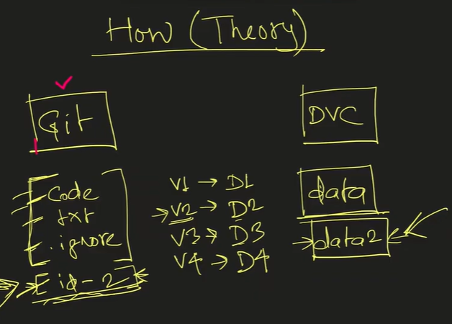
DVC works alongside Git
DVC works in parallel with Git. You can use DVC without Git or without code versioning, but usually both are used together. Every time you save a new version of data, DVC gives you a unique token which you commit along with your code version. Git has no problem committing that token and saving the version. So each new code version saved by Git will have a corresponding token saved that represents the new data version. In the future, if you reach a stage (say v4) and you are unhappy with performance and want to roll back to v2 because v2 gave comparatively the best performance, you can. Git will provide the full code of that version, and along with that code version you will also get the unique identifier corresponding to the data used with that code. DVC ensures the correct pairing of code and data versions.

