| Model | Training Accuracy | Validation Accuracy |
| --- | --- | --- |
| Conv 3D Model with 30 frames per video (16, 32, 64, 128 filters conv 3D layers + 256 dense layer + 128 dense layer + image size 120 by 120) | 88.3 | 80 |
| Conv 3D Model with 20 frames per video (16, 32, 64, 128 filters conv 3D layers + 256 dense layer + 128 dense layer + image size 120 by 120) | 88.1 | 83 |
| Conv 3D Model with 30 frames per video (16, 32, 64, 128 filters conv 3D layers + 256 dense layer + 128 dense layer) + Random data transformations on training data set | 81 | 73 |
| Conv 3D Model with 30 frames per video and a 5 by 5 filter size (16, 32, 64, 128 filters conv 3D layers + 256 dense layer + 128 dense layer + image size 120 by 120) | 83 | 75 |
| Mobilenet (re train all weights) + GRU (128 cells) + 128 dense nodes | 99.25 | 97 |
| Mobilenet (re train all wieghts) + LSTM (128 cells) + 128 dense nodes | 95.7 | 94 |

**Conv3D Best Model Plot (Conv 3D Model with 20 frames per video (16, 32, 64, 128 filters conv 3D layers + 256 dense layer + 128 dense layer + image size 120 by 120)**

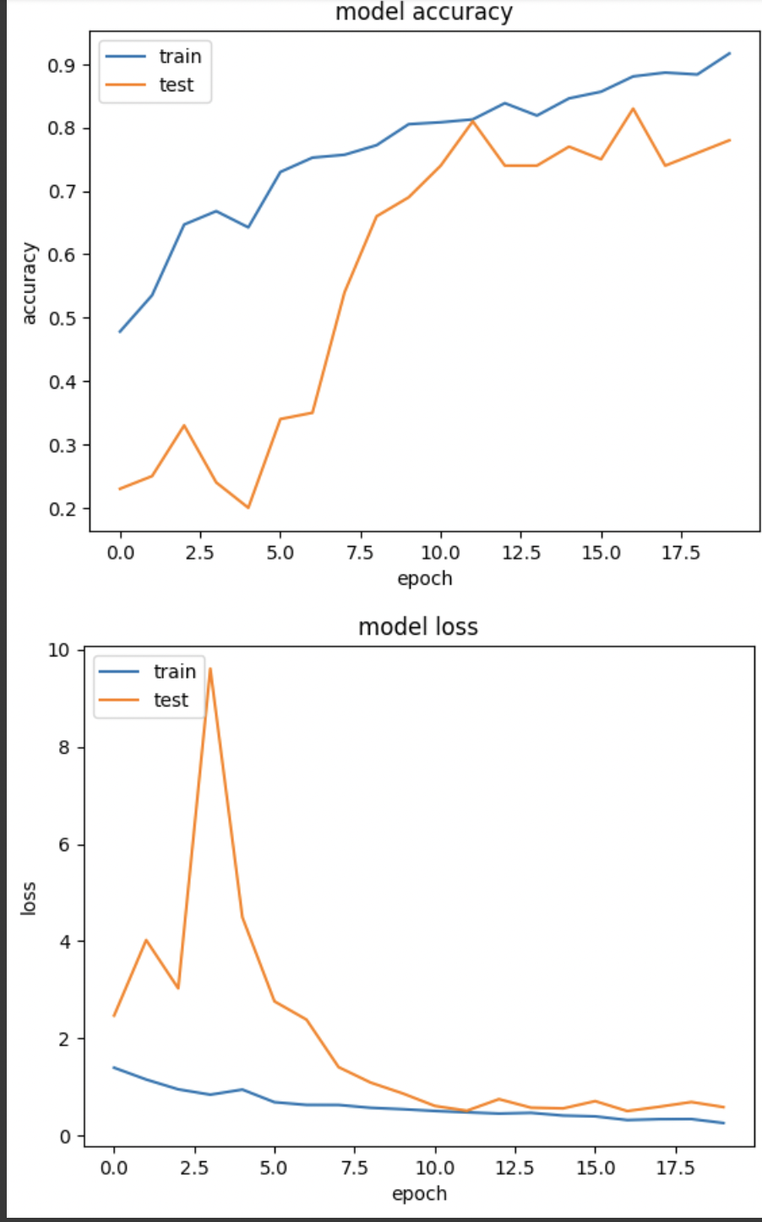

**Moblienet + GRU Best Model Plot**

