**Steps to replicate klip 'Conversion -Landing Page "healthcare1".**'

Step **1)**  Edit the given klip.

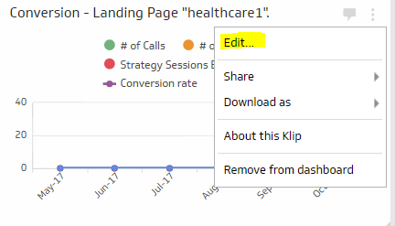

Step **2)**  Click the drop-down menu next to the Save and Exit button. Select Save as Copy.

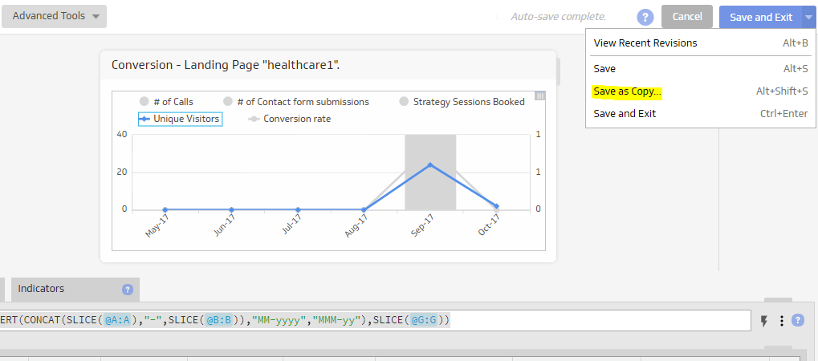

Step **3)**  Provide a name for the copied Klip and click on Save as Copy.

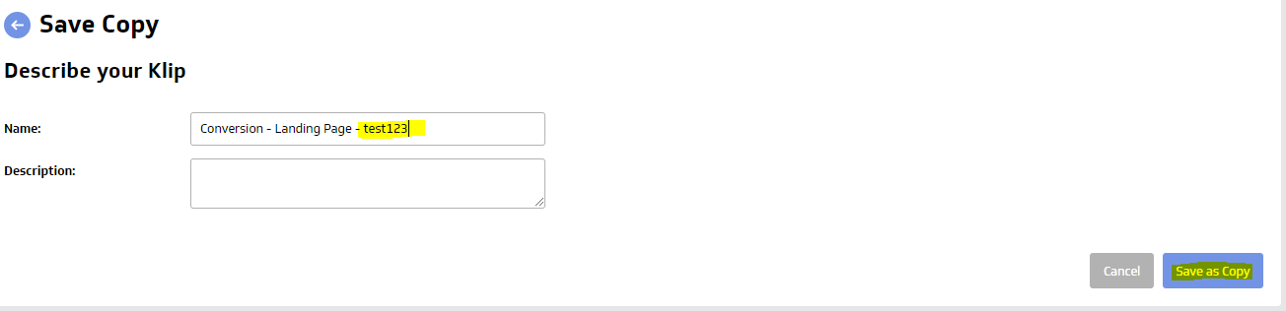

Step **4)**  Search newly created klip under Library -> Klips. Click on klip name.

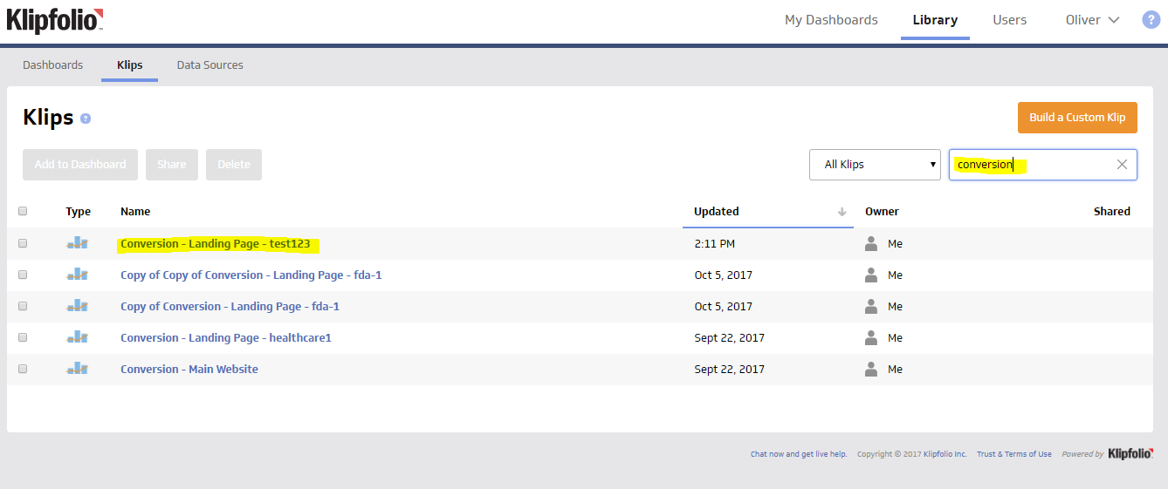

Step **5)**  Click on ‘Edit Klip’. Change the Klip Title.

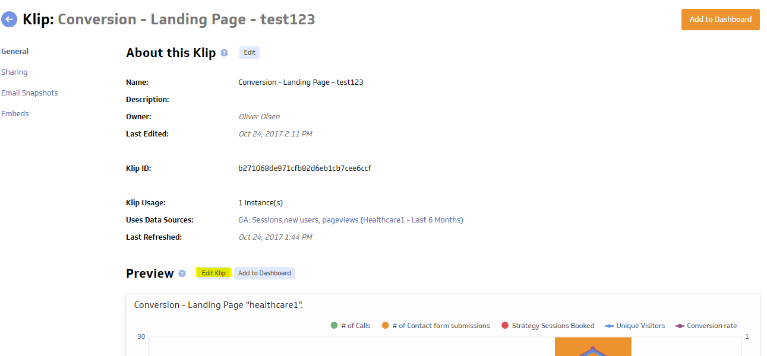

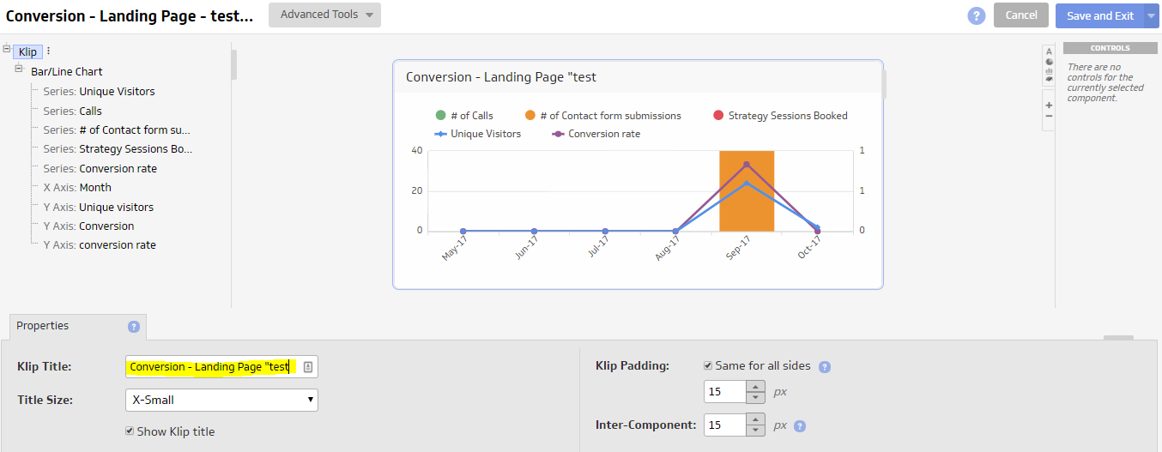

Step **6)**  Click on ‘About Data Source’. Create copy of datasource by clicking on ‘Duplicate’. Name the datasouce and click on ‘Save’.

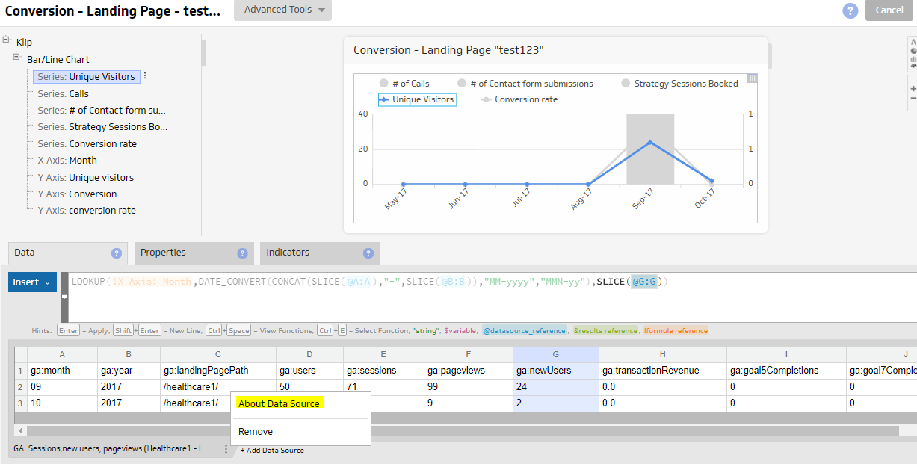

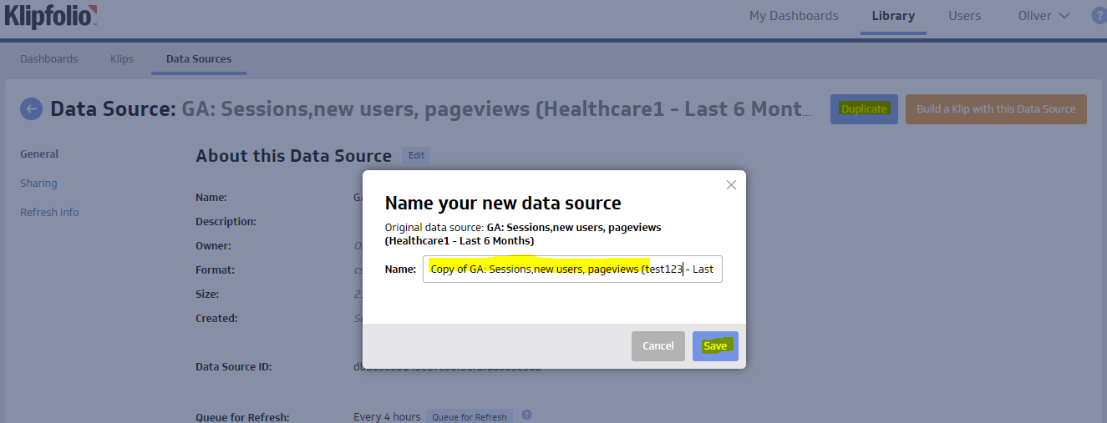

Step **7)**  Select ‘Reconfigure Data Source’ option from Duplicated datasource. Authenticate or choose a token for the account you want to work with.

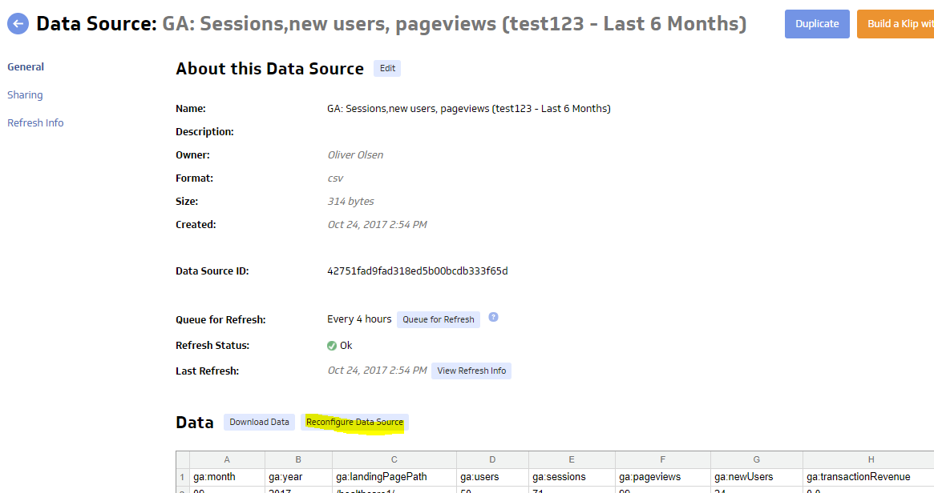

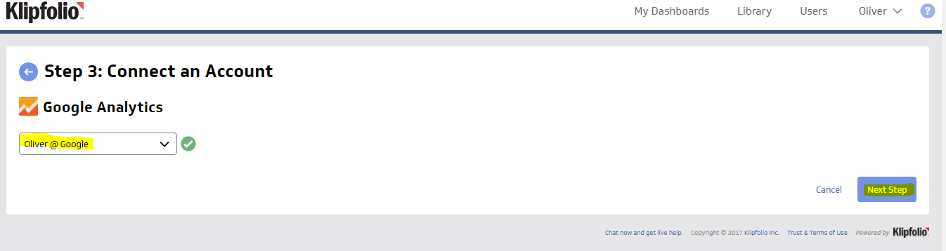

Step **8)**  You are now on the Edit Data Source page. Replace given ‘landing page path’ in filter condition with any other path you want. Then click on ‘Get data’ and ‘Done’.

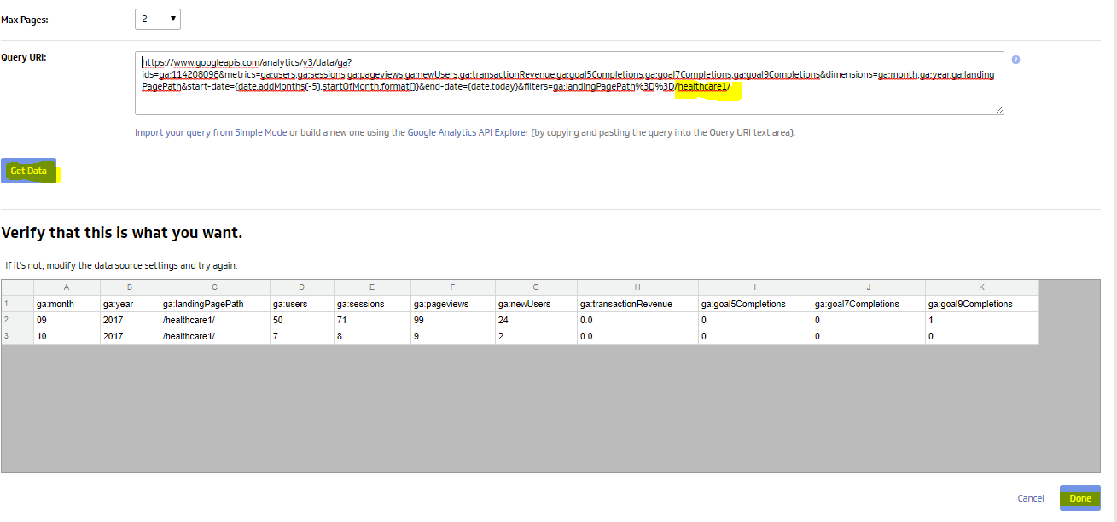

Step **9)**  Add newly created datasource in duplicated klip. Change all the datasource references from newly created datasource. Remove the old datasource.

