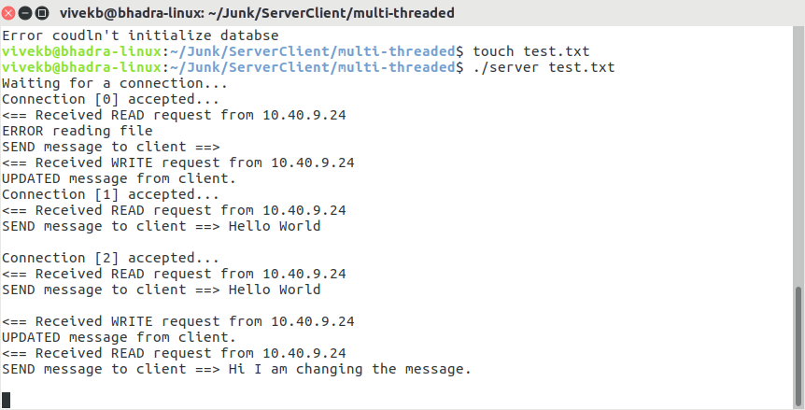1. Server Starts – with data file at command prompt which contains the message.

2. Creates socket and waits for a connection.

3. The below picture show the first client connecting to the server.

4. Client tries to read the message. At this point the database file was empty. So client gets back an empty message.

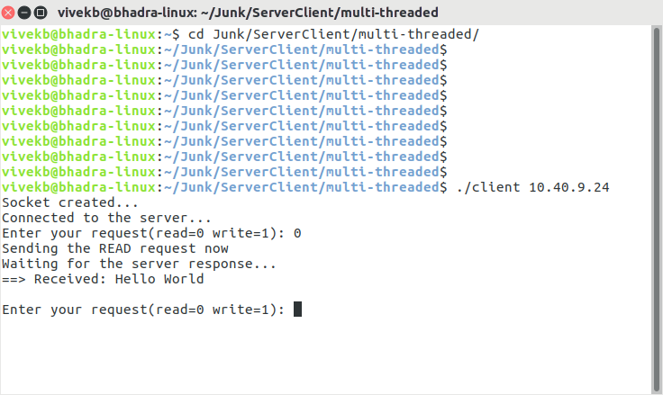

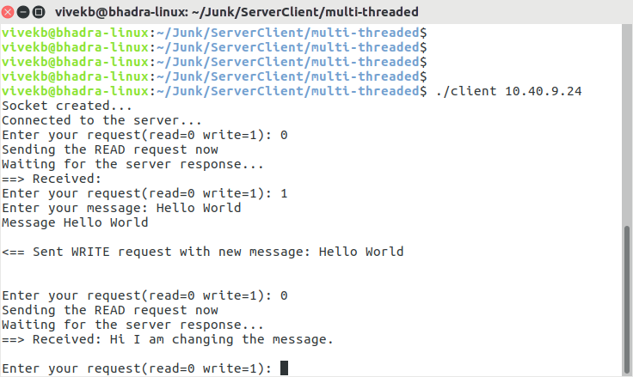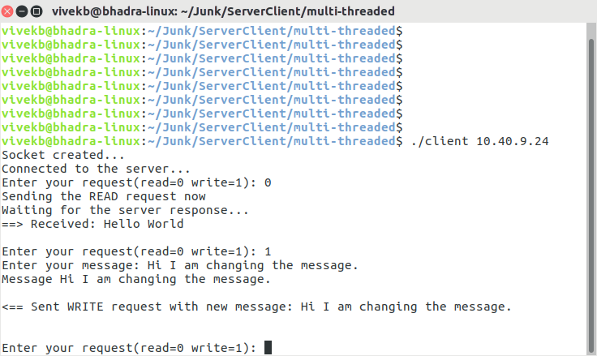5. Next the second client comes up and connects to the server.

6. Second client first tries to read, gets an empty message back from the server and then updates the message with “Hello World” as can be seen in the above screenshot.

7. Next in the above screenshot the thrid client comes up. Tries to read the message and gets back “Hellow World” from the server.

8. The third client then updates the message with “Hi I am changing the message”.

9. Then in the below screenshot clinet 1 reads back the messages from the server and receives: “Hi I am changing the message”.