

# **SINHGAD ACADEMY OF ENGINEERING**

A MINI PROJECT REPORT

ON

**“**Genetic Algorithm for optimization on IRIS Dataset obtained from UCI ML repository.**”**

SUBMITTED BY

BHAGAT VIVEK HANUMANT COBA028

CHANDGUDE NINAAD MANGESH COBA037

DEVDARE PRITAM ASHOK COBA050

**IN PARTIAL FULFILLMENT OF BACHELOR OF ENGINEERING**

**DEPARTMENT OF COMPUTER ENGINEERING**



SAVITRIBAI PHULE PUNE UNIVERSITY, PUNE

CERTIFICATE

This is to certify that the project report entitles

**“**Genetic Algorithm for optimization on IRIS Dataset obtained from UCI ML repository.**”**

SUBMITTED BY

BHAGAT VIVEK HANUMANT COBA028

CHANDGUDE NINAAD MANGESH COBA037

DEVDARE PRITAM ASHOK COBA050

is a bonafide work carried out by them under the supervision of

Prof. SHWETA SONDAWALE and it is approved for the partial

fulfillment of the requirement of final year computer engineering.

(Prof. SHWETA SONDAWALE) (Prof. S.N. SHELKE)

GuideHead Department of Computer

Department of Computer Engineering Engineering

(Dr. K.P.Patil)

Principal

Sinhgad Academy of Engineering, Pune

**ACKNOWLEDGEMENT**

We extend our sincere and heartfelt thanks to our esteemed guide for her exemplary guidance, monitoring and constant encouragement throughout the course at crucial junctures and for showing us the rightway.

We would like to extend thanks to our respected Head of the Department Prof.S.NSHELKE Sir for allowing us to use the facilities available. We would like to thank other faculty members also.

Last but not the least, we would like to thank our friends and family for the support and encouragement they have given us during the course of our work.

BHAGAT VIVEK HANUMANT COBA028

CHANDGUDE NINAAD MANGESH COBA037

DEVDHARE PRITAM ASHOK COBA050

**Problem Statement** : Apply the Genetic Algorithm for optimization on a dataset obtained from UCI ML repository. (IRIS Dataset ).

**Prerequisite:**

-Basic of Python, Data Mining Algorithm, Iris Dataset ,Genetic algorithm.

**Software Requirements:**

-Anaconda with Python 3.7

**Hardware Requirement:**

-PIV, 2GB RAM, 500 GB HDD, Lenovo A13-4089Model.

**Learning Objectives:**

-Learn How to Apply Genetic Algorithm for given Iris Dataset. The main objective of this assignment is to implement Iris Flower Dataset or any other dataset into a data frame using python .

**Outcomes:**

-After completion of this assignment students are able Implement code for the Iris Dataset with plotting diagram.

**Theory Concepts:**

**1.** Python is an interpreted high level programming language for general purpose programming created by Guido Van Rassom and First released in 1991.

**2.** Python for a design philophy that emphasizes code readability, notably using significant white space .

**3.** Python features a dynamic type of automatic memory management support multiple programming paradigm ,including object – oriented, imperative ,functional and procedural and has a large ,comprehensive standard library.

**4.** Python library is a collection of function and methods that allows you to performs lots of actions without writing your own code.

Eg: If you are working with data, numpy , scipy, pandas ,etc .are the libraries you must know.

* **Import pandas as pd**

Pandas is an open source ,BSD-licensed library providing high performance, easy to use data structure and data analysis tools for the python programming language.

* sudo apt-get install python 3.6
* sudo apt-get install python pip
* sudo apt-get install python pandas
* **Import matplotlib as plt**
* Matplotlib is a plotting library for the python programming language and its numerical mathematics extension numpy.
* If provides an object oriented API for embedding plot into applications using general purpose GUI tools like Tkinter , Wxpython.
* **Iris Dataset**
* This dataset includes three species with so samples each as well as some properties about each flower .
* The available columns in this dataset are : id , sepal length cm, sepal width cm, petal length cm , petal width cm and species .
* The Dataset is self available below in csv file . This dataset is also available in scikit-learn package of which the link description also attached in title.
* The main task in this dataset is to create an iris (name of a flower)

Classifier based on given properties that are the sepal and petal size.

* If you don’t know the difference between sepal and petal, here is an image that shows which part of the flower is sepal and which part is petal.

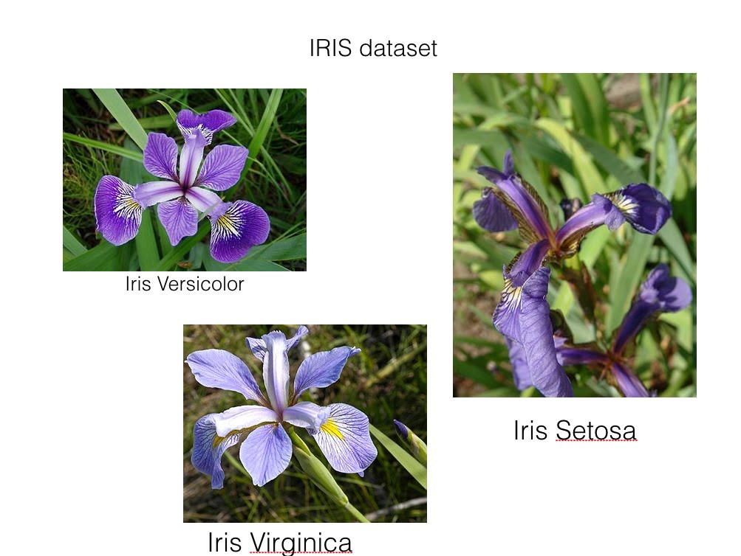

* df.isnull().any()
* It is used to check whether we have null values in our dataset or not .
* df.types()
* To know the type of each column values .
* df.describe()
* check the quick summary of data.
* Df.[‘petalwidth’].plot.hist()

Plt.show()

* It is used to represent flowers datasets of values between 0.1 and 0.5 in the graph form.

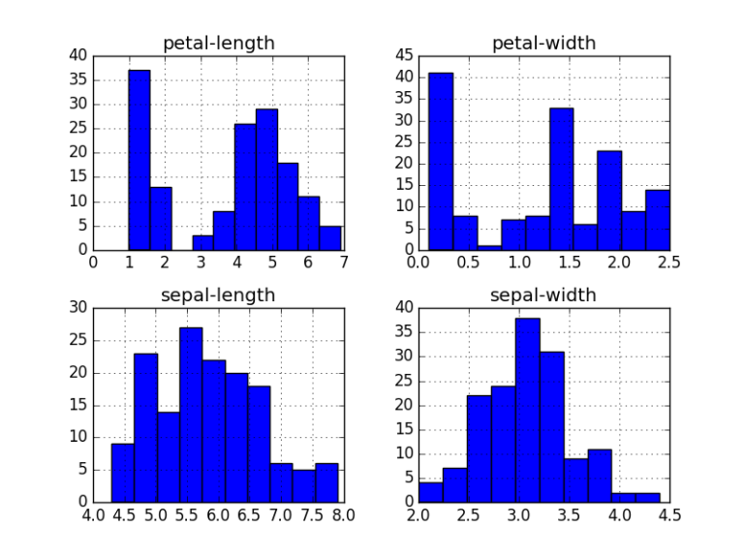

* **Splitting the Dataset**
* Since there is only dataset available, we need to divide the dataset into training and test dataset.
* To do this, we can use train_test_split method from the scikit learn.
* **BoxPlot**
* A ‘Boxplot’ or ‘box-&-whiskerplot’ is a graphical summary of the distribute.
* The box in the middle indicates ‘hinges’ and ‘median’.
* The lines(‘whisker’)show the largest or smallest observation that falls within a distance of 1.5 times the box size from the nearest hinge.

If any observation fall farther away, the additional points are considered ‘extreme’ values and are shown separately.

* A boxplot can often give a good idea of the data distribution and is often more useful to compare distributions side by side as it is more compact than histogram.
* We can use the boxplot function to calculate quick summaries for all the variables in our dataset by default.
* The real power of boxplots is really to do comparisons of variables by sub-grouping.

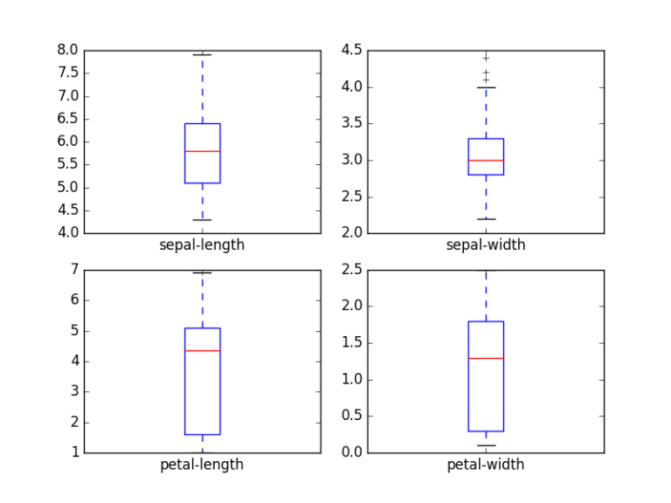

**Code:**

from google.colab import files

uploaded = files.upload()

import pandas as pd

import matplotlib.pyplot as plt

df = pd.read_csv("iris.data")

from google.colab import files

uploaded = files.upload()

print (df.head())

print (df.info())

print (df.describe())

print (df["sepal_length"])

print (df[["sepal_length","petal_length"]])

print (df.columns.values)

for col in df.columns.values[:-1]:

print (col)

df.hist(column=col)

plt.show()

df.boxplot(column=list(df.columns.values[:-1]))

plt.show()

**Output :**

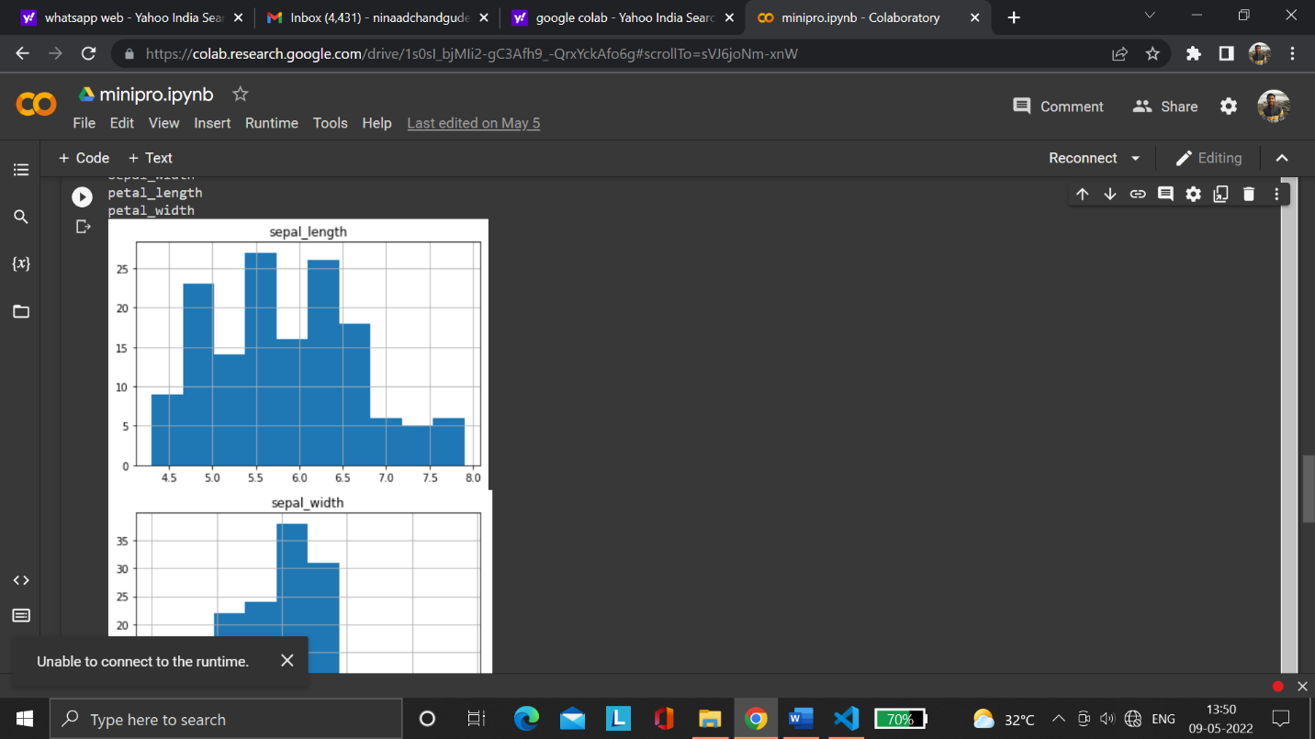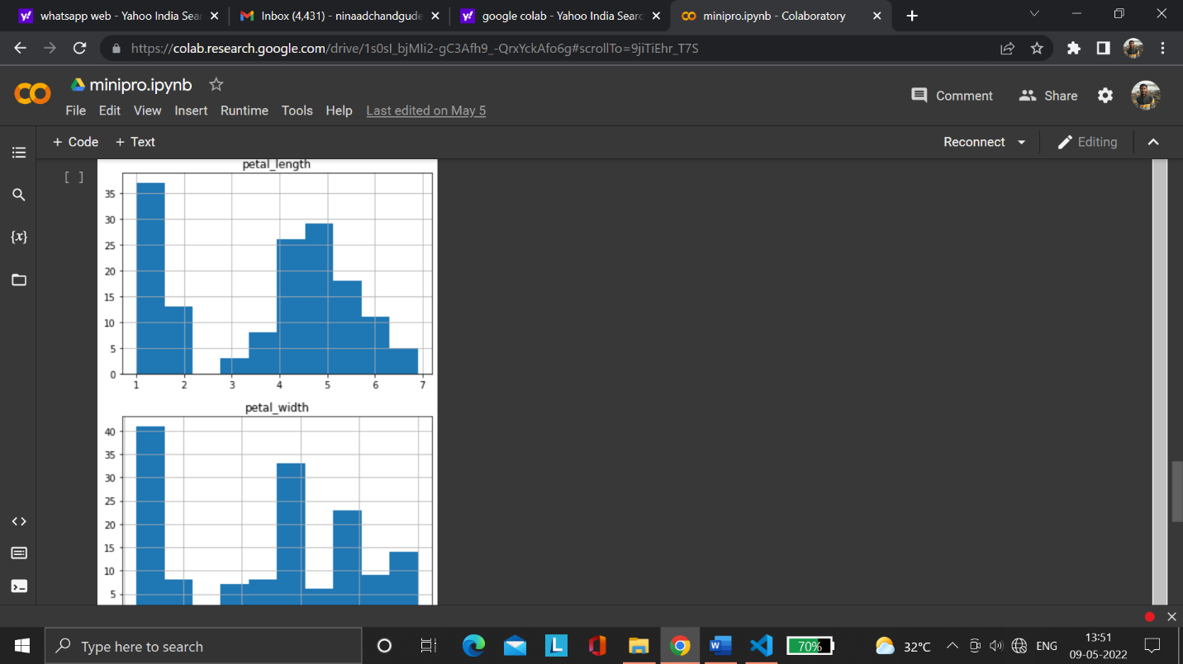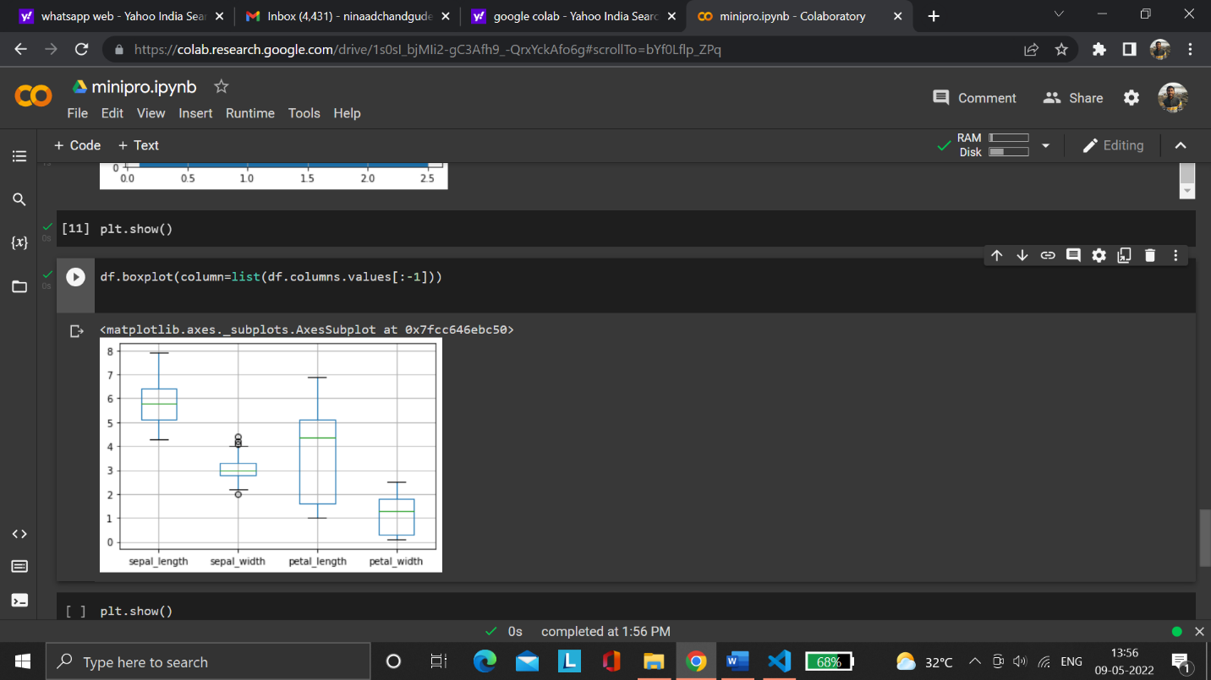

**Conclusion :**

Hence ,We have studied and practically implemented Iris flower dataset into a Data frame And we learn Genetic Algorithm for optimizing Iris Dataset .