**Invictus Assignment**

**Task**

Design and build the following:  
1. A Reactjs front end which accepts a number input N with a Submit button

2. On entering a value and pressing submit, fetch the contents of <https://raw.githubusercontent.com/invictustech/test/main/README.md>

3. Find the top N most frequently occurring words in this file (DO NOT use a ready made module for frequency computation)

4. Display the top N words and their frequency of occurrence in the frontend, in a tabular format

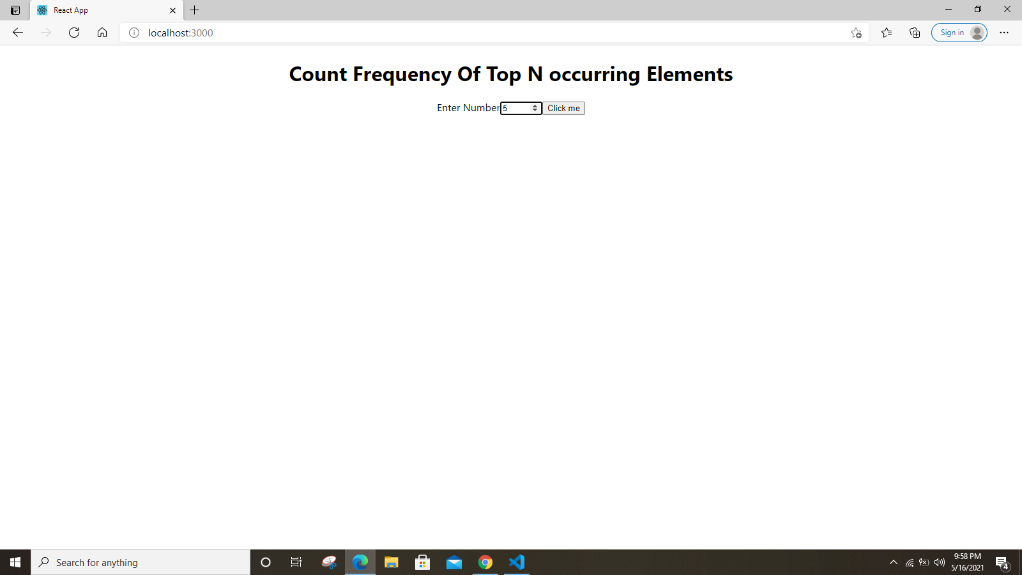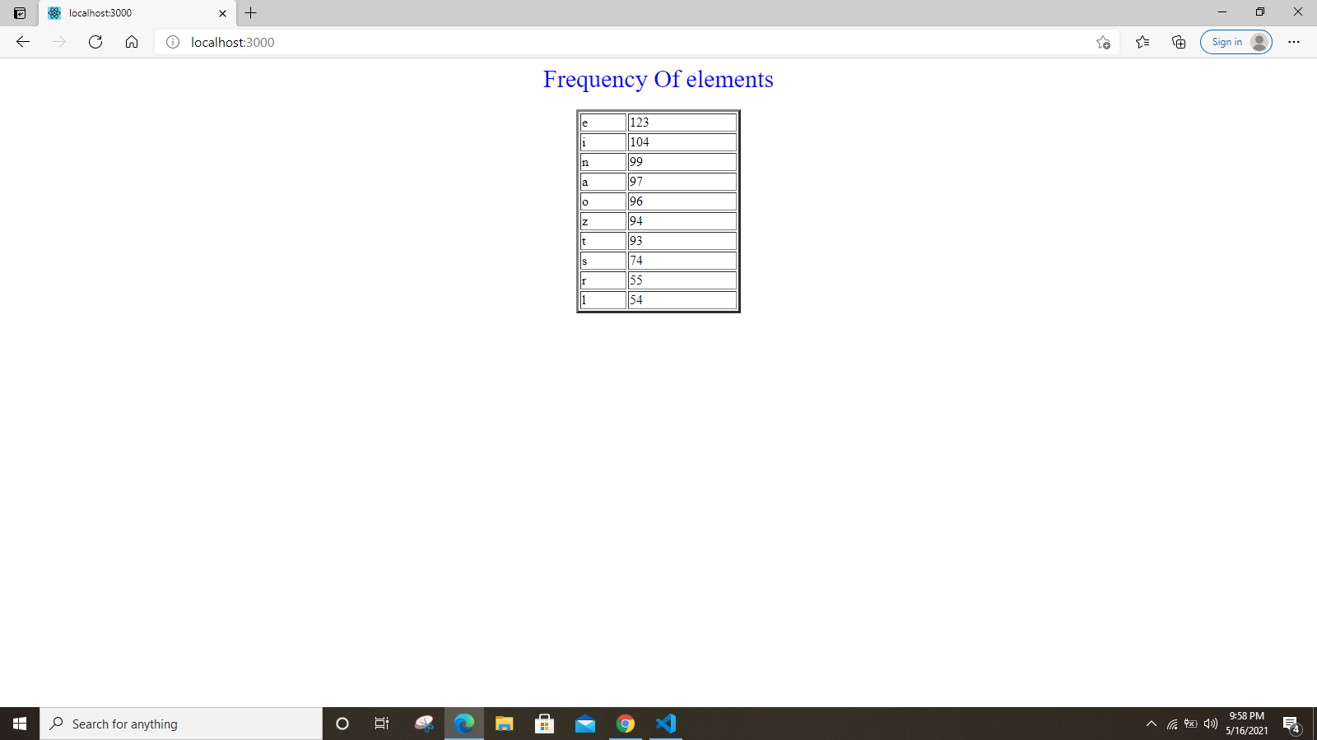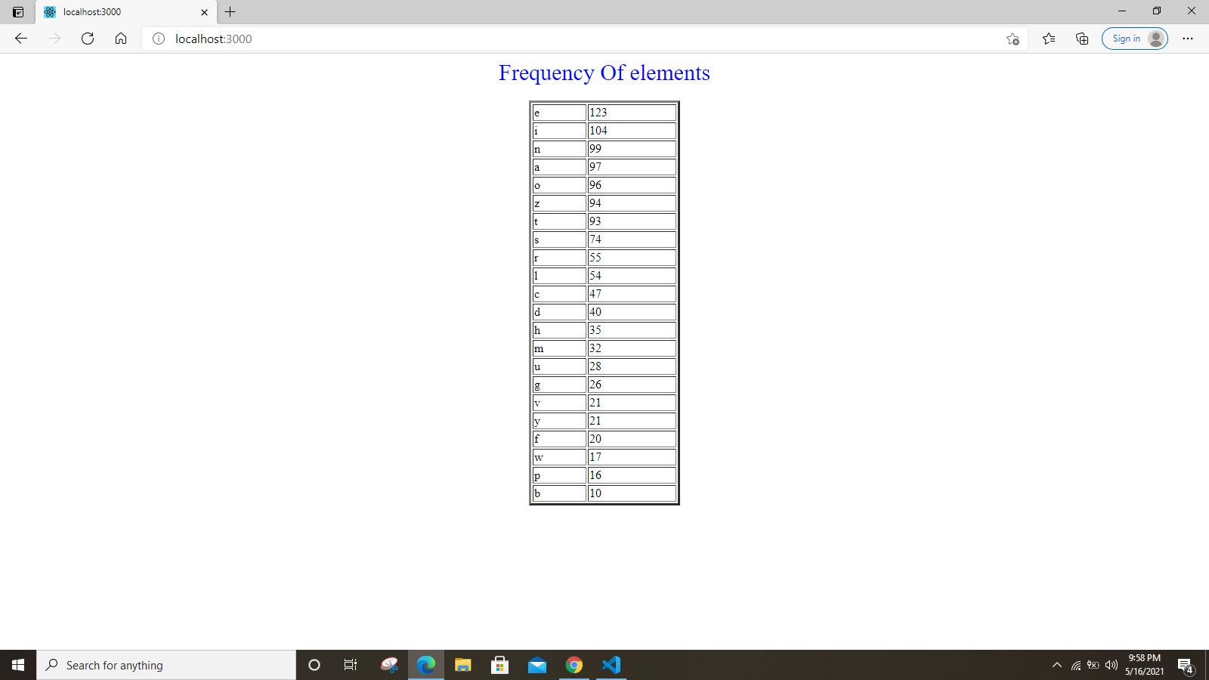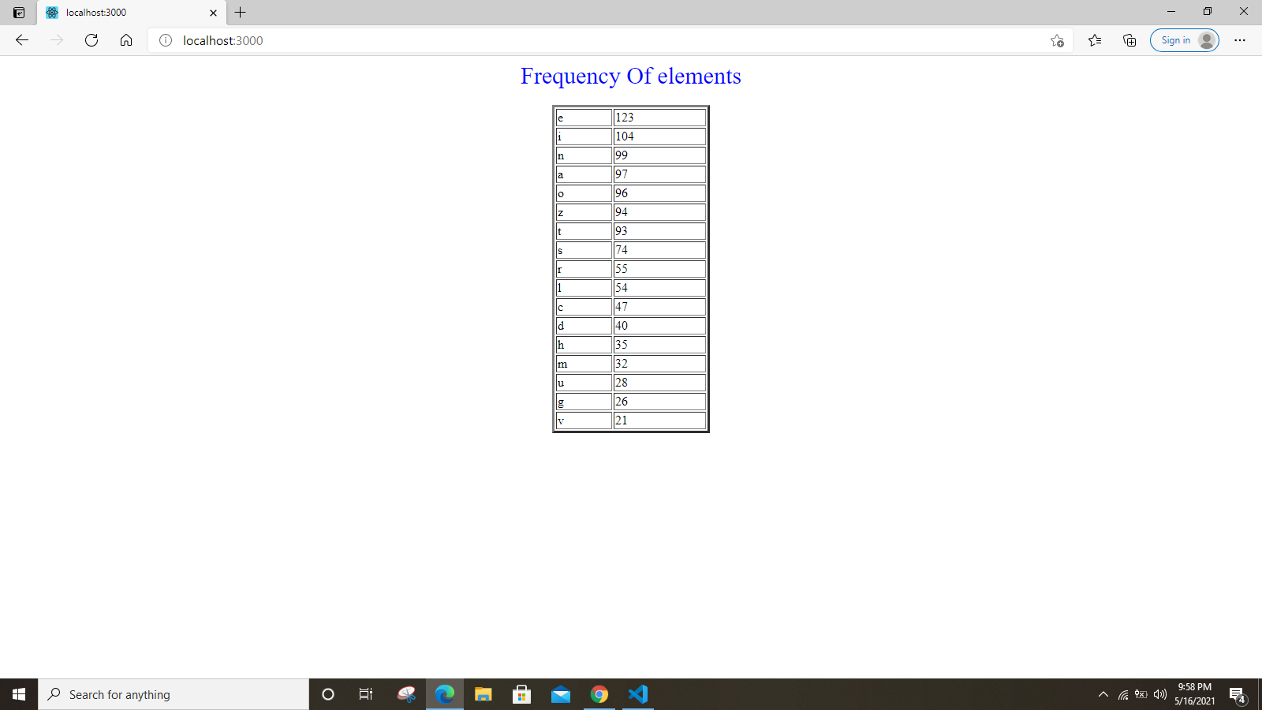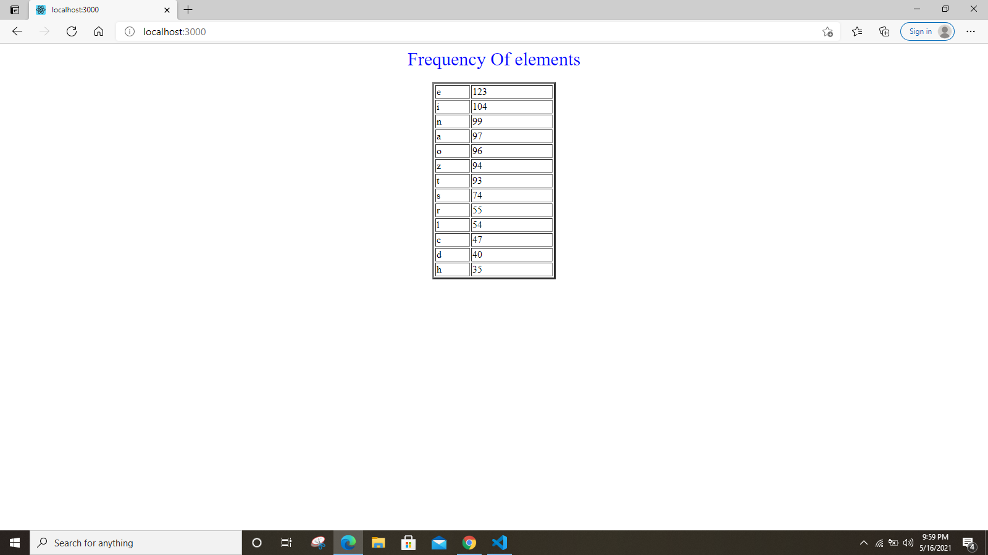

**Additional Dependencies Installed**

Axios

1. // Fetching Data using axios
2. componentDidMount() {
3. axios.get('https://raw.githubusercontent.com/invictustech/test/main/README.md')
4. .then(response => {
5. console.log(response)
6. this.setState({sentence:response.data})
7. })
8. .catch(error => {
9. console.log(error)
10. })
11. this.inputRef.current.focus()
12. }

Using axios fetching data from the given api

Counting frequency of elements by iterating over the data in the given file using for loop.

for (

    counter = 0, actualLength = sentence.length;

    counter < actualLength;

    ++counter

  ) {

    getCharacter = sentence.charAt(counter);

    //   if (!isNaN(getCharacter)) continue;

    if (getCharacter >= 'a' && getCharacter < 'z')

      noOfCount = noOfCountsOfEachCharacter[getCharacter];

    noOfCountsOfEachCharacter[getCharacter] = noOfCount ? noOfCount + 1 : 1;

  }

Printing the desired result in tabular form

   document.write('<table border="3" width="200" align="center" >')

  console.log(typeof noOfCountsOfEachCharacter)

  for (counter = 0; counter < n; ++counter){

    document.write("<tr><td>" + result[counter] + "</td>")

    document.write("<td>" +noOfCountsOfEachCharacter[result[counter] ]+ "</td></tr>")

  }

  document.write('</table>')

**Overview of all the components**

In app.js we are calling the component named as “<Frequency.js/>” which will fetch the data from the given api and there is an input field which will receive the value of number of elements from the user and using setState() method we have defined the re-rendered and updated value of state. Then onClick of button an event is fired and values of the states containing the data received and input number is then passed to the different component as props.

**Count.js**

In count.js we are calculating the frequencies of elements and later sorting them on the basis of occurrence. Most frequently occurring elements is placed on the top and so on. Then the content is being displayed in a table.