**Path Coverage Testing**

Path coverage testing is a structural testing technique used in software engineering to ensure that all possible execution paths through a program are tested at least once. The goal is to evaluate the correctness and robustness of the software by examining various paths through its source code.

**Cyclomatic Complexity**: Cyclomatic complexity is a software metric used to measure the complexity of a program. It quantifies the number of linearly independent paths through a program's source code.

**V(G) = E-V+2**

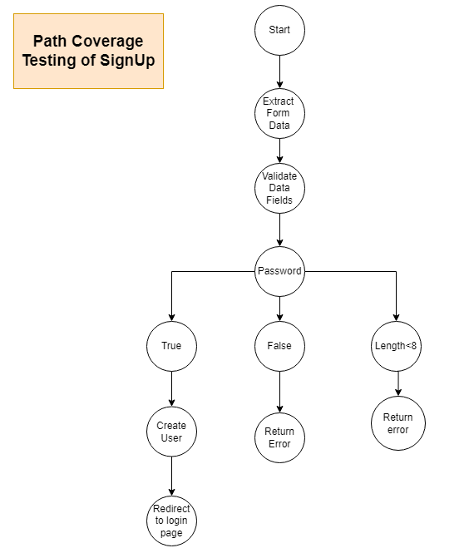

**V(G) = 10-11+2 = 1**

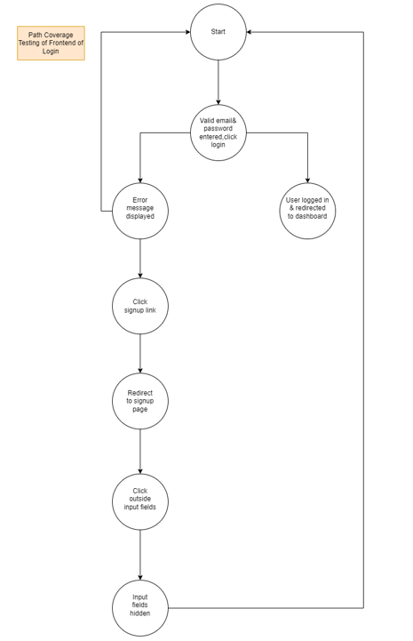

**V(G) = 9-8+2 = 3**

**Path Coverage Testing of Backend of Login**

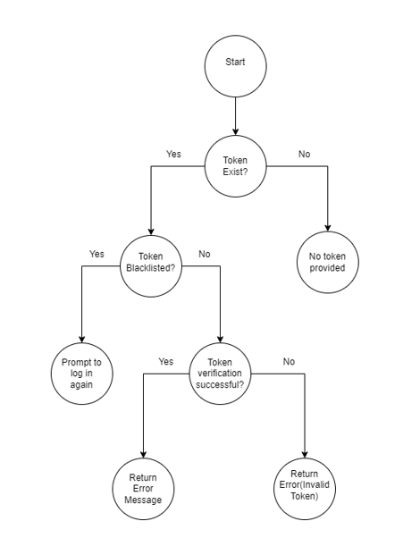

**V(G) = 7-8+2 = 1**

**Path Coverage Testing of Frontend of AddUser**

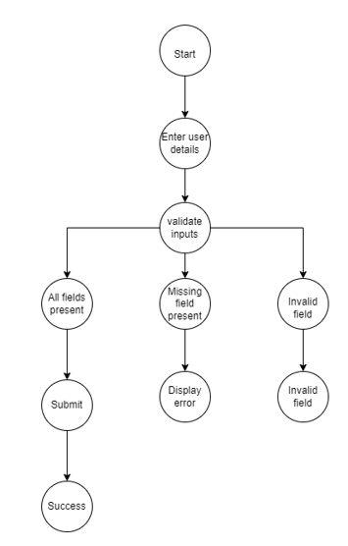

**V(G) = 9-10+2 = 1**

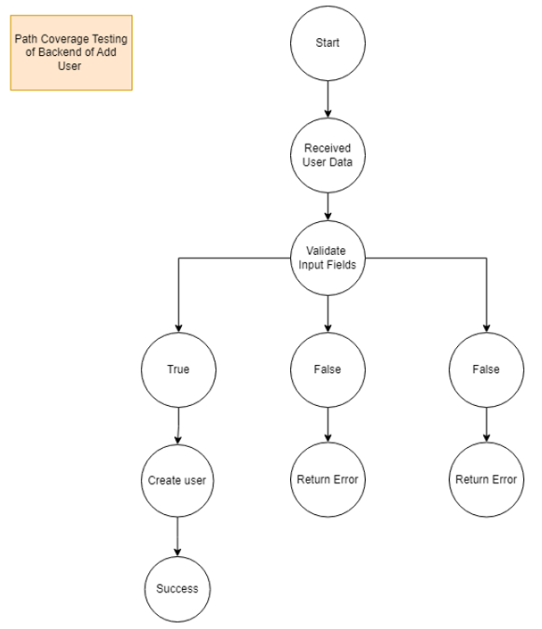

**V(G) = 9-10+2 = 1**

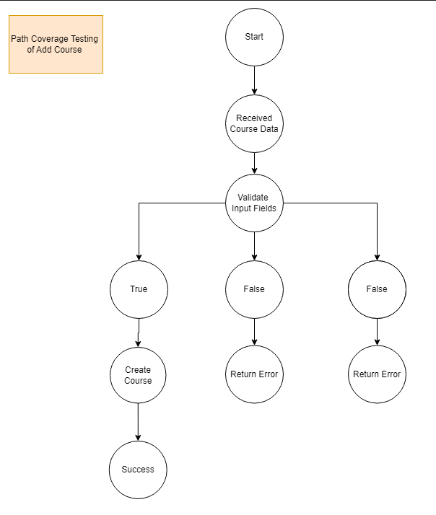

**V(G) = 9-10+2 = 1**