Experiment No 2:
Linear Search

Problem 1: Search a number in an array
Problem Statement:
Write a program to search a given number in an array of 10 integers using linear search.
Code:
#include<iostream>
using namespace std;
int main() {
int arr[10] = {3, 8, 5, 12, 6, 9, 1, 4, 7, 10};
int target, found = 0;
cout << "Enter number to search: ";
cin >> target;
for(int i = 0; i < 10; i++) {
if(arr[i] == target) {
cout << "Element found at index " << i << endl;
found = 1;
break;
}
}

if(!found)
cout << "Element not found!" << endl;

return 0;
}

Output:
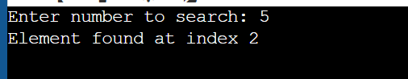

🔹 Problem 2: Search a character in an array
Problem Statement:
Write a program to search for a character in an array of characters using linear search.
Code:
#include<iostream>
using namespace std;

int main() {
char arr[] = {'a', 'e', 'i', 'o', 'u'};
char target;
bool found = false;

cout << "Enter character to search: ";
cin >> target;

for(int i = 0; i < 5; i++) {
if(arr[i] == target) {
cout << "Character found at index " << i << endl;
found = true;
break;
}
}

if(!found)
cout << "Character not found!" << endl;

return 0;
}
Output:
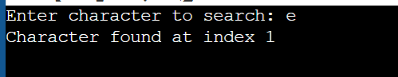

Binary Search Problems (Array must be sorted)
Problem 1: Search a number in a sorted array
Problem Statement:
Write a program to perform binary search on a sorted array of integers.
Code:
#include<iostream>
using namespace std;

int main() {
int arr[] = {2, 4, 6, 8, 10, 12, 14, 16};
int n = 8, target;
int low = 0, high = n - 1, mid;

cout << "Enter number to search: ";
cin >> target;

while(low <= high) {
mid = (low + high) / 2;
if(arr[mid] == target) {
cout << "Element found at index " << mid << endl;
return 0;
} else if(arr[mid] < target) {
low = mid + 1;
} else {
high = mid - 1;
}
}
cout << "Element not found!" << endl;
return 0;
}

Output:
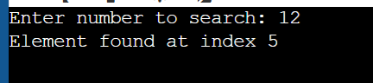

Problem 2: Search first occurrence of a number
Problem Statement:
Write a program using binary search to find the first occurrence of a number in a sorted array with duplicate elements.

Code:
#include<iostream>
using namespace std;
int main() {
int arr[] = {1, 2, 4, 4, 4, 5, 6};
int n = 7, target;
int low = 0, high = n - 1, mid, result = -1;
cout << "Enter number to find first occurrence: ";
cin >> target;
while(low <= high) {
mid = (low + high) / 2;
if(arr[mid] == target) {
result = mid;
high = mid - 1; // Move left
} else if(arr[mid] < target) {
low = mid + 1;
} else {
high = mid - 1;
}
}
if(result != -1)
cout << "First occurrence at index " << result << endl;
else
cout << "Element not found!" << endl;
return 0;
}

Output:

