Experiment No:3

Bubble Sort
Code:
#include<iostream>
using namespace std;
// Function to perform Bubble Sort
void bubbleSort(int arr[], int n) {
// Outer loop for number of passes
for(int i = 0; i < n - 1; i++) {
// Inner loop for pair-wise comparison
for(int j = 0; j < n - i - 1; j++) {
// Swap if the current element is greater than the next
if(arr[j] > arr[j + 1]) {
// Swapping using a temporary variable
int temp = arr[j];
arr[j] = arr[j + 1];
arr[j + 1] = temp;
}
}
}
}

// Function to display array elements
void display(int arr[], int n) {
cout << "Sorted array: ";
for(int i = 0; i < n; i++) {
cout << arr[i] << " ";
}
cout << endl;
}

// Main function
int main() {
int arr[100], n;

// Input size of array
cout << "Enter number of elements: ";
cin >> n;

// Input array elements
cout << "Enter " << n << " elements:" << endl;
for(int i = 0; i < n; i++) {
cin >> arr[i];
}

// Call bubble sort function
bubbleSort(arr, n);

// Display sorted array
display(arr, n);

return 0;
}

Output:
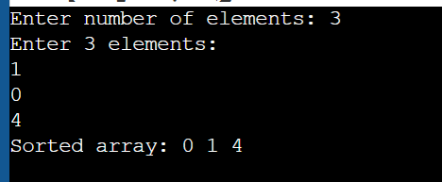
Insertion Sort:
Code:
#include <iostream>
using namespace std;
void insertionSort(int arr[],int n){
for(int i=1;i<n;i++){
int temp = arr[i];
int j= i-1;
while(j>=0 && arr[j]>temp){
arr[j+1] = arr[j];
j-- ;
}
arr[j+1]=temp;
}
}
void display(int arr[],int n){
for(int i=0;i<n;i++){
cout<<arr[i]<<endl;
}
}
int main() {
int arr[]={5,3,8,6,2};
int n=5;
insertionSort(arr,n);
display(arr,n);
return 0;
}
Output:
