Question | What should be the minimum interval between the administration of  two live vaccines?  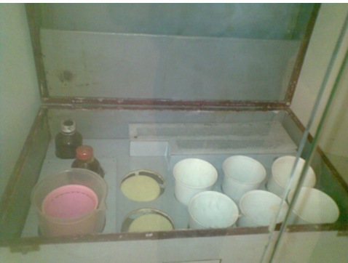
Type | multiple_choice
Option | 2 weeks
Option | 8 weeks
Option | 4 weeks
Option | 12 weeks
Answer | 2
Solution | The minimum interval between the administration of two live vaccines is 4 weeks.  This is because decreasing the interval between two doses may interfere with the antibody response and protection. Thus, live  vaccines can either be given on the same day according to the schedule or 4 weeks apart.  Note: In Park 27th ed. the minimum interval between two live vaccines is given as 3 weeks. However, several other standard  sources including CDC and UNDP suggested an interval of 4 weeks. When both are given in options, it is recommended to  mark 4 weeks as the correct answer.
Positive Marks | 4
Negative Marks | 1

Question | What is the amount of bleaching powder required to disinfect 455  litres of water if the 4th, 5th, and 6th cups of a Horrock's apparatus  show distinct blue color?
Type | multiple_choice
Option | 2 grams
Option | 4 grams
Option | 8 grams
Option | 6 grams
Answer | 3
Solution | The dose of bleaching powder required is 8 grams.  It is given by (n x 2) gms for 455 litres of water, where n is the number of the first cup that shows distinct blue color. In this  scenario, the dose of bleaching powder required to disinfect 455 litres of water Is (4 x 2) = 8grams. Horrock's Apparatus is used to estimate the chlorine demand of water.  . This is widely used in the disinfection of wells to find out how much bleaching powder Is required.  . Contents of this water-testing apparatus:  . 6 white cups of 200 ml cach and one black cup with a circular mark  " 2 metal spoons (each holds 2g of bleaching powder)  ¢ 7 glass stirring rods and 1 special pipette  · Two droppers  a Starch-lodide Indicator solution  · Procedure:  Use 2g of bleaching powder to create a thin paste in the black cup, It is now called the Chlorine stock solution,  . The six white cups are filed with the water to be tested  . Add one drop of the stock solution to the 1ª1 cup, two drops to the 2nd cup, three drops to the 3rd cup, and so on till  adding six drops to the 617 cup.  a Stir the cups and wait for half an hour.  . Add 3 drops of starch-iodide indicator to each cup  Development of blue color in the apparatus indicates free residual chlorine.  The first cup which develops this color gives an estimate of the amount of bleaching powder needed to disinfect  455 Litres of the sample water.  . Chlorine demand or the dose of bleaching powder required is given by (n x 2) g for 455 liters of water, i.c., (n x 2) g  of bleaching powder is required to disinfect 455 liters of water. Here, n represents the position of the cup (1, 2, 3, elc.)  that was first to show a distinct blue color.
Positive Marks | 4
Negative Marks | 1

Question | Which of the following is true about the standard normal distribution?  1. It has a mean of 1.0  2. It is bell shaped  3. It has a standard deviation of 0.0  4. It has a variance of 1.0  5. Standard deviation - variance
Type | multiple_choice
Option | 1,2 and 3
Option | 1 and 3
Option | 2 and 5
Option | 2, 4 and 5
Answer | 4
Solution | A standard normal distribution is a type of normal distribution. It is bell-shaped, has a mean of 0 and a standard deviation  of 1. Thus the variance, the square of standard deviation is also 1 = the standard deviation.  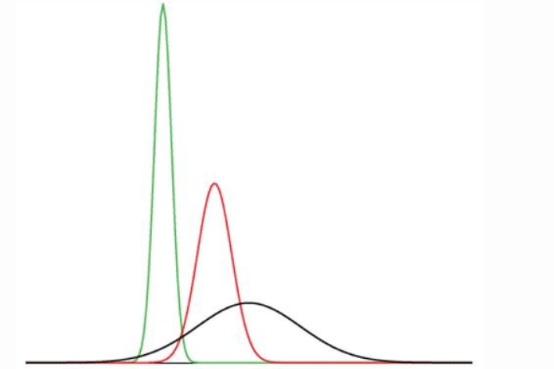
Positive Marks | 4
Negative Marks | 1

Question | According to Wechsler's scale, which of the following persons would  be categorized to have average intelligence?
Type | multiple_choice
Option | A child whose IQ Is 125
Option | A teacher whose I2 Is 115
Option | Abanker with an IQ of 95
Option | An alcoholic man with an IQ of 85
Answer | 3
Solution | According to the Wechsler's Scale, average intelligence would fall in the range of 91-110.The intelligence quotient is a score that can be obtained from several standardized tests to assess human  intelligence.  . Historically, IQ = Mental age x 100/ Chronological age  . Here, the mental age is obtained from intelligence tests.  . Higher the IQ, the more brilliant is the person.  . Classification of IQ according to Levine and Marks (1928)  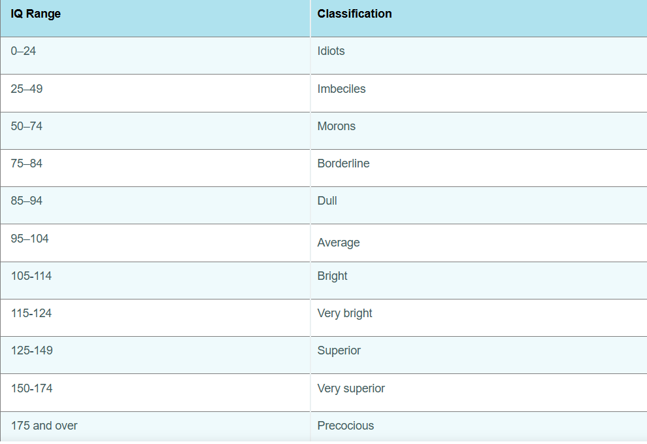
Positive Marks | 4
Negative Marks | 1

Question | Which of the following is correct about the classification of malaria  endemic states under the National Strategic Plan for Malaria?
Type | multiple_choice
Option | The states dassified under Category D  are In the elimination phase
Option | The statos with API $1 and all their  districts reporting API $1 are in the  eliminalion phase
Option | The states with districts reporting API in  between 1-2 per 1000 population are In the  elimination phase
Option | The states classified under category 2  are in the phase of intensified control
Answer | 2
Solution | The National Strategic Plan for Malaria classifies the states under Category 1 of the NVBDCP to be in the elimination phase.  Category 1 states are all states/UTs with API <1 and all their districts reporting API <1.  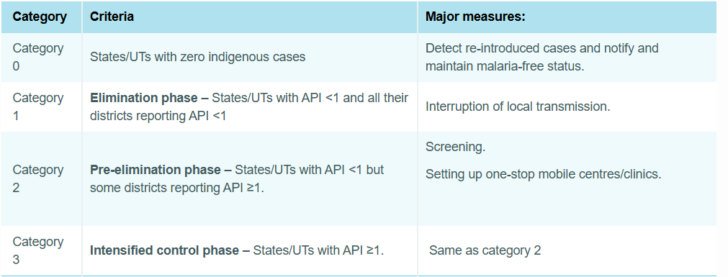
Positive Marks | 4
Negative Marks | 1

Question | A patient is diagnosed to have an allergy to eggs. Administration of  which of the following vaccines is contraindicated in this patient?
Type | multiple_choice
Option | Pneumococcal
Option | MMR
Option | Varicella
Option | Influenza
Answer | 4
Solution | Influenza and yellow fever vaccines are contraindicated in patients having an allergy to eggs.  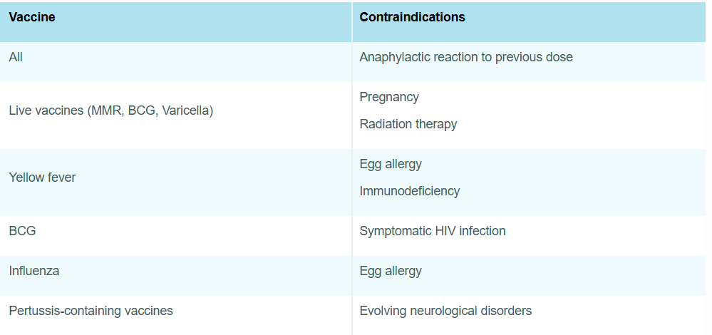
Positive Marks | 4
Negative Marks | 1

Question | According to Globocan 2020 India, which of the following are the  most common malignancies among men and women respectively?
Type | multiple_choice
Option | Ca lung and Ca cervix
Option | Ca lung and Ca breast
Option | Ca oral cavity and Ca breast
Option | Ca colon and Ca cervix
Answer | 3
Solution | According to Globocan 2020 Indla data, the most common malignancy among man la cancer llp and oral cavity, and  among women is cancer breast  .  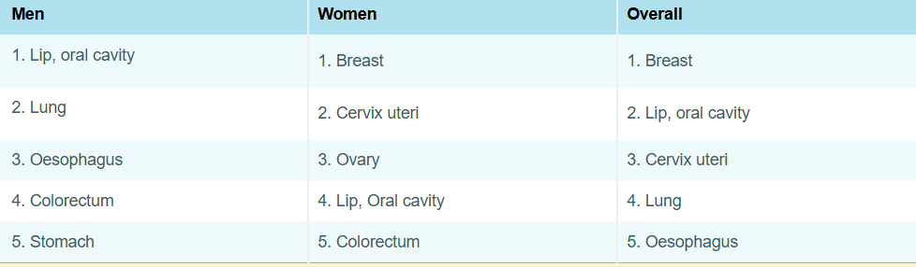
Positive Marks | 4
Negative Marks | 1

Question | Which of the following is the most common cause of blindness in  India?
Type | multiple_choice
Option | Refractive error
Option | Cataract
Option | Diabetic retinopathy
Option | Trachomatous corneal opacity
Answer | 2
Solution | According to the National Survey on Blindness (2015-2019), cataract is the most common cause of blindness in India  accounting for 66.2% of the total cases.
Positive Marks | 4
Negative Marks | 1

Question | A student was making a presentation with charts but lost titles while  editing. What could be the heading for the following chart?
Type | multiple_choice
Option | Physical Quality of Life Index
Option | Multidimensional Poverty Index
Option | Disability-adjusted life years
Option | Human Development Index
Answer | 4
Solution | "The index that is calculated using the given indicators such as life expectancy at birth, mean and expected years of  schooling, and the per capita income, is the Human Development Index (HDI).  Human Development Index (HDI) is defined as a composite index focusing on three basic dimensions of human development.  It assesses abilities  . To lead a healthy, long life, measured by life expectancy at birth  . To acquire knowledge, measured by the mean years of schooling  . To achieve a decent standard of living, measured by gross national income per capita  Hence, the 3-dimensional indices used to calculate the human development index are as follows life expectancy index,  education index, and gross national index."  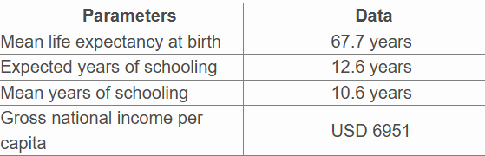
Positive Marks | 4
Negative Marks | 1

Question | "Which of the following is the correct ascending order of the  Maslow's hierarchy of needs?"
Type | multiple_choice
Option | Safety, self-actualization, belonging,  esteem, physiological
Option | Safety, physiological, belonging, esteem,  self-actualization
Option | Belonging, physiological, safety, self-  actualization, esteem
Option | Physiological, safety, belonging, esteem,  self-actualization
Answer | 4
Solution | Maslow's hierarchy of needs was suggested by psychologist Abraham Maslow. It is a motivational theory in psychology  where human needs are arranged according to hierarchy in a five-level pyramid.  He suggested that the higher needs can be fulfilled only once the lower needs are fulfilled.  The ascending order of the needs is shown in the image below.  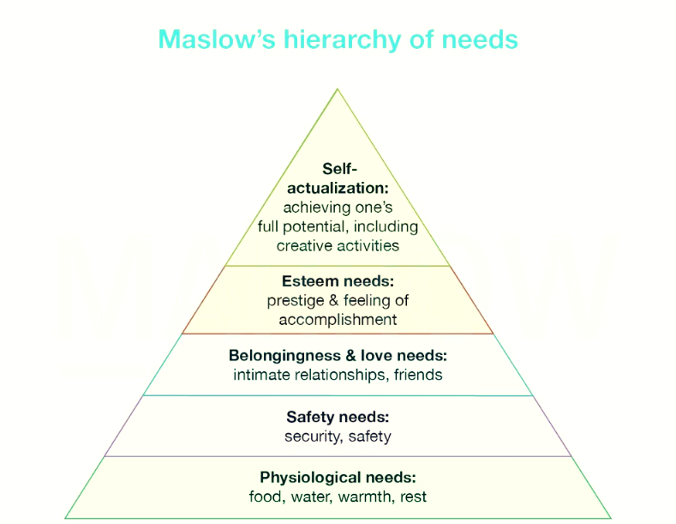
Positive Marks | 4
Negative Marks | 1

Question | The school health programs are managed by which of the following?
Type | multiple_choice
Option | Primary health center
Option | District hospital
Option | Sub-centre
Option | Sub-divisional hospital
Answer | 1
Solution | The school health programs are managed by the primary health center (PHC).  The School Health Committee (1961) in India recommended that the school health services should be a part of the general  health services administered through PHCs. Formation of school health committees at the village, block, district, state, and  national levels was recommended. The National School Health Council was created as an advisory and coordinating body.  PHCs provide the following school health services:  . Screening and general assessments for -  · Anemia/nutritional status  . Visual acuity and hearing problems  · Dental check-up  · Physical disabilities  · Learning disorders and behavior problems  . Basic medicines for common ailments  · Immunization  . Micronutrient management (vitamin A, iron, and folic acid)  - Deworming  · Mid-day meal
Positive Marks | 4
Negative Marks | 1

Question | The bone marrow density along with the gestational age is plotted  from two different studies. Which of the following is true for the relation  between bone marrow density and gestational age?  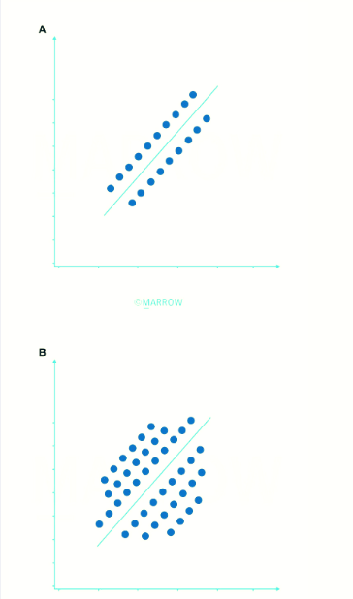
Type | multiple_choice
Option | Strength of correlation is same in A and B
Option | Strength of the correlation is more in A  than in B
Option | Strength of the correlation is more in A  than in B
Option | Strength of the variation is more in B  than A
Answer | 2
Solution | The strength of the correlation is more in graph A than in graph B.  Graphs A and B show a positive correlation between bone marrow density and gestational age.  In graph A: The data points in the scattergram are closer to the line of best fit, indicating a strong correlation.  In graph B: The data points are scattered farther away from the line of best fit, indicating a weak correlation.  Therefore, the strength of the correlation is more in graph A than B.
Positive Marks | 4
Negative Marks | 1

Question | Which is the new online software launched under the national  tuberculosis elimination program (NTEP) by the government to monitor  TB patients?
Type | multiple_choice
Option | NIKSHAY
Option | NISCHAY
Option | E-DOTS
Option | NIKUSTH
Answer | 1
Solution | Nikshay is the new online software launched under the national tuberculosis elimination program for monitoring TB patients.  Nikusth is the new online software for monitoring leprosy patients.  Nischay is a pregnancy test kit.
Positive Marks | 4
Negative Marks | 1

Question | Contraceptive failure is assessed using which of the following  methods?
Type | multiple_choice
Option | Pharmacological Index
Option | Pearl Index
Option | Performance index
Option | Efficacy index
Answer | 2
Solution | Pearl index is the common method used to measure contraceptive failure rate.  It is defined as the number of failures per 100 woman-years of exposure (HWY). This rate is given by the formula:  Pearl index = Total accidental pregnancies x 1200/Total months of exposure  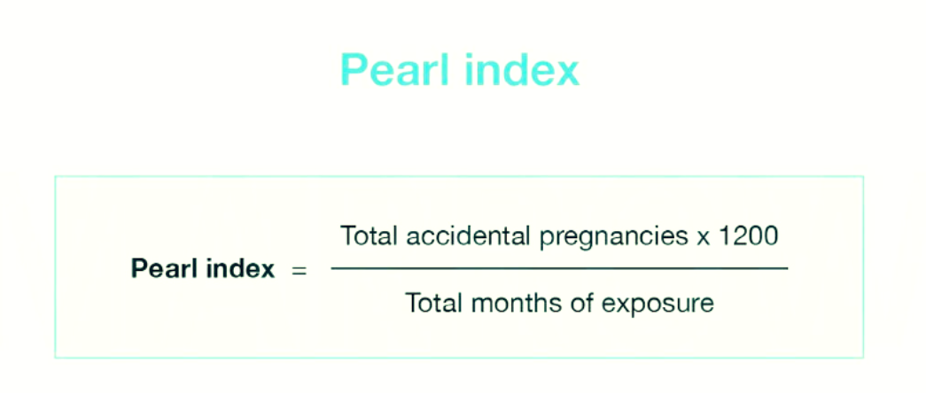
Positive Marks | 4
Negative Marks | 1

Question | In Kaplan Meier survival curve, the bands used for the confidence  interval is?
Type | multiple_choice
Option | Unequal precision band
Option | Hirshberg band
Option | Holmes band
Option | Hall-Wellner Band
Answer | 4
Solution | The bands used for confidence interval in the Kaplan-Meier survival curve are Hall-Wellner bands.  When using standard statistical software, at each point in time, the upper and lower limits of the confidence interval are also  obtained. Hall-Wellner bands, Gill bands, and Nair's Equal Precision confidence bands are used for this purpose.  Kaplan-Meier plot is a graphical representation of the number of people surviving during a given length of time. Often there  are two or more groups represented in the plot, such as those treated versus those not treated. The graph often has a  number of steps as the number of people surviving is a discrete variable. The image given below shows a Kaplan-Meier plot.  The dotted lines represent the upper and lower limits of the 95% confidence interval.  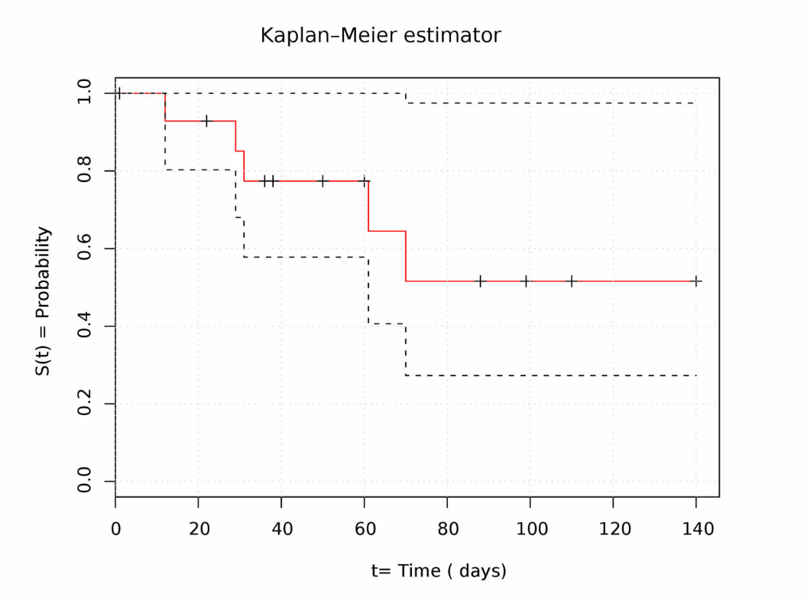
Positive Marks | 4
Negative Marks | 1

Question | ou are asked to investigate a possible act of terrorism using anthrax. Which of the following is false regarding this category of bioterrorism agent?
Type | multiple_choice
Option | High priority agents
Option | Have high mortality rates
Option | Moderately difficult to disseminate
Option | Require specialized public health responses
Answer | 3
Solution | Anthrax falls under category A of bioterrorism agents. These organisms are usually easy to disseminate. Category A refers to high priority agents. They have high case-fatality rates and high transmissibility. Thus, a specialised public health response is required to combat such attacks.
Positive Marks | 4
Negative Marks | 1

Question | Individuals with fluoride intake above which of the following are at risk of developing crippling fluorosis
Type | multiple_choice
Option | > 6 mg/L
Option | > 1.5 mg/L
Option | > 3 mg/L
Option | > 10 mg/L
Answer | 4
Solution | Individuals with fluoride intake > 10 mg/L are at risk of developing crippling fluorosis. Complications of fluorosis seen with corresponding levels of fluoride intake are:  Dental fluorosis - 1.5 mg/L  Skeletal fluorosis - 3-6 mg/L  Crippling fluorosis - > 10 mg/L  Genu valgum may occur in people who consume jowar (sorghum), as it promotes greater retention of ingested fluoride. The Nalgonda technique is used for the defluoridation of water bodies. It involves the addition of lime and alum followed by flocculation, sedimentation, and filtration.
Positive Marks | 4
Negative Marks | 1

Question | Which of the following is true about the reference woman used in the calculation of the recommended daily allowance (RDA)?
Type | multiple_choice
Option | Weight 55 kgs
Option | Height 1.73 m
Option | Works 10 hours/day
Option | Age of 18-25 years
Answer | 1
Solution | The reference woman used in the calculation of recommended daily allowance (RDA) weighs about 55 Kgs and is aged between 19-39 years, nonpregnant, non-lactating with a height of 1.62 meters, and a BMI of 20.95, is free from disease and physically fit for active work. On each working day, she must be engaged in 8 hours of occupation/work, which usually involves moderate activity. When not at work she spends 8 hours in bed, 4-6 hours in sitting and moving about, 2 hours in walking, and in active recreation or household duties.
Positive Marks | 4
Negative Marks | 1

Question | Vitamin A deficiency is considered a public health problem if the prevalence of corneal xerosis among children aged 6 months - 6 years is more than:
Type | multiple_choice
Option | 0.05
Option | 0.01
Option | 0.005
Option | 0.0001
Answer | 4
Solution | Vitamin A deficiency is considered a public health problem if the prevalence rate of corneal xerosis among children between 6 months to 6 years (high-risk category) is more than 0.01%. The presence of any 1 of the following criteria should be considered as evidence of a xerophthalmia problem in the community:  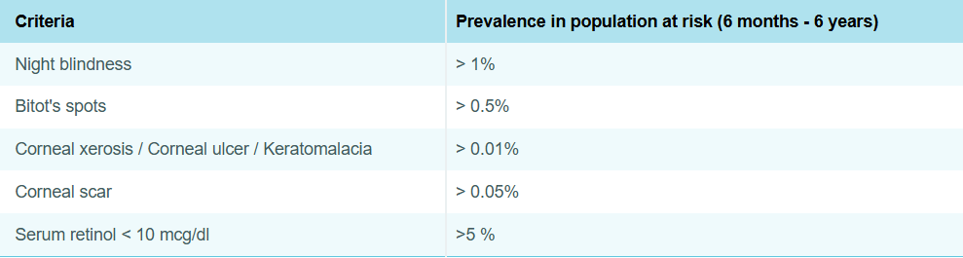
Positive Marks | 4
Negative Marks | 1

Question | Sample sizes of samples 1, 2 and 3 are 1000, 800, 600 respectively. The order of margin of error will be _____  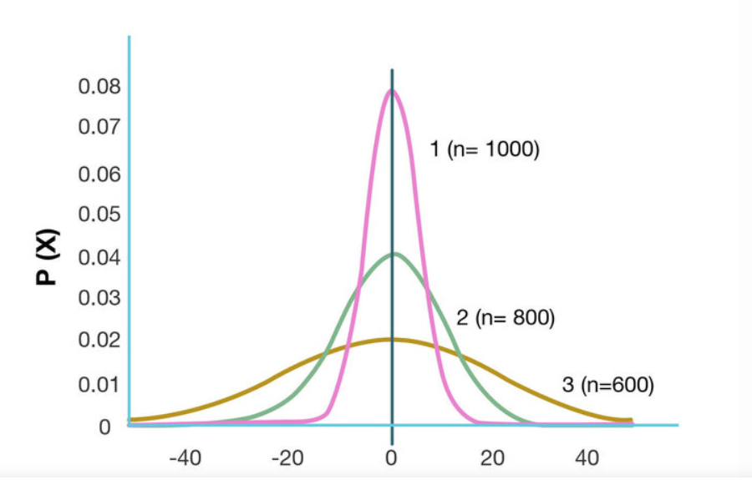
Type | multiple_choice
Option | 3 >2>1
Option | 3>1>2
Option | 1>2>3
Option | 1=2=3
Answer | 1
Solution | Curve 1 has the least margin of error, followed by curve 2, and then curve 3. So the order is 3 > 2 > 1. The image shows three normal distribution curves of different sample sizes, having the same mean but different standard deviations. As the sample size is decreasing, the peak decreases and the curve becomes more flat, implying a wider confidence of interval for the given mean. The width of the base of the curve is directly proportional to the margin of error.
Positive Marks | 4
Negative Marks | 1

Question | Primary level of prevention for specific protection includes all of the following except?
Type | multiple_choice
Option | Meningitis prophylaxis in exposed contacts/relatives
Option | Hand washing" with "pyrimethamine
Option | Vaccination
Option | Adding iron to wheat flour
Answer | 2
Solution | While handwashing is a form of primary prevention, it is not a form of specific protection since it does not target any disease or pathogen in particular. It is a method of health promotion. Health promotion is a mode of intervention which includes health education, environmental modifications, nutritional interventions, and lifestyle and behavioural changes.
Positive Marks | 4
Negative Marks | 1

Question | A pregnant woman whose niece lives with her in the same house contracted Varicella. She tested negative for serum antibodies against varicella. What would this mean?
Type | multiple_choice
Option | She is immune to zoster
Option | She is susceptible to zoste
Option | She is susceptible to chicken pox
Option | She is immune to chicken pox
Answer | 3
Solution | The given clinical scenario showing the absence of serum antibodies is indicative of susceptibility to chickenpox. The acquisition of maternal antibodies protects the infant during the first few months of life. The IgG antibodies produced during the first attack with the virus persist for life and their presence is correlated with protection against varicella. The absence of antibodies in the given scenario signifies that the patient is susceptible to chicken pox. Hence, the serologic screening of serum for IgG antibodies is used to assess immunity or susceptibility of a person to varicella, especially in unvaccinated people, e.g. in healthcare workers. Varicella in pregnant women: The contraction of the virus by a pregnant woman increases the risk of the fetus to congenital varicella syndrome. This is seen in mothers who are affected during the first 20 weeks of gestation. Affected babies present with the following:  Foetal wastage  Cutaneous scars  Atrophied limbs  Microcephaly  Low birth weight  Cataract  Microphthalmia  Chorioretinitis  Deafness  Cerebro-cortical atrophy Prevention:  Varicella-Zoster Immunoglobulin (VZIG) is given as post-exposure prophylaxis within 72 hours of exposure and has been recommended for prevention of chickenpox in exposed susceptible individuals particularly in immunosuppressed persons such as:  Persons receiving immunosuppressive therapy  Newborns  Persons with acquired immunodeficiency including HIV/AIDS  Exposed pregnant women  Persons with congenital cellular immunodeficiency  Premature infants of low birth weight  Live attenuated vaccine is administered to children who have not had chicken pox between the age of 12 to 18 months.  Malaria Treatment (Q23 Explanation): This clinical scenario and peripheral smear showing crescent-shaped gametocytes are suggestive of uncomplicated falciparum malaria. As this woman is from a North-Eastern state, the drug regimen of choice is ACT-AL (artemisinin combination therapy):  Artemether (20mg)  Lumefantrine (120mg) This regimen is followed in the North-Eastern states of India due to documented resistance to sulphadoxine-pyrimethamine in these areas. ACT-AL is contraindicated in:  1st trimester of pregnancy  Children < 5 kg
Positive Marks | 4
Negative Marks | 1

Question | A 44-year-old woman from Assam presented with fever and chills recurring every 48 hours. On examination, she was conscious, oriented, and febrile. CBC, LFT, and RFT were normal. Peripheral smear revealed the following. What is the drug of choice?  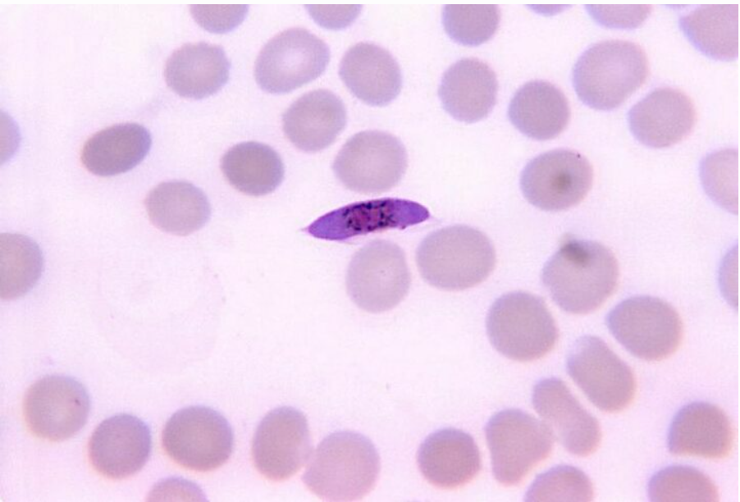
Type | multiple_choice
Option | Quinine
Option | Artesunate and sulphadoxine-  pyrimethamine
Option | Artemether and lumefantrine
Option | Chloroquine and pyrimethamine
Answer | 3
Solution | This clinical scenario and peripheral smear showing crescent-shaped gametocytes are suggestive of  uncomplicated falciparum malaria. As this woman is from a North-Eastern state, the drug regimen of choice is ACT-AL  (artemisinin combination therapy):  · Artemether (20mg)  · Lumefantrine (120mg)  This regimen is followed in the North-Eastern states of India due to documented resistance to sulphadoxine-pyrimethamine in  these areas. ACT-AL is contraindicated in:  . 1st trimester of pregnancy  . Children < 5 kg  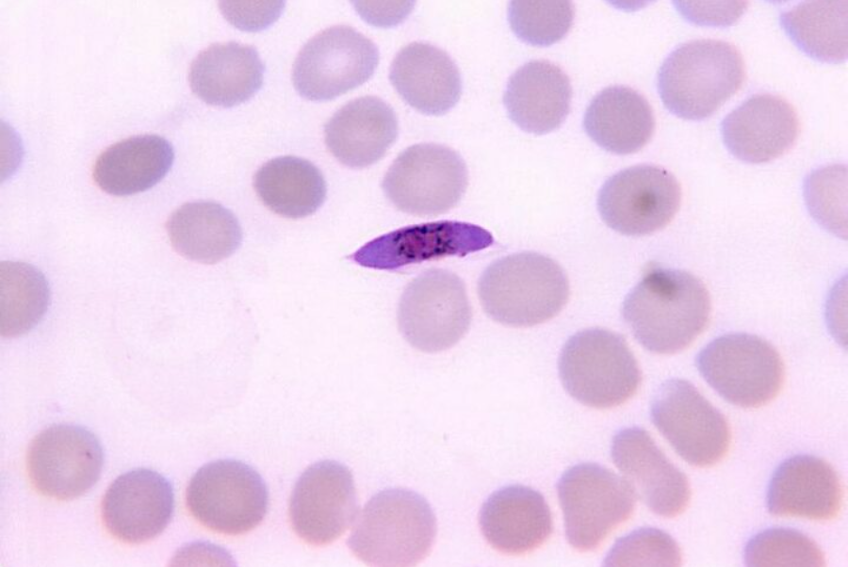
Positive Marks | 4
Negative Marks | 1

Question | In a town of 20,000 populations, total 456 births were there in a year out of which 56 were dead born. The total death were 247 out of which 56 deaths were within 28 days of life and another 34 had dies after 28 days and before completing the first birthday. Calculate the infant mortality rate of the area?
Type | multiple_choice
Option | 197
Option | 392
Option | 225
Option | 344
Answer | 3
Solution | The infant mortality rate is 225 per 1000 live births.  Infant mortality rate (IMR) is defined as the ratio of infant deaths registered in a given year to the total number of live  births in the same year. IMR is usually expressed as a rate per 1000 live births. Infants include those under the age of 1 year.  Calculation:  . IMR = (Number of deaths of children under 1 year of age in a year x 1000)/(Number of live births in the same year).  . In the given question, Out of total 456 births, 56 were dead born. Therefore, the number of live births= 456-56 = 400.  . In the same year, it is given that the number of deaths before 28 days is 56, and the number of deaths after 28 days but  before 1 year. Therefore, the total number of deaths of children under the age of 1 year is 56 + 34 = 90  · IMR = (90x1000)/400 = 900/4 = 225  . Hence, the IMR is 225 per 1000 live births.
Positive Marks | 4
Negative Marks | 1

Question | Water from a broken septic tank is collected in a container and breeding mosquitoes are seen. The image of the larva is given below. Identify the species of the mosquito.  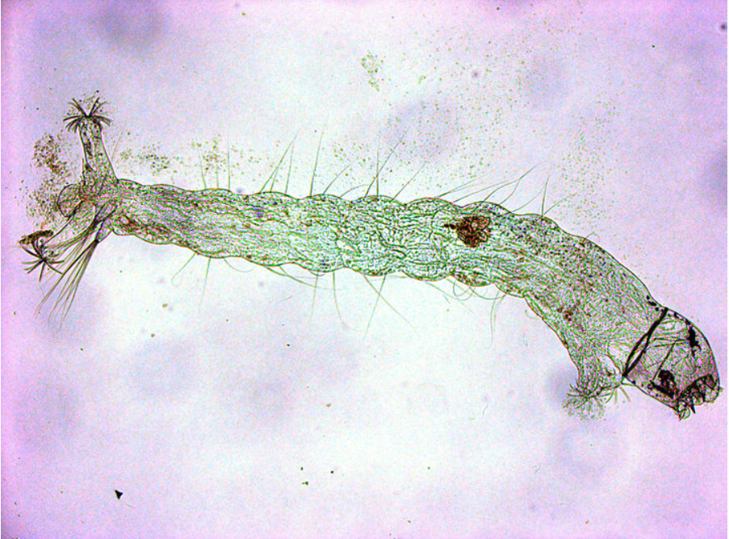
Type | multiple_choice
Option | Anopheles
Option | Aedes
Option | Mansonia
Option | Culex
Answer | 4
Solution | The species of mosquito that breeds in dirty water is Culex.  Culex fatigans are found everywhere in India and they transmit Bancroftian filariasis. Culex mosquitoes are also vectors  for Japanese encephalitis, West Nile fever, and viral arthritis.  It can be identified by the presence of unspotted wings and hunched back. The larva has a head that is suspended  downwards at an angle to the water surface and a siphon tube is present.  It breeds in dirty water collections like stagnant drains, septic tanks, and burrow pits. The peak biting time is during midnight.  The preferred biting site is the legs, mainly below the knee.
Positive Marks | 4
Negative Marks | 1

