**Boppudi Vivek(916243)**

**Day-3-Handson-session-1**

**1)Template Driven Form - Create a new component for editing employee details**

**editemp.component.html**

**<strong>Edit Employees</strong>**

**<br>**

**<br>**

**<form><label><strong>Name:</strong><input type="text" name="name1" #name1></label>**

**{{name1.value}}**

**<br>**

**<br></form>**

**<hr>**

**<label>**

**<strong>Lname:</strong>**

**<input type="text" name="name" [(ngModel)]="employees" #name=ngModel PlaceHolder="Lname" pattern="[a-z]+" minlength="3" maxlength="10">**

**{{employees}}**

**<div>name.invalid - {{name.invalid}}</div>**

**<div>name.touched - {{name.touched}}</div>**

**<div>name.dirty - {{name.dirty}}</div>**

**<!-- <div>name.errors.required - {{name.errors?.required}}</div> -->**

**<div>name.errors.minlength or maxlength - {{name.errors?.minlength | json}}</div>**

**</label>**

**<hr>**

**<br><br>**

**<label>**

**<strong>Name:</strong>**

**<input type="text" name="t1" [(ngModel)]="myname" minlength="2" maxlength="10" #t1=ngModel required="true"><br>**

**</label>**

**<span class="c1" *ngIf="t1.invalid && t1.dirty">Name must be 2 characters long</span>**

**<br>**

**<br>**

**<hr>**

**<form #empForm="ngForm" (submit)="OnSubmit()">**

**<div class="block">**

**<label>**

**<strong>Name:</strong>**

**<input type="text" [(ngModel)]="emp.Name" [ngModelOptions]="{standalone: true}">**

**</label>**

**<br>**

**<br>**

**<label>**

**<strong>Salary:</strong>**

**<input type="number" [(ngModel)]="emp.Salary" Pattern="\d+" [ngModelOptions]="{standalone: true}">**

**</label>**

**<br><br>**

**<label>**

**<strong>Is Permanent or Not?</strong>**

**<input type="radio" name="permanent" [(ngModel)]="emp.Permanent" [value]="true">Yes**

**<input type="radio" name="permanent" [(ngModel)]="emp.Permanent" [value]="false">No**

**</label>**

**<label>**

**</label>**

**<button type="submit" [disabled]="!empForm.valid">Save</button>**

**</div>**

**</form>**

**<div class="block">**

**<strong>Employee Model</strong><br>**

**<pre>{{emp | json }}</pre>**

**</div>**

**editemp.component.ts**

**import { Component, OnInit } from '@angular/core';**

**@Component({**

**selector: 'app-editemp',**

**templateUrl: './editemp.component.html'**

**})**

**export class EditempComponent{**

**public employees:string;**

**public myname:string;**

**constructor() {**

**this.employees = "";**

**this.myname="";**

**}**

**public emp:employee={Id:1,Name:"John",Salary:10000,Permanent:false, Dept:{Id:1,Name:"Payroll"},skills:[{id:1,Name:"html"},{id:2,Name:"Css"},{id:3,Name:"Javascript"}]};**

**public departmentslist:any[]=[{Id:1,Name:"Payroll"},{Id:2,Name:"Internal"},{Id:3,Name:"Hr"}];**

**public OnSubmit():void{**

**console.log(this.emp);**

**}**

**}**

**class employee{**

**public Id:number=0;**

**public Name:string="";**

**public Salary:number=0;**

**public Permanent:boolean=true;**

**public Dept:Department={Id:1,Name:"Payroll"};**

**public skills:any[]=[{}];**

**}**

**class Department{**

**public Id:number=1;**

**public Name:string="";**

**}**

**Output:**

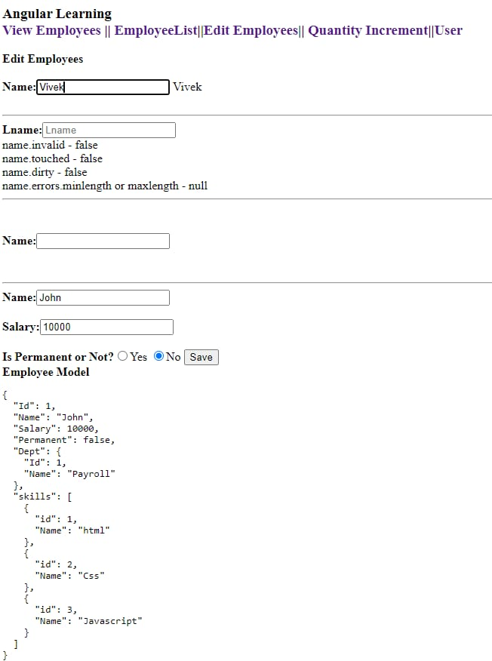

**2)Reactive Form - New Component and Name field inclusion**

**edit-emp-reactive.component.ts**

**import { Component, OnInit } from '@angular/core';**

**import {FormGroup,FormControl,Validators} from '@angular/forms';**

**@Component({**

**selector: 'app-edit-emp-reactive',**

**templateUrl: './edit-emp-reactive.component.html'**

**})**

**export class EditEmpReactiveComponent{**

**public emp:employee={Id:1,Name:"John",Salary:10000,Permanent:false, Dept:{Id:1,Name:"Payroll"},skills:[{id:1,Name:"html"},{id:2,Name:"Css"},{id:3,Name:"Javascript"}]};**

**public departmentslist:any[]=[{Id:1,Name:"Payroll"},{Id:2,Name:"Internal"},{Id:3,Name:"Hr"}];**

**Name=new FormControl('John');**

**public empForm:FormGroup = new FormGroup({**

**'name': new FormControl(this.emp.Name, [**

**Validators.required,**

**Validators.minLength(4),**

**Validators.maxLength(20)**

**])**

**});**

**public deptF:FormGroup = new FormGroup({**

**'department': new FormControl("")**

**});**

**}**

**class employee{**

**public Id:number=0;**

**public Name:string="";**

**public Salary:number=0;**

**public Permanent:boolean=true;**

**public Dept:Department={Id:1,Name:"Payroll"};**

**public skills:any[]=[{}];**

**}**

**class Department{**

**public Id:number=1;**

**public Name:string="";**

**}**

**edit-emp-reactive.component.html**

**<h2>Edit Employee</h2>**

**<label>**

**Name: <input type="text" [formControl]="Name">**

**</label>**

**<br>**

**<br>**

**<div>**

**<form [formGroup]="deptF">**

**<h3>Department</h3>**

**<select formControlName="department">**

**<option *ngFor="let department of departmentslist"**

**[ngValue]="department"**

**[selected]="department.Id == emp.Dept.Id">**

**{{department.Name}}**

**</option>**

**</select>**

**</form>**

**</div>**

**Output:**

