**Boppudi vivek(916243)**

**Day-5-Handson-Session1&2**

**1)Demonstrate using Service and HttpClient to invoke web service**

**user.component.html**

**<div class="some">**

**<input type="button" value="Get Users" (click)="retrieveAllUser()"/>&nbsp;**

**<br><br>**

**<table border="2" cellspacing="0">**

**<tr>**

**<th>Photo</th>**

**<th>Details</th>**

**</tr>**

**<tr *ngFor="let item of user.data">**

**<td><img width="100" [src]="item.avatar"></td>**

**<td style="text-align: left;">Name : {{item.first_name}} &nbsp;{{item.last_name}}**

**<br>**

**Email : {{item.email}}**

**</td>**

**</tr>**

**</table>**

**</div>**

**user.component.ts**

**import { Component, OnInit } from '@angular/core';**

**import { UserService } from '../user.service';**

**import { user } from '../user.service';**

**@Component({**

**selector: 'app-user',**

**templateUrl: './user.component.html'**

**})**

**export class UserComponent implements OnInit {**

**public user:any=[];**

**constructor(private userService:UserService ) { }**

**ngOnInit(): void {**

**}**

**retrieveAllUser() {**

**this.userService.getAll()**

**.subscribe(**

**data => {**

**this.user= data;**

**console.log(data);**

**console.log(this.user);**

**},**

**error => {**

**console.log(error);**

**});**

**}**

**}**

**user.service.ts**

**import { Injectable } from '@angular/core';**

**import { HttpClient } from '@angular/common/http';**

**const baseUrl = 'https://reqres.in/api/users?page=2';**

**@Injectable({**

**providedIn: 'root'**

**})**

**export class UserService {**

**constructor(private http: HttpClient) { }**

**getAll() {**

**return this.http.get(baseUrl);**

**}**

**}**

**//Interface for user to handle data**

**export interface user {**

**id:number;**

**email:string;**

**first_name:string;**

**last_name:string;**

**avatar : string;**

**}**

**app.module.ts**

**import { NgModule } from '@angular/core';**

**import { BrowserModule } from '@angular/platform-browser';**

**import { AppRoutingModule } from './app-routing.module';**

**import { AppComponent } from './app.component';**

**import { ViewempsComponent } from './viewemps/viewemps.component';**

**import { EditEmpReactiveComponent } from './editemp/edit-emp-reactive.component';**

**import { EmployeeListComponent } from './employee-list/employee-list.component';**

**import { EmpInfoComponent } from './emp-info/emp-info.component';**

**import { UserComponent } from './user/user.component';**

**import {Routes,RouterModule} from '@angular/router'**

**import { viewClassName } from '@angular/compiler';**

**import { QuantityIncrementComponent } from './quantity-increment/quantity-increment.component';**

**import { FormsModule, ReactiveFormsModule } from '@angular/forms';**

**import { HttpClientModule } from '@angular/common/http';**

**const appRoutes:Routes=[{path:"" , component:ViewempsComponent},**

**{path:"EditEmployees" ,**

**component:EditEmpReactiveComponent},{path:"QuantityIncrement",component:QuantityIncrementComponent},**

**{ path: 'edit-emp-reactive/:id', component: EmployeeListComponent},{path:"User",component:UserComponent}]**

**@NgModule({**

**declarations: [**

**AppComponent,**

**ViewempsComponent,**

**EmployeeListComponent,**

**EmpInfoComponent,**

**UserComponent,**

**EditEmpReactiveComponent,**

**QuantityIncrementComponent,**

**],**

**imports: [**

**HttpClientModule,**

**FormsModule,**

**BrowserModule,**

**AppRoutingModule,**

**ReactiveFormsModule,**

**RouterModule.forRoot(appRoutes)**

**],**

**providers: [],**

**bootstrap: [AppComponent]**

**})**

**export class AppModule { }**

**OUTPUT:**

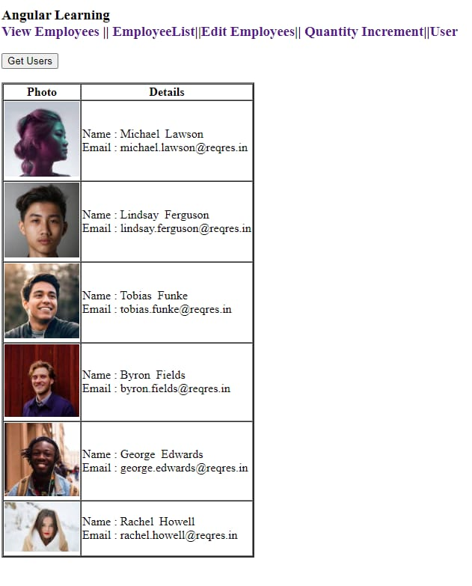

**2)Demonstrate end to end testing using Protractor**

**todo-spec.js**

**describe('angularjs homepage todo list', function() {**

**it('should add a todo', function() {**

**browser.get('https://angularjs.org');**

**element(by.model('todoList.todoText')).sendKeys('write first protractor test');**

**element(by.css('[value="add"]')).click();**

**var todoList = element.all(by.repeater('todo in todoList.todos'));**

**expect(todoList.count()).toEqual(3);**

**expect(todoList.get(2).getText()).toEqual('write first protractor test');**

**// You wrote your first test, cross it off the list**

**todoList.get(2).element(by.css('input')).click();**

**var completedAmount = element.all(by.css('.done-true'));**

**expect(completedAmount.count()).toEqual(2);**

**});**

**});**

**conf.js**

**exports.config =**

**{**

**seleniumAddress: 'http://localhost:4444/wd/hub',**

**specs: ['todo-spec.js']**

**};**