**Boppudi Vivek(916243)**

1. Web Api using .Net core with Swagger

Create a .Net core web application with API template. (Use existing application if created). Install Swashbuckle.AspNetCore Nuget package. Post this do the following steps in Startup.cs

· In ConfigureServices method, add the code provided below.

services.AddSwaggerGen(c =>

{

c.SwaggerDoc("v1", new Info

{

Title = "Swagger Demo",

Version = "v1",

Description = "TBD",

TermsOfService = "None",

Contact = new Contact() { Name = "John Doe", Email = "john@xyzmail.com", Url = "www.example.com" },

License = new License() { Name = "License Terms", Url = "www.example.com" }

});

});

· In Configure method, add the code provided below.

app.UseSwagger();

app.UseSwaggerUI(c =>

{

// specifying the Swagger JSON endpoint.

c.SwaggerEndpoint("/swagger/v1/swagger.json", "Swagger Demo");

});

**Startup.cs**

**using System;**

**using System.Collections.Generic;**

**using System.Linq;**

**using System.Threading.Tasks;**

**using Microsoft.AspNetCore.Builder;**

**using Microsoft.AspNetCore.Hosting;**

**using Microsoft.AspNetCore.HttpsPolicy;**

**using Microsoft.AspNetCore.Mvc;**

**using Microsoft.Extensions.Configuration;**

**using Microsoft.Extensions.DependencyInjection;**

**using Microsoft.Extensions.Logging;**

**using Microsoft.Extensions.Options;**

**using Microsoft.OpenApi.Models;**

**namespace Handson_2**

**{**

**public class Startup**

**{**

**public Startup(IConfiguration configuration)**

**{**

**Configuration = configuration;**

**}**

**public IConfiguration Configuration { get; }**

**// This method gets called by the runtime. Use this method to add services to the container.**

**public void ConfigureServices(IServiceCollection services)**

**{**

**services.AddMvc().SetCompatibilityVersion(CompatibilityVersion.Version_2_1);**

**services.AddSwaggerGen(c =>**

**{**

**c.SwaggerDoc("v1.0", new OpenApiInfo**

**{**

**Title = "My Demo API",**

**Version = "1.0",**

**Description = "TBD",**

**Contact = new OpenApiContact() { Name = "John Doe", Email = "john@xyzmail.com", Url = new Uri("https://www.example.com") },**

**License = new OpenApiLicense() { Name = "License Terms", Url = new Uri("https://www.example.com") }**

**}); ;**

**});**

**}**

**// This method gets called by the runtime. Use this method to configure the HTTP request pipeline.**

**public void Configure(IApplicationBuilder app, IHostingEnvironment env)**

**{**

**if (env.IsDevelopment())**

**{**

**app.UseDeveloperExceptionPage();**

**}**

**else**

**{**

**app.UseHsts();**

**}**

**app.UseHttpsRedirection();**

**app.UseMvc();**

**app.UseSwagger();**

**app.UseSwaggerUI(c =>**

**{**

**c.SwaggerEndpoint("/swagger/v1.0/swagger.json", "My Demo API (V 1.0)");**

**});**

**}**

**}**

**}**

2)Execute the application which will load the default ‘Values’ controller(Settings as per launchSettings.json) GET action method. Change the url to https://localhost:[port number]/swagger

Notice the Title, Version, Contact detail provided shown on the top of the page

Notice the Values controller HttpVerb action methods getting listed.

Click the ‘GET’ action verb method(Without the parameter).

It opens a panel which has ‘Try it out’ button. Click that and Click ‘Execute’ button.

**EmployeeController.cs**

**using Microsoft.AspNetCore.Mvc;**

**using System;**

**using System.Collections.Generic;**

**using System.Linq;**

**using System.Threading.Tasks;**

**using WebApi_Handson_Day74.Models;**

**// For more information on enabling Web API for empty projects, visit https://go.microsoft.com/fwlink/?LinkID=397860**

**namespace WebApi_Handson_Day74.Controllers**

**{**

**[Route("api/[controller]")]**

**[ApiController]**

**public class EmployeeController : ControllerBase**

**{**

**private readonly IEmployee emp;**

**public EmployeeController(IEmployee _emp)**

**{**

**emp = _emp;**

**}**

**// GET: api/<EmployeeController>**

**[HttpGet]**

**public IEnumerable<Employee> Get()**

**{**

**return emp.GetEmployee();**

**}**

**// GET api/<EmployeeController>/5**

**[HttpGet("{id}")]**

**public Employee Get(int id)**

**{**

**return emp.GetEmployeebyid(id);**

**}**

**// POST api/<EmployeeController>**

**[HttpPost]**

**public void Post(Employee e)**

**{**

**emp.AddEmployee(e);**

**}**

**// PUT api/<EmployeeController>/5**

**[HttpPut("{id}")]**

**public void Put(int id, Employee e)**

**{**

**emp.UpdateEmployee(id, e);**

**}**

**// DELETE api/<EmployeeController>/5**

**[HttpDelete("{id}")]**

**public void Delete(int id)**

**{**

**emp.DeleteEmployee(id);**

**}**

**}**

**}**

**Employee.cs**

**using System;**

**using System.Collections.Generic;**

**using System.Linq;**

**using System.Threading.Tasks;**

**namespace WebApi_Handson_Day74.Models**

**{**

**public class Employee**

**{**

**public int Id { get; set; }**

**public string Name { get; set; }**

**}**

**}**

**EmployeeRepo.cs**

**using System;**

**using System.Collections.Generic;**

**using System.Linq;**

**using System.Threading.Tasks;**

**namespace WebApi_Handson_Day74.Models**

**{**

**public class EmployeeRepo : IEmployee**

**{**

**static private List<Employee> Employees = new List<Employee>**

**{**

**new Employee{Id=1,Name="Vivek"},**

**new Employee{Id=2,Name="Vivek Bopudi"}**

**};**

**public Employee AddEmployee(Employee e)**

**{**

**Employees.Add(e);**

**return e;**

**}**

**public Employee DeleteEmployee(int id)**

**{**

**Employee e = new Employee();**

**if (!(id > Employees.Count))**

**{**

**e = Employees[id - 1];**

**Employees.RemoveAt(id);**

**}**

**return e;**

**}**

**public IEnumerable<Employee> GetEmployee()**

**{**

**return Employees;**

**}**

**public Employee GetEmployeebyid(int id)**

**{**

**Employee e = new Employee();**

**if (!(id > Employees.Count))**

**{**

**e = Employees[id - 1];**

**}**

**return e;**

**}**

**public void UpdateEmployee(int id, Employee emp)**

**{**

**if (!(id > Employees.Count))**

**{**

**Employees[id - 1]=emp;**

**}**

**}**

**}**

**}**

**IEmployee.cs**

**using System;**

**using System.Collections.Generic;**

**using System.Linq;**

**using System.Threading.Tasks;**

**namespace WebApi_Handson_Day74.Models**

**{**

**public interface IEmployee**

**{**

**public IEnumerable<Employee> GetEmployee();**

**public Employee AddEmployee(Employee e);**

**public Employee GetEmployeebyid(int id);**

**public Employee DeleteEmployee(int id);**

**public void UpdateEmployee(int id, Employee emp);**

**}**

**}**

**Swagger GetMethod:**

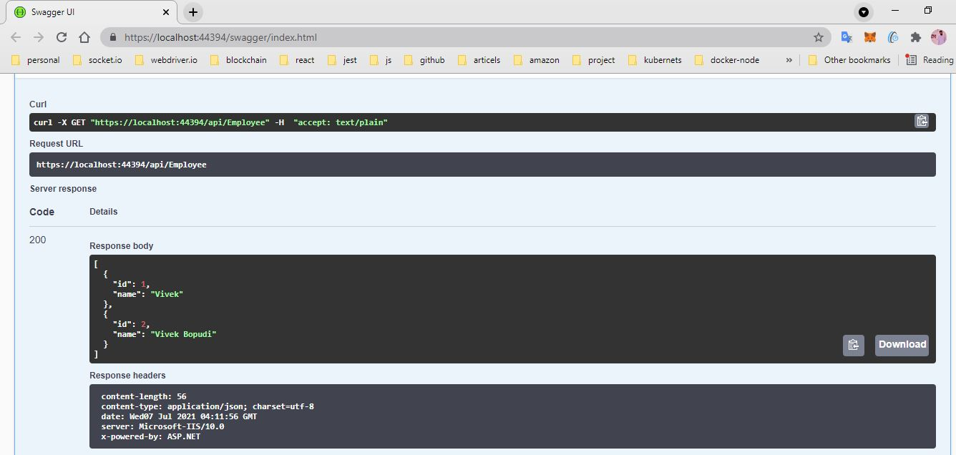

**Swagger:**

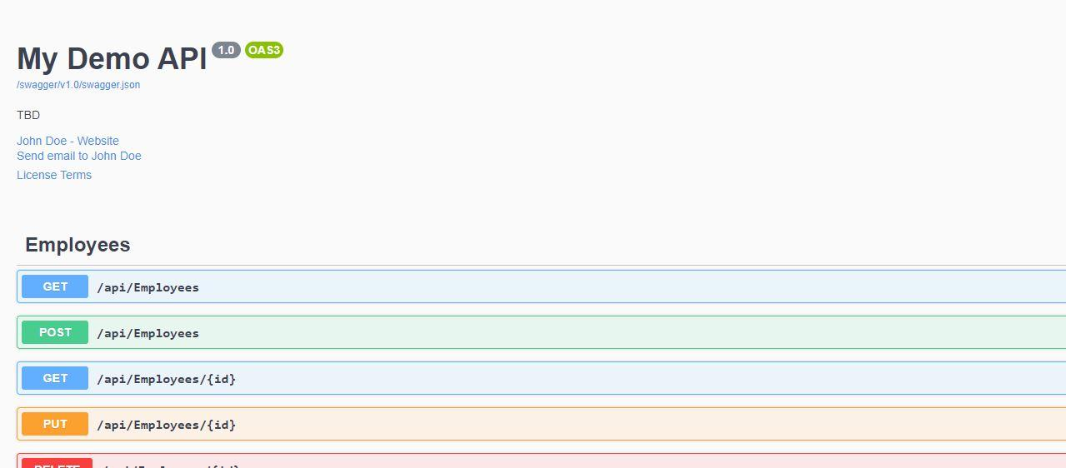

2. Use POSTMAN tool, to point to the local Web API that was created with Employee controller. Test the GET action method using POSTMAN.

Verify the output if the List of employees are listed in the ‘Body’ part of the GET window on POSTMAN tool.

Verify the Status on the right side of the output pane on POSTMAN tool.

**Output:**

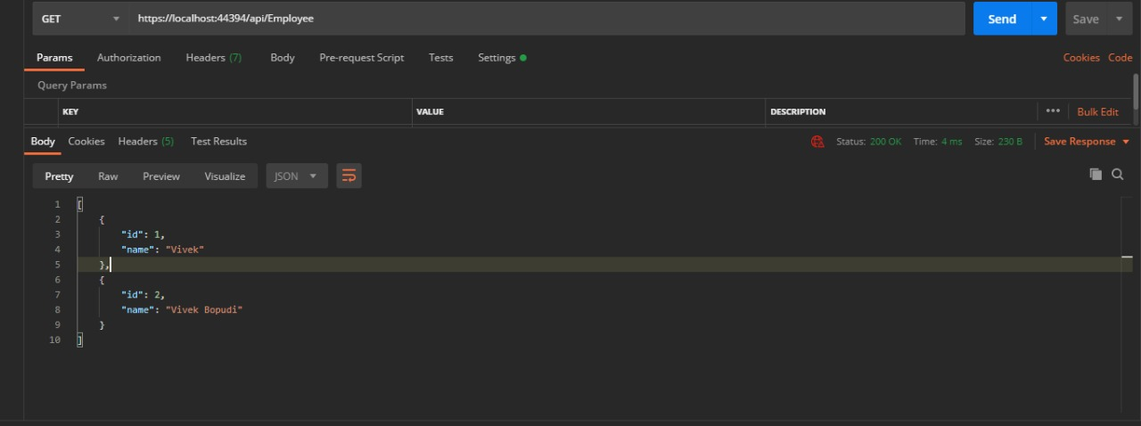

1. Modify the Controller name in the Route attribute of the Employee controller to ‘Emp’ and check its access thru POSTMAN

**Output:**