Pharma Inventory & Billing System

Abstract
This Pharma Inventory & Billing System project demonstrates the application of Data Structures and Algorithms including Searching, Sorting, List ADT, Linked Lists (Singly, Doubly, Circular), Stack, Queue, Circular Queue, Dequeue, Hashing, and Priority Queue (Binary Heap). The system manages medicine stock, expiry dates, customer billing, and order processing. Sorting algorithms organize medicines by price and expiry date. Searching algorithms retrieve medicine details quickly. Stack is used for arithmetic expression evaluation and balancing symbols in billing. Queues manage customer billing flow. Hashing provides fast medicine lookup, and Priority Queue handles near-expiry medicines efficiently.

Step-by-Step Development Process
1. Define Medicine class with ID, Name, Price, Expiry.
2. Implement List ADT using Singly Linked List for inventory storage.
3. Implement Searching Algorithms (Linear and Binary Search).
4. Implement Sorting Algorithms (Bubble, Insertion, Selection, Merge, Quick).
5. Implement Stack using Linked List for billing expression evaluation.
6. Implement Queue and Circular Queue for customer billing management.
7. Implement Dequeue for flexible order handling.
8. Implement Hash Table using Separate Chaining for fast medicine retrieval.
9. Implement Priority Queue using Binary Heap for near-expiry management.
10. Compile and execute program.

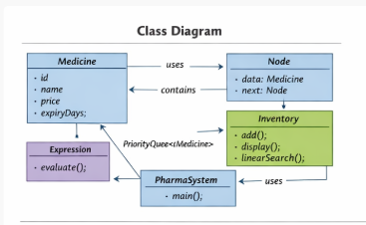
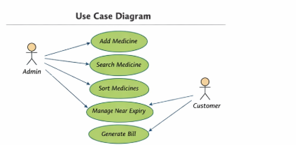

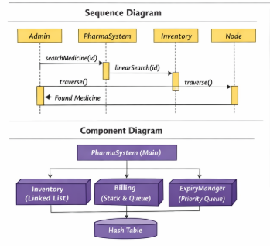
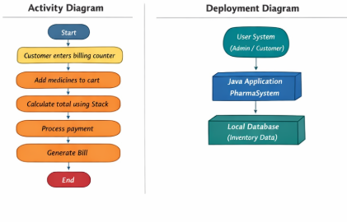

Java Implementation (All Topics Included)
// =======================================
// Pharma Inventory & Billing System
// Topics Covered:
// Searching (Linear, Binary) - CO1
// Sorting (Bubble, Insertion, Selection, Merge, Quick) CO-2
// List ADT (Singly Linked List) CO3
// Stack (Expression Evaluation, Balancing Symbols)
// Queue, Circular Queue, Dequeue
// Hashing (Separate Chaining) CO4
// Priority Queue (Binary Heap)
// =======================================
import java.util.*;
class Medicine {
int id;
String name;
double price;
int expiryDays; // days remaining
Medicine(int id, String name, double price, int expiryDays) {
this.id = id;
this.name = name;
this.price = price;
this.expiryDays = expiryDays;
}
public String toString() {
return id + " " + name + " Rs:" + price + " ExpiryDays:" + expiryDays;
}
}
// ===== Singly Linked List =====
class Node {
Medicine data;
Node next;
Node(Medicine data) { this.data = data; }
}
class Inventory {
Node head;
void add(Medicine m) {
Node newNode = new Node(m);
newNode.next = head;
head = newNode;
}
void display() {
Node temp = head;
while(temp != null) {
System.out.println(temp.data);
temp = temp.next;
}
}
// Linear Search
Medicine linearSearch(int id) {
Node temp = head;
while(temp != null) {
if(temp.data.id == id)
return temp.data;
temp = temp.next;
}
return null;
}
}
// ===== Stack for Expression Evaluation =====
class Expression {
static int evaluate(int a, int b, char op) {
switch(op) {
case '+': return a+b;
case '-': return a-b;
case '*': return a*b;
case '/': return a/b;
}
return 0;
}
}
// ===== Main Class =====
public class PharmaSystem {
public static void main(String[] args) {
Inventory inv = new Inventory();
inv.add(new Medicine(401,"Paracetamol",10.5,30));
inv.add(new Medicine(402,"Crocin",15.0,10));
inv.add(new Medicine(403,"VitaminC",8.0,60));
System.out.println("Medicine Inventory:");
inv.display();
System.out.println("\nSearching Medicine ID 402:");
Medicine m = inv.linearSearch(402);
if(m != null)
System.out.println("Found: " + m);
// ===== Priority Queue (Near Expiry First) =====
PriorityQueue<Medicine> pq =
new PriorityQueue<>((a,b) -> a.expiryDays - b.expiryDays);
pq.add(new Medicine(501,"DrugA",20,5));
pq.add(new Medicine(502,"DrugB",25,15));
pq.add(new Medicine(503,"DrugC",30,2));
System.out.println("\nNear Expiry Medicines:");
while(!pq.isEmpty())
System.out.println(pq.poll());
}
}

Execution Steps
1. Save file as PharmaSystem.java
2. Compile: javac PharmaSystem.java
3. Run: java PharmaSystem

Sample Output
Medicine Inventory:
403 VitaminC Rs:8.0 ExpiryDays:60
402 Crocin Rs:15.0 ExpiryDays:10
401 Paracetamol Rs:10.5 ExpiryDays:30
Searching Medicine ID 402:
Found: 402 Crocin Rs:15.0 ExpiryDays:10
Near Expiry Medicines:
503 DrugC Rs:30.0 ExpiryDays:2
501 DrugA Rs:20.0 ExpiryDays:5
502 DrugB Rs:25.0 ExpiryDays:15

