Wingfoot Parvus

User Guide

Wingfoot Parvus 1
User Guide 1
1. Abstract 3
2. Installing Wingfoot Parvus 3
3. Building and Deploying a Web Service 5
4. Consuming Web Services with Parvus 7
5. Developer tools support: Custom Ant tasks 8
6. Building secure Web Services 11
7. Additional Resources 12

Abstract

Wingfoot Parvus is a lightweight SOAP engine that can be embedded in custom applications, or deployed as a SOAP server inside a servlet container. This user guide explains how to install it, and how to build and deploy Web Services.

Installing Wingfoot Parvus

In this user guide, we use Jakarta Tomcat 4.1.x as our servlet container.

If you download Parvus from the website, it is available as a zip file (e.g. parvusX.Y.zip). The first step for installation is to extract out the installable zip file into a directory of choice. This can be done either using the Winzip utility on Windows or unzip on Linux. The java ‘jar’ command can also be used to extract out the files.

$ jar xvf parvus1_0a.zip .

This would extract out the files to the ‘parvus’ directory. We will refer to this directory as PARVUS_HOME in the rest of the user guide.

If installing from a CD, copy the ‘parvus’ directory to a location of choice on your file system. This location is referred to as PARVUS_HOME in the rest of the user guide.

Next, we copy PARVUS_HOME/lib/parvus.war to CATALINA_HOME/webapps/ and restart Tomcat. Here, CATALINA_HOME is the Tomcat 4.1.x install directory. We now have to restart Tomcat in order to have the parvus web application loaded. In case we use Tomcat’s manager application to install the webapp, we would need to restart Tomcat.

Check Parvus installation:

Now browse over to the URL http://localhost:8080/parvus. Here localhost and 8080 are the host and port number that Tomcat runs on- this might be different in your installation.

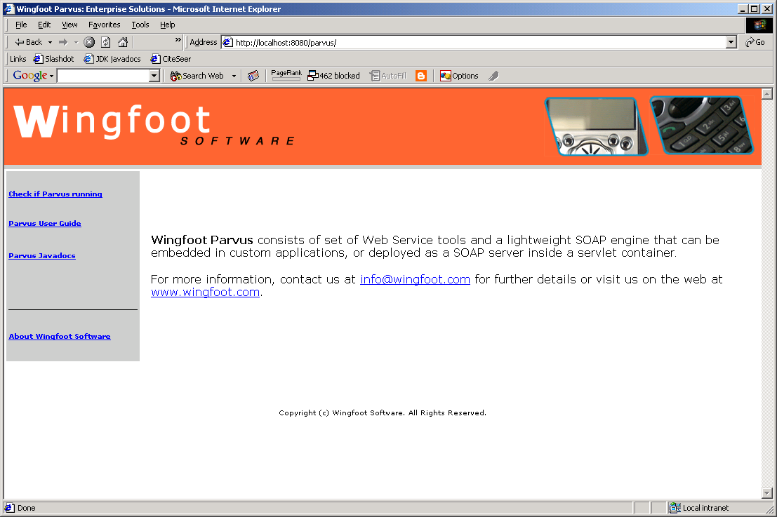

Click on the ‘Check if Parvus running’ link on the left hand side- you should see the following message on your browser window (the actual version number displayed might be different).

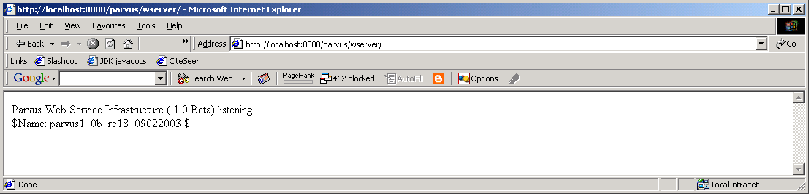
Configure Parvus:

There are some configuration parameters that may need to be tuned. Edit the CATALINA_HOME/webapps/parvus/WEB-INF/classes/wingfoot.properties file and modify as required. The configurable parameters in this file are:

- deploymentFile: This is the file that contains persistent data identifying the services already deployed. Change this to the absolute path of a file. The permissions of the file and directory should be such that only the Tomcat user can read and modify this file.
- logger: This is the file where parvus logs the payload it send/receives. Since the log files are not rolled, set this to a location with some amount of space. The size of the log files should also be monitored periodically. In case this parameter is missing, logging is turned off.
All the paths should be absolute.

Once these parameters have been modified, Tomcat (or the parvus web application) should be restarted for them to take effect.

Building and Deploying a Web Service

The first step is to write and compile the Web Service. The Echo Web Service shown below is a simple java class with methods that echo the input parameters. The code for the service is listed below.

package com.wingfoot.demos.echo;

/**
* A simple echo Web Service
*/
public class EchoService {

/**
* Echo a string
*/
public String echoString (String input) {
return input;
}

/**
* Echo an integer
*/
public int echoInt (int input) {
return input;
}

}

We now compile this class:

$ java –d . EchoService.java

The next step is to generate the WSDL file for the class, and the deployment descriptor.

On UNIX/Linux:

$ java –classpath $PARVUS_HOME\lib\parvus.jar com.wingfoot.tools.Java2WSDL -e http://127.0.0.1:8080/parvus/wserver/ -f echo.wsdl com.wingfoot.demos.echo.EchoService

On Windows:

$ java –classpath %PARVUS_HOME%/lib/parvus.jar com.wingfoot.tools.Java2WSDL -e http://127.0.0.1:8080/parvus/wserver/ -f echo.wsdl com.wingfoot.demos.echo.EchoService

If the –d option is not passed to the command, the deployment descriptor file will not be generated.

The parvus.jar jar file can be added to the CLASSPATH to avoid passing it via the command line every time.

The Java2WSDL command does the following:
- Generates a WSDL description of the service (here echo.wsdl)
- Copies the WSDL file to the Parvus SOAP engine, and displays the location of this WSDL file (e.g. http://127.0.0.1:8080/parvus/wsdl/echo.wsdl)
- Generates a Parvus deployment descriptor (echo.dd) to the local filesystem.

Running Java2WSDL without any options shows the other features it supports:

$ java com.wingfoot.tools.Java2WSDL
Java2WSDL usage: java com.wingfoot.tools.Java2WSDL <options> <classname>
Available options:
-e <ServiceEndpoint> the URI of a Parvus server. If specified, the WSDL is published to the server. If not specified, the WSDL is written to the local file system.
-f <WSDL filename> the name of the WSDL to create. If not specified, a name is assigned.
-s generate the WSDL using document style. If not specified, RPC style is used.
-l generate the WSDL using literal encoding. If not specified, Section V encoding is used.
-m <java package> <namespace> maps a java package to a target namespace

Please note that <classname> refers to the java package and classname (for example: com.foo.class)

Finally, we deploy the service in Parvus. This can be done via the DeploymentAdmin command.

$ java com.wingfoot.soap.server.DeploymentAdmin http://127.0.0.1:8080/parvus/wserver/ deploy echo.dd

After this is done, the java classes for the service need to be moved to the location where the Servlet engine can find them.

On Linux:

$ cp EchoService.class $CATALINA_HOME/webapps/parvus/WEB-INF/classes

On Windows:

$ copy EchoService.class %CATALINA_HOME%/webapps/parvus/WEB-INF/classes

We can use the ‘list’ command to confirm that the service has been deployed.

$ java com.wingfoot.soap.server.DeploymentAdmin http://127.0.0.1:8080/parvus/wserver/ list

The complete set of options the DeploymentAdmin supports is:

$ java com.wingfoot.soap.server.DeploymentAdmin
Incorrect Arguments!!!
java com.wingfoot.soap.server.DeploymentAdmin listenerURL [deploy | undeploy | list] [ DescriptorFileName | Service to remove]

Later in the chapter we’ll see how to automate these tasks using custom Ant tasks.

Consuming Web Services with Parvus

Given the WSDL definition of a Web Service, it is easy to build a client to consume the service. Parvus comes with tool to generate client side stubs.

$ java com.wingfoot.tools.WSDL2Java

WSDL2Java usage: java com.wingfoot.tools.WSDL2Java <options> <wsdl file>
Available options:
-p <namespace> <java package> The p switch allows for specifying namespace to package mapping
-t <transport class> The t switch allows for specifying an alternate transport
-s The s switch specify that the stubs maintain a session variable
The <wsdl file> can be a URL or a file on the filesystem

In the following example, we show how to consume a publicly available Web Service. We use a Web Service listed as xmethods.net that returns the temperature of a given US ZIP code.

$ java com.wingfoot.tools.WSDL2Java http://www.xmethods.net/sd/2001/TemperatureService.wsdl
Parvus generated the following client files:
TemperaturePortTypeBind.java
TemperaturePortType.java

If the command is run from behind a proxy server to get a WSDL file outside the local network, the -Dhttp.proxyHost and -Dhttp.proxyPort options can be used to specify the proxy settings.

As can be seen above, two java files are generated a XXXPortTypeBind.java file containing the interface class for the SOAP methods exposed and the XXXPortType.java that has code to ‘bind’ to the SOAP endpoint.

A client application would need to bind to the SOAP endpoint and invoke the method listed in the interface on it. The following is a sample client application using this service:

public class TemperatureClient {
public static void main (String args[]) throws Exception {
TemperaturePortType port = TemperaturePortTypeBind.bind ();
port.getTemp (args[0]);
}
}

We can then build and run this application as shown:

$ javac -d . Temp*.java
$ java TemperatureClient 94538

Again, the -Dhttp.proxyHost and -Dhttp.proxyPort options can be used to specify the proxy settings when running behind proxy servers.

Developer tools support: Custom Ant tasks

Parvus comes with custom Ant tasks for a convenient interface for managing Web Services. In order to begin using these tasks, you would need to copy the parvus.jar and wingfoot-ant.jar file from PARVUS_HOME/lib to your Ant library directory (ANT_HOME/lib).

For example, if the Ant install directory is /home/jdoe/jakarta-ant-1.5.1 and the Parvus install directory is /home/jdoe/parvus, the following command should be executed:

$ cp /home/jdoe/parvus/lib/wingfoot-ant.jar /home/jdoe/jakarta-ant-1.5.1/lib
$ cp /home/jdoe/parvus/lib/parvus.jar /home/jdoe/jakarta-ant-1.5.1/lib

Once this is done, the Parvus Ant tasks can be added to build scripts. The following Ant script is an example of the steps that need to be done.

<!--
** Sample build.xml for a Web Service that is deployed in
** the Wingfoot SOAP server
-->
<project name="EchoService" default="compile" basedir=".">
<!-- Configure properties for building the web service -->
<property name="src" value="."/>
<property name="build" value="${basedir}/build"/>
<!-- Java class that has the Web Service methods -->
<property name=”serviceClass”
value=” com.wingfoot.demos.echo.EchoService”/>

<!-- Configure properties to access Wingfoot SOAP -->

<!-- verbose=true prints trace messages while performing
admin tasks
-->
<property name="verbose" value="true"/>
<!-- Wingfoot SOAP router URL -->
<property name="url"
value="http://127.0.0.1:8080/parvus/wserver/"/>

<!--URL that the WSDL description for this service will be
published at.
-->
<property name="wsdlUrl"
value="http://127.0.0.1:8080/parvus/echo.wsdl"/>

<!-- Deployment descriptor file for the Echo Web Service -->
<property name="ddfile" value="echo.wsdlDD.xml"/>

<!-- URN for the Echo Web Service -->
<property name="serviceURN" value="urn:echo"/>

<!-- Configure the Wingfoot custom Ant tasks -->
<taskdef name="list"
classname="com.wingfoot.tools.ant.ListServiceAntTask"/>
<taskdef name="deploy"
classname="com.wingfoot.tools.ant.DeployServiceAntTask"/>
<taskdef name="undeploy"
classname="com.wingfoot.tools.ant.UndeployServiceAntTask"/>
<taskdef name="wsdl2java"
classname="com.wingfoot.tools.ant.WSDL2JavaAntTask"/>
<taskdef name="java2wsdl"
classname="com.wingfoot.tools.ant.Java2WSDLAntTask"/>

<!-- Create the build directory structure used by compile -->
<target name="init">
<mkdir dir="${build}"/>
</target>

<!-- Compiles the Web Service code -->
<target name="compile" description="Compile web application"
depends="init">
<javac srcdir="${src}" destdir="${build}"/>
</target>

<!-- Lists all deployed Web Services -->
<target name="list" description="List all web applications">
<list url="${url}" verbose="${verbose}"/>
</target>

<!-- Deploys the Echo Web Service -->
<target name="deploy" description="Deploy web service"
depends="compile">
<deploy url="${url}" DDFile="${ddfile}" verbose="${verbose}"/>
</target>

<!-- Undeploys the Echo Web Service -->
<target name="undeploy" description="Undeploy web service">
<undeploy url="${url}" serviceURN="${serviceURN}"
verbose="${verbose}"/>
</target>

<!—Generates a WSDL description for the service -->
<target name="java2wsdl" description="Generate WSDL description">
<java2sdl serviceEndpoint="${url}" wsdlFile=”echo.wsdl”
publishedURL=”${wsdlUrl}”
classname=”${serviceClass}”
verbose="${verbose}"/>
</target>

</project>

Using this ant script, deployment and listing of deployed Web Services can be done using the following ant targets. We could also have set the dependencies for the targets such that a ‘deploy’ would first invoke ‘build’ and then ‘java2wsdl’.

$ ant
$ ant java2wsdl
$ ant deploy
$ ant list

The table(s) below documents the attributes of all the ant tasks:

List

Attribute | Description | Required
verbose | Sets the trace flag | Optional.
url | Sets the Parvus SOAP router endpoint | Mandatory.

Deploy

Attribute | Description | Required
verbose | Sets the trace flag | Optional.
url | Sets the Parvus SOAP router endpoint | Mandatory.
DDFile | Sets the Deployment Descriptor file | Mandatory.

Undeploy

Attribute | Description | Required
verbose | Sets the trace flag | Optional.
serviceURN | Sets the URN for the deployed service | Mandatory.

Java2WSDL

Attribute | Description | Required
verbose | Sets the trace flag | Optional.
serviceEndpoint | Sets the endpoint of the Parvus SOAP router | Mandatory.
wsdlFile | Name of the WSDL file to generate | Mandatory.
publishedURL | Sets the URL that the WSDL file will be published at. | Mandatory.
document | Use Document style (true) or not (false).  The default is false. | Optional.
literal | Use Literal style (true) or not (false).  The default is false. | Optional.
publish | Publish (true) WSDL to SOAP server or not (false).  The default is false. | Optional.
classname | The name of the java class containing the Web Service methods. | Mandatory.

Java2WSDL can include one or more nested <mapping> elements that specify the namespace to java package name mappings. These have the following attributes.

Attribute | Description | Required
namespace | XML Namespace | Mandatory.
packageName | Java package name | Mandatory.

WSDL2Java

Attribute | Description | Required
verbose | Sets the trace flag | Optional.
transportClass | Alternate SOAP transport class to use | Optional.
sessions | Enable (true) or disable support (false) for sessions in generated client stubs.  The default is false. | Optional.
wsdlFile | The URL or file system path name to the WSDL file. | Mandatory.

Java2WSDL can include one or more nested <mapping> elements that specify the namespace to java package name mappings. These have the following attributes.

Attribute | Description | Required
namespace | XML Namespace | Mandatory.
packageName | Java package name | Mandatory.

Building secure Web Services

Secure Web Services can be achieved at two levels: at the transport layer level, and at the XML message level. Parvus currently does not support XML layer security mechanisms.

SSL (Secure Socket Layer) can be used to secure the transport layer. To do this, we need to configure the servlet engine for SSL support such that the Parvus SOAP router URL (https://127.0.0.1:8080/parvus/wserver/) is now an https URL. This step is servlet engine specific, and hence not covered in this document.

Once this is done, the steps listed in sections (3) and (4) can be repeated, as required, to generate the WSDL and client side stubs.

On the service side, no other changes are required.

On the client side, while accessing a service over SSL, the following two lines would need to be added (shown below), and the JSSE jar files (jsse.jar, jcert.jar, jnet.jar) added to the client application’s CLASSPATH.

public class TemperatureClient {
public static void main (String args[]) throws Exception {
/* Add SSL as supported protocol */
System.setProperty("java.protocol.handler.pkgs", "com.sun.net.ssl.internal.www.protocol");
java.security.Security.addProvider(new com.sun.net.ssl.internal.ssl.Provider());
TemperaturePortType port = TemperaturePortTypeBind.bind ();
port.getTemp (args[0]);
}
}

JSSE is an optional package available from http://java.sun.com/products/jsse/. It is not required for JDK 1.4 and above.

Using the configuration explained above, the data (i.e. the SOAP messages) is encrypted and the server is authenticated. The client however is not authenticated- this requires client side SSL support, which is currently not available in Parvus.

Additional Resources

Wingfoot maintains a moderated mailing list to discuss all aspects of its products including technical how to and suggestions for future enhancements. You can find additional information about joining the newsgroup at http://www.wingfoot.com/mailinglist.jsp.

