**RESUME**

**PINKU RATHOUR**

**Mail-id:** [**pinku.rathour.cs.2021@mitmeerut.ac.in**](mailto:pinku.rathour.cs.2021@mitmeerut.ac.in)

**Contacts No: 7355462016**

RESUME

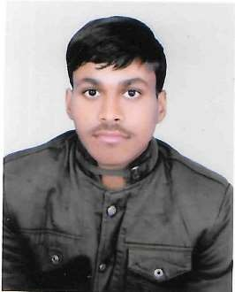

RAJABABU

Branch: Mechanical Production

Mail Id: rb88334139@gmail.com

Contact no.:9005738222

Career Objective

“To work such a environment where I can give my best in growth of self and firm.”

# Academic Detail

|  |  |  |  |  |  |  |
| --- | --- | --- | --- | --- | --- | --- |
|  | Qualification | Year(s) | College/Institute | Board/University | Percentage |  |
| Diploma | 2018-21 | GOVERNMENT  POLYTECHNIC  SHAHJAHANPUR | BTEUP | Appearing |
| Intermediate | 2018 | SWAMI ADAGANAND  MAHARAJ INTER COLLEGE  , PRAYAGARAJ | U.P Board | 80.66 |
| High School | 2016 | SWAMI ADAGANAND  MAHARAJ INTER COLLEGE  , PRAYAGARAJ | U.P Board | 79.80 |
|  | | | | |  | |

# Computer proficiency

* Compatible with MS Excel
* Worked on Tally
* Data Entry

# Hobbies

* Keen to know about new things. • Suffering Internet
* Playing Cricket And Volleyball

# Strength

* Eager to learn
* Believe in team
* Helpful in nature

# Personal Profile

Father's Name: Mr. Ramesh Chandra Keshari Date of Birth: 15 April 2000 Gender: Male.

Nationality: Indian.

Permanent Address:

Village: Soroan panti, Mejaroad

Post : Mejaroad

District : Prayagraj (U.P) Pin code: 212303

Languages: Hindi & English

# Declaration

I am confident of my ability to work in a team and I declare that all the information furnished above is true in the best of my knowledge.

Place: Prayagraj RAJABABU