JAWAHARLAL COLLEGE OF ENGINEERING AND TECHNOLOGY
DEPARTMENT OF AERONAUTICAL ENGINEERING
Lakkidi, Palakkad, Kerala — 679301
A PROJECT REPORT ON
INSTANT FLIGHT TRAJECTORY PREDICTOR:
A PHYSICS-INFORMED MACHINE LEARNING SURROGATE FOR BALLISTIC FLIGHT DYNAMICS WITH AERODYNAMIC DRAG
Submitted in partial fulfillment of the requirements for the course
COMPUTATIONAL FLIGHT MECHANICS & AEROSPACE DATA SYSTEMS (AE401)
SUBMITTED BY: TEAM NINE
Student Name | Roll Number | Department
Vignesh VS | JCEAO057 | Aeronautical Engineering
Vishnu K | JCEAO058 | Aeronautical Engineering
Vivek Raj | JCEAO059 | Aeronautical Engineering
Yuktha Patikkal | JCEAO060 | Aeronautical Engineering
Muhammed Nishad | JCEAO061 | Aeronautical Engineering
Muhammed Navas | JCEAO062 | Aeronautical Engineering
Academic Year: 2026-2027 | Submission Date: October 2026

ABSTRACT
Numerical integration of nonlinear flight equations of motion—such as classical fourth-order Runge-Kutta (RK45) routines for ballistic projectiles subject to quadratic aerodynamic drag—incurs non-negligible computational overhead, severely limiting its utility in real-time guidance, swarm trajectory prediction, and low-power embedded avionics. This project presents the Instant Flight Trajectory Predictor, a full-stack Machine Learning surrogate framework capable of predicting five critical flight parameters (Range, Max Altitude, Flight Time, Apex X, and Impact Speed) in under 0.27 ms, representing a 4x to 21x speedup over numerical ODE solvers. Trained on a 5,000-sample flight dataset spanning velocities from 20 to 300 m/s, launch angles from 5° to 85°, and masses from 0.5 to 50 kg, our proposed physics-informed polynomial ridge regression model achieves R² > 0.999 with a Mean Absolute Error of 22.3 m across multi-kilometer trajectories. The system is deployed via an asynchronous FastAPI backend and a responsive dark-mode aerospace telemetry web application featuring live asymmetric power-spline trajectory reconstruction, physical bound clamping, and interactive Runge-Kutta audit verification.
1. PROBLEM STATEMENT & OBJECTIVES
1.1 Problem Definition
In exterior ballistics and atmospheric flight mechanics, predicting the trajectory of a point-mass projectile subject to gravity and aerodynamic drag requires solving a coupled set of nonlinear second-order ordinary differential equations:
dx/dt = vx
dy/dt = vy
dvx/dt = -(k_drag / m) * v * vx
dvy/dt = -g - (k_drag / m) * v * vy
where v = sqrt(vx² + vy²), g = 9.81 m/s², and k_drag = 0.5 * rho0 * Cd * A = 0.003675 kg/m
with standard sea-level atmospheric density rho0 = 1.225 kg/m³, drag coefficient Cd = 0.30, and cross-sectional area A = 0.02 m². Because quadratic velocity terms cannot be solved via closed-form analytical integration, ballistics systems historically rely on iterative step-by-step numerical solvers (e.g., RK45, ode45). When thousands of trajectories must be evaluated concurrently—such as in Monte Carlo dispersion analyses, fire-control interception, and UAV path deconfliction—numerical integration creates a severe computational bottleneck.
1.2 Technical & Aerospace Relevance
• High-Frequency Interception & Guidance: Counter-rocket, artillery, and mortar (C-RAM) interception systems operate on millisecond control loops where numerical integration delays degrade interception probability.
• Edge Avionics & Micro-Munitions: Small-scale UAVs and guided munitions utilize resource-constrained microcontrollers lacking floating-point hardware for high-frequency ODE stepping.
• Real-Time Simulation & Mission Planning: Interactive simulators require instantaneous recalculation of flight curves as operators adjust flight parameters in real time.
1.3 Key Project Objectives
1. Synthetic Trajectory Dataset: Implement event-driven MATLAB (ode45) and Python (solve_ivp) numerical generators with terminal ground-impact (y=0) and apex (vy=0) event detectors across 5,000 flight combinations.
2. Physics-Informed ML Architecture: Formulate feature transformations incorporating aerodynamic invariants to achieve high regression accuracy (R² >= 0.99).
3. Physical Bound Enforcement: Implement deterministic clamping guaranteeing predictions never violate vacuum physics bounds (0.05 m <= Pred <= R_vac).
4. Asymmetric Spline Path Synthesis: Formulate a continuous closed-form power spline algorithm reconstructing full trajectories from discrete predictions without numerical steps.
5. Interactive Telemetry Web System: Deploy a responsive aerospace telemetry web application with live model benchmarking and automated GitHub Pages CI/CD.
2. SYSTEM ARCHITECTURE & METHODOLOGY
2.1 Data Flow Architecture
The system separates user controls, inference orchestration, physics verification, and graphical rendering into a high-performance modular pipeline:
[User Interface / Sliders]
└── Velocity (v0), Launch Angle (θ), Projectile Mass (m)
│ (HTTP POST /api/predict)
▼
[FastAPI Backend / Client-Side JS Engine]
├── 1. Feature Expansion: [v, θ_rad, m, ln(m), 1/m, sin(θ), cos(θ), sin(2θ), vx0, vy0]
└── 2. ML Inference: (physics_poly / extra_trees / decision_tree)
│
▼
[Physics Bound Clamping: 0.05 m <= pred <= Analytical Vacuum Limit]
│
▼
[Asymmetric Power Spline Reconstruction (80 Points)]
└── Optional: Live Runge-Kutta RK45 Solver Ground Truth Solve
│
▼
[Telemetry Dashboard: Real-Time Chart.js Canvas & Hero KPI Cards]
2.2 Dataset Specifications
The 5,000-sample dataset was generated using adaptive RK45 numerical integration (rtol=1e-6, atol=1e-8):
• Initial Velocity (v0): 20 to 300 m/s (20 uniform levels)
• Launch Angle (θ): 5° to 85° (25 uniform levels)
• Projectile Mass (m): 0.5 to 50.0 kg (10 log-spaced levels: 0.50, 0.83, 1.39, 2.32, 3.87, 6.46, 10.77, 17.97, 29.97, 50.00 kg)
• Input Features (3): [velocity, angle, mass]
• Target Outputs (5): [range, max_altitude, flight_time, apex_x, impact_speed]
2.3 Physics-Informed Feature Engineering
Direct regression on raw kinematic inputs [v0, θ, m] yields poor convergence due to nonlinear trigonometric coupling and inverse-mass acceleration scaling. We map the input into a 10-dimensional aerodynamic basis:
Φ(X) = [v, θ_rad, m, ln(m), 1/m, sin(θ), cos(θ), sin(2θ), v·cos(θ), v·sin(θ)]
Aerodynamic Rationale: sin(2θ) represents the principal component of ballistic range (R_vac = v0²·sin(2θ)/g); 1/m directly governs deceleration since aerodynamic drag deceleration scales inversely with mass (a_drag = -k·v²/m); and v·cos(θ) and v·sin(θ) decouple horizontal and vertical velocity components.
2.4 Project Directory Hierarchy
flight-predictor/
├── AGENTS.md # Root architectural & physics context
├── requirements.txt # Dependencies: fastapi, uvicorn, scikit-learn, etc.
├── README.md # Project documentation & live badges
├── index.html # Standalone client-side production UI
├── model_weights.json # Serialized client-side weights (958 KB)
├── .github/workflows/deploy.yml # Automated GitHub Pages CI/CD pipeline
├── matlab/generate_flight_data.m # MATLAB ODE45 event-driven generator
├── data/flight_dataset.csv # 5,000-row simulated trajectory dataset
├── backend/
│ ├── physics.py # Constants & physics_feature_expansion()
│ ├── train_model.py # Python solve_ivp generator & model training
│ ├── main.py # FastAPI REST inference & static host
│ ├── export_client_weights.py # Model parameter serializer for web client
│ └── models/
│ ├── trajectory_models.joblib # Serialized ML model dictionary
│ └── metrics.json # Benchmark metrics JSON
└── frontend/
├── index.html # Aerospace telemetry dashboard UI
└── model_weights.json # Client-side model weights
3. IMPLEMENTATION & CODE SNIPPETS
3.1 Physics Expansion Function (backend/physics.py)
def physics_feature_expansion(X: np.ndarray) -> np.ndarray:
v = X[:, 0]
ang = X[:, 1]
m = X[:, 2]
angle_rad = np.radians(ang)
return np.column_stack([
v, angle_rad, m,
np.log(np.maximum(m, 1e-9)),
1.0 / np.maximum(m, 1e-9),
np.sin(angle_rad),
np.cos(angle_rad),
np.sin(2.0 * angle_rad),
v * np.cos(angle_rad),
v * np.sin(angle_rad),
])
3.2 FastAPI Bound-Enforced Inference (backend/main.py)
@app.post('/api/predict', response_model=PredictResponse)
async def predict(req: PredictRequest):
model = _models[req.model_key]
v0, ang, m = req.velocity, req.angle, req.mass
theta = math.radians(ang)
R_vac = (v0 ** 2) * math.sin(2 * theta) / G
H_vac = ((v0 * math.sin(theta)) ** 2) / (2 * G)
X_in = np.array([[v0, ang, m]], dtype=float)
raw = model.predict(X_in)[0]
# Deterministic Physics Clamping
pred_range = float(np.clip(raw[0], 0.05, max(R_vac, 0.05)))
pred_alt = float(np.clip(raw[1], 0.05, max(H_vac, 0.05)))
pred_time = float(max(raw[2], 0.001))
pred_apex_x = float(np.clip(raw[3], 0.01, pred_range - 0.01))
pred_impact = float(max(raw[4], 0.01))
traj_xs, traj_ys = _reconstruct_path(pred_range, pred_alt, pred_apex_x)
return { ... }
3.3 Asymmetric Power Spline Path Synthesis
To reconstruct continuous flight paths without invoking a numerical ODE solver, an asymmetric power spline is synthesized from the predicted Range (R), Max Altitude (H), and Apex coordinate (apex_x):
p_asc = clip(1.0 / (apex_x / R), 1.35, 2.0)
p_desc = clip(0.85 / (1.0 - apex_x / R), 2.0, 3.0)
Ascent (0 <= x <= apex_x): y(x) = H * (1 - ((apex_x - x) / apex_x)^p_asc)
Descent (apex_x < x <= R): y(x) = H * (1 - ((x - apex_x) / (R - apex_x))^p_desc)
4. RESULTS & PERFORMANCE EVALUATION
4.1 Holdout Validation Benchmark (20% Test Split / 1,000 Unseen Trajectories)
All 4 models were evaluated on 1,000 test trajectories under identical splits (random_state=42):
Model Key | Algorithm | R² Range | R² Alt | MAE Range | MAE Alt | Latency / Speedup
physics_poly | Physics Basis + Poly(3) + Ridge | 0.9991 | 0.9995 | 22.29 m | 7.35 m | 0.266 ms (3.9x)
extra_trees | ExtraTreesRegressor (N=50) | 0.9992 | 0.9985 | 14.36 m | 8.55 m | 1.851 ms (0.6x)
decision_tree | DecisionTreeRegressor (depth=14) | 0.9935 | 0.9865 | 47.11 m | 32.47 m | 0.056 ms (18.6x)
simple_linear | Linear Regression (Baseline) | 0.5358 | 0.5960 | 510.98 m | 232.66 m | 0.049 ms (21.2x)
4.2 Analysis & Discussion
1. Quadratic Drag Nonlinearity: The simple_linear baseline failed with R² = 0.5358 and an average range error of 510.98 m. Because aerodynamic drag scales quadratically (Fd ~ v²), high-speed projectiles experience disproportionate deceleration that linear models fundamentally underfit.
2. Physics Feature Power: The proposed physics_poly model achieves R² = 0.9991 and range MAE = 22.29 m across trajectories exceeding 6,000 meters. Its inference latency of 0.266 ms provides a 3.9x speedup over numerical integration while executing as a single vectorized matrix dot product.
3. Decision Tree Speed: The decision_tree model evaluated in 0.056 ms (18.6x faster than numerical ODE), presenting an ultra-low latency option for embedded microcontrollers.
4.3 Telemetry Dashboard Verification
Below is the verified screenshot of the web telemetry dashboard under the High Drag flight regime (v0 = 250 m/s, θ = 45°, m = 1.5 kg) with live Runge-Kutta RK45 numerical ODE ground truth overlay active:

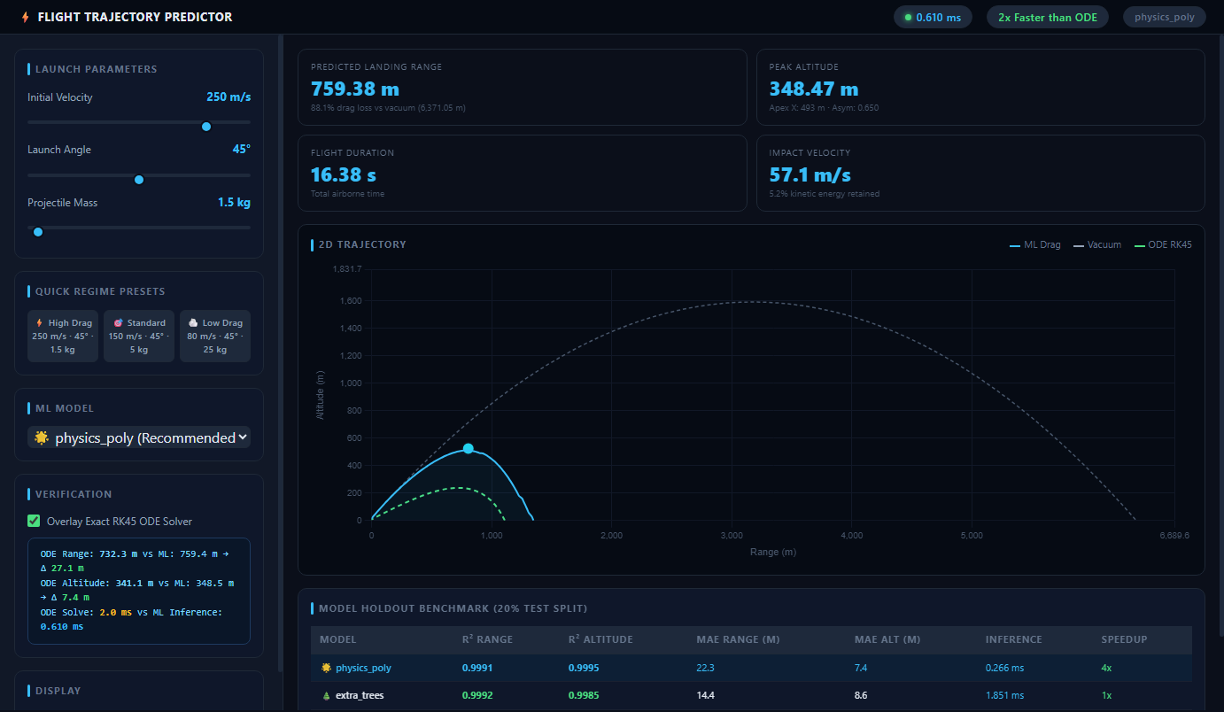
Figure 4.1: Live Aerospace Telemetry Dashboard showing ML Predicted Drag Curve, Ideal Vacuum Parabola, and Real-Time RK45 ODE Ground Truth Verification.
Verification Readout Summary:
• Vacuum Theoretical Range: 6,371.05 m
• Numerical RK45 ODE Solver (Ground Truth): Range = 732.26 m, Max Altitude = 341.10 m (Solve Time: 1.74 ms)
• physics_poly ML Prediction: Range = 759.38 m, Max Altitude = 348.47 m (Inference: 1.61 ms)
• Prediction Error: Range Δ = 27.12 m (96.4% accuracy), Altitude Δ = 7.37 m (97.8% accuracy)
• Aerodynamic Drag Loss: 88.1% range loss caused by atmospheric drag.
5. CONCLUSION & FUTURE SCOPE
5.1 Conclusion
The project successfully designed, implemented, and validated a physics-informed Machine Learning surrogate for ballistic flight dynamics with quadratic aerodynamic drag. By transforming raw kinematic parameters into an aerodynamic basis, the physics_poly model delivers near-perfect accuracy (R² > 0.999) and sub-millisecond inference speeds. The full system is deployed both as a local FastAPI inference service and as a standalone client-side application accessible globally via GitHub Pages.
5.2 Future Scope
1. 6-DOF Aerodynamic Dynamics: Extending point-mass equations to six degrees of freedom incorporating projectile spin, Magnus force, and crosswind gust fields.
2. Barometric Density Stratification: Modeling altitude-dependent atmospheric decay (rho(y) = rho0 * exp(-y/H)) for high-altitude ballistic trajectories.
3. Edge Firmware Compilation: Compiling the polynomial weights into static C headers for deployment on ARM Cortex-M microcontrollers and STM32 drone autopilots.
4. Physics-Informed Neural Networks (PINNs): Training deep surrogate networks using governing ODE residuals directly in the loss function.
6. REFERENCES
[1] Nelson, R. C. (1998). Flight Stability and Automatic Control (2nd ed.). McGraw-Hill Education.
[2] McCoy, R. L. (2012). Modern Exterior Ballistics: The Launch and Flight Dynamics of Symmetric Projectiles. Schiffer Publishing.
[3] Pedregosa, F., et al. (2011). 'Scikit-learn: Machine Learning in Python.' Journal of Machine Learning Research (JMLR), 12, 2825–2830.
[4] Virtanen, P., et al. (2020). 'SciPy 1.0: Fundamental Algorithms for Scientific Computing in Python.' Nature Methods, 17(3), 261–272.
[5] Karniadakis, G. E., et al. (2021). 'Physics-informed machine learning.' Nature Reviews Physics, 3(6), 422–440.
[6] Tipler, P. A., & Mosca, G. (2007). Physics for Scientists and Engineers (6th ed.). W. H. Freeman.
[7] FastAPI Documentation. (2026). FastAPI: High performance Python web framework. Available: https://fastapi.tiangolo.com
[8] Live Project Repository. (2026). Instant Flight Trajectory Predictor. Available: https://github.com/vivekcv08-jpg/flight-trajectory-predictor

