
LearnPracticeNewsletter
Resources
F
Toggle theme
5

New
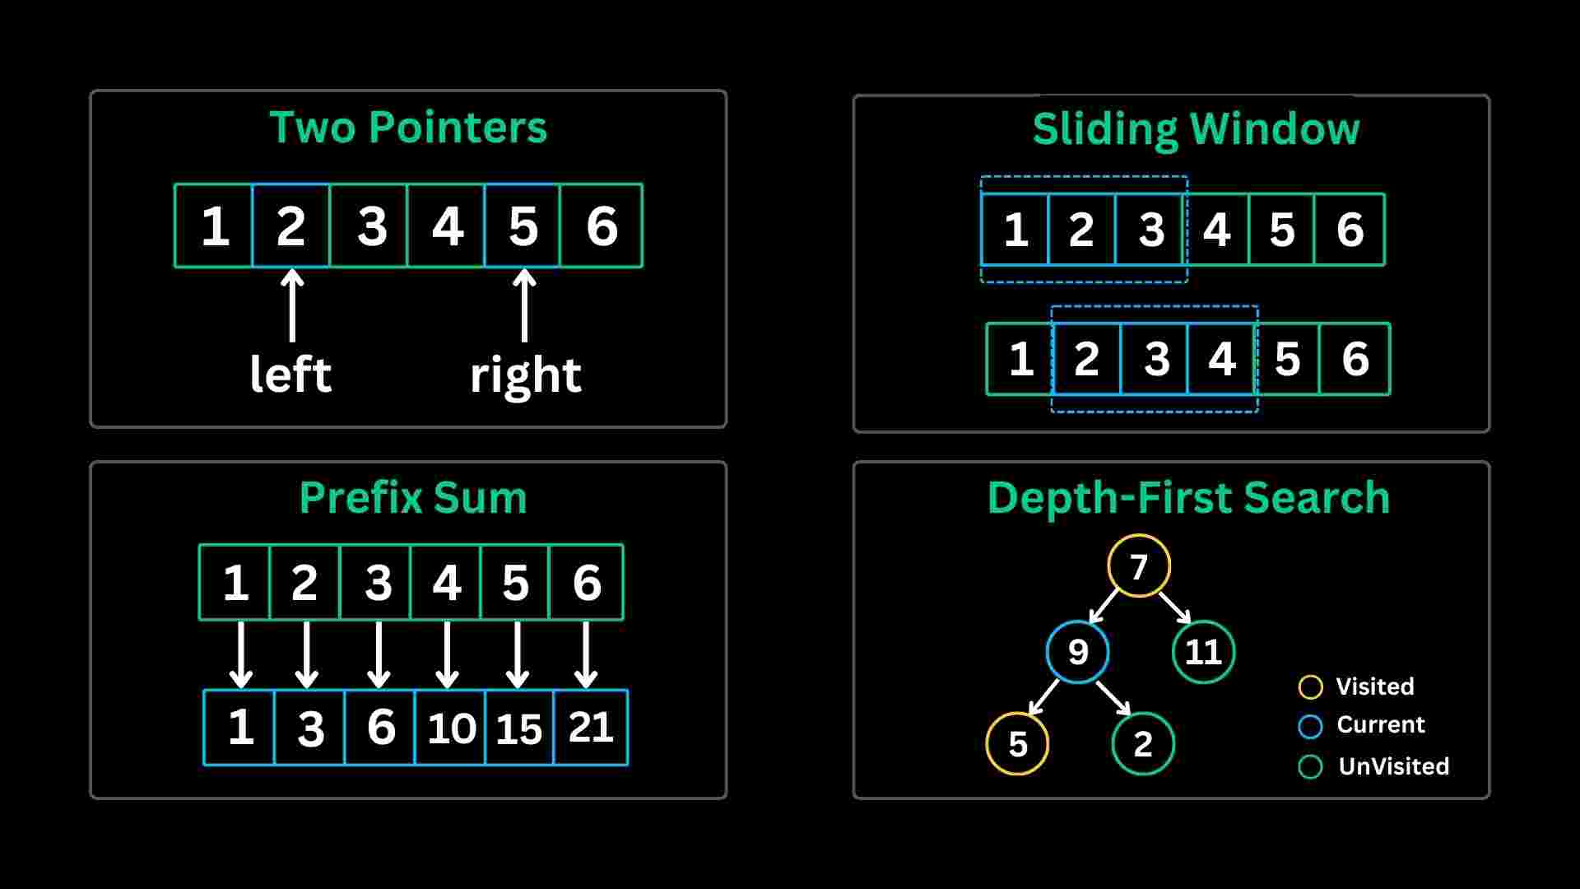
DSA Course
Master data structures & algorithms
New

Company-Wise Problems
Practice problems by top companies

New🎓AlgoMaster 600(6+ Months)
🏆AlgoMaster 300(3+ Months)
💪AlgoMaster 150(1-3 Months)
⚡AlgoMaster 75(<1 Month)
Master DSA Patterns: Practice 150 curated coding interview problems organized by patterns. Ideal for 1–3 months of preparation time.
Filters
Sort
Pick Random Problem:
Unsolved (140)Starred (0)Any (150)
Start Mock InterviewNew
Progress
10 / 150 solved
Easy1/24(4%)
Medium7/102(7%)
Hard2/24(8%)
Arrays
0 / 5
Status | Problem | Difficulty | Frequency | Leetcode | Solution | Actions
 | Move Zeroes | Easy
 | Majority Element | Easy
 | Product of Array Except Self | Medium
 | Best Time to Buy and Sell Stock II | Medium
 | First Missing Positive | Hard
Strings
0 / 3
Status | Problem | Difficulty | Frequency | Leetcode | Solution | Actions
 | Is Subsequence | Easy
 | Valid Palindrome | Easy
 | Reverse Words in a String | Medium
Bit Manipulation
0 / 3
Status | Problem | Difficulty | Frequency | Leetcode | Solution | Actions
 | Single Number | Easy
 | Counting Bits | Easy
 | Single Number III | Medium
Hash Tables
0 / 5
Status | Problem | Difficulty | Frequency | Leetcode | Solution | Actions
 | Isomorphic Strings | Easy
 | Contains Duplicate II | Easy
 | Group Anagrams | Medium
 | Encode and Decode TinyURL | Medium
 | Longest Consecutive Sequence | Medium
Two Pointers
4 / 4
Status | Problem | Difficulty | Frequency | Leetcode | Solution | Actions
 | Two Sum II - Input Array Is Sorted | Medium
 | Container With Most Water | Medium
 | 3Sum | Medium
 | Trapping Rain Water | Hard
Prefix Sum
0 / 3
Status | Problem | Difficulty | Frequency | Leetcode | Solution | Actions
 | Range Sum Query - Immutable | Easy
 | Subarray Sum Equals K | Medium
 | Contiguous Array | Medium
Sliding Window - Fixed Size
2 / 2
Status | Problem | Difficulty | Frequency | Leetcode | Solution | Actions
 | Find All Anagrams in a String | Medium
 | Permutation in String | Medium
Sliding Window - Dynamic Size
2 / 2
Status | Problem | Difficulty | Frequency | Leetcode | Solution | Actions
 | Longest Substring Without Repeating Characters | Medium
 | Minimum Window Substring | Hard
Kadane's Algorithm
0 / 2
Status | Problem | Difficulty | Frequency | Leetcode | Solution | Actions
 | Maximum Subarray | Medium
 | Maximum Product Subarray | Medium
Matrix (2D Array)
0 / 3
Status | Problem | Difficulty | Frequency | Leetcode | Solution | Actions
 | Spiral Matrix | Medium
 | Rotate Image | Medium
 | Set Matrix Zeroes | Medium
Linked List
0 / 5
Status | Problem | Difficulty | Frequency | Leetcode | Solution | Actions
 | Intersection of Two Linked Lists | Easy
 | Remove Nth Node From End of List | Medium
 | Swap Nodes in Pairs | Medium
 | Rotate List | Medium
 | Add Two Numbers | Medium
LinkedList In-place Reversal
0 / 2
Status | Problem | Difficulty | Frequency | Leetcode | Solution | Actions
 | Reverse Linked List | Easy
 | Reverse Nodes in k-Group | Hard
Fast and Slow Pointers
0 / 2
Status | Problem | Difficulty | Frequency | Leetcode | Solution | Actions
 | Middle of the Linked List | Easy
 | Linked List Cycle II | Medium
Stacks
0 / 4
Status | Problem | Difficulty | Frequency | Leetcode | Solution | Actions
 | Valid Parentheses | Easy
 | Min Stack | Medium
 | Remove Duplicate Letters | Medium
 | Longest Valid Parentheses | Hard
Monotonic Stack
0 / 2
Status | Problem | Difficulty | Frequency | Leetcode | Solution | Actions
 | Daily Temperatures | Medium
 | Largest Rectangle in Histogram | Hard
Monotonic Queue
0 / 1
Status | Problem | Difficulty | Frequency | Leetcode | Solution | Actions
 | Sliding Window Maximum | Hard
Bucket Sort
0 / 1
Status | Problem | Difficulty | Frequency | Leetcode | Solution | Actions
 | Top K Frequent Words | Medium
Recursion
0 / 2
Status | Problem | Difficulty | Frequency | Leetcode | Solution | Actions
 | Merge Two Sorted Lists | Easy
 | Decode String | Medium
Divide and Conquer
0 / 1
Status | Problem | Difficulty | Frequency | Leetcode | Solution | Actions
 | Convert Sorted List to Binary Search Tree | Medium
Merge Sort
0 / 1
Status | Problem | Difficulty | Frequency | Leetcode | Solution | Actions
 | Sort List | Medium
QuickSort / QuickSelect
0 / 2
Status | Problem | Difficulty | Frequency | Leetcode | Solution | Actions
 | Sort Colors | Medium
 | Kth Largest Element in an Array | Medium
Binary Search
0 / 6
Status | Problem | Difficulty | Frequency | Leetcode | Solution | Actions
 | Find First and Last Position of Element in Sorted Array | Medium
 | Search in Rotated Sorted Array | Medium
 | Find Peak Element | Medium
 | Koko Eating Bananas | Medium
 | Search a 2D Matrix | Medium
 | Median of Two Sorted Arrays | Hard
Backtracking
0 / 5
Status | Problem | Difficulty | Frequency | Leetcode | Solution | Actions
 | Generate Parentheses | Medium
 | Permutations | Medium
 | Subsets | Medium
 | Palindrome Partitioning | Medium
 | N-Queens | Hard
Tree Traversal - Level Order
0 / 3
Status | Problem | Difficulty | Frequency | Leetcode | Solution | Actions
 | Binary Tree Level Order Traversal | Medium
 | Binary Tree Right Side View | Medium
 | Populating Next Right Pointers in Each Node II | Medium
Tree Traversal - Pre Order
0 / 6
Status | Problem | Difficulty | Frequency | Leetcode | Solution | Actions
 | Binary Tree Preorder Traversal | Easy
 | Symmetric Tree | Easy
 | Convert Sorted Array to Binary Search Tree | Easy
 | Path Sum III | Medium
 | Construct Binary Tree from Preorder and Inorder Traversal | Medium
 | Serialize and Deserialize Binary Tree | Hard
Tree Traversal - In Order
0 / 4
Status | Problem | Difficulty | Frequency | Leetcode | Solution | Actions
 | Binary Tree Inorder Traversal | Easy
 | Validate Binary Search Tree | Medium
 | Kth Smallest Element in a BST | Medium
 | Binary Search Tree Iterator | Medium
Tree Traversal - Post-Order
0 / 5
Status | Problem | Difficulty | Frequency | Leetcode | Solution | Actions
 | Binary Tree Postorder Traversal | Easy
 | Invert Binary Tree | Easy
 | Diameter of Binary Tree | Easy
 | Lowest Common Ancestor of a Binary Tree | Medium
 | Binary Tree Maximum Path Sum | Hard
BST / Ordered Set
0 / 3
Status | Problem | Difficulty | Frequency | Leetcode | Solution | Actions
 | My Calendar I | Medium
 | My Calendar II | Medium
 | Stock Price Fluctuation | Medium
Tries
0 / 4
Status | Problem | Difficulty | Frequency | Leetcode | Solution | Actions
 | Implement Trie (Prefix Tree) | Medium
 | Design Add and Search Words Data Structure | Medium
 | Search Suggestions System | Medium
 | Word Search II | Hard
Heaps
0 / 2
Status | Problem | Difficulty | Frequency | Leetcode | Solution | Actions
 | Furthest Building You Can Reach | Medium
 | Single-Threaded CPU | Medium
Two Heaps
0 / 2
Status | Problem | Difficulty | Frequency | Leetcode | Solution | Actions
 | Find Median from Data Stream | Hard
 | IPO | Hard
Top K Elements
0 / 3
Status | Problem | Difficulty | Frequency | Leetcode | Solution | Actions
 | Kth Largest Element in a Stream | Easy
 | Top K Frequent Elements | Medium
 | K Closest Points to Origin | Medium
Intervals
0 / 3
Status | Problem | Difficulty | Frequency | Leetcode | Solution | Actions
 | Merge Intervals | Medium
 | Insert Interval | Medium
 | Non-overlapping Intervals | Medium
K-Way Merge
0 / 2
Status | Problem | Difficulty | Frequency | Leetcode | Solution | Actions
 | Kth Smallest Element in a Sorted Matrix | Medium
 | Merge k Sorted Lists | Hard
Data Structure Design
0 / 4
Status | Problem | Difficulty | Frequency | Leetcode | Solution | Actions
 | Design Browser History | Medium
 | LRU Cache | Medium
 | Insert Delete GetRandom O(1) | Medium
 | Maximum Frequency Stack | Hard
Greedy
0 / 3
Status | Problem | Difficulty | Frequency | Leetcode | Solution | Actions
 | Jump Game II | Medium
 | Gas Station | Medium
 | Task Scheduler | Medium
Depth First Search (DFS)
0 / 5
Status | Problem | Difficulty | Frequency | Leetcode | Solution | Actions
 | Number of Islands | Medium
 | Clone Graph | Medium
 | Is Graph Bipartite? | Medium
 | Surrounded Regions | Medium
 | Pacific Atlantic Water Flow | Medium
Breadth First Search (BFS)
0 / 3
Status | Problem | Difficulty | Frequency | Leetcode | Solution | Actions
 | Rotting Oranges | Medium
 | 01 Matrix | Medium
 | Word Ladder | Hard
Topological Sort
0 / 1
Status | Problem | Difficulty | Frequency | Leetcode | Solution | Actions
 | Course Schedule II | Medium
Union Find
0 / 2
Status | Problem | Difficulty | Frequency | Leetcode | Solution | Actions
 | Number of Provinces | Medium
 | Redundant Connection | Medium
Minimum Spanning Tree
0 / 1
Status | Problem | Difficulty | Frequency | Leetcode | Solution | Actions
 | Min Cost to Connect All Points | Medium
Shortest Path
0 / 3
Status | Problem | Difficulty | Frequency | Leetcode | Solution | Actions
 | Network Delay Time | Medium
 | Cheapest Flights Within K Stops | Medium
 | Swim in Rising Water | Hard
1-D DP
2 / 2
Status | Problem | Difficulty | Frequency | Leetcode | Solution | Actions
 | Climbing Stairs | Easy
 | House Robber II | Medium
0/1 Knapsack
0 / 2
Status | Problem | Difficulty | Frequency | Leetcode | Solution | Actions
 | Partition Equal Subset Sum | Medium
 | Target Sum | Medium
Unbounded Knapsack
0 / 2
Status | Problem | Difficulty | Frequency | Leetcode | Solution | Actions
 | Coin Change | Medium
 | Coin Change II | Medium
Longest Increasing Subsequence (LIS)
0 / 2
Status | Problem | Difficulty | Frequency | Leetcode | Solution | Actions
 | Longest Increasing Subsequence | Medium
 | Russian Doll Envelopes | Hard
2D Grid DP
0 / 4
Status | Problem | Difficulty | Frequency | Leetcode | Solution | Actions
 | Unique Paths II | Medium
 | Minimum Path Sum | Medium
 | Count Square Submatrices with All Ones | Medium
 | Longest Increasing Path in a Matrix | Hard
String DP
0 / 4
Status | Problem | Difficulty | Frequency | Leetcode | Solution | Actions
 | Longest Common Subsequence | Medium
 | Longest Palindromic Subsequence | Medium
 | Decode Ways | Medium
 | Word Break | Medium
Tree / Graph DP
0 / 3
Status | Problem | Difficulty | Frequency | Leetcode | Solution | Actions
 | House Robber III | Medium
 | Unique Binary Search Trees II | Medium
 | Binary Tree Cameras | Hard
Bitmask DP
0 / 2
Status | Problem | Difficulty | Frequency | Leetcode | Solution | Actions
 | Fair Distribution of Cookies | Medium
 | Shortest Path Visiting All Nodes | Hard
State Machine DP
0 / 1
Status | Problem | Difficulty | Frequency | Leetcode | Solution | Actions
 | Best Time to Buy and Sell Stock III | Hard
Maths / Geometry
0 / 3
Status | Problem | Difficulty | Frequency | Leetcode | Solution | Actions
 | Palindrome Number | Easy
 | Reverse Integer | Medium
 | Max Points on a Line | Hard
FEEDBACK
Share Your Feedback
Feedback Type
IssueImprovementContent RequestOther
Message0/200
Add screenshot(max 5MB)
Anonymous
Submit Feedback
AlgoMaster.io - Master DSA Patterns | AlgoMaster.io

