Screenshot -1

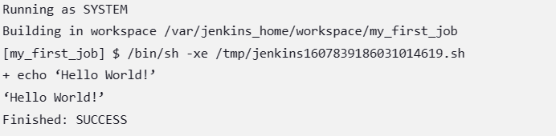

Screenshot -2

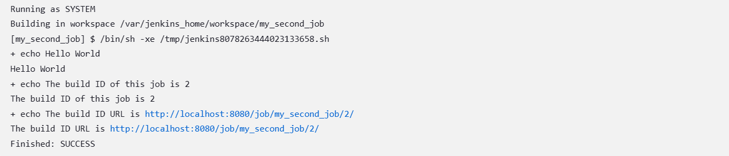

Screenshot-3

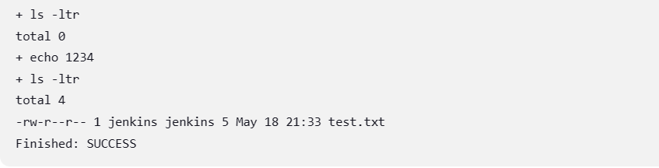

Screenshot -4

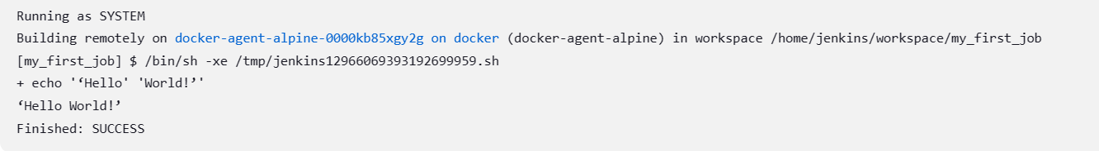

Screen shot -5

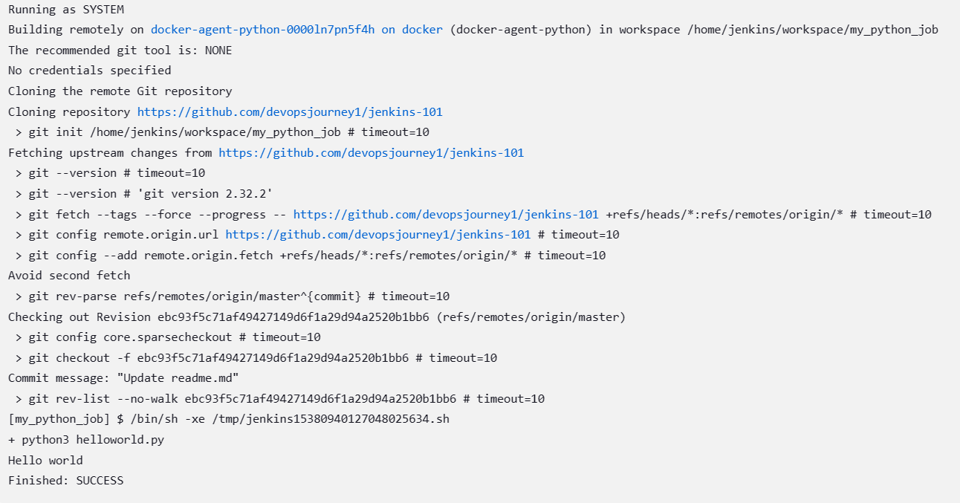screenshot -6

