**Description of LM75:**

This **LM75 Temperature Sensor Module** is specifically designed for the Banana Pi but it can also be used with the Arduino. This module uses the NXP **LM75 Temperature IC**. The LM75 temperature sensor includes a delta-sigma analog-to-digital converter and a digital over-temperature detector.

**LM75 Temperature Sensor Module Features & Specifications**

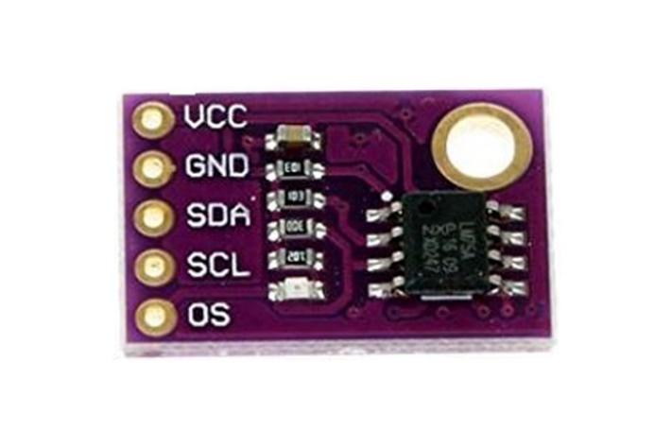Operating Voltage: 3.3V to 5V DC

Range: -25°C~125°C

LM75 based design.

Low Operating Supply Current: 250µA

I²C Bus Interface

Easy to use with Microcontrollers or even with normal Digital/Analog IC

Small, cheap and easily available

**Pin Configuration of LM75 Temperature Sensor Module**

**Pin Name**  **Description**

VCC The Vcc pin powers the module, typically with +5V

GND Power Supply Ground

OS Over-temperature Shutdown Pin

SCL Serial Clock Input. Open drain. Connected through a pullup resistor

SDA Serial-Data Input/output Line. Open drain. Connect through a pullup resistor.

**Alternate Sensor Modules**:

IR Sensor Module, LDR Sensor Module, TP4056A Module, DS3231 RTC Module, TMC2209 Stepper Motor Driver Module, DRV8825 Stepper Motor Driver Module, A4988 Stepper Motor Driver Module, NEO-6MV2 GPS Module, Joystick Module, EM18 - RFID Reader Module, ADXL335 Accelerometer Module, HMC5883L Magnetometer Module, Soil Moisture Sensor

**Related Components:** LM75 IC, Capacitor, Resistor

**Working Principle Of LM75:**

The LM75 is a digital temperature sensor IC that communicates over the I2C bus. Here's a short working principle for the LM75:

1. Temperature Sensing: The LM75 senses temperature using an integrated temperature sensor. It converts the analog temperature readings into digital data for processing.

2.I2C Communication: The LM75 communicates with the microcontroller or host device using the I2C (Inter-Integrated Circuit) bus protocol. It has a unique address on the bus, allowing multiple LM75 sensors to be connected to the same bus.

3. Register-Based Interface: The LM75 provides temperature data through a set of registers accessible via the I2C interface. The microcontroller reads these registers to obtain temperature readings.

4. Resolution and Accuracy: The LM75 typically offers a resolution of 0.5°C or 0.125°C, depending on the specific variant. It provides accurate temperature measurements within its specifiedoperating range.

5. Alert Functionality: The LM75 may include alert functionality, allowing it to trigger an interrupt or set a flag when the temperature exceeds a predefined threshold. This feature is useful for temperature monitoring and control applications.