# VISVESVARAYA TECHNOLOGICAL UNIVERSITY



**JNANA SANGAMA, BELAGAVI-590018.**

**A Seminar Report on**

# “POD CLUB”

*A Technical Seminar report submitted in partial fulfillment of the requirements as a part of the 2nd semester for the award of degree of* ***Master of Computer Applications.***

*Submitted By:*

**G VIVEK**

**(1AM22MC025)**

*Under the internal guide*

**MR.GUNASEKARAN K**

**Department of Master of Computer Applications**

**AMC ENGINEERING COLLEGE**

## Bannerghatta Road, Bengaluru-560083.

**October-2023**



**AMC ENGINEERING COLLEGE**

**Affiliated to VTU, Approved by AICTE and Accredited by NAAC A+, NBA**

**Bannerghatta road, Bangalore-83**

# Department of Master of Computer Applications

**CERTIFICATE**

This is to certify that **G VIVEK (1AM22MC025) has successfully completed his second semester seminar (22MCA29) work entitled “POD CLUB”** as a partial fulfillment for the award of the Master of Computer Applications degree during the academic year of 2022-2023 at Visvesvaraya Technological University, Belagavi.

**Signature of the Guide Head of the Department**

**Mr. Gunasekaran K, Dr M. S. Shashidhara**  Asst. Prof., Dept. of MCA,Prof. & Head, Dept of MCA

AMC Engineering College, AMC Engineering College

Bengaluru – 560083 Bengaluru – 560083

**DECLARATION**

I, **G VIVEK,** student of 2nd semester MCA at **AMC Engineering College,** bearing USN **1AM22MC025,** hereby declare that a technical seminar has been carried out by me under the supervision of technical seminar **internal guide Mr. GUNASEKARAN K, Assistant Professor of Master of Computer Applications at** AMC Engineering College, Submitted in partial fulfillment of the requirements for the award of the degree of **Master of Computer Applications by Visvesvaraya Technological University, Belagavi**, During the academic year 2022-2023.

### **Name: G VIVEK**

**Signature:**

**ACKOWLEDGEMENT**

Firstly, I thank God for helping me throughout this project and strengthening me to complete this work successfully and at my best. I would like to dedicate this work to my parents for their constant support and encouragement during the course of this work,

The success of any task depends on many factors, with people being the most important. Several people have contributed directly and in-directly to the successful completion of this. I express my gratitude and respect to all those who helped to steer the technical seminar towards its completion and inspire me for the same.

I express my sincere thanks to **Dr. K Paramahamsa, Chairman, AMC Engineering College, Bangalore,** or providing all the resources required for the timely completion of this technical seminar.

I thank **Dr. R Nagaraja Principal, AMCEC,** for his support to provide the best faculty.

I express my sincere thanks and deepest gratitude to technical seminar chairman **Dr. M. S.** **Shashidhara**, **Professor & Head, Department of MCA, AMC Engineering College**, for providing me with adequate faculties, ways and means by which I was able to complete this technical seminar report.

My deepest gratitude to my internal Technical Seminar guide **Mr. Gunasekaran K Assistant professor of Master of computer Applications, AMCEC, Bangalore** for his guidance and encouragement given to me in this Technical Seminar and Report. I also take this opportunity to thank all faculty members of our MCA departmentand my friendsfor their co-operation and support they have given me for the completion of this technical seminar report.

## G VIVEK

(**1AM22MC025**)

**Table of Contents: Page no:**

1. Abstract 2
2. Introduction 4
3. Overview of the Podcast Industry 8

* Global Growth
* Growth in India

1. The Benefits and Outcomes of Podcasting 9

* Information Dissemination
* Branding and Marketing
* Educational Impact
* Monetization

1. Psychology of Podcasting 9

* Why People Listen
* Host-Listener Connection
* Cognitive Benefits

1. Key Features and Functionality of Pod club 10

* Creation and Hosting
* Distribution
* Engagement and Interactivity
* Monetization Models

1. Tech Stack 15
2. Market Trends and Analysis 18

* Podcast Genres and Popularity
* Emerging Trends in Podcasting
* Competitive Landscape

1. Podcasting in India 19

* Growth and Adoption
* India-Specific Content
* Challenges and Opportunities

1. Case Studies 21

* Successful Podcasts and Creators
* Monetization Strategies

1. The Future of Podcasting 23

* Technological Advancements
* Expanding Audiences
* Challenges Ahead

1. Conclusion 24
2. References 25

**LIST OF FIGURES**

|  |  |  |
| --- | --- | --- |
| **FIGURE**  **NUMBER** | **FIGURE NAME** | **PAGE NUMBER** |
| FIG 1 | PODCAST INTRODUCTION | 1 |
| FIG 2 | SHARING OF KNOWLEDGE | 3 |
| FIG 3 | OVERVIEW OF THE UI | 5 |
| FIG 4 | KEY FEATURES | 7 |
| FIG 5 | REVENUE STREAM | 10 |
| FIG 6 | POTENTIAL IMPACT | 11 |
| FIG 7 | MARKET ANALYSIS | 15 |
| FIG 8 | INDUSTRY IN INDIA | 16 |
| FIG 9 | ANALYTICS | 17 |
| FIG 10 | CASE STUDY | 18 |
| FIG 11 | GLOBAL PODCASTING MARKET | 19 |
|  |  |  |

**1.Abstract**

**1.Abstract:**

In the dynamic world of digital media, podcasting has emerged as a powerful, user-driven medium that transcends boundaries and fosters a sense of community. At the forefront of this transformative movement stands "Pod Club," a visionary concept poised to revolutionize the podcasting landscape. Pod Club is not just another platform; it represents a paradigm shift in how we create, discover, and engage with podcasts.

Central to Pod Club's ethos is simplicity. Podcasting, while immensely popular, can be daunting for newcomers. Pod Club reimagines this process by offering a user-friendly interface that streamlines podcast creation, from scheduling to recording and editing. It invites both aspiring and seasoned podcasters to contribute their voices to the global conversation.

But Pod Club is not content with mere convenience. It aims to foster community and interaction. Through innovative features like interactive polls, quizzes, and real-time comments, listeners become active participants, enriching the content with their insights and perspectives. It's a platform where meaningful connections are forged.

Discoverability is a cornerstone of Pod Club. With a sophisticated recommendation engine, it tailors podcast suggestions based on individual preferences and listening history. This personalized approach ensures that every listener finds content that resonates deeply.

Pod Club also empowers creators with diverse monetization options, from traditional ads to premium subscriptions and merchandise sales. It's a platform that not only values creators' stories but also supports their creative journey.

In this seminar, we embark on a comprehensive exploration of Pod Club's features, its potential impact on the podcasting landscape, and its role in shaping the future of digital audio. Join us as we venture into the heart of Pod Club, where podcasting meets limitless possibilities, community thrives, and voices resonate across the digital spectrum.

**Keywords:**

Podcasting, Digital Audio, Podcast Creation, Content Discovery, User-Friendly, Community Building, Interactive Features, Personalized Recommendations, Monetization Options, User Engagement, Simplified Podcasting, Collaboration Tools, Podcast Distribution

**2.Introduction**

**2.Introduction:**

Welcome to "Pod Club," a pioneering venture poised to revolutionize podcasting. In an era where digital audio storytelling holds sway, Pod Club stands as a beacon of innovation and community. It envisions a platform where creators and listeners unite seamlessly, offering user-centric features and a thriving ecosystem. Join us on this exploration, as we delve into the essence of Pod Club, revealing its potential to streamline podcasting, bridge gaps, and create a vibrant community. This isn't just another platform; it's a transformative force shaping the future of podcasting. Step into the world of Pod Club, where podcasting reaches new heights.



Fig. 1

**Pod Club - Revolutionizing Podcasting**

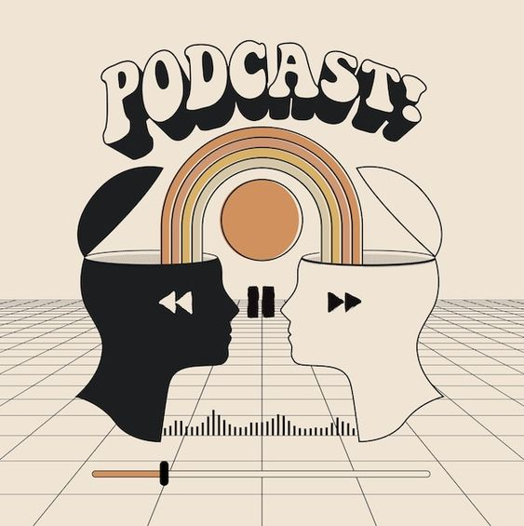

Fig.2

What is a podcast?

*A podcast is a digital audio or video program that is made available on the internet for streaming or downloading. It is typically episodic and can cover a wide range of topics, including news, education, entertainment, storytelling, interviews, and more. Podcasts are often produced by individuals, organizations, or companies and are accessible through various platforms and apps.*

Here are some reasons why podcasts are helpful:

Accessibility: Podcasts are easily accessible to anyone with an internet connection and a device, such as a smartphone or computer. They can be listened to or watched at any time, making them highly convenient for users.

Diverse Content: Podcasts cover a vast array of topics and genres. Whether you're interested in learning, entertainment, self-improvement, or niche hobbies, there is likely a podcast that caters to your interests.

On-Demand: Podcasts are on-demand content. This means you can listen to them when and where it's convenient for you, whether you're commuting, exercising, or doing household chores.

Long-Form Content: Unlike short social media posts or news articles, podcasts often offer in-depth discussions and insights. They allow for deeper exploration of topics, making them educational and informative.

Community Building: Many podcasts have dedicated communities of listeners who engage in discussions, share feedback, and connect with like-minded individuals. This sense of community can be enriching for both creators and listeners.

Entertainment: Podcasts can be highly entertaining. They include genres such as comedy, storytelling, and fiction, which offer listeners a break from their daily routines and a chance to relax and unwind.

Learning Opportunities: Educational podcasts provide valuable information and insights on a wide range of subjects. They serve as a form of informal learning that can complement formal education.

Inspiration: Podcasts often feature interviews with successful individuals, experts, or people with unique experiences. These interviews can inspire and motivate listeners to pursue their goals and passions.

Time Management: Podcasts can make productive use of time that might otherwise be unproductive, such as during commutes or workouts. They turn idle time into learning or entertainment opportunities.

Global Reach: Podcasts have a global reach, allowing creators to share their content with a worldwide audience. This accessibility has led to diverse perspectives and voices being heard.

**3.Overview of the Podcast Industry**

**3.Overview of the Podcast Industry:**

The podcasting industry has experienced exponential growth in recent years. Globally, the number of podcasts and listeners has soared, with millions of episodes covering an extensive range of topics. In India, this growth has been particularly pronounced, with a significant surge in podcast adoption. According to industry analytics, India has witnessed a remarkable increase in podcast listenership, driven by improved internet connectivity, smartphone penetration, and a diverse range of content catering to Indian audiences. This surge has made India one of the fastest-growing podcast markets globally, promising immense opportunities for content creators and businesses alike.

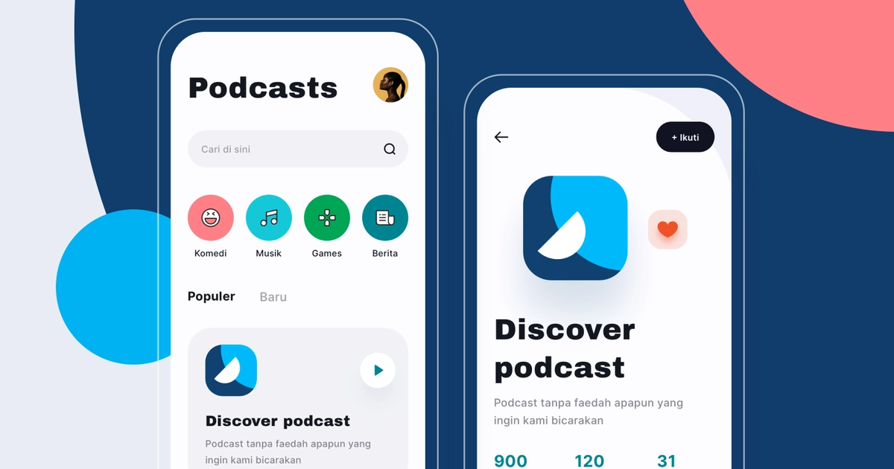

Fig.3

**4.The Benefits and Outcomes of Podcasting:**

Podcasting offers a multifaceted array of benefits and outcomes. Firstly, it serves as a powerful tool for information dissemination, allowing creators to share knowledge, news, and stories with a global audience. Additionally, it offers unique opportunities for branding and marketing, enabling businesses to connect with their target demographics through engaging, long-form content. Educationally, podcasts have become valuable resources, providing in-depth insights and tutorials on a myriad of subjects. Furthermore, monetization avenues, such as sponsorships and premium subscriptions, empower content creators to earn income while offering valuable content to their listeners.

**5.Psychology of Podcasting:**

The psychology of podcasting delves into the motivations and behaviors of podcast listeners. Listeners are drawn to podcasts for various reasons, including the desire for in-depth knowledge, entertainment, or personal development. The unique host-listener connection is a pivotal aspect; listeners often feel a sense of intimacy and trust with podcast hosts, which fosters a loyal audience. Cognitive benefits of podcasting include improved multitasking abilities and enhanced focus. The medium's on-demand nature allows listeners to consume content when and where it's convenient, aligning with their preferences and lifestyles, contributing to its widespread popularity.

**6.Key Features and Functionality of Podcasting Platforms:**

Podcasting platforms provide creators with essential tools for content creation, distribution, engagement, and monetization. These platforms offer user-friendly interfaces for recording, editing, and scheduling podcast episodes. They also simplify the distribution process, automatically pushing episodes to various podcast directories. Features like listener engagement tools, including polls and comments, enhance audience interaction. Monetization options encompass advertising, premium subscriptions, merchandise sales, and donation models. These multifunctional platforms are pivotal in streamlining the podcasting process, making it accessible to both novice and experienced creators.

* **Key Features of Pod Club:**

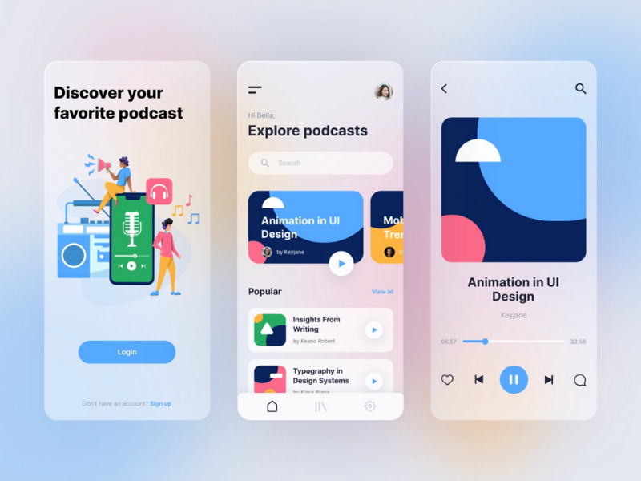

Fig 4

*1. Simplified Podcast Creation*

Pod Club offers a user-friendly interface for creating podcasts. Creators can easily schedule, record, and edit episodes. The platform supports multiple hosts and provides collaborative tools for interviews and discussions.

*2. Discoverability and Recommendation Engine*

Pod Club incorporates a robust recommendation engine that suggests podcasts to users based on their interests, listening history, and the podcasts they follow. This feature helps users discover new content that aligns with their preferences.

*3. Monetization Opportunities*

>Pod Club offers multiple monetization options for podcast creators:

* *Advertisement*: Creators can earn revenue through ad placements within their episodes.
* *Verification Tick*: A verification system provides creators with a sense of authenticity, which can attract sponsors and advertisers.
* *Distribution Services*: The platform charges a fee for distributing podcasts to external platforms like YouTube and Spotify.
* *Monetization Tools*: Creators can sell merchandise, tickets to live events, and exclusive content through the platform.

*4. Collaboration Tools*

Pod Club facilitates collaboration among podcast hosts and guests. Multiple participants can join a podcast, making it ideal for interviews, panel discussions, and co-hosted shows.

*5. Analytics Dashboard*

Creators have access to a comprehensive analytics dashboard that provides insights into their episodes' performance, listener demographics, retention rates, and engagement metrics. This data empowers creators to refine their content strategy.

*6. Interactive Elements*

Pod Club introduces interactive elements within podcast episodes, including polls, quizzes, and surveys. This fosters greater listener engagement and interactivity.

*7. Accessibility Features*

The platform is designed with accessibility in mind, offering features like closed captioning and screen reader compatibility to ensure that all users can enjoy podcast content.

*8. Content Moderation*

To maintain a high-quality and safe environment, Pod Club incorporates content moderation tools to ensure that podcasts adhere to community guidelines and legal requirements.

*9. Quick Search and Lookup*

Pod Club now includes a Quick Search and Lookup feature powered by AI and GPT. It provides real-time, explanations, and references related to podcast topics, enhancing the educational value of content.

*10. Download and Save for Later*

Listeners can download podcast episodes to listen offline and save them for future reference, ensuring content is accessible even without an internet connection.

*11. Text Message-Based Reminders*

Pod Club offers text message-based reminders to keep users informed about new episodes, important events, or updates related to their followed podcasts. This feature integrates with WhatsApp and email.

*12. Streaming Distribution*

Pod Club enables podcast streaming on various platforms, including YouTube, Twitch, Twitter Spaces, and the official pages of Instagram and Spotify, expanding the reach of content.

*13. Precise Summary at the End*

At the end of each podcast episode, Pod Club provides a precise summary generated with the help of GPT technology. This summary aids in recall and revision of key takeaways.

**7.Business Model:**

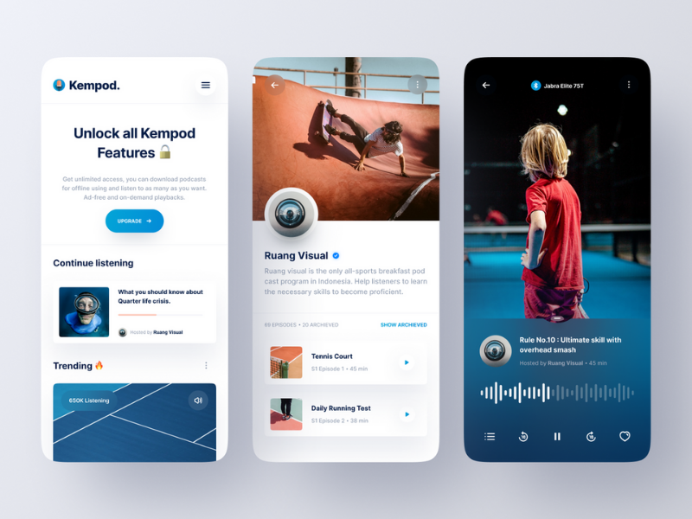

Fig.4

**Pod Club's revenue streams include:**

***Advertisement Revenue***: Through ads and sponsorships within podcasts.

***Verification Subscription***: Creators can pay for a verification tick to enhance their credibility.

***Distribution Services***: Charging podcast creators for distributing their content to external platforms.

***Monetization Tools*:** A percentage of transactions from merchandise, ticket sales, and exclusive content.

***Premium Subscription*:** Offering a premium subscription model to access advanced features.

**8.Potential Impact:**

Pod Club has the potential to revolutionize podcasting by simplifying the podcast creation process, enhancing discoverability, and providing multiple monetization avenues for creators. It could become the go-to platform for podcasting, appealing to a wide range of users and industries, including education, entertainment, news, and more.



Fig.5

**9.Tech Stack:**

Building a podcast application involves a combination of technologies to handle various aspects, from content hosting and streaming to user interfaces and interactions. Here's a tech stack commonly used to build a podcast application:

**Backend Server:**

Programming Language: Python, Node.js, Ruby, or Java

Framework: Express (Node.js), Flask (Python), Ruby on Rails (Ruby)

Database: PostgreSQL, MySQL, MongoDB

APIs: RESTful or GraphQL for communication between the client and server

**Content Storage and Delivery:**

Content Hosting: Amazon S3, Google Cloud Storage, or a dedicated server

Content Delivery Network (CDN): CloudFront, Akamai, or Cloudflare for efficient content distribution

**Audio/Video Encoding and Streaming:**

Media Server: FFmpeg for audio/video processing

Streaming Protocol: HTTP Live Streaming (HLS) or Dynamic Adaptive Streaming over HTTP (DASH)

Media Player: ExoPlayer (Android), AVPlayer (iOS), or open-source HTML5 players for web

**Database and Data Management:**

Database: PostgreSQL, MySQL, or NoSQL databases like MongoDB for storing user data, episodes, and metadata

Caching: Redis or Memcached for optimizing data retrieval and improving app performance

**Authentication and Authorization**:

Authentication: OAuth 2.0, JWT (JSON Web Tokens), or OpenID Connect for user authentication

Authorization: Role-based access control (RBAC) for managing user privileges

**Frontend Development:**

Web: HTML, CSS, JavaScript (React, Angular, or Vue.js)

Mobile: Swift for iOS, Kotlin/Java for Android (using frameworks like React Native, Flutter, or Xamarin for cross-platform development)

**User Interface (UI) Design:**

UI/UX Design Tools: Adobe XD, Sketch, Figma

UI Frameworks: Material-UI, Ant Design, or custom components

**Notifications:**

Push Notifications: Firebase Cloud Messaging (FCM), Apple Push Notification Service (APNS), or third-party services like OneSignal

**Search and Discovery:**

Search Engine: Elasticsearch or Algolia for efficient content search and discovery

Recommendation: Machine learning models and algorithms for personalized content recommendations

**Payment Processing:**

Payment Gateways: Stripe, PayPal, or in-app purchase systems for handling premium subscriptions or donations

**Analytics and Monitoring:**

Analytics: Google Analytics, Mixpanel, or custom analytics solutions

Error Tracking: Sentry, Crashlytics, or Rollbar for monitoring and resolving issues

**Hosting and Deployment**:

Hosting: Amazon Web Services (AWS), Google Cloud Platform (GCP), Microsoft Azure, or Heroku

Containerization: Docker and Kubernetes for container orchestration

Continuous Integration/Continuous Deployment (CI/CD): Jenkins, Travis CI, or GitLab CI/CD

**Security:**

Security Practices: Secure coding practices, encryption, and user data protection measures

Authentication: Two-factor authentication (2FA) for enhanced security

**Compliance and Legal Requirements:**

Ensure compliance with copyright laws, data privacy regulations, and terms of service.

**Testing and Quality Assurance:**

Automated testing tools like Selenium, Jest, or Appium for UI and functional testing

Load testing tools like Apache JMeter for assessing application performance

**DevOps and Monitoring**:

DevOps tools for automation, such as Ansible, Puppet, or Chef

Monitoring tools like Prometheus, Grafana, or New Relic for application performance monitoring

**Scalability and High Availability**:

Horizontal scaling with load balancers to handle traffic spikes and ensure high availability.

**Documentation and Version Control:**

Version control using Git, and documentation using tools like Swagger or ReDoc for APIs.

Building a podcast application involves a complex tech stack, and the choice of technologies may vary depending on your specific requirements and development team's expertise.

**10.Market Trends and Analysis:**

Podcast market trends reveal fascinating insights into audience preferences and content consumption. Various podcast genres, including true crime, technology, self-help, and comedy, have gained immense popularity. Serial storytelling, investigative journalism, and in-depth interviews are emerging trends shaping the industry. Competitive analysis highlights dominant players and newcomers, fostering healthy competition and innovation. The shift towards exclusive content deals with prominent creators and platforms further signifies the industry's maturation. As the market continues to evolve, understanding these trends is crucial for content creators and investors seeking opportunities within the podcasting landscape.

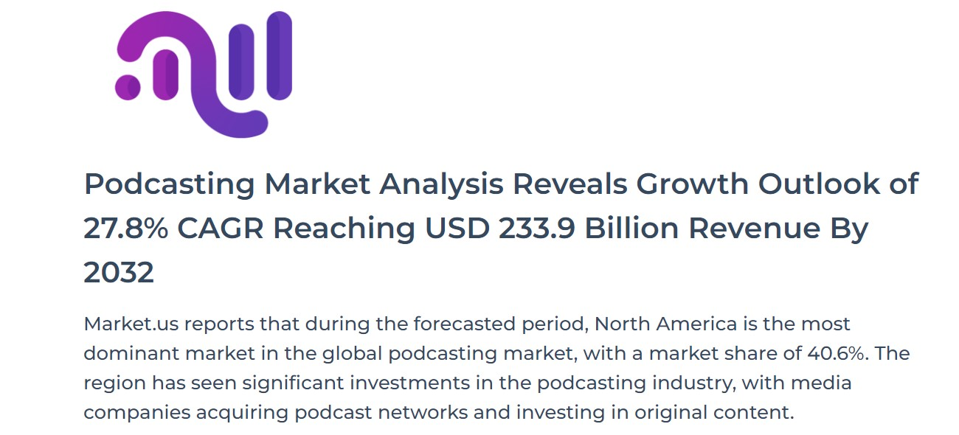

Fig.6

**11.Podcasting in India:**

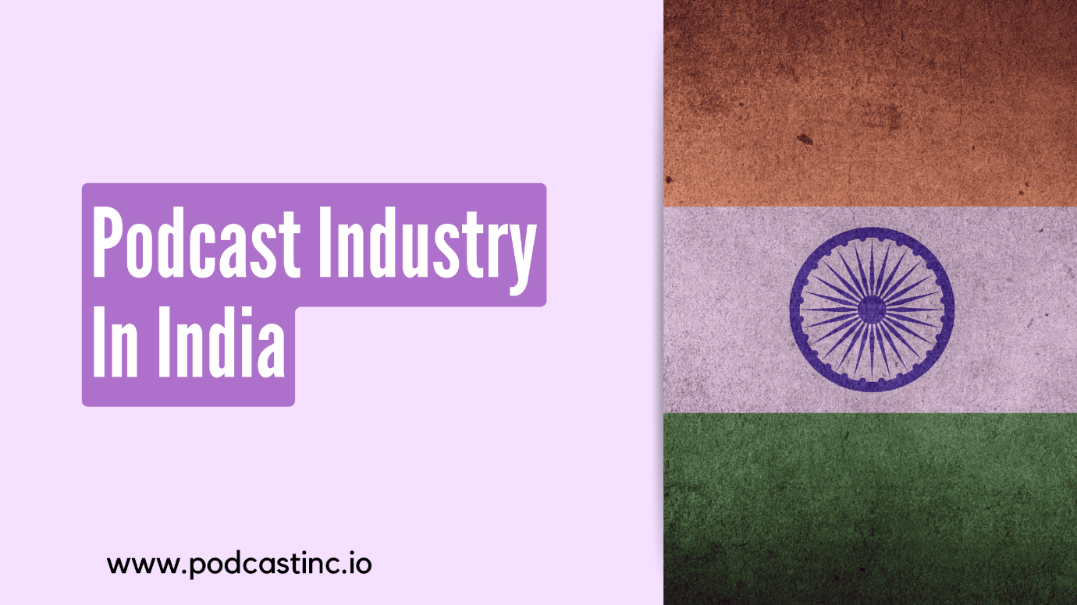

Fig.7

India's podcasting landscape is characterized by rapid growth and dynamic content creation. The Indian market has witnessed a surge in podcast adoption, driven by factors such as smartphone penetration, increased data affordability, and culturally relevant content. India-specific podcasts, catering to diverse languages and regional preferences, have gained prominence. Despite its promising growth, the Indian podcasting scene faces unique challenges, including content piracy concerns and the need for localized monetization strategies. Opportunities lie in the production of niche content and fostering collaborations with regional influencers, contributing to the industry's ongoing evolution.

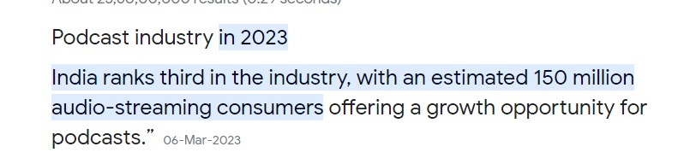

Fig. 8

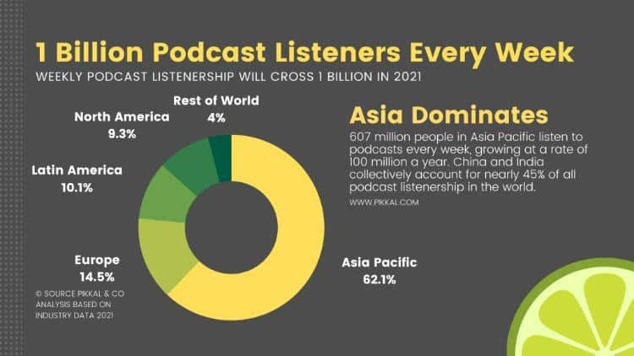

Fig.9

**12.Case Studies:**



Fig. 10

Examining successful podcasts and creators provides valuable insights into effective strategies and diverse approaches within the industry. Examples include podcasts that have achieved viral success, those with dedicated niche audiences, and creators who have successfully monetized their content. Case studies reveal the creativity and adaptability of podcasters, showcasing how they navigate challenges, build loyal listener communities, and harness various monetization methods. These real-world examples serve as sources of inspiration and guidance for both aspiring and established podcast creators, offering tangible lessons from the field.

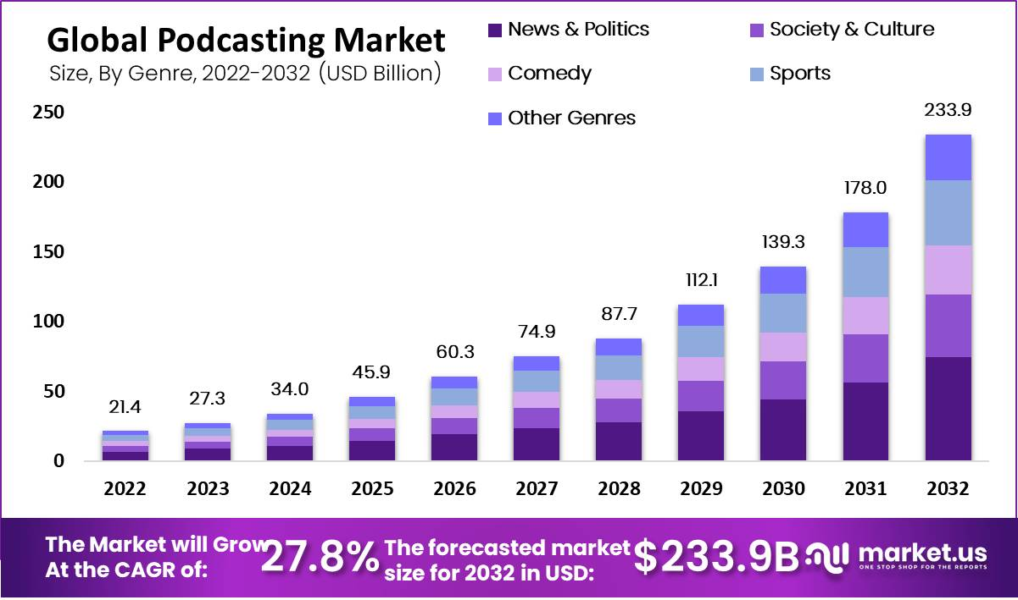

Fig.11

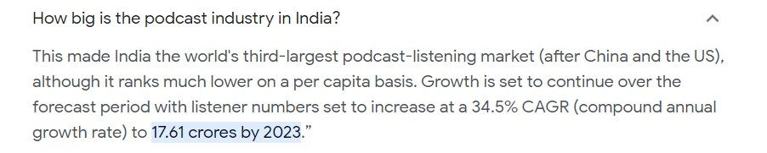

Fig.12

**13.The Future of Podcasting:**

The future of podcasting promises continued innovation and expansion. Advancements in technology, such as AI-driven content recommendations and improved voice recognition, will enhance the listening experience. The democratization of podcasting will enable a broader range of voices to enter the space, leading to more diverse content. As audiences grow, podcasting will become an integral part of mainstream media, further solidifying its importance. However, challenges such as discoverability and content saturation must be addressed to ensure sustainable growth. Overall, the future holds immense potential for podcasting as it continues to captivate audiences and shape the media landscape.

**14.Conclusion:**

In envisioning "Pod Club," we've embarked on a journey to redefine the podcasting experience. This concept represents the culmination of innovation and vision, offering a dedicated platform that addresses the needs and desires of both podcast creators and avid listeners.

Throughout our exploration, we've outlined features that simplify podcast creation, enhance discoverability, and facilitate monetization. We've seen how "Pod Club" could become a hub for knowledge-sharing, entertainment, and community-building, fostering connections among creators and their audiences.

While "Pod Club" remains a hypothetical idea, it symbolizes the boundless potential within the podcasting industry. It demonstrates our commitment to harnessing technology and creativity to enrich the podcasting ecosystem.

As the podcasting landscape continues to evolve, it is ventures like "Pod Club" that inspire us to think beyond the status quo, pushing the boundaries of what this medium can achieve. Whether "Pod Club" becomes a reality or not, it serves as a testament to the enduring spirit of innovation and the ever-expanding horizons of podcasting.

**15.References:**

1. <https://www.globenewswire.com/en/news-release/2023/05/01/2658279/0/en/Podcasting-Market-Analysis-Reveals-Growth-Outlook-of-27-8-CAGR-Reaching-USD-233-9-Billion-Revenue-By-2032.html>
2. <https://unsplash.com/photos/T2KXgTdssx4>
3. <https://www.emizentech.com/blog/podcast-mobile-app-development.html>
4. <https://chat.openai.com/c/49cb6200-d899-4f74-9dc3-a738b0d929c7>